

**Version: draft**

**Last Updated: 01/2025**

**Author(s): Benjamin Roberts**

End Point Assessment -

Level 4 Software Development

Benjamin Roberts

# Table of Contents

Table of Contents 2

Table of Figures 5

Introduction 11

1) Java Decisioning Program 12

1.1. Introduction & Requirements 12

1.1.1. Project Description 12

1.1.2. Acceptance Criteria/Project Outcomes 12

1.2. Stakeholders Involved 13

1.3. Development – Set Up Dependencies 14

1.3.1. CRUD - Database Connection 14

1.3.2. Standing up a Database Solution 14

1.3.3. Handing Azure firewall 15

1.3.4. Uploading Data 16

1.3.5. Access Management 17

1.3.6. Personal Data (PII) Protection 20

1.3.7. Credentials within the Java program 21

1.4. Development -Java 23

1.4.1. User Input 23

1.4.2. Data Model 25

1.4.3. Credit Policy built 27

1.5. Testing the program 37

1.5.1. JUnit Unit Tests 37

1.5.2. End to End 38

1.5.3. Debugging Errors 40

1.6. Conclusions 44

1.6.1. Project Outcome 44

1.6.2. Future Additions 44

2) React Web App – Decisioning Dashboard 45

2.1. Introduction & Requirements 45

2.1.1. Project Description 45

2.1.2. Acceptance Criteria 45

2.2. Design 46

2.2.1. Existing product for inspiration 46

2.2.2. Wireframes 47

2.3. Development 50

2.3.1. Backend Setup – for supporting functionality 50

2.3.2. Testing connectivity 52

2.3.3. Front End – React 53

2.4. Final Tech Stack 75

2.5. Feedback - Review with Employer 76

2.6. Final Application Pages 77

2.6.1. Home.jsx 77

2.6.2. SummaryData.jsx 77

2.6.3. PremiumValue.jsx 78

2.6.4. RawData.jsx 78

2.7. Conclusions 79

2.7.1. Project Outcome 79

2.7.2. Future Additions 79

3) Application Testing 80

3.1. Introduction 80

3.2. Testing Frameworks 82

3.2.1. Software 82

3.2.2. Language Libraries 83

3.3. Testing Methodologies 84

3.3.1. Strategical Approach: Shift-Left Testing 84

3.3.2. Functional Testing 89

3.3.3. Non-Functional Testing 101

3.4. Conclusion 110

4) DevOps Framework End 2 End 111

4.1. Background / Context 111

4.1.1. Agile vs Waterfall Project Management 111

4.1.2. DevOps 113

4.1.3. Stakeholders and Roles 114

4.1.4. Software Development Life Cycle (SDLC) 117

4.1.5. The “Definition of Done” 121

4.2. SDLC Applied 122

4.2.1. Requirements 122

4.2.2. Planning 127

4.2.3. Design & Development 136

4.2.4. Deployment (UAT) 141

4.2.5. Testing 149

4.2.6. Deployment (Production) 156

4.2.7. Review 163

4.3. Development Standards 165

4.3.1. Clean Code - Use Datastore Functionality where possible 165

4.3.2. SOLID: Single Responsibility 167

4.3.3. Avoid Lock-in – Why we maintain a separate Build Specification 169

4.3.4. Code Reuse (Templates) 170

4.3.5. DRY (Don’t repeat yourself) 171

4.3.6. KISS 174

4.4. Concluding Summary 175

5) Microservices, Databases and API’s 176

5.1. Introduction 176

5.2. Discovery 177

5.2.1. Relational Databases 177

5.2.2. Non-Relational (NoSQL) Databases 179

5.2.3. Current Architecture 183

5.3. Strengths and Weaknesses 188

5.4. Alternative – Microservice Architecture 189

5.4.1. Proposed Architecture 190

5.4.2. How to Implement 191

5.5. Conclusion 193

Additional Evidence 194

Final Reflections 195

Future Development 195

Appendices 196

React Web App 196

Initial Backend attempt, with React & Node.JS running via the “concurrently” library 196

Hosting in Azure Static Web App 197

Application Testing 201

Appendix A – Exported PDF Report of Performance Testing results 201

Appendix B – Exported PDF of Load Testing Results 203

Acronyms and Terms 206

Guidance (Delete this later) 209

Bibliography 210

# Table of Figures

Figure 1 - A Java Class called “AzureJDBC.java which handles a connection to an Azure SQL Database 13

Figure 2 - A screenshot showing a Firewall rule in place on my database to only allow access from my network (with IP Addresses redacted) 14

Figure 3 - Teams Messages – Uploading Test data Into Azure SQL Database 15

Figure 4 - Azure Data Studio flow for loading data into a database 16

Figure 5 - SQL Code showing the creating of the integration user for the Java Program to use. 17

Figure 6 - SQL Views used within the Java Program 17

Figure 7 - SQL Table use to log results history of the Java Program 18

Figure 8 - Properties file with the credentials stored in Key-Value pairs, with sensitive information redacted 20

Figure 9 - .gitignore file with a record to not include .properties files 20

Figure 10 - Implementation of Java reading from an external file to set variables 21

Figure 11 - Code used to define the “UserInput” class, importing the necessary Scanner class & defining 22

Figure 12 - Java Console showing the Scanner Class in use to capture user input 22

Figure 13 - An object method used to prompt the user for a Residential Status 23

Figure 14 - the “AppData” class written to act as a Data Model 24

Figure 15 - Importing and using the GSON library to create a JSON Representation to log to the console 24

Figure 16 - An example of the GSON output, returning a JSON Representation of the Java Program's data model 25

Figure 17 - Java Classes for both Scorecards. 26

Figure 18 - View of the AppData Class constructor, which the Champion/Challenger split 27

Figure 19 - NULL handling for a Scorecard characteristic. 31

Figure 20 - Probability of Default formula (Silva et al, 2020) 32

Figure 21 - Java Class method to calculate Probability of Default 32

Figure 22- SetIndex method for the Champion Scorecard 33

Figure 23- SetIndex Method for the Challenger Scorecard 33

Figure 24 - Email Chain with colleague for peer review 34

Figure 25 - JUnit 5 Test cases written to test individual parts of the program independently 36

Figure 26 - A test case written to test a program set up class that reads properties from an external file 37

Figure 27 - A demonstration of running the program within the Eclipse Software, with console output 37

Figure 28 - Console output for supporting debugging the program 38

Figure 29- Unit Test for testing probability of default 39

Figure 30 - Unit Test on the Offers class 40

Figure 31- Unit Test results showing Illegal Argument Exceptions 40

Figure 32 - Java Switch case missing Break statements 41

Figure 33- Correcting the Switch Case, allowing the tests to pass 41

Figure 34 - Meeting Minutes for presentation on final version with employer 42

Figure 35- Requesting screenshots of a similar existing product from a colleague 45

Figure 36- Initial draft Wireframe drawn on Whiteboard 46

Figure 37 - Figma Wireframe of a Home Page for the React app 47

Figure 38- Importing "mssql" into a React Component called "Home.jsx" 49

Figure 39- Compile error from importing the "mssql" library 49

Figure 40 - Initialising an Express app based on a template 50

Figure 41 - Install http-errors dependency 50

Figure 42- "user.js", a default route provided by Express 51

Figure 43- Postman HTTP Request showing the expected response from the "users.js" route 51

Figure 44-Top Bar Navigation for all pages on the application 52

Figure 45- HTML and React Code for the Navigation Bar 52

Figure 46 - NavBar Component placed into the main App.jsx Component 53

Figure 47 - CSS code used to make the Top Navigation bar scroll with the user 53

Figure 48 - Top Bar Navigation scrolls with user 54

Figure 49 – Webpage with enough content to require the user to scroll down to view different sections 55

Figure 50- Side Bar HTML code, with <a> to provide the links 55

Figure 51- <h2> tags with Id's allowing the side navigation bar to link to them 56

Figure 52- Original CSS, with an issue on the "top" property not working as expected 56

Figure 53- Altered CSS, with unnecessary properties removed & issue with "top" property fixed 57

Figure 54 – Final Side Bar for the PremiumValueData page, with links to each section and sub-section 57

Figure 55- Required imports for this new "db.js" file 58

Figure 56- Configuration object 58

Figure 57 - SQL Query in use 58

Figure 58 - Code behind the "db.js" file that makes the Database Connection possible 59

Figure 59- Calling the Back End with fetch, wrapped in the "UseEffect" React function 60

Figure 60 - CORS Error message 60

Figure 61- Code added to "db.js" to resolve CORS Policy errors 61

Figure 62 - Rendered Database results 61

Figure 63- Permissions applied to the SQL Integration account 62

Figure 64- Definition of E1B08 from Experian (2024) documentation 63

Figure 65 - Definition of AccountStatus from Experian (2024) documentation 63

Figure 66- Installing csv-parser 64

Figure 67- Error attempting to load a dependency directly into React for my lookup function 64

Figure 68- router.et method for the backend to accept a search parameter 65

Figure 69 - Endpoint logic showing the lookup function being used & sending this back to the calling application 66

Figure 70 - Code for Lookup functionality 67

Figure 71- OnClick property using the lookup function 68

Figure 72 - Lookup prompt presented to the user for E1B08 as seen in Firefox 69

Figure 73- Lookup prompt presented to the user for E1B08 as seen in Microsoft Edge 69

Figure 74- Switch case to translate AccountStatus into a business-friendly value 70

Figure 75 - CaisRow component return statement, showing the translated value in use 70

Figure 76- React JSX code showing the rendering of the CaisRow components via the .map() method 71

Figure 77 - Rendered React application showing the business-friendly language used instead of the original values 71

Figure 78 - Hardcoded URL within the React Application 72

Figure 79 - .env file added to allow dynamic configurations without altering the raw code 72

Figure 80 - Altered code to use the newly created .env file 73

Figure 81 - Diagram showing the Tech Stack of the full application 74

Figure 82 - Teams Call arranged to discuss Apprenticeship progress 75

Figure 83- Home Page (final) 76

Figure 84 - Summary Data page (final) 76

Figure 85- Premium Value page (final) 77

Figure 86- Raw Data page (final) 77

Figure 87 - Internal Email Communication with IT Development & Testing Leads (names redacted for privacy) 79

Figure 88- Email Response from IT with starting point suggestions 80

Figure 89 - Testing Framework Software 81

Figure 90- Testing Framework Language libraries 82

Figure 91- Microsoft Teams meeting for discussing approaches to Software Testing 83

Figure 92- Traditional view o Shift-Left testing, with various forms of testing applied (Wikimedia.org, 2024) 83

Figure 93 - Escalating costs of bugs/faults as they are found later in the Development process (Deepsource, 2019) 84

Figure 94 - Table Breakdown of Gherkin Keywords (Cucumber, 2024) 85

Figure 95- Generic example of a complete Gherkin Test case (SmartBear, 2023a) 86

Figure 96 - Example of a workplace Test case written in Gherkin language (with sensitive information redacted) 86

Figure 97- Visual of Test Driven Development (IBM, 2024) 87

Figure 98 - Typical Hierarchy to order different types of Functional Testing is conducted (GeeksForGeeks, 2024b) 88

Figure 99 - Unit Test cases 90

Figure 100- Java JUnit representation of a Unit Test my team would write within our Credit Decisioning platform 90

Figure 101- Unit Test Results as seen in our Credit Decisioning platform 91

Figure 102 - Flowchart of the workflow for conducting System Testing (GeeksForGeeks, 2024b) 92

Figure 103- Generic Postman Test to check HTTP Status Code received 92

Figure 104 - System Test cases 93

Figure 105 - Using Postman to load Test data for System Testing 93

Figure 106 - Postman Test code in practice (with sensitive information redacted) 94

Figure 107 - Results for System Test Case 1 94

Figure 108 - Results for System Test Case 2 95

Figure 109 - Results for System Test Case 3 95

Figure 110- Visual Representation of Integration Testing (SmartBear, 2024a) 96

Figure 111 - Integration Test case 1 - JavaScript code 97

Figure 112- Initial run of Integration tests showing failures 98

Figure 113- DELETE HTTP Requests added to clean up test data preventing repeatable testing 99

Figure 114- Integration Test cases passing after clean up steps added 99

Figure 115 - Postman Software plans, showing Performance Testing features not being available on the Enterprise plan (Postman, 2024) 100

Figure 116 - Postman Support ticket about Early Access to Performance Testing feature 101

Figure 117- Demonstrating Postman’s "Run Collection" feature 102

Figure 118- Configuring Postman's collection runner for my Performance Tests 103

Figure 119 - Visualisation of Postman Performance testing results 103

Figure 120 - Focus on final statistics of Performance Test run 104

Figure 121 - Exporting Performance testing results to a PDF file 104

Figure 122 - Load Testing configuration used 105

Figure 123 - Load Testing - results visualisation 106

Figure 124 - Load Testing showing a single HTP 429 Error 107

Figure 125 - Typical hierarchy of agile Work Items (Microsoft Learn, 2024) 111

Figure 126 - DevOps Lifecycle (Atlassian a, 2024) 112

Figure 127 - Software Development Life Cycle (SDLC) as applied in Decisioning Engine Development 116

Figure 128 - Technical Requirements Document Template Cover page 122

Figure 129 - Workflow of the Requirements stage + roles involved. 123

Figure 130 - Example of a Change Request loaded in Azure DevOps, ready for Planning. 125

Figure 131 - Workflow diagram of the Planning stage + roles involved. 127

Figure 132 - Azure DevOps notification created when a PBI is assigned to a user, with a comment left for them clarifying what action is needed. 129

Figure 133 - History of the PBI, showing it being moved into Approved and the user who did. 130

Figure 134 - Example of a Product Backlog Item (redacted where needed) with all the detail required for Development to commence. 130

Figure 135- Example of Backlog Meetings set up in Microsoft Teams 131

Figure 136- Matrix of T-Shirt sizing to Fibonacci Sequence Story Points 132

Figure 137 - Example of Master Reference List, describing previous Work Items and sizes. 133

Figure 138 - Workflow of the Design & Planning phases + roles involved. 136

*Figure 139 - Example Specification Document for a build of the system (exact content is Redacted.* 137

Figure 140 - Example of a Stand-Up series, set up in Microsoft Teams 139

Figure 141 - Example of a Team Chat, set up in Microsoft Teams 139

Figure 142 - Workflow of the Deployment phase + roles involved. 141

Figure 143- Example of Debug Inbound Adapter test. 144

Figure 144 - Example of business-friendly version number set within the platform. 144

Figure 145 - Release Note (part 1), showing the high-level summary of the changes in the build and contacts. 145

Figure 146 - Release Note (Part 2), showing the individual Work Items deployed in the release 146

Figure 147 - Workflow for the Testing phase 149

Figure 148 - Example of the Test Completion Report showing the Test Scenarios, with sensitive information redacted. 152

Figure 149 - Example of Postman in use, with a JSON Request and a HTTP 200 Response received (exact message bodies redacted) 152

Figure 150 – Snippet of the Test Completion Report showing the pass rate of all test scenarios 152

Figure 151 - Workflow of Production Deployment 156

Figure 152 - Example Change Request form (which specifics redacted) 159

Figure 153 -Approval workflow as seen in the change management system. 159

Figure 154- Outlook meeting invite to Change Approval Board (CAB) 160

Figure 155 - Pre-deployment communication informing stakeholders across the business of the change. 160

Figure 156 - Post Deployment communication informing stakeholders across the business that the change is in production. 161

Figure 157 - Post change review section of the Change Request Form 161

Figure 158 - Summary slide of a Demo presentation created by our IT Teams for an end of Sprint Review. 163

Figure 159 - Example of a condition using a Hard-Coded threshold. 164

Figure 160 - Parameterised threshold within Zoot’s Datastore Functionality 164

Figure 161- The same code as the previous figure, but instead using a Parameter with a Meaningful Name 165

Figure 162 - Example of a module conforming to Single Responsibility 166

Figure 163 - Example of Single Responsibility failure. 167

Figure 164 - The Build Specification being updated. 168

Figure 165 - Example of existing templates within the Web Rules platform, for common components we develop. 169

Figure 166 - Shared Platform Objects folder, showing multiple re-usable procedures. 170

Figure 167 - Bad Practice example of approaching Enum values in code. 171

Figure 168 - Attribute Objects in the platform used instead of raw text, with all occurrences shown via the Search functionality. 171

Figure 169- Good Practice example of approaching Enum values in code. 172

Figure 170 - Example of Business Logic Requirements, showing complexity in the design (exact logic has been redacted) 173

Figure 171 - Example of a Monolith platform (Atlassian, 2024) 175

Figure 172 - Example of tables in a relational database, where a Foreign Key "EmployeeId" is used to relate the tables (Pluralsight, 2020) 176

Figure 173 - Example of data storage in a Document store, a type of non-relational database (Microsoft Learn, 2024) 179

Figure 174 - Visual representation of a Key-Value store (Microsoft Learn, 2024) 180

Figure 175 - Visual representation of a column database (Amazon AWS, 2024) 180

Figure 176 - Representation of a graphical database (Microsoft Learn, 2024) 180

Figure 177 - Current Architecture for calling External Data Providers 182

Figure 178 - Snippet of the Decisioning Engines HTTP Response, which the front-end references to control the next screen shown to applicants 183

Figure 179 - Front-end screen shown to applicants for a "Progress" result. 184

Figure 180 - Check Record in the Front-End system, saving a record of the decision(s) received from the decisioning system 184

Figure 181 - Multiple Check records created in the Front-End system (UAT Environment as to not show any actual customer data) 185

Figure 182 - Additional blocks of data within the decisioning engine HTTP Response 185

Figure 183 - Check record created from the Scorecard data from the decisioning engine's HTTP response 186

Figure 184 - Check record created from the External Info data from the decisioning engine's HTTP Response 186

Figure 185 - Visual representation of a Microservice Architecture (Atlassian, 2024) 188

Figure 186 - Proposed changes to Architecture, focusing on reusing API Integrations 189

Figure 187 - JSON Schema for an Experian API Product as seen within our low-code decisioning engine 190

Figure 188 - Example of a RegEx match function being used on a variable within this parsed JSON schema 190

Figure 189 - Proposed JSON Schema for the Microservice Payloads 191

Figure 190- Initial Backend npm start logic 195

Figure 191 - Setting up an Azure Static Web App to host the React application 196

Figure 192 - The React App home page as deployed to the Azure Static Web App 198

Figure 193 - Confirmation a user can access the deployed React App 199

Figure 194 - Postman Performance Test Report - Page 1 200

Figure 195- Postman Performance Test Report - Page 2 201

Figure 196 - Postman Load Testing Report - Page 1 202

Figure 197 - Postman Load Testing Report - Page 2 203

Figure 198- Postman Load Testing Report - Page 3 204

# Introduction

My name is Benjamin Roberts. Currently I am a Lead Credit Risk Analyst at Vanquis Banking group, a specialist finance provider that targets underserved customers in the UK Financial Services market e.g. customers who would have difficulty accessing financial services with more mainstream banking services, typically due to poor credit history.

My team is responsible for the implementation of Credit Risk decisioning logic within our Decisioning Systems across the group i.e. the business logic that decides if someone is eligible for a credit product e.g. a Credit Card. To do this, we make use of a licences low-code tool from a 3rd party, which acts as a framework for us to be able to build HTTP API’s that can accept POST Requests and return responses with data necessary to drive credit application journeys.

Whist we sit within a business function, our role requires us to operate more like an IT Function. This requires our skill set to align close to Software Development & Testing. While our 3rd party partner does give us training within their low-code tool for developing, this knowledge is bespoken to the tool and limits opportunity for skills development. Using the 3rd party tool also enforces a specific architecture upon us, limiting out ability to experiment with new technology. We also have some experience in software testing developed on the job by necessity, but this is not formalised.

I wanted to expand my knowledge beyond the limitations of the low-code solutions I work with day-to-day, which led me to the Level 4 Software Developer apprenticeship. This has given me opportunities to study and apply:

* Object Orientated Programming (practiced in Java)
* Front-End Development (HTML, CSS and JavaScript)
* Front-End Frameworks e.g. React
* Software Testing
* DevOps
* Microservice architecture

Throughout the apprenticeship, I have completed various projects to apply this learning to my role, either directly or in an experimental capacity. This portfolio details these projects.

# Java Decisioning Program

## Introduction & Requirements

The team I work in is primarily responsible for developing and maintaining a Credit Decisioning software platform. The software we use to do this is provided by a 3rd party and provides a low-code graphic user interface (GUI) for developing business logic into a callable Web service, without the need for specialised IT support. Currently I work as one of the Lead Analysts for this, effectively a Technical Lead for mentoring junior members of the team in building business logic and developing more complex functionality to orchestrate executing business logic e.g. modular designs, integrating database connections & integrating external data sources via HTTP.

This software is built within the Java language, with the GUI interface acting as a layer of separation to allow business users to develop without needing to have experience in the Java language. Personally however, I wish to have a greater understanding of Java, due to a desire to have more experience in object-oriented programming and to better understand how a Java program and various libraries scale to a full application.

With the support of my employer (after a 1-to-1 meeting), I decided to try to build a similar decisioning application within Java directly. Goals and acceptance criteria have been defined below:

### Project Description

Create a Java program that implements Credit Decisioning logic at an introductory level. This must include:

1. Some ability to capture relevant applicant information required to make a credit decision and enter this information into the program.
2. Execute credit decisioning policy rules that conditionally reject an application if set criteria is met.
3. Connect to an external database to retrieve more data to use for decisioning.
4. Use additional data gathered from this database to execute Scorecards in a champion/challenger approach (requiring at least 2 scorecards to be created)
5. Return a final decision and an offer to the user depending on the decisioning logic.
6. A record of the program run is then saved into an external database (for monitoring and further credit decisioning use)

### Acceptance Criteria/Project Outcomes

1. Final program must have an interface for a user to input application data
2. Application data input must include:
   1. A Match ID of some kind to look up in the external database.
   2. Residential Status
   3. Employment Status
3. A database connection is made to allow CRUD operations for logging activity made in the program.
4. A database connection is made to allow a lookup to be made based on the data received in the program.
5. Multiple credit decisioning policy rules are built and executed in the program flow.
   1. Policy rules are grouped in a modular way to breakdown testing.
   2. A mix of the application input data and data retrieved from the external database is used.
6. Multiple credit decisioning scorecards are built and executed.
   1. A credit offer is made in a champion/challenger style i.e. only 1 is used as the basis for the offer despite both being executed

## Stakeholders Involved

To develop the project, I consulted several stakeholders for support. A summary of the input from each stakeholder is recorded below. Communication methods used are also logged as:

* **F** = Face to Face
* **IM** = Instant Messaging via Microsoft Teams
* **C** = Call via Microsoft Teams
* **E** = Email

|  |  |  |
| --- | --- | --- |
| **Stakeholder** | **Methods** | **Input** |
| Credit Risk | **F, IM, C** | * Sign-off for project with Line Manager * Consulted for specific business logic that could be applied to the project & would be appropriate to share * Final review of the project |
| IT Delivery Managers | **F** | * Consulted for advice on how to host the application, specifically for the database link for CRUD operations |
| Asset Management | **E** | * Arranged the installation of all software and licenses required for this project, including:   + Eclipse IDE   + Visual Studio 2022 subscription with Microsoft Azure credits |
| Data Delivery | **IM** | Consulted for:   * advice on setting up an Azure SQL Database user. * importing data into a database that could be used for the program |
| Model Management | **E** | * Fact-checking on the theory sections of the Scorecard Development |

## Development – Set Up Dependencies

### CRUD - Database Connection

In practice, Decisioning Systems like these use a backend database to log application & API call data. They may also store data used in part of the Decisioning Strategy e.g. matching to internal customer data. Creating an integration therefore was a natural requirement. The below sections cover the work required for this.

### Standing up a Database Solution

2 Options were considered for this:

1. MySQL localhost database, a solution I know to be open-source (and therefore free to use)
2. An Azure SQL Database, which was recommended by my employer’s IT Delivery Managers as we hold licences for Visual Studio 2022 subscription, which come with $50 of monthly Azure Credits

The Azure SQL Database was chosen due to:

* The localhost nature of the MySQL solution limited the program to only working on the developer machine.
* Azure representing the opportunity to work with Cloud Computing resources.
* Azure potentially providing a host to deploy this application to if it went further.

Once set up, a connection was established within Java using the MS SQL JDBC library. This is contained within the “AzureJDBC.java” class within my project:

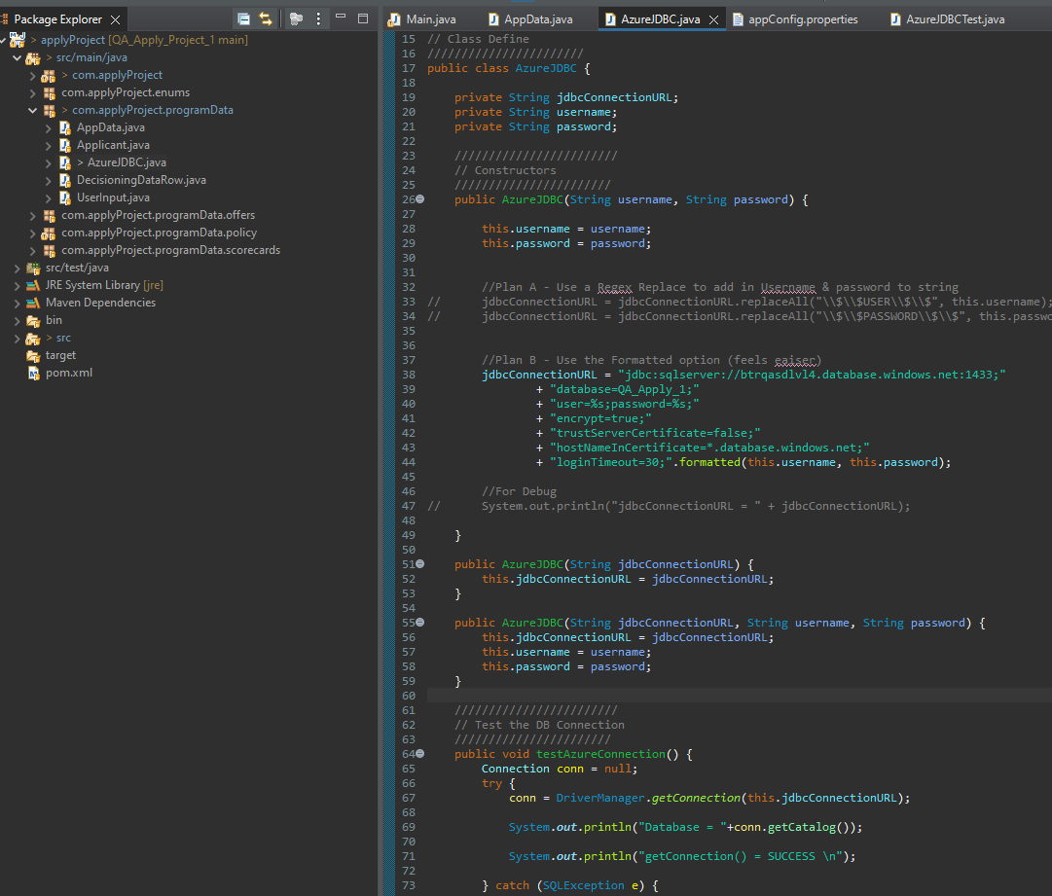

Figure 1 - A Java Class called “AzureJDBC.java which handles a connection to an Azure SQL Database

### Handing Azure firewall

One issue I had with connecting to the database was that Azure protects its resources with a firewall.

To resolve this, I added my local IP Address to the Firewall rules within Azure to allow devices on my network to interact with the database.

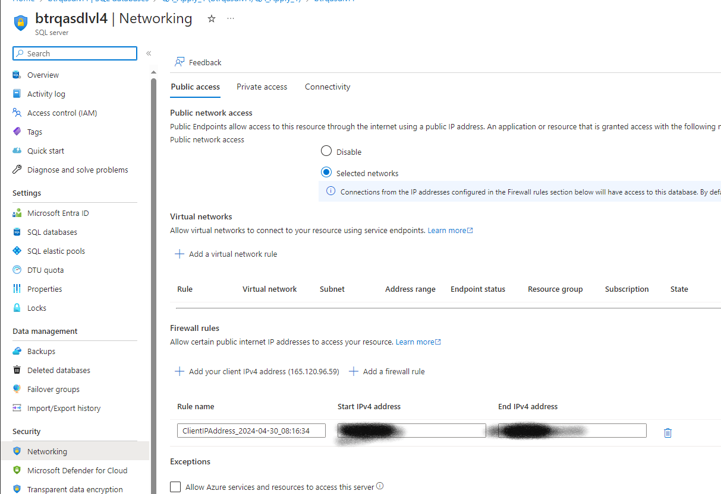

Figure 2 - A screenshot showing a Firewall rule in place on my database to only allow access from my network (with IP Addresses redacted)

### Uploading Data

Credit Decisioning logic typically relies on external data provided by credit bureaus e.g. for the UK those are Experian, TransUnion and Equifax. Being able to retrieve a source for this data was vital to the program.

The scope I set for this project meant that I needed a batch of data the program could access. For this, I used a set of data based on Experian’s DelphiSelect API. This provides users with access to the data Experian hold on a person, which is used to create a credit file for that person. Lenders can then use this to inform their credit decisions (Experian, 2024).

For my program to work, I needed a way to upload a Dataset to the SQL database. For support on this, I consulted our internal Data Delivery team. This was done over Microsoft Teams:

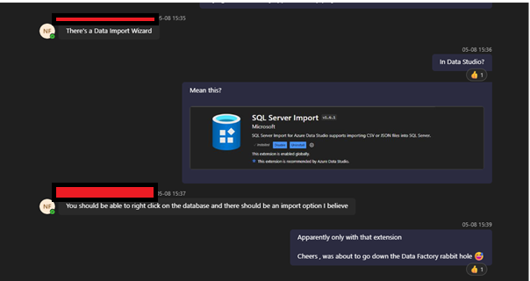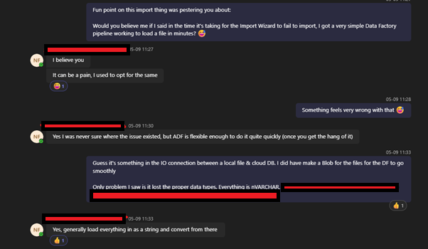

Figure 3 - Teams Messages – Uploading Test data Into Azure SQL Database

From this conversation, 2 solutions for uploading a dataset based off this API into the Database were identified:

1. **Import Wizard** via the Azure Data Studio Software, the main software used for working with Azure Databases
2. **Azure Data Factory** – another cloud-based tool offered by Microsoft for ETL (Extract, Transform, Load) Data flows.

The Import Wizard was preferred due to its simplicity, but this kept timing out while loading. Azure Data Factory was the alternative I discussed with our Data Delivery team (see Appendix). The tool provides a beginner friendly “Ingest” template, which I was able to use to get my test dataset loaded.

Shown below is an example of this in action. The pipeline was run in “Debug” mode, which caters for one-off scenarios like this,

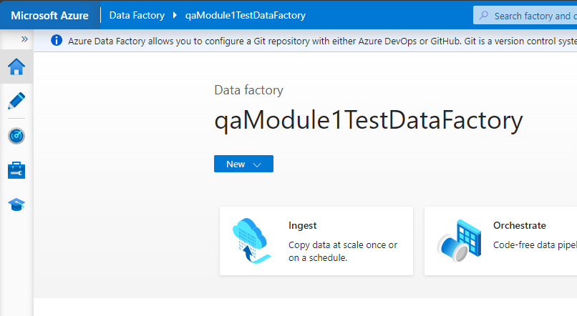

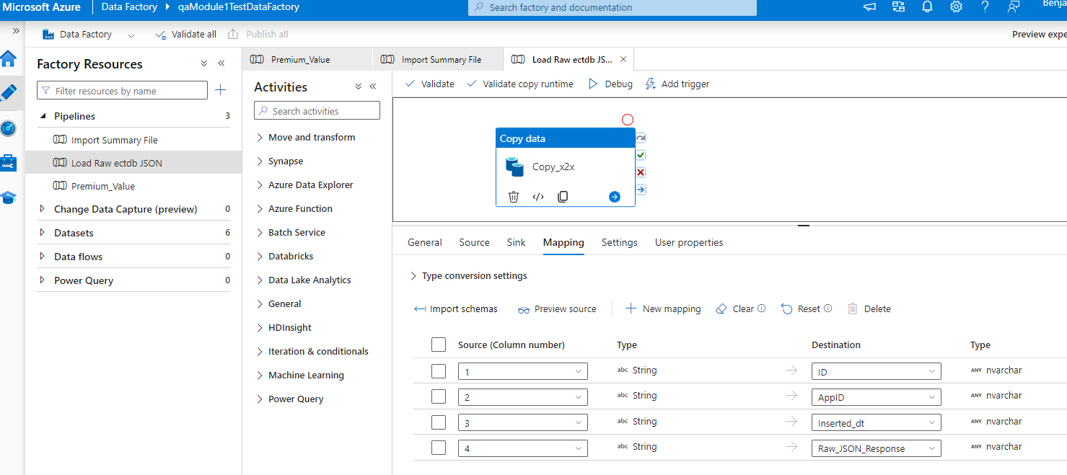

Figure 4 - Azure Data Studio flow for loading data into a database

### Access Management

When creating the database, I was required to create a root/admin user, with full permissions to edit the database. It’s not appropriate to use this for my application as it has far more permissions than it needs, introducing security risks (Snowflake, 2024).

To set an appropriate level of access, I created a new Integration User within my database & granted only permissions that were needed.

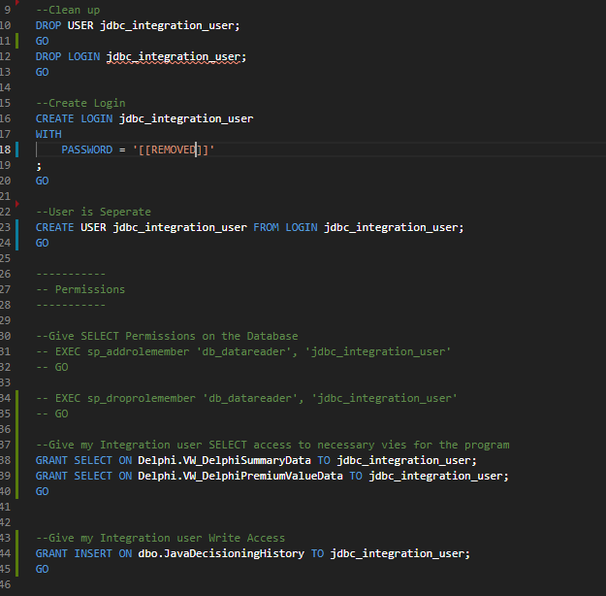

Figure 5 - SQL Code showing the creating of the integration user for the Java Program to use.

Permissions granted to this user included:

* SELECT access to the views required by the program to execute (Microsoft, 2024a)

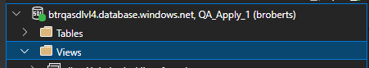

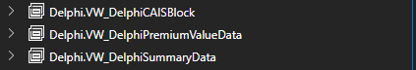

Figure 6 - SQL Views used within the Java Program

* INSERT access to the “dbo.JavaDecisioningHistory” table where transaction history will be logged.

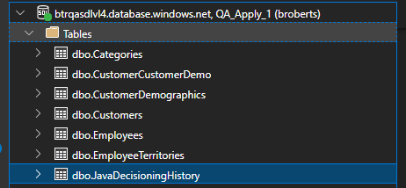

Figure 7 - SQL Table use to log results history of the Java Program

### Personal Data (PII) Protection

This **access management configuration can also be used for another purpose**: **protecting Personal Data (PII).** Credit Decisioning Systems like this must collect personal data to be able to conduct a credit search on a person e.g. Experian’s DelphiSelect API requires at least:

* Full name of the person in question
* Date of Birth
* At least the current address of the person in question
* Previous addresses are also often needed if the person in question has resided at their current address for less than 3 years

(Experian, 2024)

Each of these Data Points are protected under the UK's Data Protection Act 2018, which also codifies the GDPR into UK Law (UK Government, 2018). The program is currently collecting the Full Name of the user as a starting point to allow a full API integration in future. This means the program must be mindful of Data Protection/GDPR requirements.

Using a SQL databases within the program creates the risk of SQL Injection, where malicious input into the program can lead to arbitrary execution e.g. a user passes in a SQL command instead of a name (W3Schools, 2024a). This is where the SELECT and INSERT permissions assigned above come into effect. The Full Name collected in the application is only saved to the **“dbo.JavaDecisioningHistory**” , which the integration user only has INSERT permissions on. This prevents a malicious user from entering a query to retrieve data from this table, as the database permissions will result in the query being rejected.

The only other permission the Integration User has been granted is the SELECT permission on the “**Delphi.VW_DelphiPremiumValueData**” and the “**Delphi.VW_DelphiSummaryData**” views. These are the only other views required by the program, so by limiting the access like this the possibility of risk incurred by SQL Injection is minimised and therefore acts as a control to protect Personal Data.

### Credentials within the Java program

To avoid hard coding these credentials within the program, a “.properties” file was created:

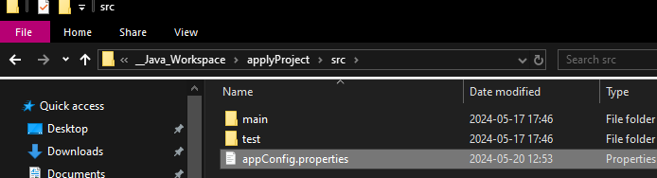

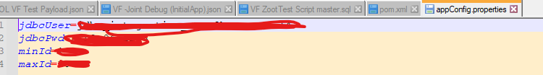

Figure 8 - Properties file with the credentials stored in Key-Value pairs, with sensitive information redacted

For security purposes, this properties file is not committed to the GitHub repository used for this project. It falls into a general rule to exclude all .properties files from the repository. This is done by adding a record to the “.gitignore” file, which tells Github files matching the names or expressions within should not be monitored. The *.properties line acts as a catch-all to filter out all properties files like this.

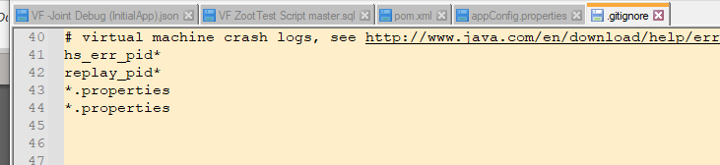

Figure 9 - .gitignore file with a record to not include .properties files

Java can read these files by the “key” names e.g. for this file, Java can reference “jdbcUser” within the program and extract the value. The advantages of this are:

* Credentials are not hard coded, making them easy to change
* They can be stored in files that are not tracked by Version Control software like Github.

Below is code showing how this is implemented in the program:

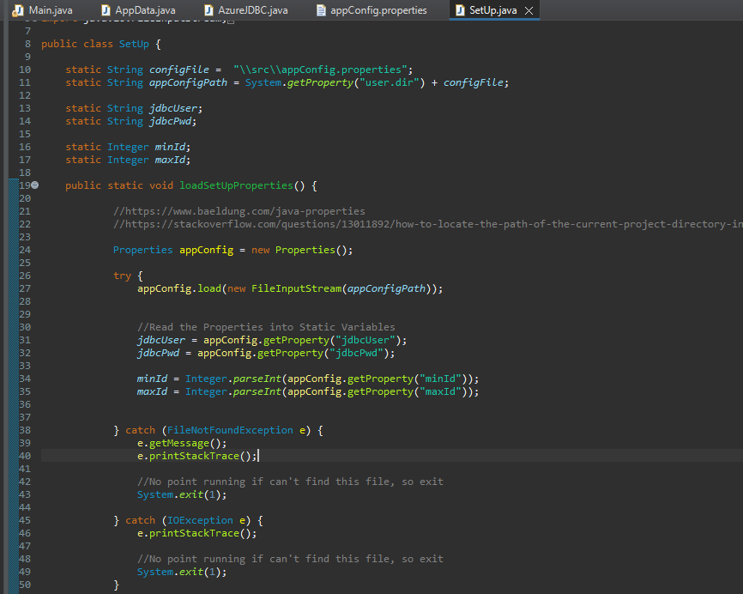

Figure 10 - Implementation of Java reading from an external file to set variables

The try-catch logic is used to catch scenarios where the config properties filed cannot be found. Without this, the program can’t run. To avoid any unnecessary behaviour if this occurs, the “System.Exit” method is used to terminate the program immediately.

## Development -Java

### User Input

The Java Scanner class was used to prompt the user for input. Defined below is a class called “UserInput” which has been written to group all methods related to capturing user input together:

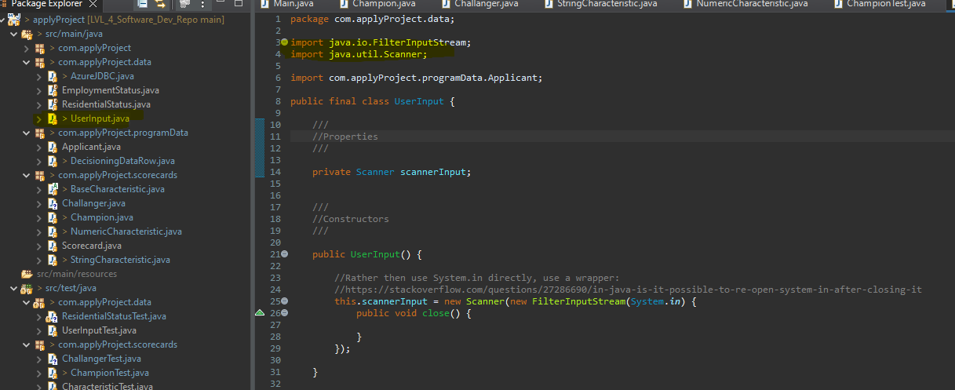

Figure 11 - Code used to define the “UserInput” class, importing the necessary Scanner class & defining

Upon running the program, the user will be asked a series of questions:

1. Their Forename
2. Surname
3. The ResidentialStatus and their EmploymentStatus, presented as a menu.

Console output for this is below:

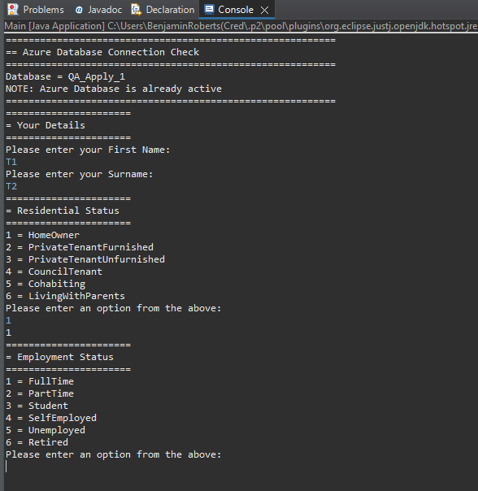

Figure 12 - Java Console showing the Scanner Class in use to capture user input

An example of the code that generates this console output is annotated below:

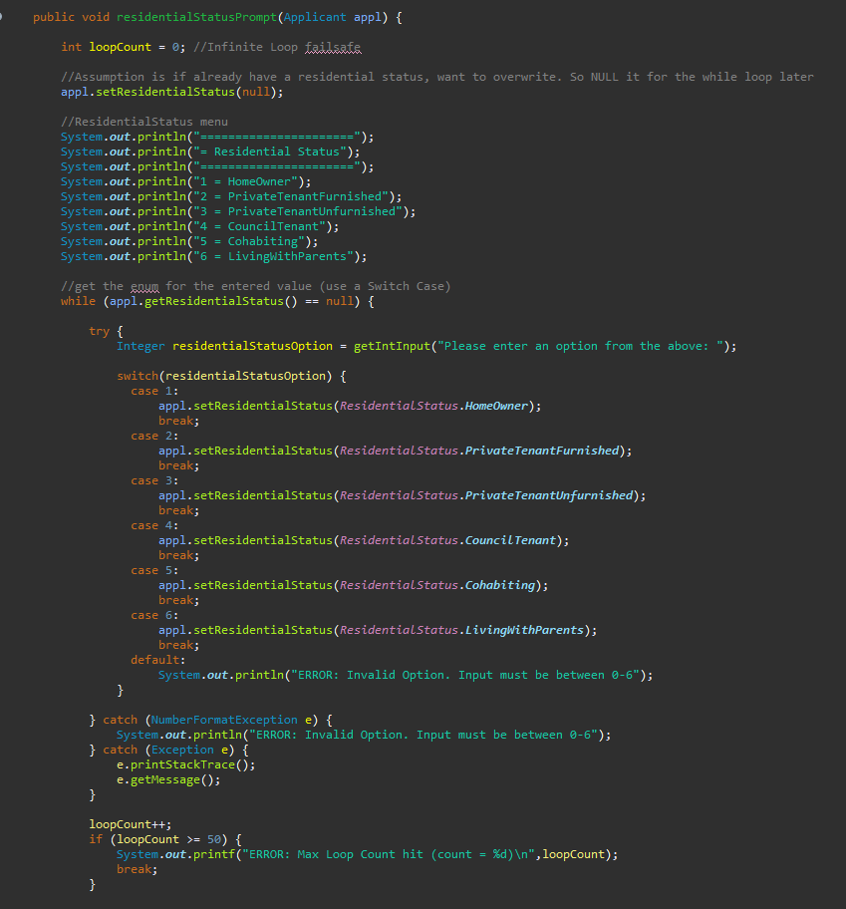

Figure 13 - An object method used to prompt the user for a Residential Status

What each part of this does:

* “println()” functions print out a menu of options to the console for the user
* A custom defined “getIntInput” method calls the Java Scanner & writes out another prompt to the console with instructions to the user
* A “while” loop traps the user in this loop until they provide a valid option
* The “try-catch” block is included to capture invalid characters e.g. string values when expecting a value of 1 to 6
* The “loopCount” increment logic is included as a failsafe for ending the while loop in case of too many bad inputs and/or preventing an infinite loop

### Data Model

One issue I ran into early on was how to logically structure the data used within the program. When working with Credit Decisioning systems in the workplace, we use a Data Model to define what data the application has access to and how it is stored.

I chose to apply a similar approach to this program, by defining an “AppData” class:

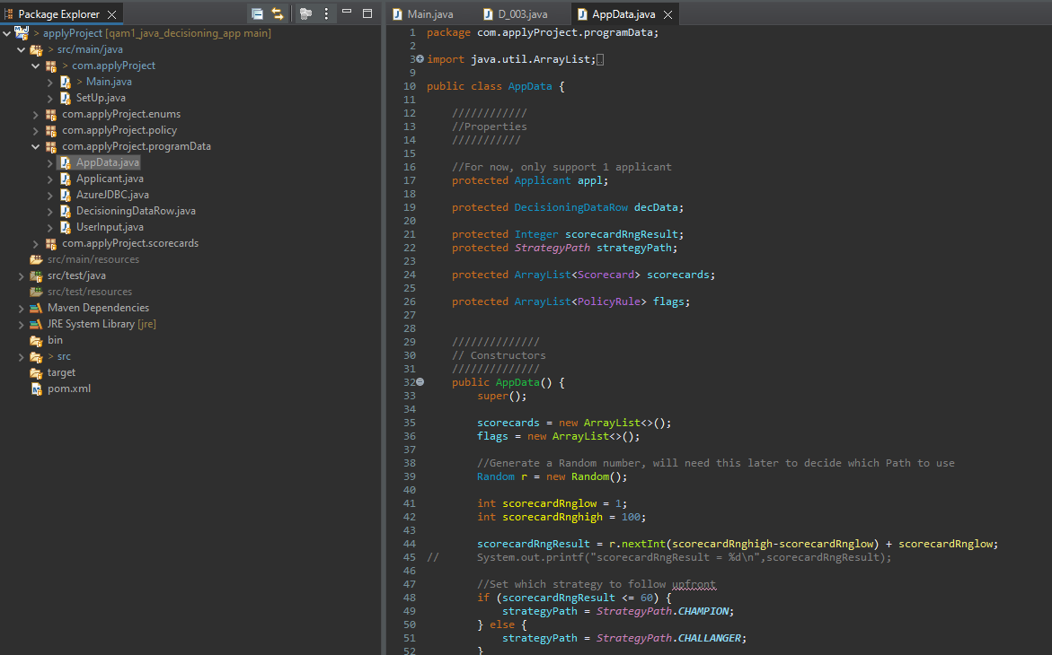

Figure 14 - the “AppData” class written to act as a Data Model

Doing this gave these advantages:

1. All application data is logically grouped
2. A single data object can be logged for review
3. Java Methods could be written to accept this model, allowing some flexibility around Java’s strongly typed data constraints when writing methods

Once the program completes its run, this Data model is populated with all the data used during the run. This allows the data to be logged easily for review. To do this, I made use of the GSON library to get a JSON representation of this (Google, 2024):

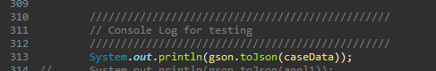

Figure 15 - Importing and using the GSON library to create a JSON Representation to log to the console

An abridged example output of this is below:

{

"appl": {

"forename": "T",

"surname": "T",

"employmentStatus": "FullTime",

"residentialStatus": "HomeOwner"

},

"decData": {

"pk": 4874,

"E1B07": "0",

"E1B08": "0",

"E1B09": 2,

"TRD_A_13": -3,

"E1A09": 0,

"E5S051": 777,

"NDSPCII": -4,

"TRD_A_06": 2,

"E1B13": 0,

"E1B01": 0,

"TRD_STL_14": -2,

"TRD_STL_19": -2

},

"scorecardRngResult": 77,

"strategyPath": "CHALLANGER",

"scorecards": [

{

"scorecardName": "ChampionScorecard",

"score": 733,

"index": 0,

"probOfDefault": 0.0024726231566347745,

"stringCharacteristics": [

{

"characteristicValue": "0",

"name": "E1B07",

"bandingScore": 27

},

{

"characteristicValue": "HomeOwner",

"name": "ResidentialStatus",

"bandingScore": 40

}

],

"numberCharacteristics": [

{

"characteristicValue": 2,

"name": "E1B09",

"bandingScore": 10

},

{

"characteristicValue": -3,

"name": "TRD-A-13",

"bandingScore": 40

},

{

"characteristicValue": 0,

"name": "E1A09",

"bandingScore": 46

},

{

"characteristicValue": -2,

"name": "TRDSTL14",

"bandingScore": -30

}

]

},

{

"scorecardName": "ChallangerScorecard",

"score": 691,

"index": 0,

"probOfDefault": 0.01798620996209156,

"stringCharacteristics": [

{

"characteristicValue": "FullTime",

"name": "EmploymentStatus",

"bandingScore": 45

}

],

"numberCharacteristics": [

{

"characteristicValue": -4,

"name": "NDSPCII",

"bandingScore": -40

},

{

"characteristicValue": 2,

"name": "TRD-A-06",

"bandingScore": 14

},

{

"characteristicValue": 0,

"name": "E1B13",

"bandingScore": 26

},

{

"characteristicValue": 0,

"name": "E1B01",

"bandingScore": 34

},

{

"characteristicValue": -2,

"name": "TRD-STL-19",

"bandingScore": 32

}

]

}

],

"flags": [

{

"policyCode": "D_001",

"ruleOutcome": "PASS",

"decisionType": "DECLINE"

},

{

"policyCode": "D_002",

"ruleOutcome": "PASS",

"decisionType": "DECLINE"

},

{

"policyCode": "D_003",

"ruleOutcome": "PASS",

"decisionType": "DECLINE"

},

{

"policyCode": "A_001",

"ruleOutcome": "PASS",

"decisionType": "ACCEPT"

}

]

}

Figure 16 - An example of the GSON output, returning a JSON Representation of the Java Program's data model

### Credit Policy built

The below section details the Credit Decisioning Logic built into the program.

#### Scorecards

Credit Scorecards are a tool in credit risk management used by Credit Risk Management teams to model/predict the likelihood of default for a given subject borrower (i.e. an applicant/customer) over a period (Huang and Scott, 2017). They are used for evaluating the creditworthiness of a customer, making them critical part of the Credit Decisioning process. This made them a natural choice to build in this project.

Scorecards from a program point of view are made up of:

* Characteristics which receive a score based on their value
* A final calculated score based on the sum of the characteristic scores + a starting score
* A “Score Index” used to group ranges of scores together. Typically translates into groups the business can use to simply communicate which applicants are more risky
* A “Probability of Default”, which translates the raw score into a percentage chance the applicant would default on a credit offer i.e. they are unable to pay

This project implements 2 scorecards in a champion/challenger fashion. This is an approach that deploys multiple competing strategies into a production environment and monitoring which provides the best (FICO, 2020). Using this is an effective demonstration of using Object-Oriented programming to build Credit Decisioning logic.

Note that both scorecards are not based on any actual statistical model. They are only for demonstrating how the concept can be implemented in an Object-Oriented program.

The Characteristics form the core of any scorecard. Given that each scorecard is unique in what variables it uses and how it assesses each variable, I chose to use classes containing static methods to implement these. This is shown in the figure below:

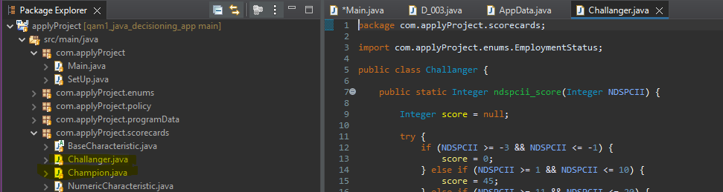

Figure 17 - Java Classes for both Scorecards.

##### Decide between Champion and Challenger

For a Champion/Challenger strategy, the goal is to send a percentage of applicants down the challenger path and compare the outcomes to the champion. To start, most of the volume would be directed to the known good model (i.e. the champion). This allows the business to test the challenger model with a limited volume to analyse if better business outcomes are given by the challenger.

To apply this to my program, I added logic into my AppData model constructor to decide which strategy path the program should follow. This logic is below:

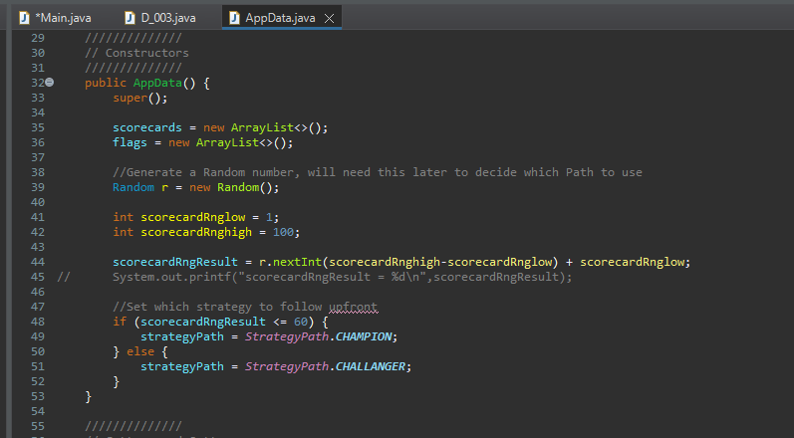

Figure 18 - View of the AppData Class constructor, which the Champion/Challenger split

Defining this logic in the constructor of the Data Model allows me to easily ensure this split is made early in the program. It is implemented as:

* 60% of the users will use the Champion Path
* 40% use the Challenger Path

The “Random” Java class is used to generate a random number to enforce this split.

##### Characteristics

These scorecards consist of a starting/base score plus a series of characteristics, variables with values that represent a statistical insight into the applicant/customer e.g. the E1A09 characteristic in the Champion scorecard count how many delinquent (i.e. in arrears) account they have present on their account (Experian, 2024). Specific values in that variable get assigned Banding Scores (or Points) which represent if they are a positive or negative indication of the applicant’s credit worthiness.

Once calculated, all the Banding scores are added together, along with an initial starting/base score to calculate a final score for the applicant, which represents their credit worthiness. A financial institution can use this as a basis for deciding a credit offer i.e. do they offer them a product and what terms they will offer if they do.

Below are specifications of both the Champion and Challenger scorecards built into the program, documented in a style typical in the workplace. The columns mean:

* **Characteristic** = the name of the variable used. Can reference ether data the applicant enters on an application form or data available on their Credit records accessed via Credit Bureaus like Experian
* **Data Type –** documents the type of values the characteristic can hold. Useful for guiding developers in how to handle the values within
* **Min Value & Max Value –** These relate to the **Points** column & defines the ranges used to set a specific Banding Score/Points. For String values, this is a 1-to-1 mapping for value to points
* **Points –** The actual Banding score assigned to the characteristic, which is then added to the overall score on the scorecard

##### Champion Specification

|  |  |  |  |  |  |
| --- | --- | --- | --- | --- | --- |
| **Characteristic** | **Data Type** | **Min Value** | **Max Value** | **Points** | **Notes** |
| Base Score | Numeric | [default] | | 600 | This is a static value that all instances of this scorecard will start from. |
| E1B07 | String | T | | 0 | External data provided by Experian’s Credit Record API: DelphiSelect  Defined as: ***Worst Status in the last 6 months of all Active CAIS accounts (SP)***  (Experian, 2024) |
| N | | 0 |
| D | | 0 |
| U | | 0 |
| 0 | | 27 |
| 1 | | 14 |
| 2 | | -10 |
| 3 | | -23 |
| 4 | | -23 |
| 5 | | -23 |
| 6 | | -23 |
| 8 | | -50 |
| [default] | | -50 |
| E1B09 | Numeric | -1 | 0 | -20 | External data provided by Experian’s Credit Record API: DelphiSelect  Defined as***: Number of Active CAIS Accounts (SP)***  (Experian, 2024) |
| 1 | 2 | 10 |
| 3 | 4 | 20 |
| 5 | 6 | 30 |
| 7 | max | 18 |
| [default] | | -20 |
| TRD-A-13 | Numeric | -3 | -3 | 40 | External data provided by Experian’s Credit Record API: DelphiSelect  Defined as***: Number of Months Since Most Recent Arrears on all Accounts allowed***  (Experian, 2024) |
| -2 | -2 | -20 |
| -1 | 0 | -20 |
| 1 | 1 | 10 |
| 2 | 2 | 5 |
| 3 | max | -30 |
| [default] | | -30 |
| E1A09 | Numeric | -1 | -1 | 0 | External data provided by Experian’s Credit Record API: DelphiSelect  Defined as: ***Number of Delinquent CAIS Accounts, excluding Mail Order accounts***  (Experian, 2024) |
| 0 | 0 | 46 |
| 1 | 2 | 24 |
| 3 | max | -26 |
| [default] | | -26 |
| TRD-STL-14 | Numeric | -2 | -2 | 26 | External data provided by Experian’s Credit Record API: DelphiSelect  Defined as: ***TSMR Active Short Term Loans account opened (Active CAIS)***  (Experian, 2024) |
| -1 | -1 | 0 |
| 0 | 0 | 26 |
| 1 | 6 | -24 |
| 7 | 18 | -15 |
| 19 | 36 | 6 |
| 36 | max | 15 |
| [default] | | -24 |
| ResidentialStatus | String | HomeOwner | | 40 | This data point is one of the User Input questions.   The status indicates the type of accommodation someone lives in. |
| PrivateTenantFurnished | | 26 |
| PrivateTenantUnfurnished | | 34 |
| CouncilTenant | | 10 |
| Cohabiting | | 34 |
| LivingWithParents | | 10 |
| [default] | | 10 |

##### Challenger Specification

|  |  |  |  |  |  |
| --- | --- | --- | --- | --- | --- |
| **Characteristic** | **Data Type** | **MIn Value** | **Max Value** | **Points** | **Notes** |
| Base | Numeric | [default] | | 580 | This is a static value that all instances of this scorecard will start from. |
| NDSPCII | Numeric | -3 | -1 | 0 | External data provided by Experian’s Credit Record API: DelphiSelect  Defined as: ***Consumer Indebtedness Index (SP)***  This is an index that represents how in debt a person is. Higher values indicate the subject is using more of their available credit.   (Experian, 2024) |
| 1 | 10 | 45 |
| 11 | 20 | 23 |
| 21 | 25 | 14 |
| 26 | 40 | 5 |
| 41 | 50 | -20 |
| 51 | max | -40 |
| default | | -40 |
| TRD-A-06 | Numeric | -2 | -2 | 0 | External data provided by Experian’s Credit Record API: DelphiSelect  Defined as: ***Number of Consistently up-to-date accounts L12m*** (Experian, 2024) |
| -1 | -1 | -10 |
| 0 | 0 | -20 |
| 1 | 1 | 6 |
| 2 | 2 | 14 |
| 3 | max | 21 |
| default | | -20 |
| E1B13 | Numeric | -1 | -1 | -10 | External data provided by Experian’s Credit Record API: DelphiSelect  Defined as: ***Number of CAIS Status 3 or worse, within the last 6 Months for all Active CAIS accounts (SP)***  (Experian, 2024)  CAIS Status refers to the arrears position of the account e.g. 3 means 3 missed payments on the account. |
| 0 | 0 | 26 |
| 1 | 1 | -12 |
| 2 | max | -56 |
| default | | -56 |
| E1B01 | Numeric | -1 | -1 | 0 | External data provided by Experian’s Credit Record API: DelphiSelect  Defined as: ***Number of Active CAIS Accounts Opened in the Last 3 Months (SP)***  (Experian, 2024) |
| 0 | 0 | 34 |
| 1 | 1 | 12 |
| 2 | 2 | -11 |
| 3 | max | -33 |
| default | | -33 |
| TRD-STL-19 | Numeric | -2 | -2 | 32 | External data provided by Experian’s Credit Record API: DelphiSelect  Defined as: ***Total Number of Default Short Term Loans accounts (Default CAIS)***  (Experian, 2024) |
| -1 | -1 | 0 |
| 0 | 0 | 28 |
| 1 | 1 | -14 |
| 2 | max | -27 |
| default | | -27 |
| EmploymentStatus | String | FullTime | | 45 | This data point is one of the User Input questions.   The status indicates the type of employment an applicant is in. |
| PartTime | | 24 |
| Student | | 6 |
| SelfEmployed | | 33 |
| Unemployed | | -10 |
| Retired | | 22 |
| default | | -10 |

##### NULL Handling in characteristics

NULL values are technically possible within the External Data variables detailed in the specifications above. In this program the expectation is that those should fall into the “default” bands and get assigned the relevant points.

To handle this in Java, try-catch blocks are used to specifically catch a NullPointerException that would arise from attempting to use these values e.g. the screenshot below shows this applies to the E1B09 characteristic on the Champion scorecard:

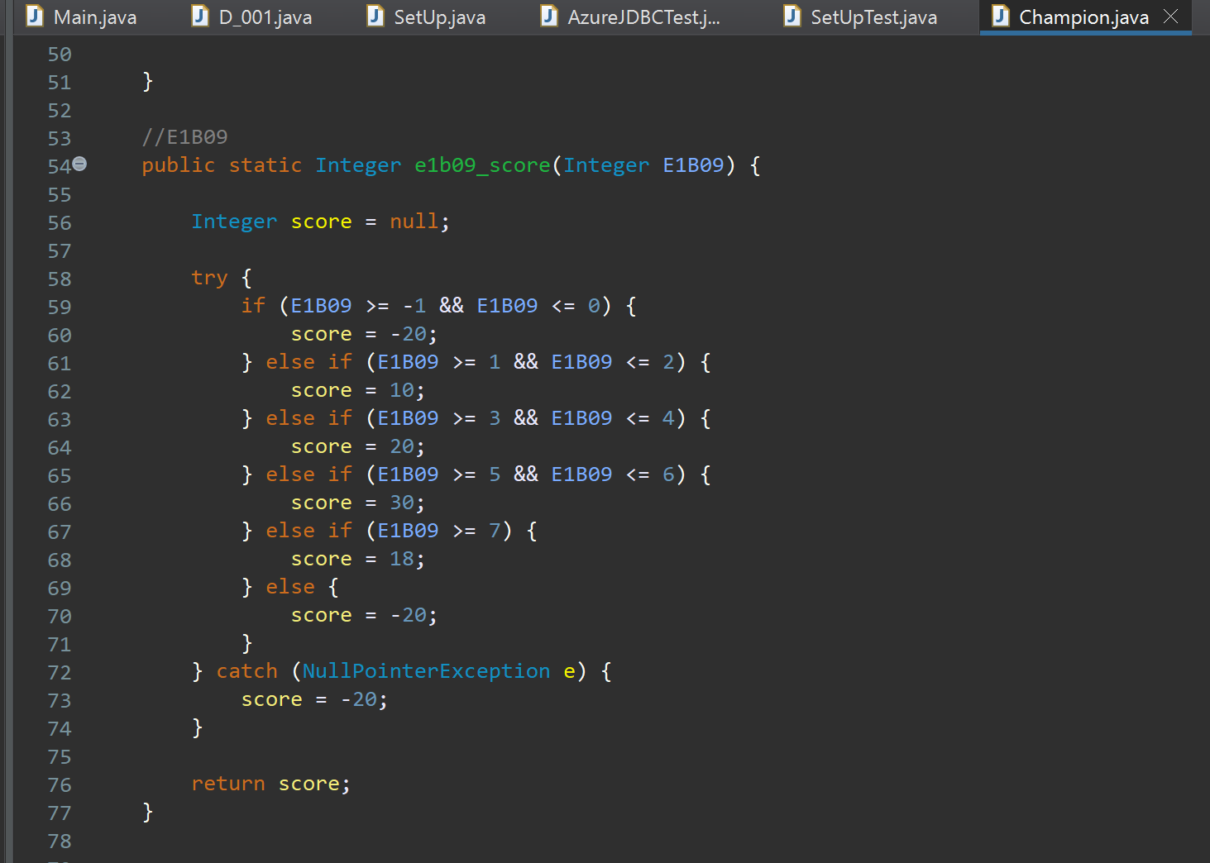

Figure 19 - NULL handling for a Scorecard characteristic.

##### Probability of Default formula

The calculated score on a Scorecard is intended to be a representation of how likely a subject is likely to default on any offered credit. In its natural form however, this isn’t a clear value to communicate probability to non-technical stakeholders. This becomes important when collaborating with product teams in credit decisioning, who typically do not have the subject matter expertise to interpret raw credit scores. The probability of default works as a more effective communication tool to help them set product offers e.g. max loan amounts and terms.

The Probability of Default formulas allow us to translate this raw score into a percentage value that can be more cleanly communicated to non-technical stakeholders. It makes use of coefficients (called “beta” β) and model variables defined early on in the Scorecard Model Development process to convert the raw score into a percentage value.

An accepted model for calculating this value (based on Logical Regression) is provided below:

|  |  |
| --- | --- |
| Probability of Default formula | **e** = Eular’s Number (i.e. exponent)  **β** = beta (i.e. the model coefficients)  **x** = Model variables defined in the Scorecard Model Development process |

Figure 20 - Probability of Default formula (Silva et al, 2020)

Beta i.e**. β** is a static value defined as part of the development process. Doing so requires using historical data on the population we’re modelling for. This data is run through statistical analysis (e.g. logical regression) to estimate a co-efficient to use.

X represents model variables defined in the scorecard process. For the purpose of this mock model, those are our Scorecard Characteristics covered above. The Points assigned to each variable are added together to form this.

Defining the constants to use in this model is typically done in the model development process. As only mock scorecards are used for this program to demonstrate the scorecards concept, the output of this will have no statistically meaningful value. The focus is solely on the Java implementation.

This screenshot below shows this coded in the “Scorecard.java” class:

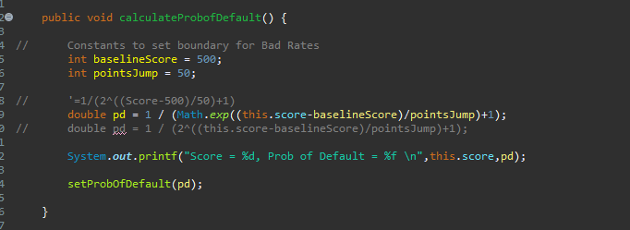

Figure 21 - Java Class method to calculate Probability of Default

Where:

* Math.exp() function provides the Exponent value required for the formula
* baselineScore & pointsJump represent the constants to be uses in the formula

##### Score Indexes

Score indexes are another method of translating the raw score from the Scorecard into an easier to understand metric for non-technical stakeholders. They help group ranges of scores/probability of defaults together to allow other business teams to make decisions on how they treat the person in question. One key example of this is deciding terms for offering a person a credit agreement e.g. how much money the business is prepared to lend over a set period of time (months, years etc).

To demonstrate this, I’ve coded “**setIndex**” methods into both my Champion and Challenger scorecards:

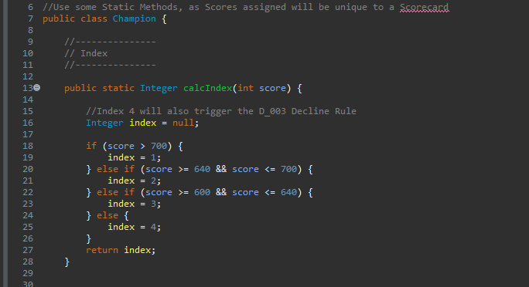

Figure 22- SetIndex method for the Champion Scorecard

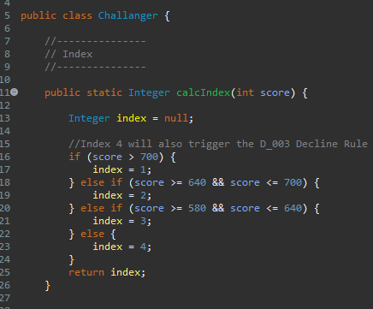

Figure 23- SetIndex Method for the Challenger Scorecard

##### Peer Review

Given the complexity of the Scorecard Development process, I wanted to have the information above peer reviewed to ensure accuracy. For this I reached out to our internal Model Monitoring team. They act as an Internal Audit team who reviewing the performance and development process of how models like these Scorecards are built, making them perfect technical stakeholder contact for validating this information.

Below is the email chain that came from this:

Hi Ben,

I have modified some wordings in the scorecard section and added my comments on the probability of default formula(p12).

Hope this helps.

Kind Regards,

[Colleague]

**From:** Benjamin Roberts (Credit) <Benjamin.Roberts@vanquis.com>  
**Sent:** Wednesday, May 29, 2024 1:53 PM  
**To:** [Colleague]

**Subject:** Re: Scorecard training docs?

Thanks [Colleague]🙂

Could I take you up on that please?

One thing I need to do for the project is explain the concept of a scorecard & the parts of it. I've put something together in the attached word doc from my basic understanding.

Could you give the Scorecard section a read please & fact check it?

**Sent:** Monday, May 20, 2024 15:07  
**To:** Benjamin Roberts (Credit) <[Benjamin.Roberts@vanquis.com](mailto:Benjamin.Roberts@vanquis.com)>  
**Subject:** RE: Scorecard training docs?

Hi Ben,

It’s a while back (maybe 9 years ago) when [Colleague] and people at that year joined the company I did run some model/scorecard development training courses. I don’t know if I keep those and have moved them to SharePoint as PFG had been transformed greatly. I will do a digging to see if I could find anything.

In the meantime, I am very happy to help you to understand any steps/procedures on the Scorecard development life cycle if you have any questions.

Kind Regards,

[Colleague]

**From:** Benjamin Roberts (Credit) <[Benjamin.Roberts@vanquis.com](mailto:Benjamin.Roberts@vanquis.com)>  
**Sent:** Monday, May 20, 2024 1:03 PM  
**To:** Weidong Peng (Credit) <[Weidong.Peng@vanquis.com](mailto:Weidong.Peng@vanquis.com)>  
**Subject:** Scorecard training docs?

Hi Weidong,

Hope your well 🙂

Rizwan suggested I approach you on this question: Do you have any internal training documentation on Scorecard Model Development I could look at please?

I'm doing an Apprenticeship for personal development. One of the things I'm doing for that is building a Scorecard within the Java language & as part of it I need to explain what one is to a non-technical stakeholder. My own knowledge admittedly isn't on the end-to-end Model Development so I was hoping we had some documentation around?

Kind Regards,

Benjamin Roberts

Lead Credit Risk Analyst – Credit Systems

Phone: 07798 848049

Email: [Benjamin.roberts@vanquis.com](mailto:Benjamin.roberts@vanquis.com)

Address: 1 Godwin Street | Bradford | West Yorkshire | BD1 2SU



Figure 24 - Email Chain with colleague for peer review

#### Policy Rules

Policy rules check the available data on the applicant for specific signs of financial difficulty or any other indication that the applicant may be outside the credit institutions risk appetite.

Policy Rules can be of 1 of these types:

* **Decline** = If the logic is met, no offer of credit given to the applicant
* **Accept** = Valid only if the logic for all instances of the other 2 types are not met. Represents no concerns found on the provided data, an offer of credit can be given

|  |  |  |  |
| --- | --- | --- | --- |
| **Code** | **Rule Name** | **Decision** | **Logic** |
| D_001 | Worst Arrears status is 2+ payments behind | Decline | IF DecisioningDataRow.E1B08 regex match 2|3|4|5|6|8 THEN FAIL |
| D_002 | Experian Score below threshold | Decline | IF DecisioningDataRow.E5S051<= 600 THEN FAIL |
| D_003 | Scorecard | Decline | IF (  decisionPath = “CHAMPION” AND Scorecards.Champion.score < 600  )  OR (  decisionPath = “CHALLENGER” AND  Scorecards.Challenger.score < 580  ) THEN FAIL |
| D_004 | Unemployed | Decline | If EmploymentStatus == “Unemployed” |
| A_001 | Accept | Accept | If none of the above Policy rules are hit |

## Testing the program

To be sure my program worked as intended and to the project requirements, testing was necessary. This was approached in 2 ways:

* Unit Tests via Junit 5
* End to end tests via running the program in the Eclipse IDE

### JUnit Unit Tests

When programming logic within the bespoke tool I use in my workspace, Unit Tests are used to ensure components of the code work as expected before a deployment is done. These are small scale tests that can be separated from the main program & re-used when any changes are made, allowing code quality to be maintained (AWS, n.d.). JUnit 5 is a Java package that provides a framework for writing these test & executing them (TutorialsPoint.com, n.d.). Examples written for this project are covered below:

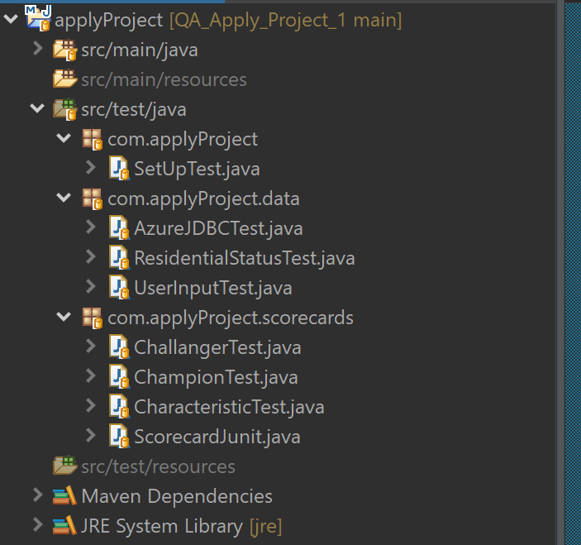

Figure 25 - JUnit 5 Test cases written to test individual parts of the program independently

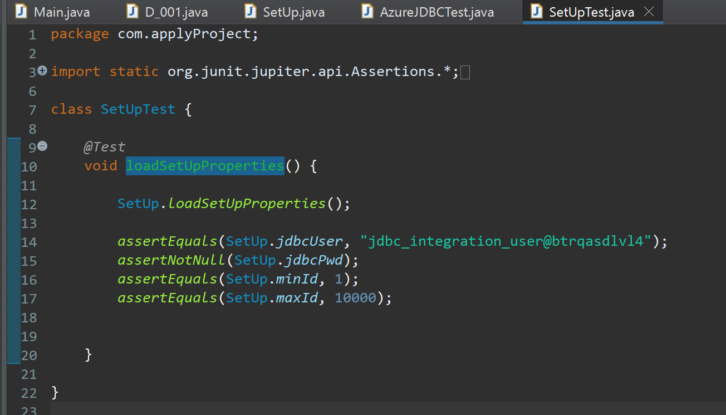

Figure 26 - A test case written to test a program set up class that reads properties from an external file

### End to End

To fully test the program, it was executed within the Eclipse IDE:

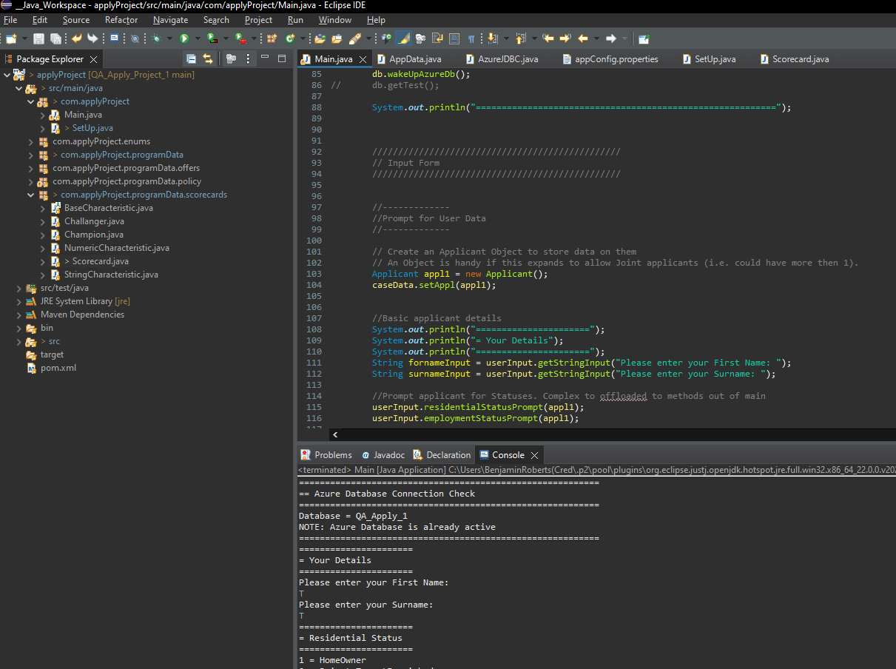

Figure 27 - A demonstration of running the program within the Eclipse Software, with console output

Towards the end of the program, there are steps to output decisions made to the console. This includes the full Data Model used. This allowed manual review of the decisions made vs the specifications covered in this document.

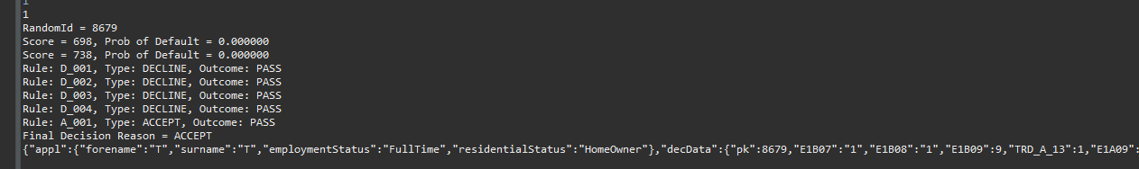

Figure 28 - Console output for supporting debugging the program

### Debugging Errors

These forms of testing allowed me to identify unexpected behaviour (i.e. bugs) in my program. Below are 2 examples I’ve pulled out for demonstration.

#### Probability of Default - Result always Infinity

One issue the Unit Tests on the Scorecards uncovered was that the Probability of Default function would always return an “Infinity” value, regardless of the formula input. This made the calculation effectively useless for its intended purpose.

To start debugging this, I added a specific check to my Unit Test to check for infinity values:

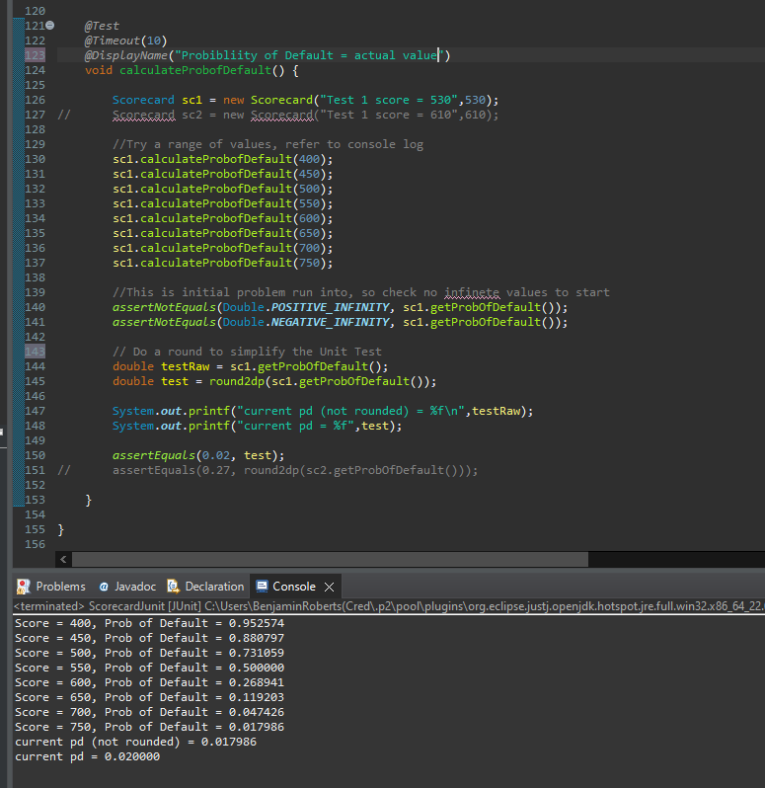

Figure 29- Unit Test for testing probability of default

With some trial and error when running this test, I was able to correct the error (unfortunately I did not have a specific commit in my GitHub repository capturing this).

#### Offers class returning exceptions

One Issue I faced with my program was that the Credit Offers the “Offers.java” class I wrote was not returning any of the expected results.

Examples of these tests are below:

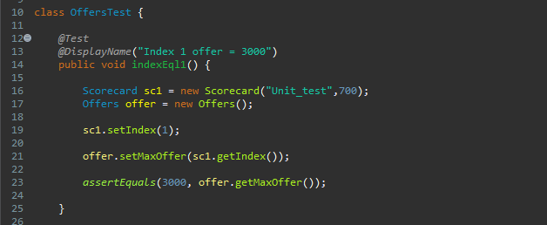

Figure 30 - Unit Test on the Offers class

This test works by creating a new Scorecards & assigning a Score (via the constructor) and setting a Score Index of 1. The Score Index is what determines the maximum offer an applicant can receive e.g. in this test, we’re expecting the Index of 1 to mean that person could ask for up to £3000.

When I ran this test however, this was not what I was getting. Instead. The Fail trace should Illegal Argument Exceptions being raised:

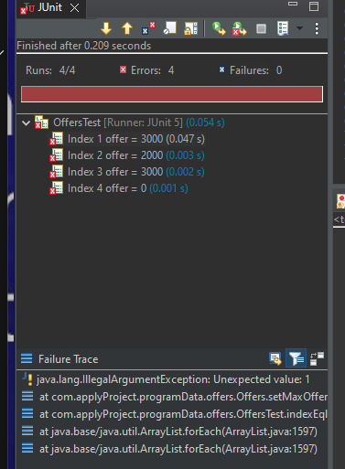

Figure 31- Unit Test results showing Illegal Argument Exceptions

After reviewing the code, I spotted I had neglected to add in the “break” statements for the Switch-Cases used within the “**setMaxOffer**” method this Unit Test was testing:

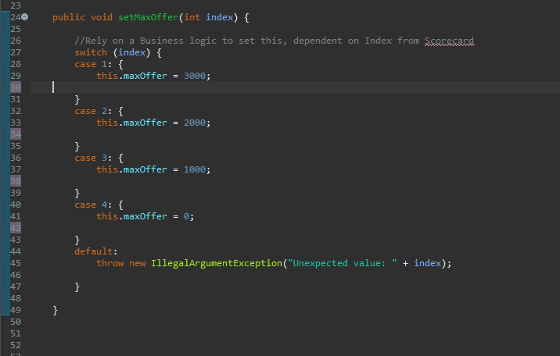

Figure 32 - Java Switch case missing Break statements

The “**break**” statements are essential in Java’s implementation of the switch case, as they prevent Java from executing the next case (Geeks for Geeks, 2024a). Without it, what happens here is that every switch case gets evaluated, even if a matching case is found. Ultimately, this ends up with the “default” case running, which generated the Illegal Argument Exception causing my unit test to fail. Once corrected, the test pass as expected:

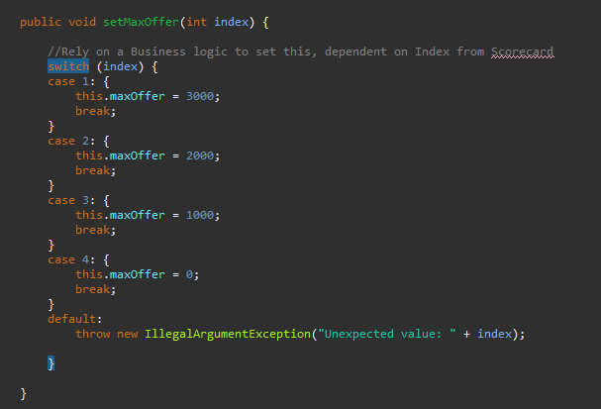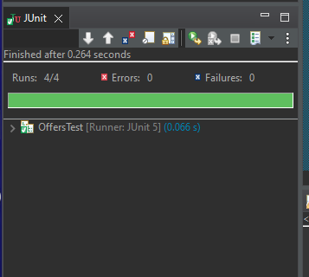

Figure 33- Correcting the Switch Case, allowing the tests to pass

Attendees (by initials):

* BR, TD [Head of Function, cover for RK]

Apologies (by initials):

* RK (on leave)

Positives

* Reusable code is shown via the Scorecard and Policy rule templates.
* JSON output of the decisions made provides a full view of the data used for auditing.
* Champion/Challenger scorecards considered and implemented logically.
* Some Error Handing steps in place to prevent redundant program execution if the program could not complete e.g. database credentials missing.

Possible Improvements

* Error Handling has room for improvement e.g. if the program is unable to connect to the database, a specific Policy Rule could be built for reporting.
* Scorecard points, index boundaries etc could be better placed as configurable values (ether via external config file or in the SQL database), which avoids hard-coding them into the complied program (and difficult to change)
  + Also creates possibilities to hand controls of this to business teams, potentially creating competitive advantage via fast to implement change.
* Database timeouts should be explicitly considered e.g. 30 second timeout.

Agreed overall the program met the Acceptance criteria set out and had scope to improve should the project be developed further.

Figure 34 - Meeting Minutes for presentation on final version with employer

Overall, I believe this went well. My employer agreed the project criteria has been met and provided many valuable points of feedback from a less technical, more business practical point of view.

## Conclusions

### Project Outcome

Overall, the project succeeded in meeting the criteria set out in the introduction. The major functionality (Scorecards and Policy Rules) used within the bespoke Credit Decisioning software platform my team used has been developed into the program with re-usable classes that are suitable for creating many instances. A Credit decision is also made based on data retrieved from a backend database.

Additional Java Libraries were also discovered to expand the functionality of the program to effectively meet some of the requirements. For example, using the GSON library allows representations of the Java objects to be converted into JSON. That greatly simplified the requirement for retaining a record of the transaction, as this meant that all the data could be added to a Data Model object. All that was needed then was to save this Data Model to the logged history.

There was a significant amount of pre-requisite steps needed to get this project working e.g. setting up an Azure SQL database and loading data into it. This will be useful for later projects as a re-usable resource.

### Future Additions

Below are a few ideas I have in mind to expand this project in future:

* Front end interface to collect more data on an applicant e.g.
  + Addresses
  + Income
  + Expenditure
* Submit the collected applicant data to the program as a semi-structured message body e.g. JSON
* Use previous runs of the application within business logic e.g. check the history for a count of same person re-running the program
* Replace the random database lookup with a connection to the Delphi Select Sandbox API
* Automate execution of the JUnit test cases & generate a report on the results

Reviewing with my employer also identified areas for improvement:

* Change approach to setting values to allow configurations like Scorecard points to be done outside the program, making them easier to change (potentially by business users as well)
* Improved Error Handing, in ways that made Management Information (MI) available to business users
  + Specifically, an explicitly defined timeout on the database connection

# React Web App – Decisioning Dashboard

## Introduction & Requirements

With my team being responsible for developing and maintaining our Credit Decisioning system, we require various kinds of Management Information (MI), and views of the data used by the platform (both in the aggregate and within individual applications). This is also important for monitoring the performance of the platform.

Today, we use various tools to monitor and report on the performance of the system e.g.:

* Ad-Hoc analysis done via querying a SQL Database
* Summarised Microsoft Excel Reports
* Microsoft Power BI reports
* Manually extracting and reviewing raw data (typically via SQL)

All these tools are useful for their specific purposes but what they don’t do is give us a presentable view of the low-level data used in deciding on an application. We could license other software for this purpose e.g. the Credit Bureau providers Experian, TransUnion and Equifax all provide software to present the data they hold on an applicant. These however require software licenses to be purchased. I believe we could use the React Framework to build a similar tool that would be more bespoke to our business needs.

### Project Description

Using the React JavaScript Framework, design and develop a simple Web Application to:

1. Leverage the Java Decisioning Application I developed in a previous “Java Decisioning Program” project & it’s logged output
2. Display a list of recent applications made to the Credit Decisioning system
3. Allow a user to click on a specific application to view the data used for it in more detail
4. Provide reference material for the data definitions of the data used (i.e. a Data Dictionary function)

### Acceptance Criteria

1. Wireframe of the design of the website is provided
2. Final product aligns to the wireframe
3. Intuitive user interface created & evidenced via feedback from technical & non-technical stakeholders
4. The web app can query a database where logs from the Decisioning program/software are retained
5. Low level detail of the data used in the application, including:
   1. Data used for running Scorecards + their values
   2. Summary data on an applicant’s Credit file
   3. Raw data used to create the above summary data

## Design

To give myself a starting point, I referred to the Software Development Life Cycle, which has the “design” stage as one of the 1st stages (after planning), making it a key starting point for building a piece of software (Amazon AWS, 2024b). With the requirements already defined (effectively acting as the planning stage), I needed a design to work towards.

### Existing product for inspiration

From my time in the workplace, I was aware of a similar product that provided similar functionality to what I was aiming to achieve in this project. I believed it would be worthwhile to examine this product as a source of inspiration for how to approach my project.

I did not have access to this product myself, but I knew a colleague who did who also had good technical knowledge of the product and its comparisons to my project brief, making explaining the purpose of the ask simple. I sent them a message over the Microsoft Teams application asking if they could share some screenshots of what they see within this product. They provided me with 5 screenshots.

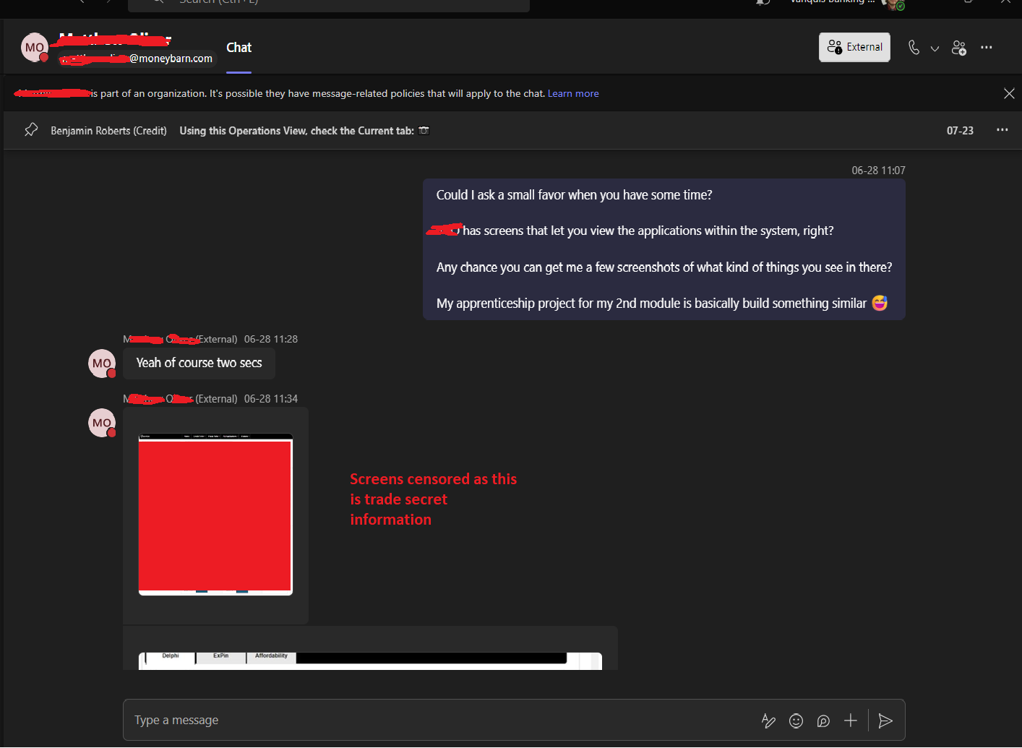

Figure 35- Requesting screenshots of a similar existing product from a colleague

I’ve not included the provided screenshots in this report & have removed most of the previews from the figure above. This information can be considered trade secrets, so this was done to protect the privacy of the stakeholders involved.

### Wireframes

With some inspiration from an existing system Vanquis Banking Group already use, I started with a draft wireframe and then expanded upon it with a 2nd iteration.

#### Initial Draft for page template

To keep a simple process to start, I drew a basic template on a white board for that I had in mind for a “home” page:

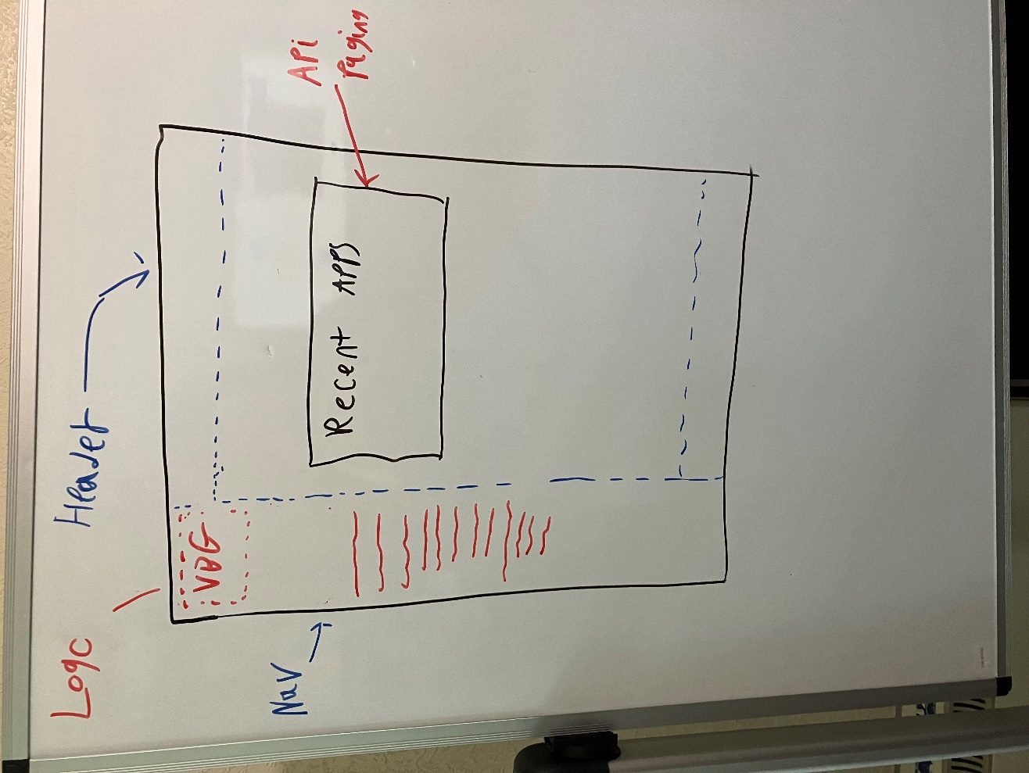

Figure 36- Initial draft Wireframe drawn on Whiteboard

Doing this simple approach gave me a way to get a starting point for what I wanted the layout of my application to look like, without having to decide on specific details (like styling).

#### Figma Wireframe

The whiteboard draft was useful to get a foundation, but I wanted to go into a little more detail before I started creating the React Application. This meant I needed a more detailed wireframe.

Figma is a solution I was familiar with, as our internal Marketing team have shared wireframes they’ve created for internal projects with me previously in the past. I believed this made it a good tool to look at for developing my wireframe into something ready for development.

Below is what I created for the Home page. The idea was to use this as a template for the design of the remaining pages.

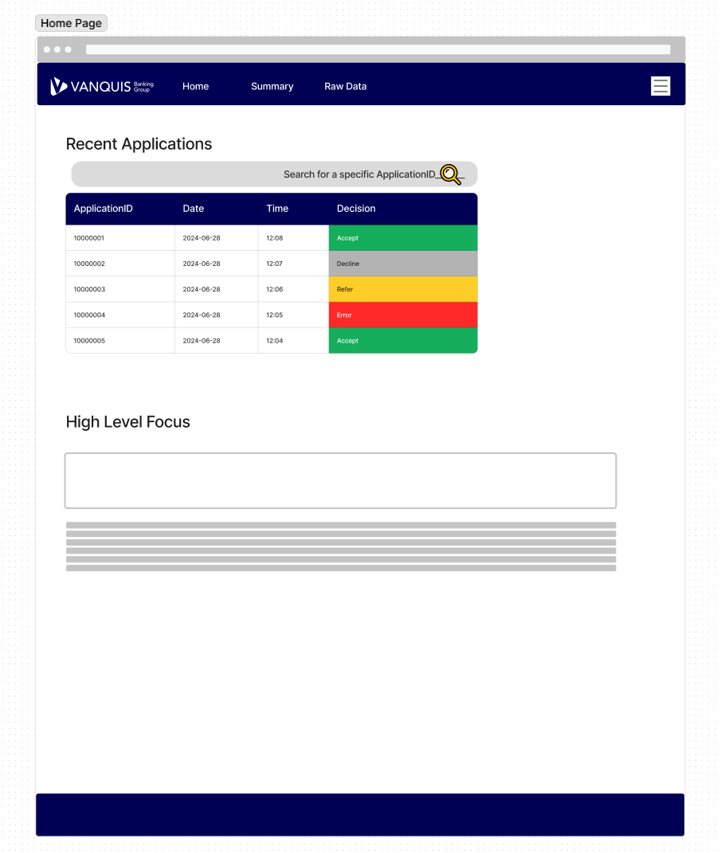

Figure 37 - Figma Wireframe of a Home Page for the React app

One key change I made from my initial draft wireframe was to use a header Navigation Bar instead of a left-hand side bar. This simplified the layout of the website and meant the functionality presented to the end user could be focused here, allowing them to navigate the core of the application more easily.

For styling, I consulted our Vanquis Banking Group branding guidelines (which are available on our internal staff intranet). I wanted something that looked like it could really be in use in the organisation & to do this effectively, it was critical to follow the branding guidelines to provide a professional appearance to corporate (Iconic Digital Marketing Agency, 2024).

#### Pages to develop

With a wireframe template ready for the basic design I wanted, I was ready to think about what pages I wanted in the applications. Below is a list of pages to build, along with some information behind their meaning

* **Home** – A simple home page showing the most recent applications logged in the database
  + This will be the landing page a new user is taken to when they open the application
  + This will be where the most recent applications are displayed to the user
* **Summary** – A page where a user could view what we refer to as the “Summary” data provided by Experian (2024), which is an aggregated view of the data they hold on a person’s Credit File
  + Within a business context, the data points in this block of data are primarily used within the Credit Decisioning processes that decide if an applicant should be given a line of credit
* **Premium Value** – Similar to Summary, but provides significantly more data points
  + This page’s use case is like the Summary page as a result
  + In the business view, this is called “Premium Value Data” as they are additional blocks of data Experian provide for an extra fee.
  + They are very rich data source for use in Credit Decision, as they can be used to identify problematic or positive trends on a person’s credit file, often to a better extent then the Summary data alone
  + There are also product specific data blocks, which allow a lender to check for behaviour on specific products where trends would be more meaningful e.g. status of Mortgage and Utility accounts on a person’s credit record
* **Raw Data** – This should contain the unaggregated data used to derive all the datapoints displayed in the Summary and Premium Value pages

## Development

### Backend Setup – for supporting functionality

Some of the requirements I set required a full Backend to be created to implement the functionality required. This included:

* Ability to connect to a database to retrieve application data (an Azure SQL Server Database specifically was used in the project)
* Searching an External file for definitions of data variables

#### Why one was required

Initially I tried importing the “**mssql**” package directly into the React component to meet the 1st use case of connecting to a database to retrieve application data. When doing that however, I faced 26 compiler errors in React. These came about purely from importing the library for use:

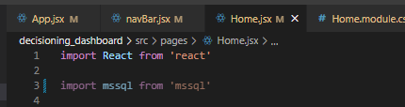

Figure 38- Importing "mssql" into a React Component called "Home.jsx"

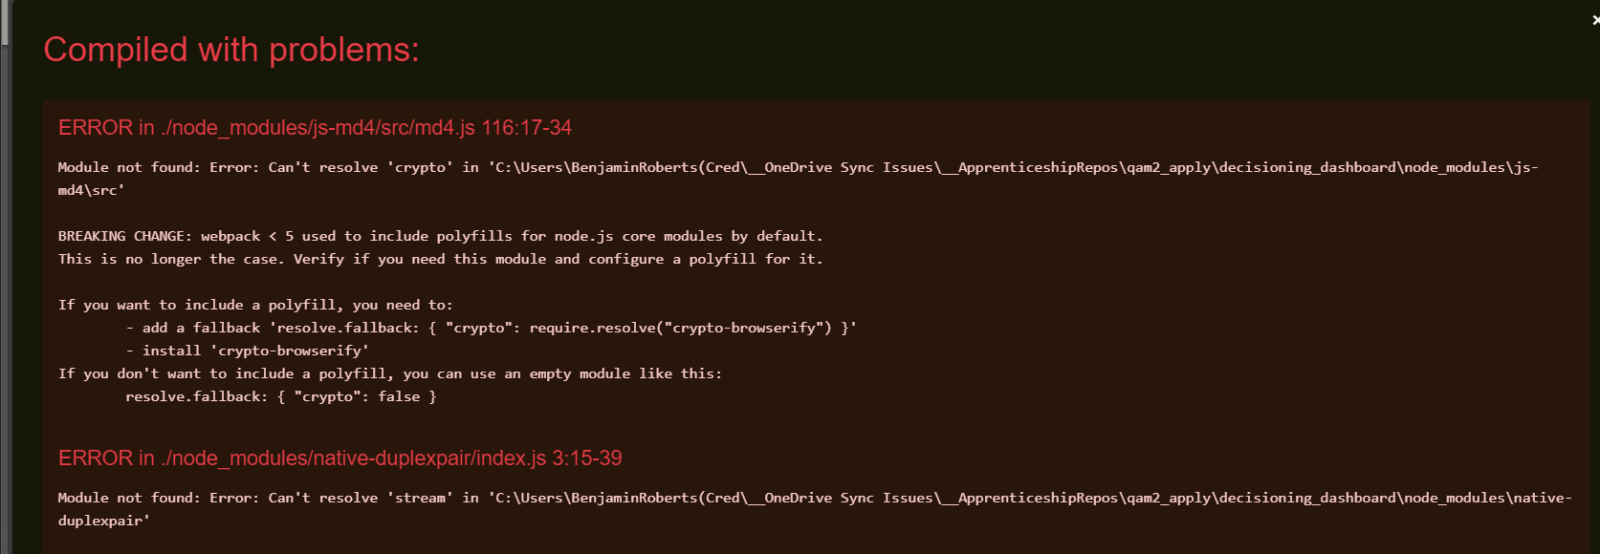

Figure 39- Compile error from importing the "mssql" library

One thing I didn’t understand was what this “**Polyfill**” concept the error messages referred to. That felt like the 1st step to resolving the error, so I did some quick research. I found that **Polyfills** are pieces of code to provide modern functionality to older browsers, at the expense of functionality and performance (Mozilla, 2024a). From the context of the error message, I can see that this means that the “crypto” module mentioned in the error message is no longer automatically included, so creating a **polyfill** is necessary to resolve.

Attempting to create one of these polyfills did not resolve my issue. From further research I concluded that it would be significantly easier to set up a back-end application that the main React application could call over HTTP e.g., via the fetch method. This allows offloading complex logic into a separate app and avoids the need for complicated polyfill logic.

#### Initialising Node.js Express

After some trial and error, I came to think that it would be easiest (to develop and maintain) a separate Node.js Backend and use HTTP calls within the main React application to get the necessary data. That creates a clear distinction between front-end and back-end, plus means they can be maintained separately. I found the Express framework (Express, n.d.) from some research, which provided the framework I needed and could be generated with a command line function, shown in the figure below.



Figure 40 - Initialising an Express app based on a template

This did require an additional dependency via a library called “http-errors”, as shown in the figure below. To resolve this, I ran another npm install command to add this into my repository.

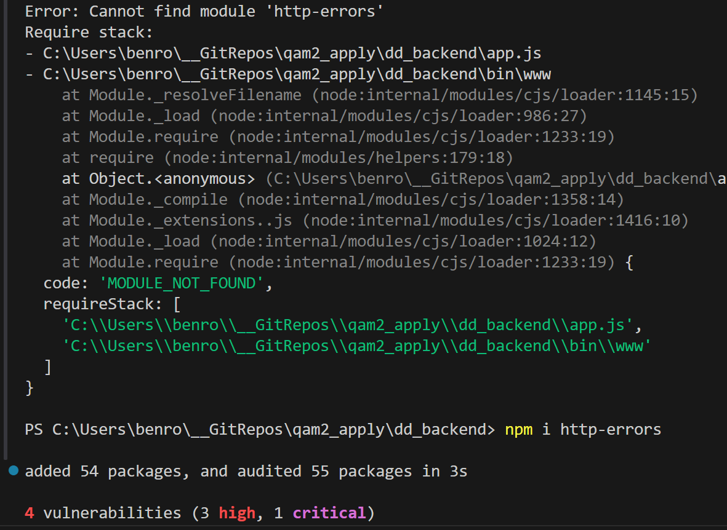

Figure 41 - Install http-errors dependency

Once this package was installed, I was able to initialise the Express application.

### Testing connectivity

Once the Express application was initialised, the next step was to test connectivity. By default, the application starts with a basic “users.js” route that can be used for this (the routes being what Express uses to stand up resources with different functionality).

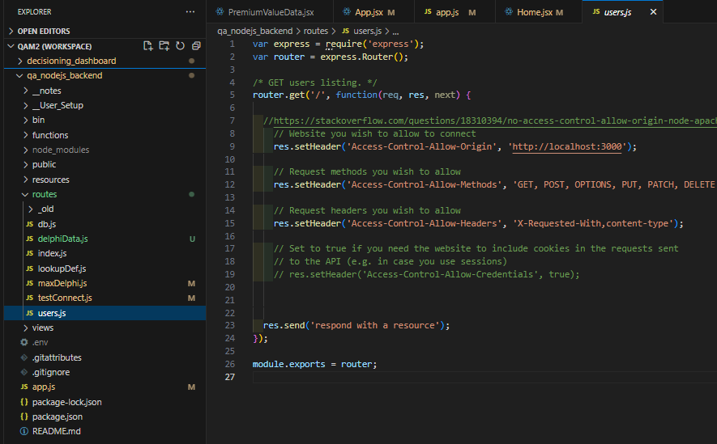

Figure 42- "user.js", a default route provided by Express

When a HTTP call is made to this “users” route, it will simply send a text string with the value “respond with a resource”, back to the requesting service. This simplicity makes it useful to test that the application can be communicated with.

After starting the Express application with “npm start”, I made use of a software called Postman to test connectivity. This is a tool made for API Development and is primarily used for sending requests to websites to get a response. Automated tests could then be run as test cases on the response received. I use this software almost daily in my Day-to-Day role, so I was certain it was an effective choice for this test.

Show below is a Postman HTTP request to conduct the test. We can see the locally hosted express app did indeed respond with the expected value.

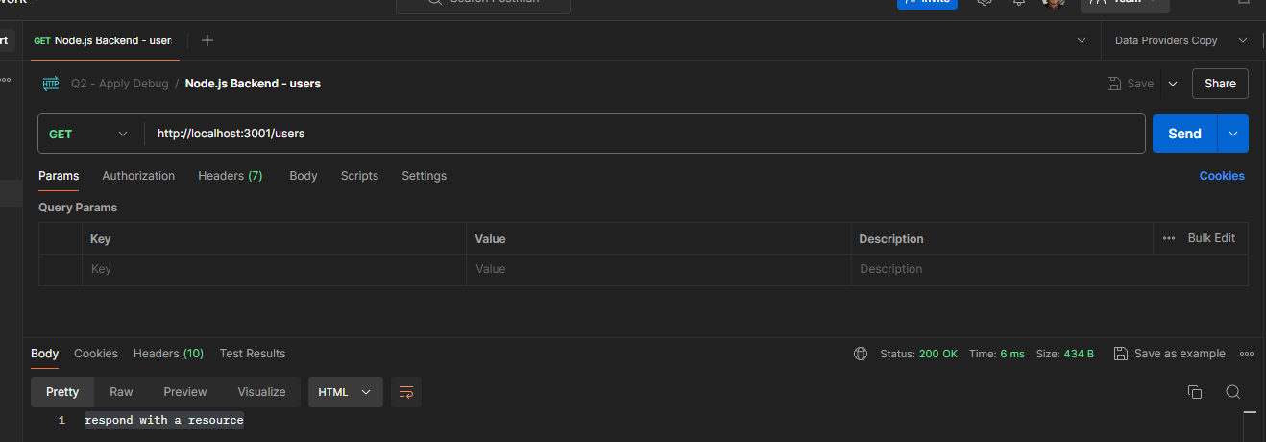

Figure 43- Postman HTTP Request showing the expected response from the "users.js" route

### Front End – React

Details of specific functionality developed for the Front End are given below:

#### Top Navigation Bar

Critical to the application was a user navigation interface. I wanted something simple that was always accessible by the user no matter where they were on the page, hence a navigation bar at the top of the screen. Using my wireframe as a reference, I created the below:

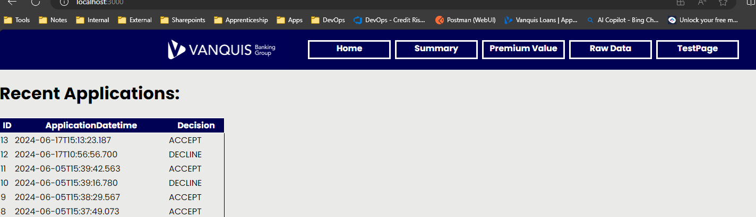

Figure 44-Top Bar Navigation for all pages on the application

The below figure shows the HTML and React code that creates this navigation bar, called “NavBar.jsx” within the files. This is designed to return a simple <nav> html object to the page where this component is rendered, allowing it to be reused across the application. Link objects from the “react-router-dom” library are used to link to the different pages of the application, which allows the user to switch pages without triggering a refresh of the web browser used (React Router, n.d.).

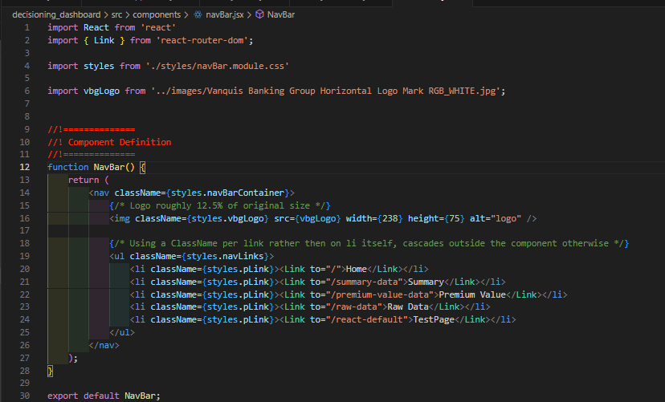

Figure 45- HTML and React Code for the Navigation Bar

This “NavBar.jsx” component is then placed within the root “App.jsx” component of the React Front End application, allowing it to be displayed across all pages. It is placed within the parent <BrowerRouter> component provided by “react-router-dom” library to provide seamless navigation between pages.

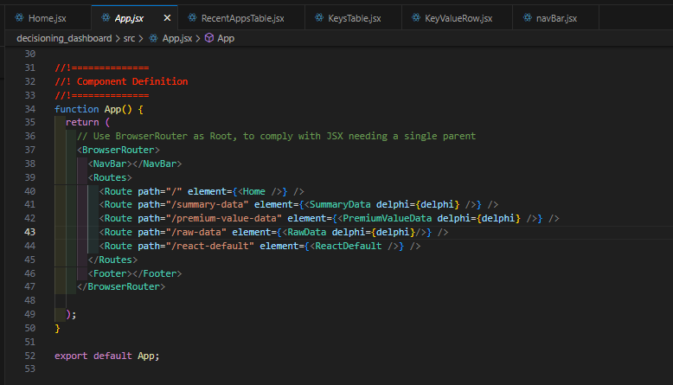

Figure 46 - NavBar Component placed into the main App.jsx Component

To meet the desire to have this navigation bar visible to the user no matter how far they scroll on the page, I added CSS logic. The <nav> html tags that contain the Navigation bar has the “sticky” position property applied to it, which enables this feature (W3Schools, 2024b).

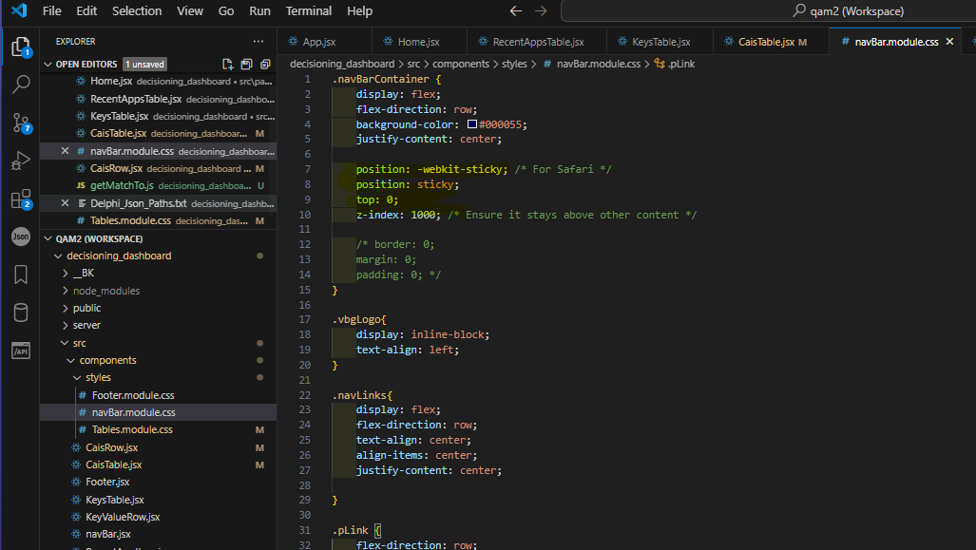

Figure 47 - CSS code used to make the Top Navigation bar scroll with the user

Below is an example of this feature working as expected. In this example, a user has scrolled down one of the pages while viewing a table component. Despite this however, we can see the top navigation bar has stayed at the top of the user’s window, allowing them to access it immediately.

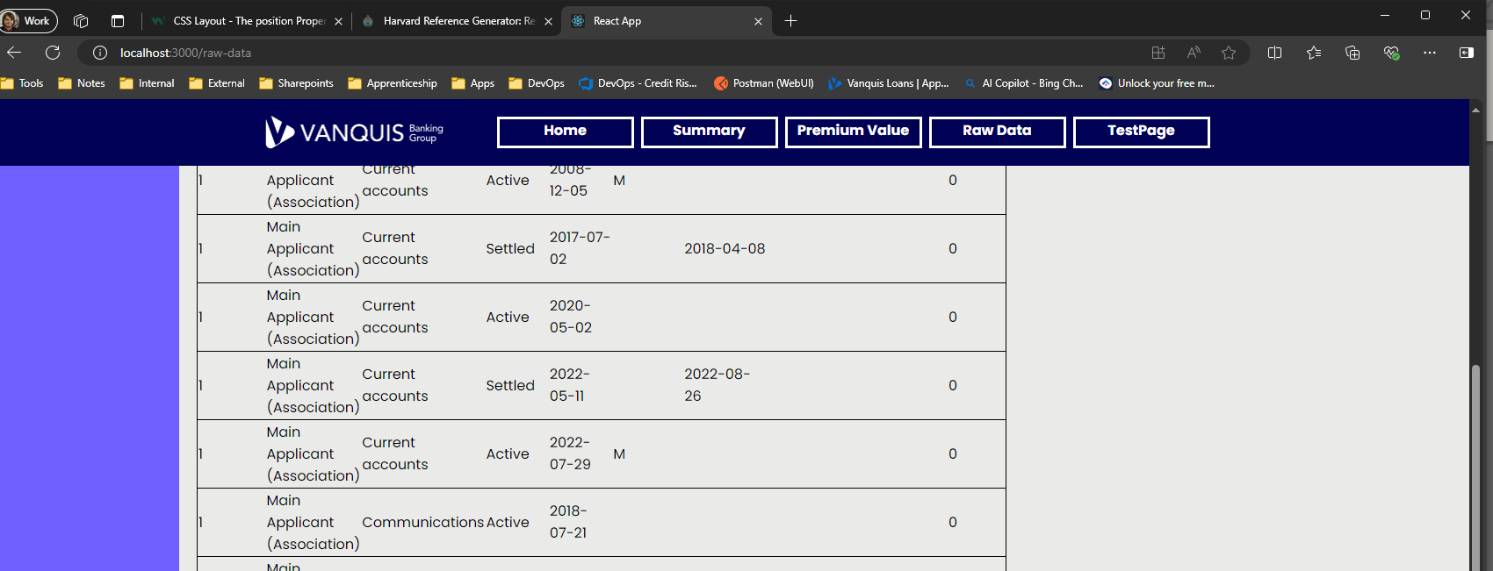

Figure 48 - Top Bar Navigation scrolls with user

#### Side Bar Navigation for longer pages

One issue I felt while developing the pages that displayed the detailed application data to the end user was that displaying all this data resulted in very long web paged e.g. shown below is a page called “Premium Value Data”, which displays various data points provided by Experian (2024). This section of the data has multiple sections, each with many variables. The React application renders these as HTML tables, but the number of variables in each section results in a long web page, making it difficult to navigate.

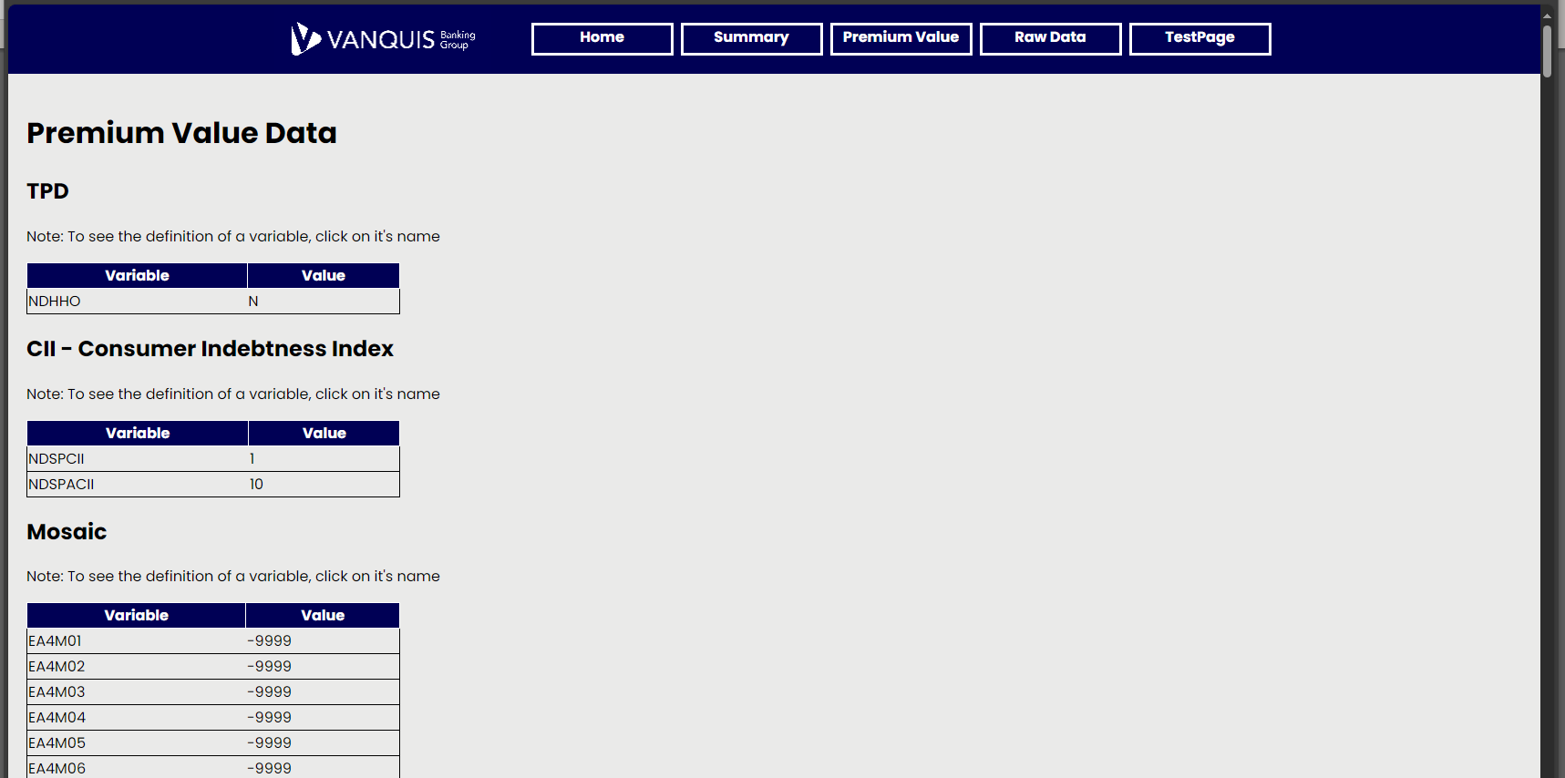

Figure 49 – Webpage with enough content to require the user to scroll down to view different sections

To address this, I went back to the side bar navigation idea I had on my original wireframe. Shown below is a snippet of the HTML code that creates this side bar. As the links are bespoke to the current webpage, I chose to stick to simple HTML rather than creating specific React components. This works by creating a container <div> tag to store all the links the user can click, which allows formatting to be applied to that section of the web page. Links are then ordered by creating a bullet point list with the <li> tags. The <a> these contain are what provide the links.

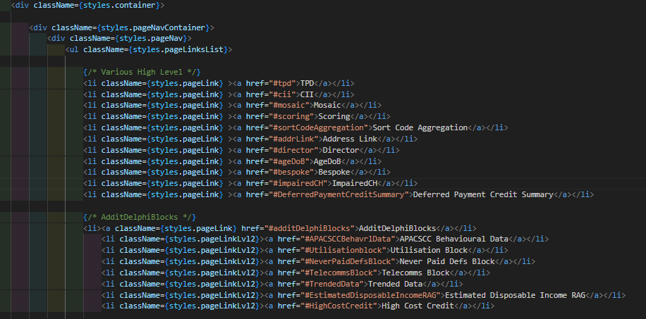

Figure 50- Side Bar HTML code, with <a> to provide the links

Each <a> tag above has an id given for its “href” property, which tells the tag to take the user to the object with the same name as what’s in the “href” property. Shown below are examples of the corresponding HTML tags those links connect to:

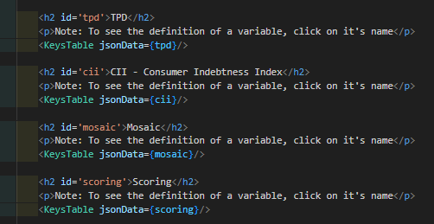

Figure 51- <h2> tags with Id's allowing the side navigation bar to link to them

With the HTML in place, I added a new CSS module file to use for this navigation bar, which could be re-used for any page that needed one. My initial CSS code for this can be seen in the figure below. With this I was attempting to have a similar “sticky” function as the top bar navigation covered above i.e. no matter how far the user scrolled, the links would stay visible to the user. This did not work however with the CSS in the figure below.

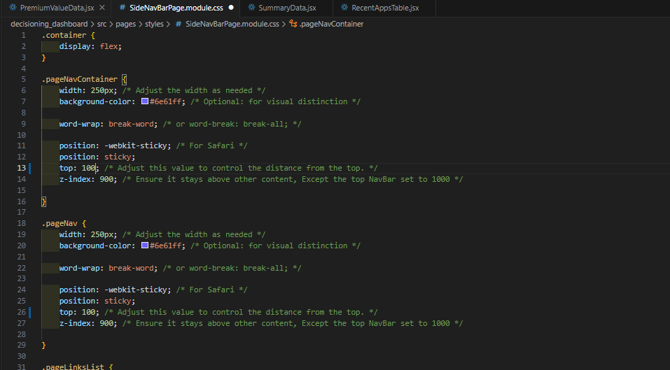

Figure 52- Original CSS, with an issue on the "top" property not working as expected

To address this issue, I looked for a reference on how to apply this feature. I found that my issue was the top property was missing a unit of measurement (Mozilla, 2024b). After adding “px” to the tags (indicating pixel measurements). The scroll feature worked as expected. I was also able to refactor the CSS code to remove properties that were redundant to the feature I wanted here.

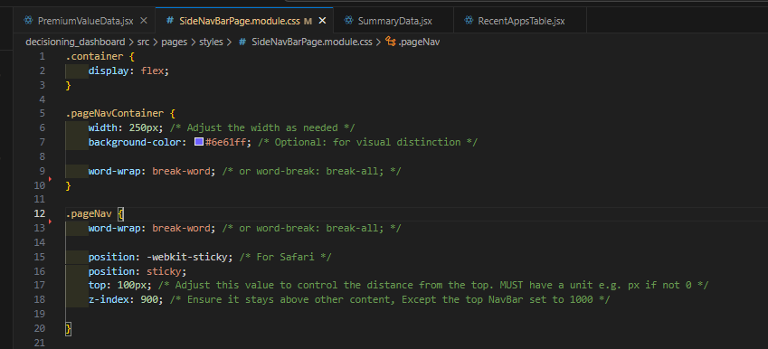

Figure 53- Altered CSS, with unnecessary properties removed & issue with "top" property fixed

These steps provided a way to provide section links on the page, allowing the user to navigate quickly to various sections. The final version, when applied to the Premium Value Data page appears as such:

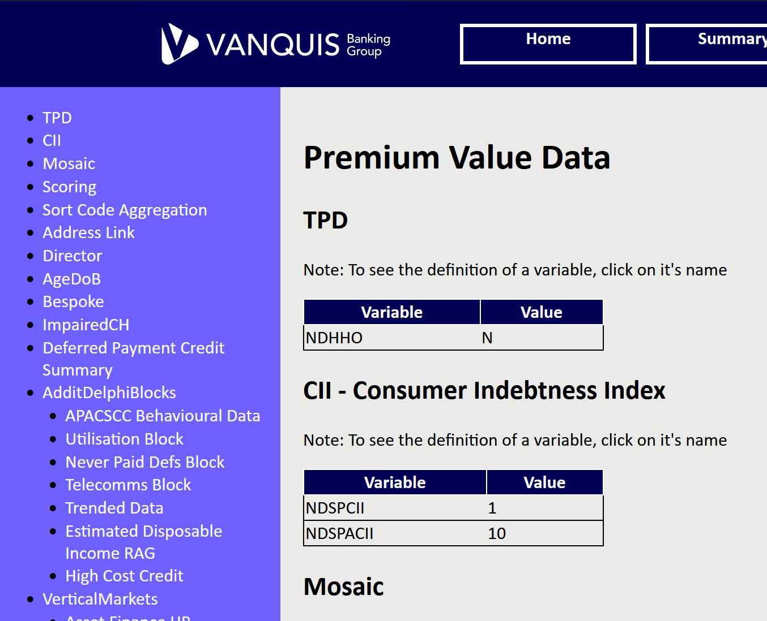

Figure 54 – Final Side Bar for the PremiumValueData page, with links to each section and sub-section

#### SQL - Search for Recent Applications

Meeting the requirement to show recent applications logged to the backend database required making a SQL connection. The Node.JS Express Back End created earlier was used for this. To get started, I needed an Endpoint I could call with the Front end to get the data. An Endpoint represents a point where 2 applications can talk to each other (Yasar, 2024), so creating one in my backend is required for it to be able to communicate with the front end.

I created a new JavaScript file called “db.js” under the “routes” folder the Express framework uses by default to store Endpoints. I used the existing “users.js” that is initialised by default as a reference to start. I then imported the “**mssql**” node module I needed to make the database connection.

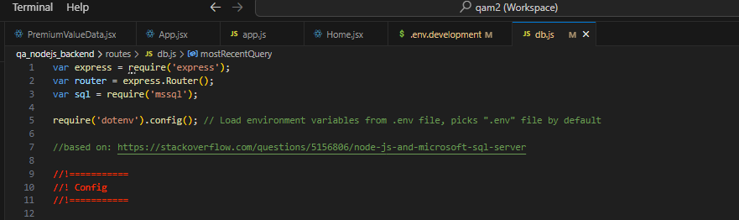

Figure 55- Required imports for this new "db.js" file

To make this connection work, I next needed something to store the configuration details in. The reference of the **mssql** library in use created a “config” object (Microsoft, 2024c), so I did the same. To start with, I left this as a hard-coded object so I could get this working on a localhost first:

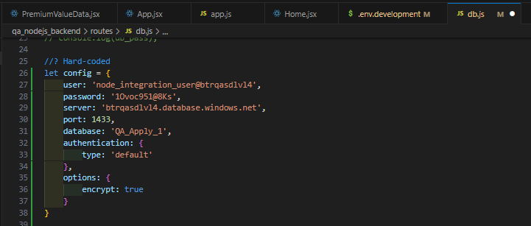

Figure 56- Configuration object

A SQL Query was also needed, which I defined as a string within the “db.js” code:

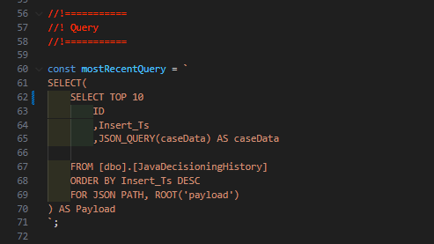

Figure 57 - SQL Query in use

Finally, the bulk of the logic occurs within this “router.get” method. This will listen for all HTTP traffic that is intended for the Endpoint in question e.g. “db.js” in this case. The “sql.connect” method within is part of the imported “mssql” library and is what makes the database connection possible. This reads the “config” object defined earlier for connection settings.

The “request.query” method then actualy executes the passed in SQL statement. The 1st IF-THEN-ELSE Logic exists for catching a connection error to the database (i.e. something went wrong communicating to the database), while the 2nd logic handles any errors in the query itself e.g. reference column does not exist.

Assuming no errors are returned, then a object called “recordset” contains the data returned by the database. This is then sent back to the requesting service via the “res.send()” method. If there is an error, the “err” object will be populated and that will be sent instead.

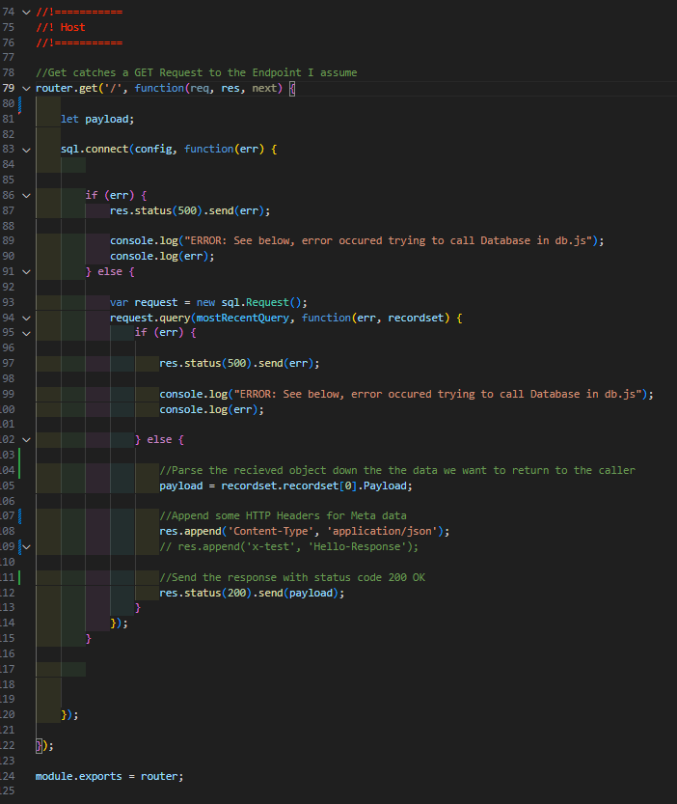

Figure 58 - Code behind the "db.js" file that makes the Database Connection possible

With the Back End logic built, the Front End can now call this via the “fetch” method within native JavaScript to make a HTTP call to the backend, which retrieves the data. This method is wrapped in the “useEffect” function from the React library, as not including caused an issue where the data would not be displayed when received. The “useEffect” function forces React to re-render the webpage when the “fetch” method completes.

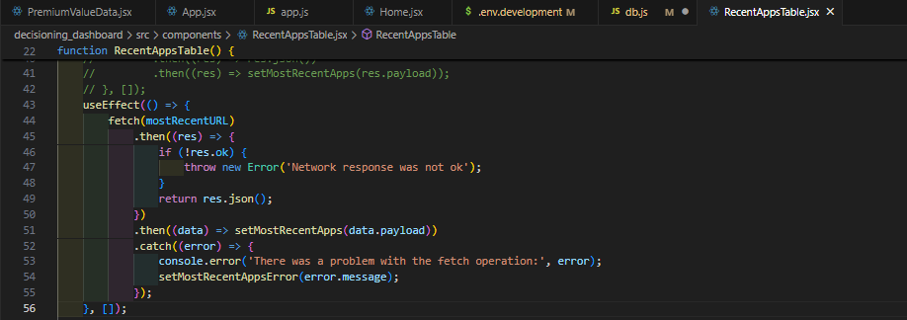

Figure 59- Calling the Back End with fetch, wrapped in the "UseEffect" React function

One problem I ran into while testing this is that the fetch method would not succeed. Looking at the Web Browser console, I saw errors indicating the HTTP request to the backend was being blocked by CORS policy:

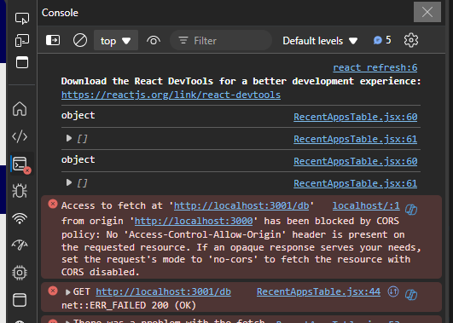

Figure 60 - CORS Error message

I wasn’t sure how to handle this, so I did some research. I found that these CORS errors are a common problem. I found a suggested fix on to add in some response headers to the response sent by the “db.js” endpoint in my backend, which did correspond to the wording within the error message I was getting (Stack Overflow, 2014). Based on this, I added the below lines into my “db.js” code:

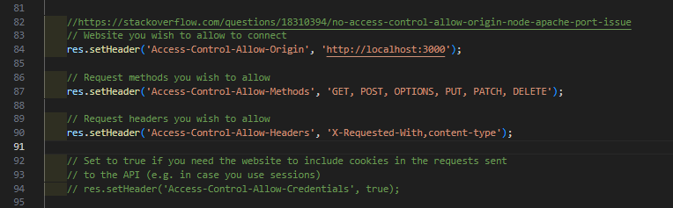

Figure 61- Code added to "db.js" to resolve CORS Policy errors

Once that change was made, the call to the Back End succeeded and the database results rendered in the React application as expected:

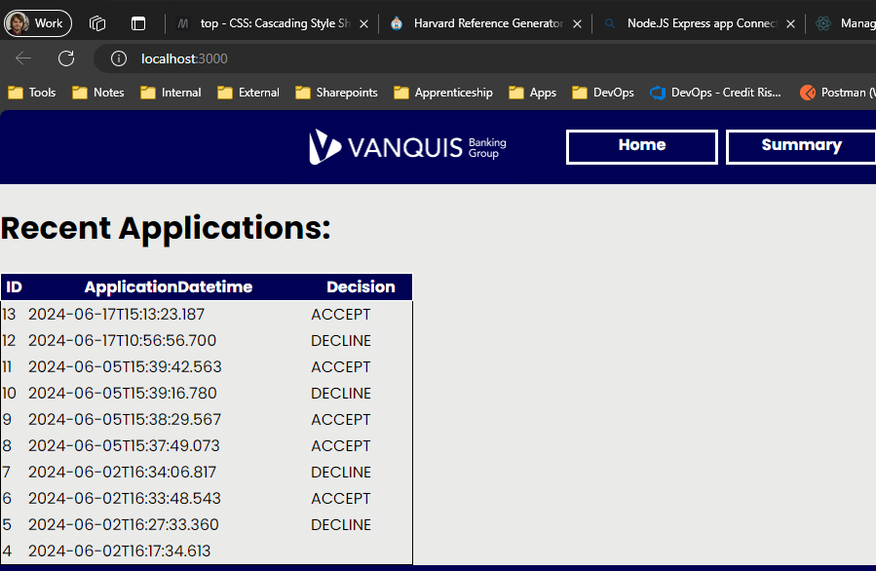

Figure 62 - Rendered Database results

#### SQL misuse and Personal Data (PII) Protection

One consideration for the database was connection was the potential for PII to be exposed, as using the Back End Express application. The data used within the program needed to be used with caution, as the Experian dataset used requires the below to be able to search a person’s credit file:

* Full name of the person in question
* Date of Birth
* At least the current address of the person in question
* Previous addresses are also often needed if the person in question has resided at their current address for less than 3 years

(Experian, 2024)

Each of these Data Points are protected under the UK's Data Protection Act 2018, which also codifies the GDPR into UK Law (Data Protection Act, 2018). This becomes an issue with the Experian Data used as it retains this information in the response data their API sends when used. As the idea of this application was to display all application data, this creates a conflict. As such, the program only displays data that does not contain PII data. PII Data is not rendered at all.

Also, to avoid any misuse of the database that could put this information at risk, I applied minimal permissions to my SQL connection. Core to this was the user account I created in the database to enable access, called “**node_integration_user**”. I applied only SELECT permission on this user and only to SQL Tables and Views required by the program.

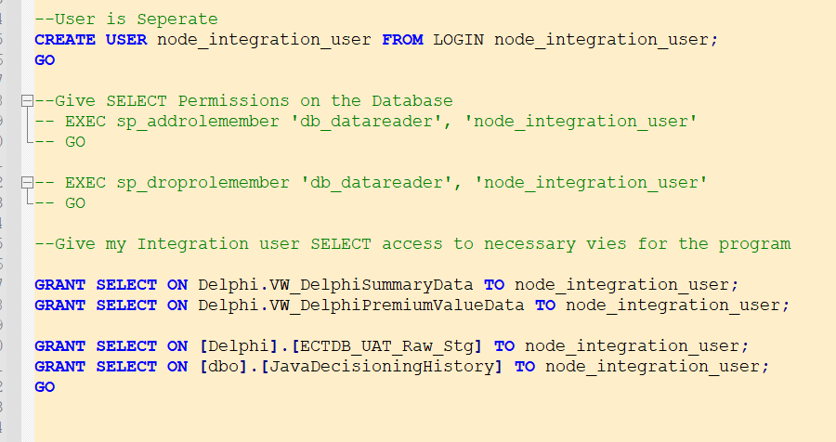

Figure 63- Permissions applied to the SQL Integration account

#### Data – Decoding for Business Users

One issue I had to solve was to consider how end users would understand the data presented to them by the application. There was however a complication caused here by the data sources used for this application, as a key part of the data used comes from data provided by Experian’s API for accessing data they hold on a person (Experian, 2024). This challenge manifests itself in 2 ways:

**Scenario 1**: Names of variables are highly codified to make their meaning unclear at 1st view e.g. E1B08 is a variable returned by the Experian API. Without its documentation as shown below however, this gives no indication as to what the variable means in business terms.

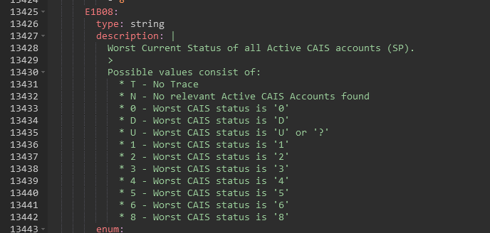

Figure 64- Definition of E1B08 from Experian (2024) documentation

**Scenario 2:** Some variables may have clear business names, but the values used are codified and would not make sense without documentation to explain the values e.g. the AccountStatus variable shown below has 4 values but only shows 1 character. Some of these are intuitive but others can be confusing e.g. F standing for default.

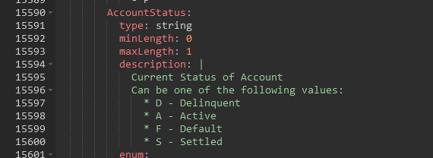

Figure 65 - Definition of AccountStatus from Experian (2024) documentation

These cases were going to be a key blocker to having an application that could effectively communicate its content to the end user if left unresolved. Functionality to provide easy to access definitions to the end user was required to avoid this issue. The nature of both issues meant that I could approach each separately.

##### Scenario 1 resolution

This was the more complicated scenario to solve, as the Experian API used as the data source contains 1000’s of variables per its documentation (Experian, 2024). Rendering a description for each of these did not seem practical or efficient.

The solution I arrived at to handle this was to instead provide the functionality for a user to automatically get the definition of a variable as needed, allowing technical users with deep knowledge of the underlying data to use the application without this while also allowing non-technical users to have the ability to quickly lookup the definitions of data points they may not use often. This presented an acceptable compromise between being able to communicate data to end users and keeping the application code simple.

To make this work, I needed a dictionary source that the application could use to look up variable descriptions. To keep this simple I decided to use a **CSV file to store both the variable names and a description**, the variable name being used to match to. Using this kind of lookup also allows the program to store its own definitions of variables if the documentation provided is lacking. For reading CSV files, I required a node.js library called **csv-parser**, so I installed this:

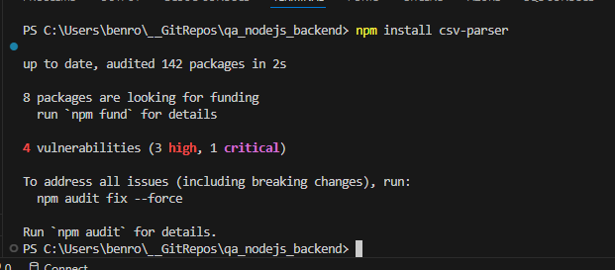

Figure 66- Installing csv-parser

Using this library, I created a function within my Backend Node.JS express application. I did this in the Backend as trying to import one of the dependent node modules resulted in an error:

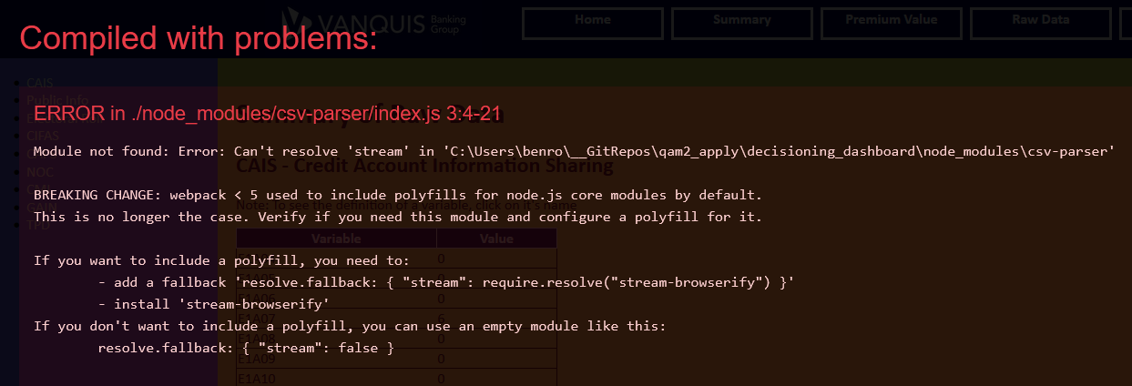

Figure 67- Error attempting to load a dependency directly into React for my lookup function

As I found out when trying to establish a connection to a SQL database, it’s easier to offload this logic to a dedicated Backend application rather than handle polyfills to get the logic working directly within the front-end application.

###### Backend Logic for lookup function

To provide a point of interaction, I needed to expose an Endpoint that the Front End could send a HTTP call to. To do this, I created a new router object within the Node.js Express application, using one of the default ones provided by the officially provided generator (Express, n.d.) as a starting point. I added in a URL Parameter which will allow a variable name to be passed in to carry out a search for its definition. This is done via the “:searchKey” parameter seen in the router.get() method:

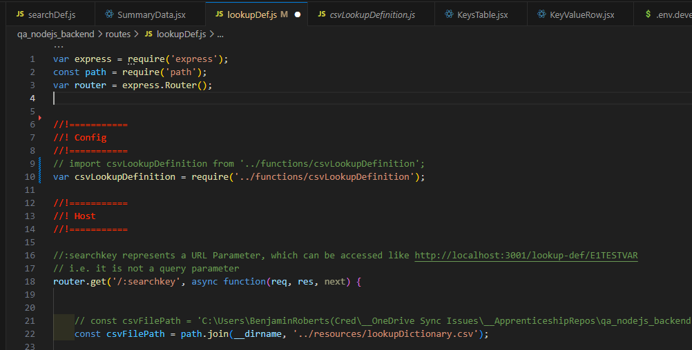

Figure 68- router.et method for the backend to accept a search parameter

Once that endpoint is in place, the parameter is be passed into a dedicated asynchronous function that performs the lookup on the CSV file (the function is asynchronous as a regular function generated error messages within the code editor). The function is then wrapped in a Try-Catch statement to account for the possibility of an error e.g. the input file not being available. The result is then loaded into a JSON payload and sent back the calling application (i.e. the Front End) via the res.send() method.

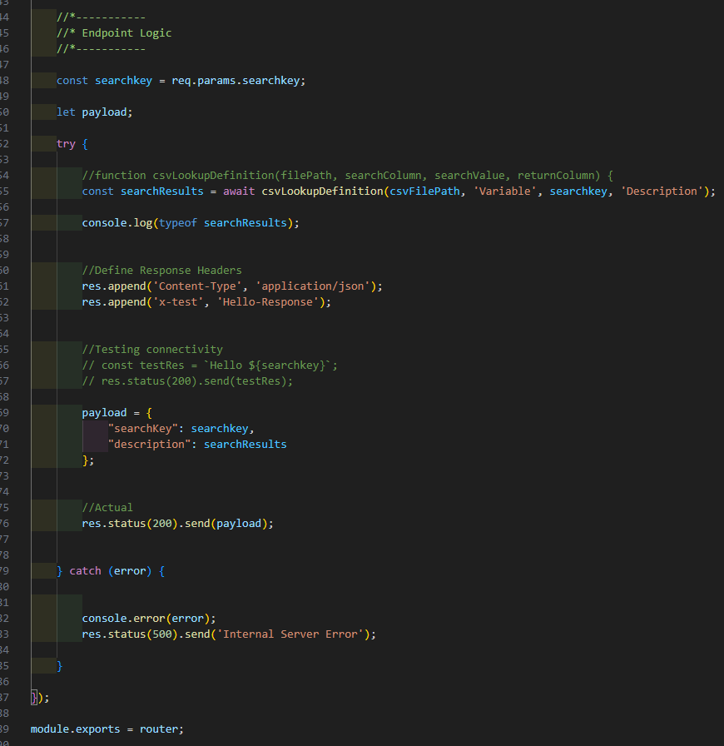

Figure 69 - Endpoint logic showing the lookup function being used & sending this back to the calling application

###### Front End Logic for lookup function

For the front-end, I coded the function as below:

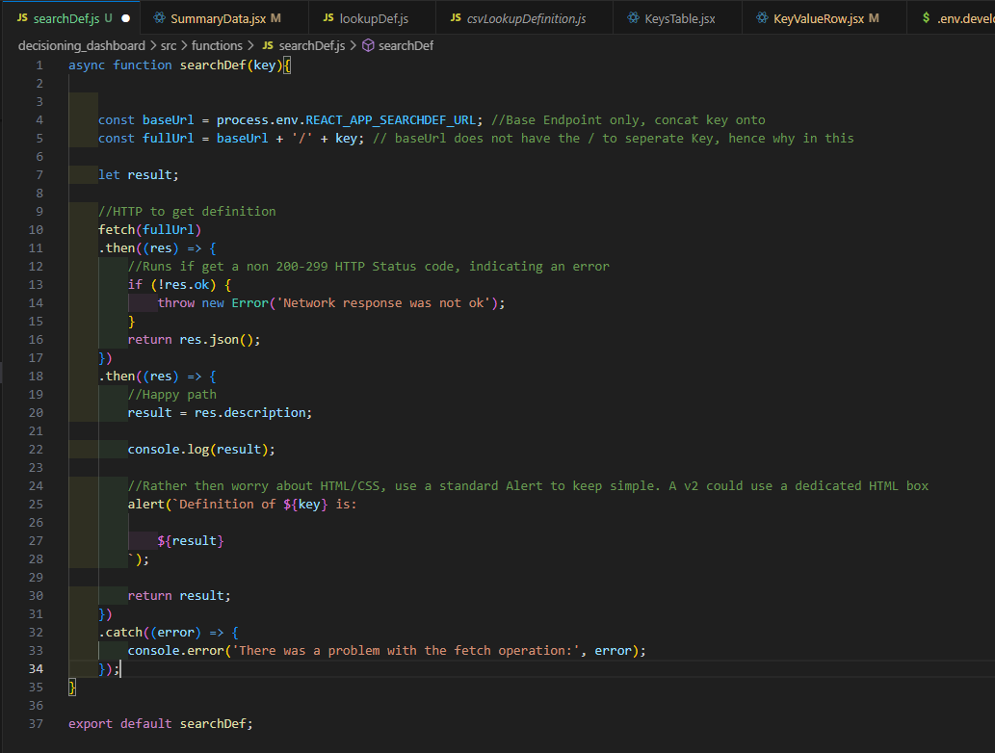

Figure 70 - Code for Lookup functionality

This code will:

1. Accept an input parameter called “key”, which will hold the variable name we want a definition for
2. Attempt to retrieve the definition by using the “fetch” function to make a HTTP call to the Backend, using a host name stored within the process environment and passing in the “key” as part of the URL
3. Fetch will return 1 of 2 outcomes:
   1. An error is thrown if there is a network error
   2. Parse a successful response for a variable called “description”
4. Assuming a successful response, the description returned by the Backend is provided to the user via JavaScript’s inbuilt “alert” method

Each variable that contains data the end user can review is rendered in the application by a React component called “KeyValueRow”. Within this component, this lookup function is then called via the “onClick” property of the table row that displays the data to the user:

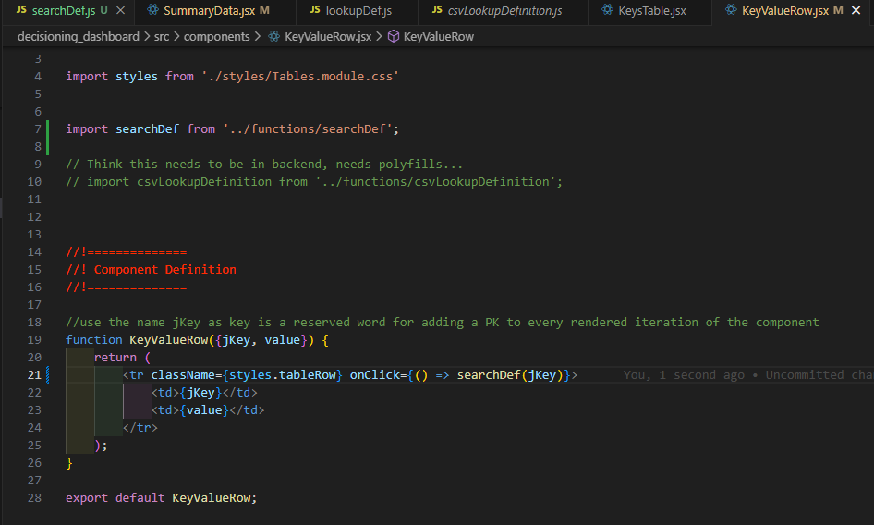

Figure 71- OnClick property using the lookup function

When the function is successful, a definition will pop up on the end users screen e.g. for the E1B08 variable, the below prompt is currently presented to the user. Below is an example of this done in the Firefox web browser:

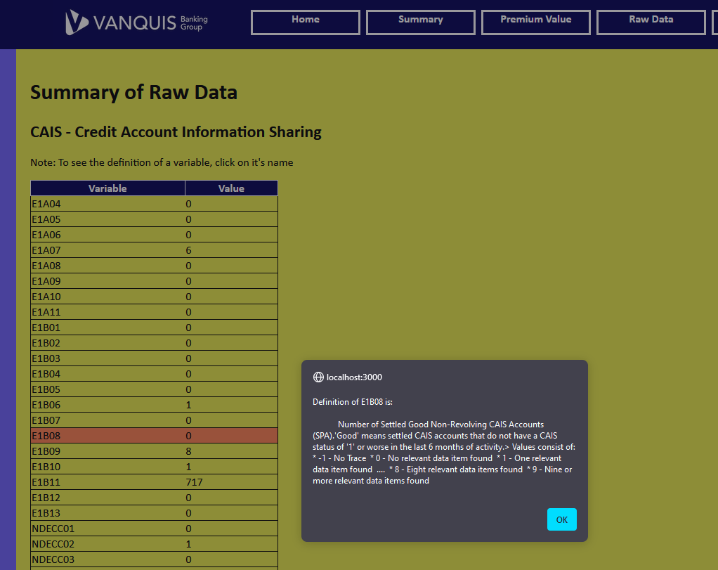

Figure 72 - Lookup prompt presented to the user for E1B08 as seen in Firefox

Below is another example of this functionality done in the Microsoft Edge web browser:

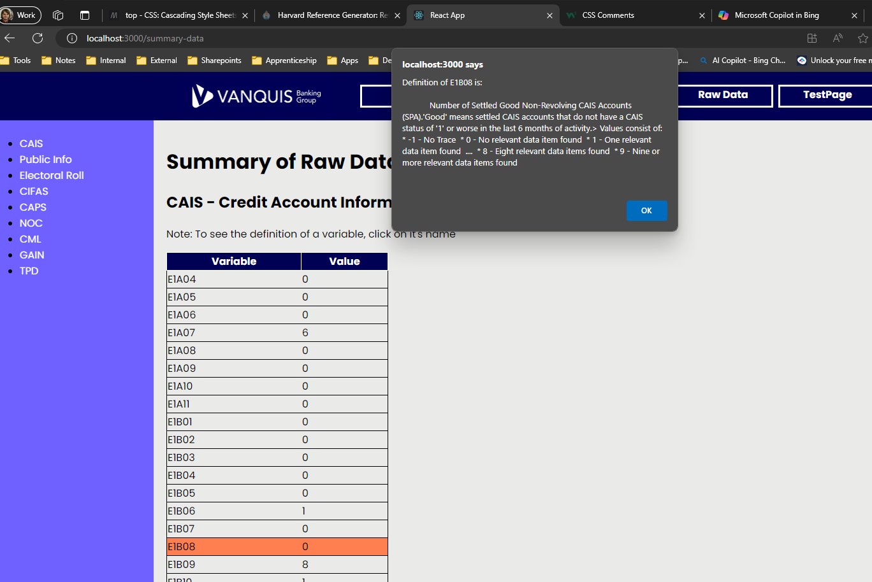

Figure 73- Lookup prompt presented to the user for E1B08 as seen in Microsoft Edge

The row within the table will also highlight, to give the user an indication that the row can be clicked on to bring this definition up. An instruction is also given at the top of the table.

Using an alert textbox for this allows the description to be communicated to the end user easily without the need for more complex HTML & CSS components to render the description on page.

##### Scenario 2 resolution

Translating the values of a given variable into business-friendly language could be done in a simpler approach then the 1st scenario. So long as the documentation provided a dictionary of values, it was possible to code a switch statement to return a detailed value that communicated more clearly with business users. Taking the “AccountStatus” variable as an example, I added this switch case into the code:

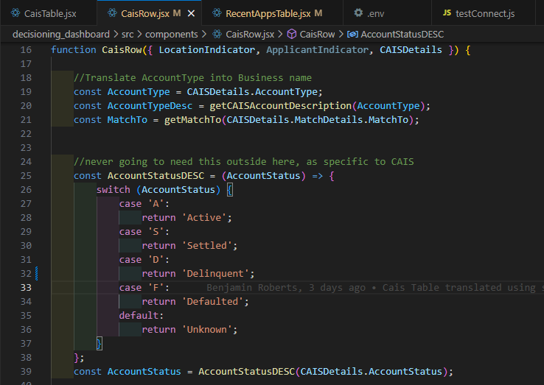

Figure 74- Switch case to translate AccountStatus into a business-friendly value

This is written directly into a React component called “CaisRow”, which receives the coded value for AccountStatus as part of a prop called “CAISDetails”. This is then parsed to get the raw value. A business-friendly value can then be returned by simply passing this value into the switch case:

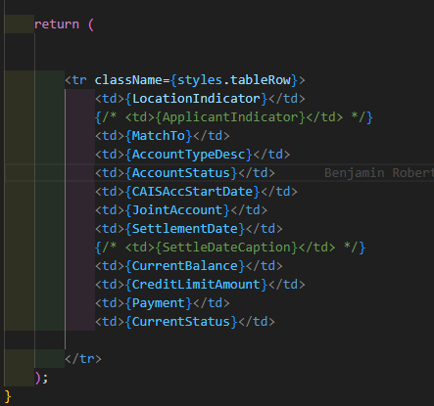

Figure 75 - CaisRow component return statement, showing the translated value in use

This “**CaisRow**” component gets rendered multiple times based on the data received by the program:

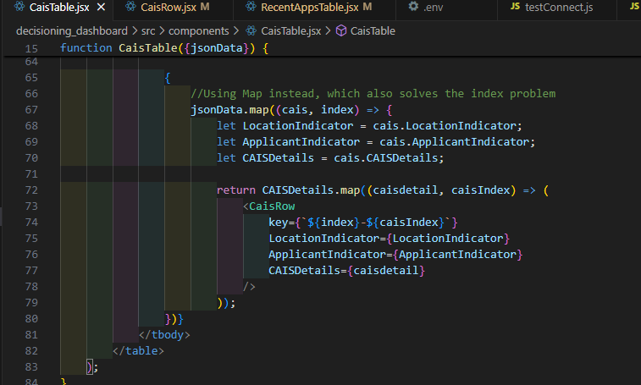

Figure 76- React JSX code showing the rendering of the CaisRow components via the .map() method

When the React application renders these CaisRow components, we can see a clear test value has been rendered for the user, instead of the shortened value that could be mis-interpreted.

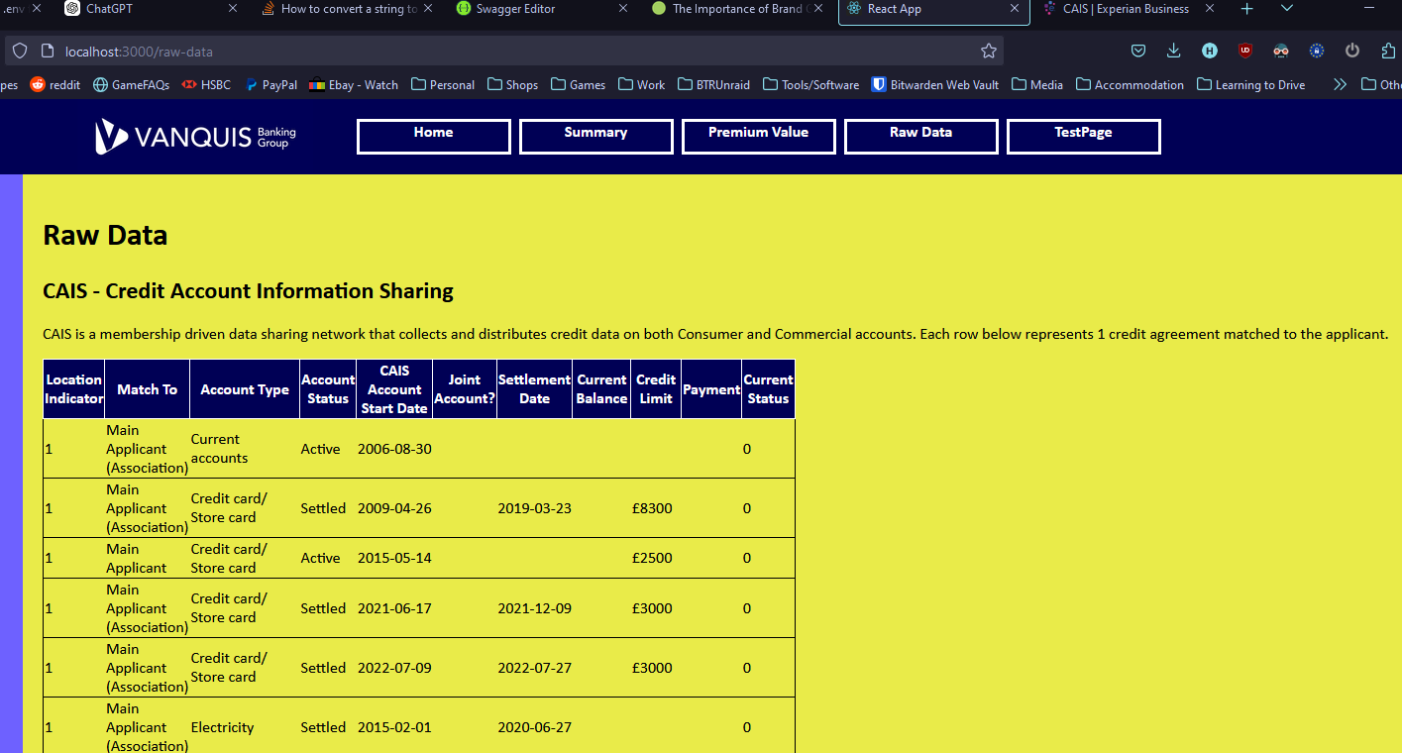

Figure 77 - Rendered React application showing the business-friendly language used instead of the original values

This same technique was then applied to any similar variables, allowing clear values to be shown instead of original values requiring documentation to interpret.

#### Environments configuration

One stretch goal I wanted to achieve with this project was to have the final application in a state where it would be ready to be deployed to an actual environment aside from the localhost I developed on. The aspiration was to have a UAT version of the application I could share with colleagues and gather feedback on the usefulness of the app & how easy it was to navigate.

To do this though, I had to deal with a logical flaw in my code. For example, to meet the requirement of displaying a list of recent applications, the front end React app makes a HTTP call to the Backend via the “**fetch**” method, which enables HTTP calls to be made in base JavaScript (W3Schools, 2024c). In my first version of this however, I hardcoded the URL the fetch method would call, as seen below:

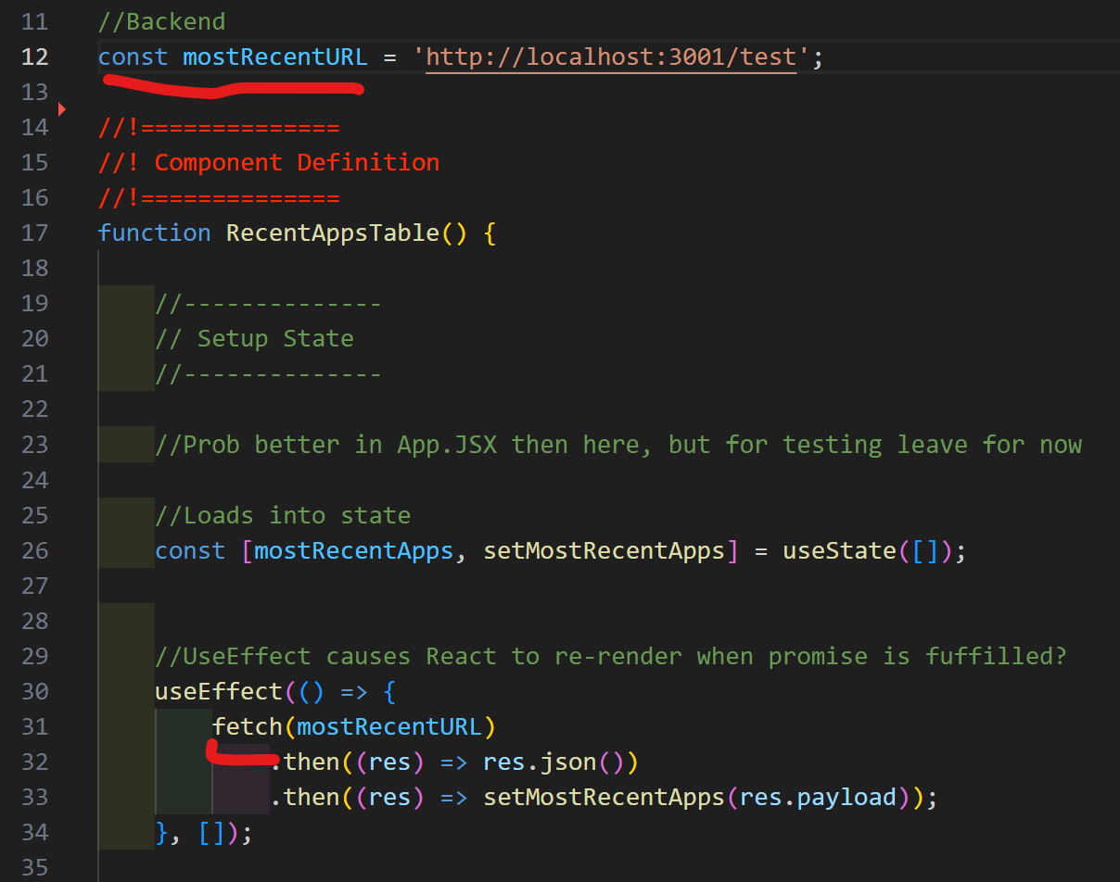

Figure 78 - Hardcoded URL within the React Application

This logically would not work anywhere but my local machine, so this was a barrier to meeting this deployment aspiration. To address this, I created a “.env” file that my React App could read from when it is started to get the appropriate variables for a given environment:

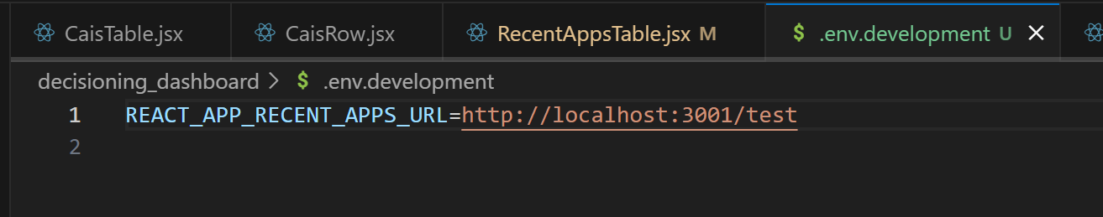

Figure 79 - .env file added to allow dynamic configurations without altering the raw code

I then altered my code to use this environment instead of the hard-coded value it previously had:

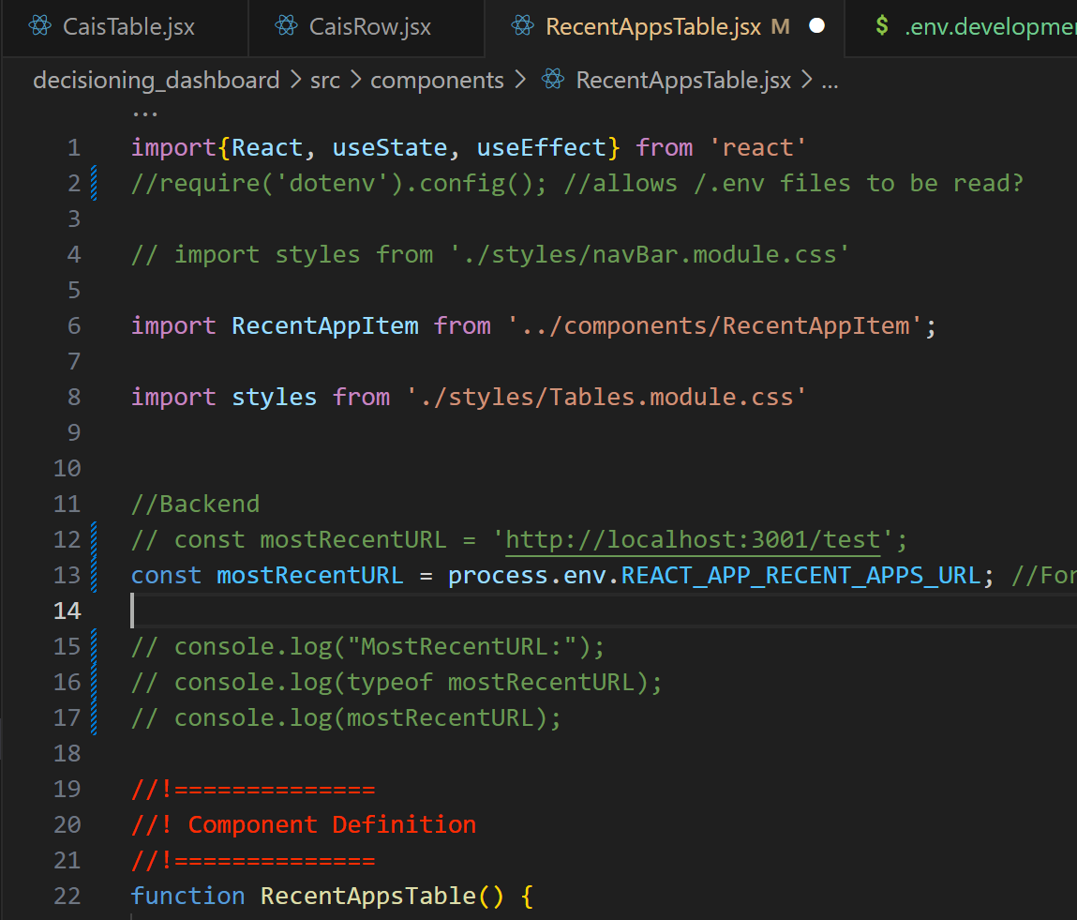

Figure 80 - Altered code to use the newly created .env file

For localhost development, I used the same localhost:port URL I had before, allowing the app to still work on my development machine. When it comes to a deployment however, I can now swap this .env file for a configuration appropriate to the environment e.g. a ”.env.uat” file with the URL for a UAT version of the back end.

The naming of the variable is due to React requiring the “REACT_APP_” prefix on all variables, which allows React to find the variables when using the default “npm start” command to start the server (Facebook, 2024).

## Final Tech Stack

By the end of my project, the final Tech Stack looked like this:

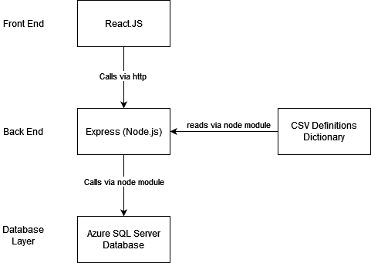

Figure 81 - Diagram showing the Tech Stack of the full application

## Feedback - Review with Employer

When I was ready to show the progress made on this, I made use of a regular 1 to 1 with my Line Manager to gather some feedback on the application. From the tech stack point of view, my line manager would be a non-technical stakeholder but is an expert in the business context the application would be used in, so I considered him a good source of feedback for the practicality of this project.

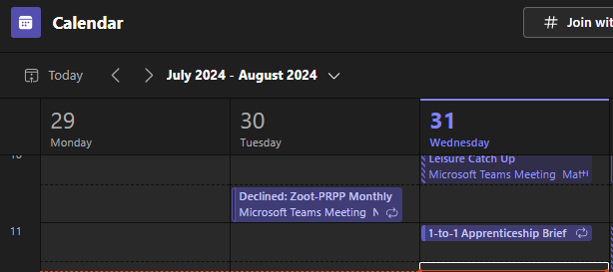

Figure 82 - Teams Call arranged to discuss Apprenticeship progress

I showed the React web pages I had created and explained how the functionality works. Below are minutes of the feedback received:

* *Overall, impressed with the work completed so far*
* *Navigating the web application was simple and effective*
* *The Summary and Premium Value pages are effective in how they can render all the data points with minimum code*
* *The Lookup function has good potential, however the CSV file used may not age well given the complexity of the data the application is using. Consider an alternative*

One concern I did raise was the timescales it would take to render all the data provided by Experian (2024) on the RawData page of my application. Given the scope of the project as is, my Line Manager advised that I should focus only on the most used data blocks provided by Experian. We discussed that the CAIS (Credit Account Information Sharing) was by far the most useful data block that could be shown here, so I prioritised rendering this data on the RawData page.

## Final Application Pages

The below figures show what the final web pages look like.

### Home.jsx

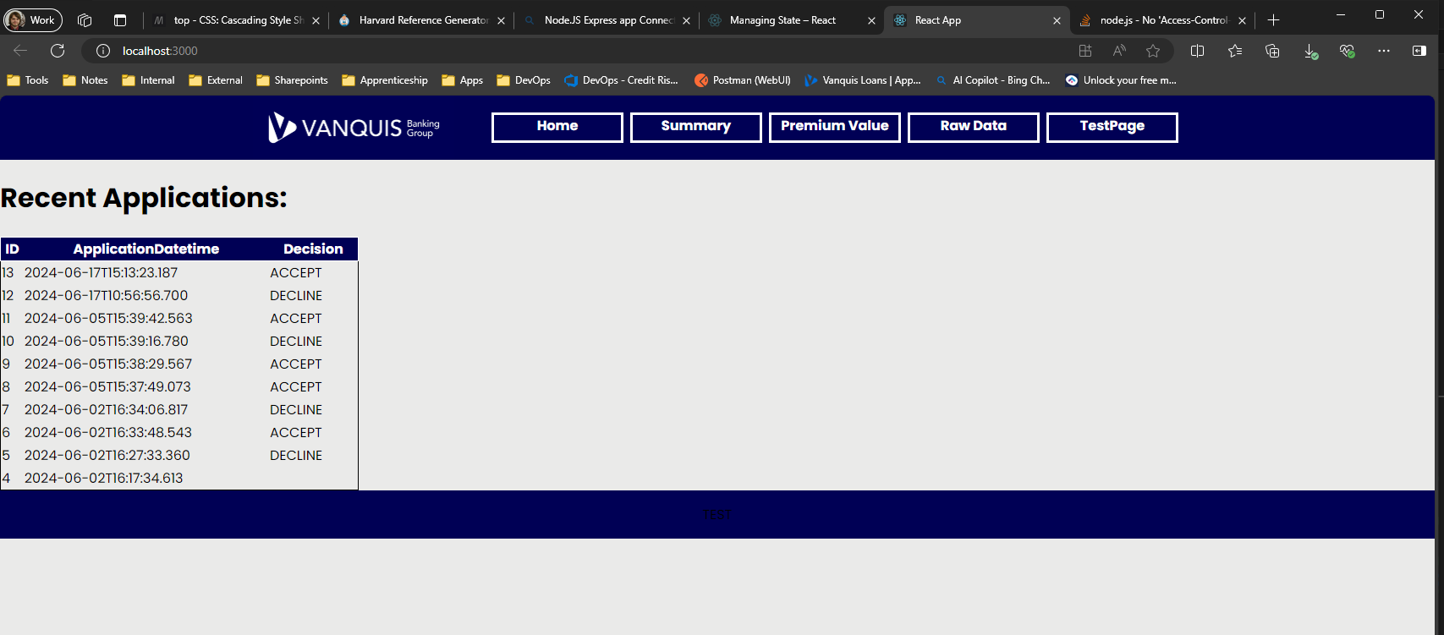

Figure 83- Home Page (final)

### SummaryData.jsx

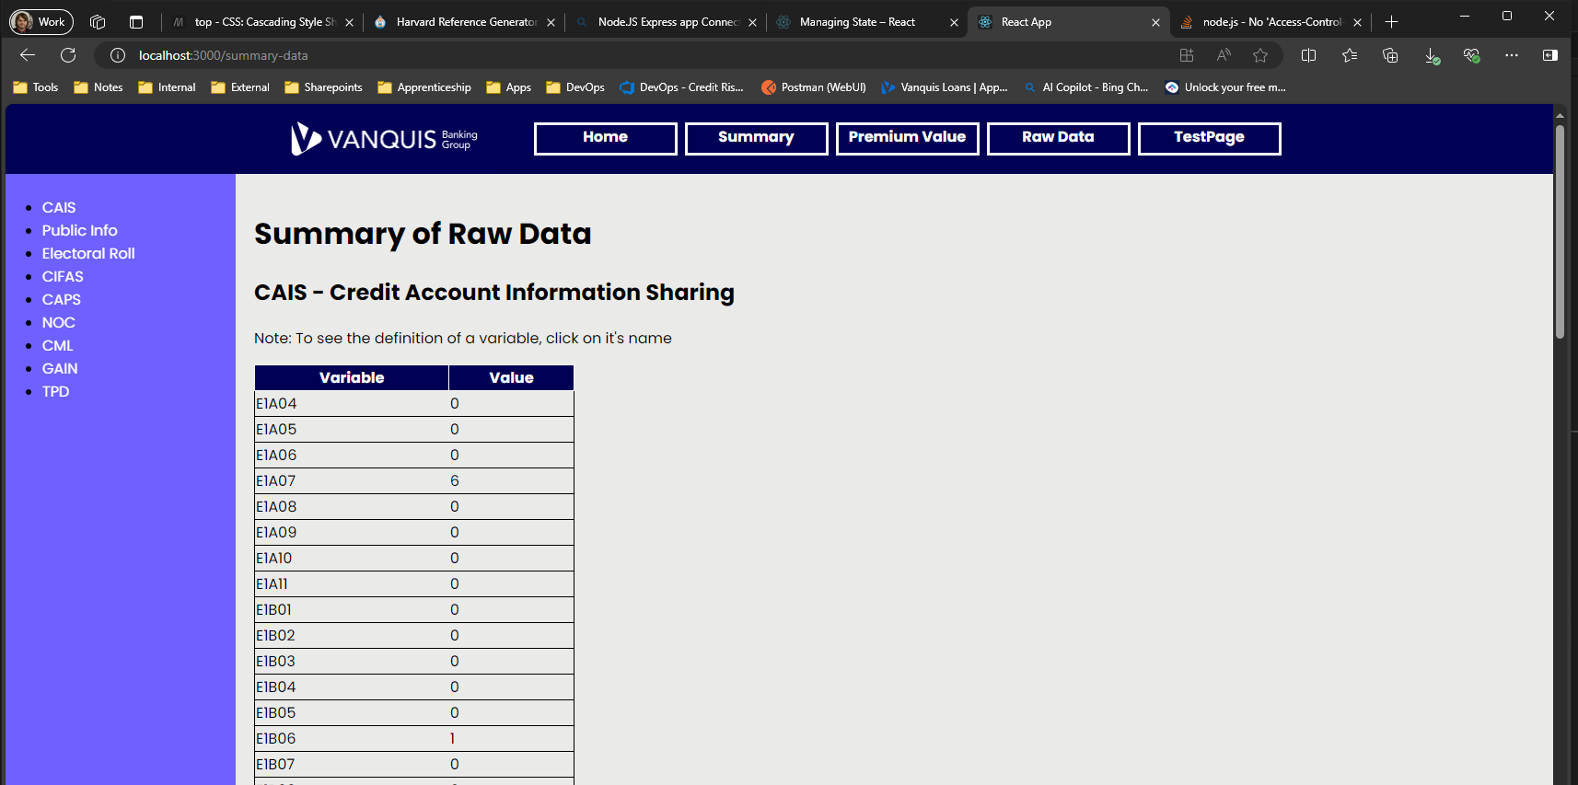

Figure 84 - Summary Data page (final)

### PremiumValue.jsx

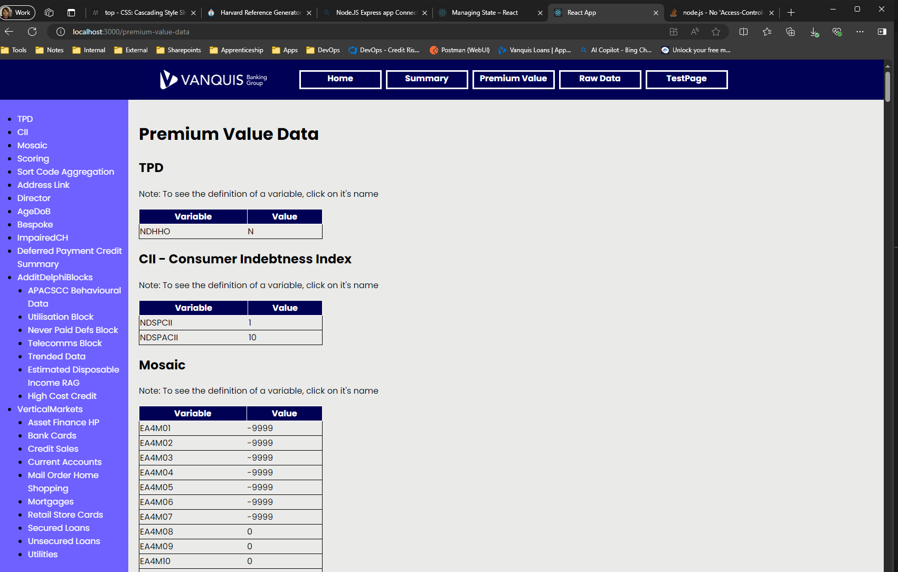

Figure 85- Premium Value page (final)

### RawData.jsx

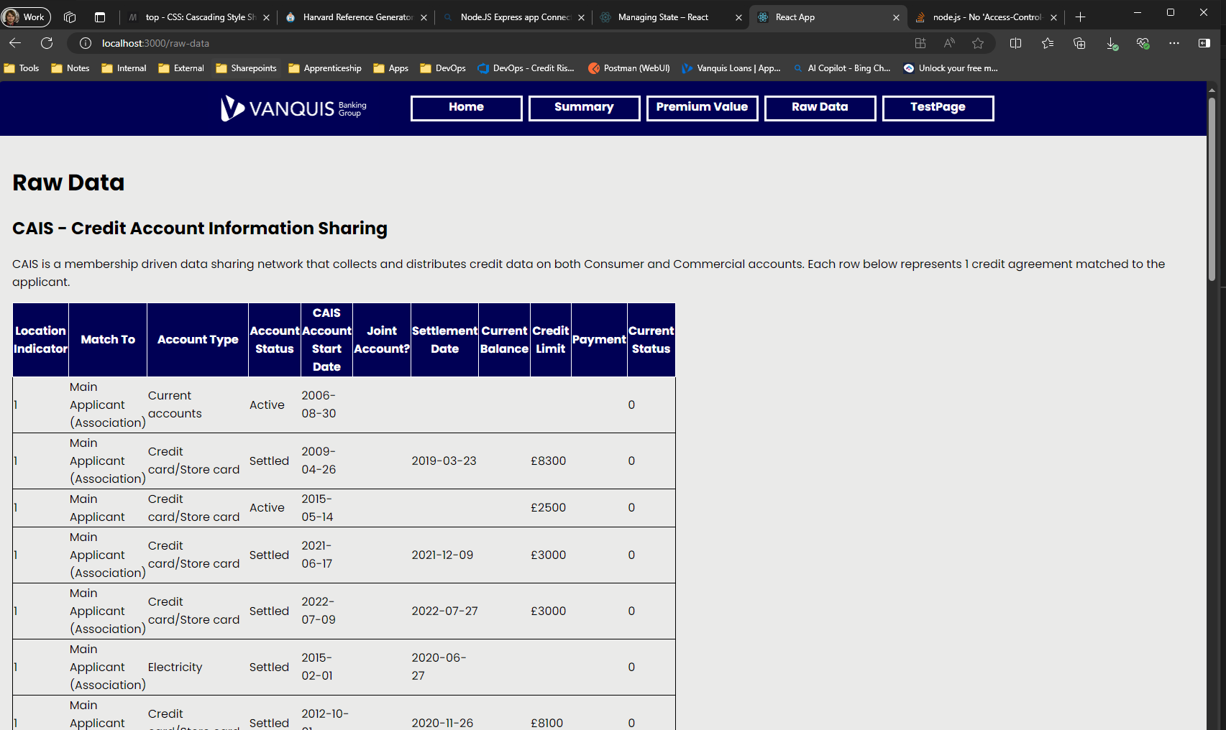

Figure 86- Raw Data page (final)

## Conclusions

Below are my thoughts from reflecting on the work completed for this project:

### Project Outcome

For the most part, the final application did achieve its aims and met its requirements, however I did run into many challenges being able to make this work.

Being unable to include the “**mssql**” Node.js package directly into my React application was a significant hurdle I had to overcome to complete this project, as making a database connection was a fundamental requirement set in the project acceptance criteria. Researching the errors I was getting led me to concepts I had not encountered before e.g. **polyfills**. I was able to eventually resolve the errors I faced by setting up a dedicated backend, but this had the impact of unexpected scope creep.

### Future Additions

If I were to take this project further, below are a few things I would like to add/do differently:

* Try using a different framework for the backend rather than the Node.js Express framework. I found this framework to be awkward to use for the functionality I needed, mainly due to the confusing syntax around how it defines its endpoints and how it makes the request and response available to the developer
* Explore using a dedicated CSS Framework to handle the formatting of the Front-End application. CSS is something I have not been enjoying working with, so Frameworks to simplify its use would be preferable to use in future. Frameworks I could look at include Bootstrap, Tailwind & Foundation (WeAreDevelopers, 2024) & (W3Techs, 2024).
* Rethink how the lookup function in my code used to display the data definitions works. While the version I have works, it has a few flaws I’m not satisfied with:
  + Using the native JavaScript alert() function poses a breaking issue if the users machine blocks these e.g. Firefox provides this functionality (Mozilla Support, n.d.). It would be preferable to display a dedicated HTML element with the information that can be dismissed by the user.
  + A CSV file I don’t feel is the most reliable way to store this information. One key issue I have is that the current solution only works reliably if there is a single record in the file to return, which I believe would break from a full UAT test of the application. From speaking to a peer privately (who does not work for Vanquis), an alternative we identified was a SQLite database, which is a lightweight public domain database what can be deployed directly with an application (SQLite, 2024).
* Discover how to get a working deployed version of the full application (Front End and Back End) that can communicate with each other. The furthest I got with this project was deploying a Front End only (see Appendix). This will be critical to making my developed applications available to end users.

# Application Testing

## Introduction

This report covers my research into Testing Frameworks and Methodologies, undertaken as an upskilling exercise so I can expand my knowledge and toolkit for ensuring the quality of software I work on. This will cover:

* A **theory review** of various Testing Frameworks and Methodologies accepted by the industry (with references)
* Provide details on which **Frameworks and Methodologies** are **used within my team**
* Expand on this via reaching out to our dedicated IT Testing teams, who I know engage in more testing methodologies then my team do, which will allow a view of testing in the wider organisation

Also covered are my efforts to apply these Testing Frameworks and Methodologies. To do this I put together a Test Plan for testing a deployed version of an implementation of our Credit Decisioning system. Within this plan I cover:

* **System Testing** - conducted via the Postman software, which makes use of JavaScript test cases via an implementation of the Chai library for running test cases on the HTTP response received from a web application
* **Integration testing** – for testing that our Credit Decisioning system integrates with 3rd party API's successfully (i.e. no errors returned for multiple real-world scenarios)
* **Performance Testing** - via testing peak volumes the system can handle

***Note***: As showing specific workings of our Credit Decisioning system would be considered trade secrets, certain information (e.g. code showing data structures) will be censored.

To get started with this, I consulted our IT Development and Testing team leads for information on what methodologies and frameworks were used within the workplace. I approached these stakeholders as I knew they had a higher level of technical expertise then my team (who are a more hybrid team).

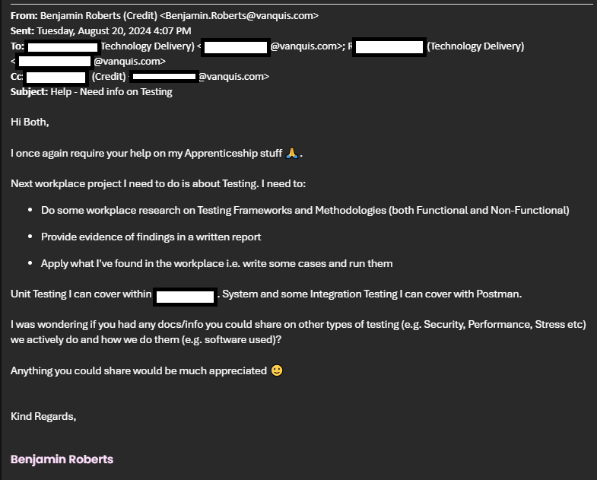

Figure 87 - Internal Email Communication with IT Development & Testing Leads (names redacted for privacy)

Below shows the response I got from the stakeholders. They provided suggestions of where to start with methodologies and frameworks for my theory review, along with suggestions of tools I could look at for conducting testing. Also was an invitation to discuss further in person.

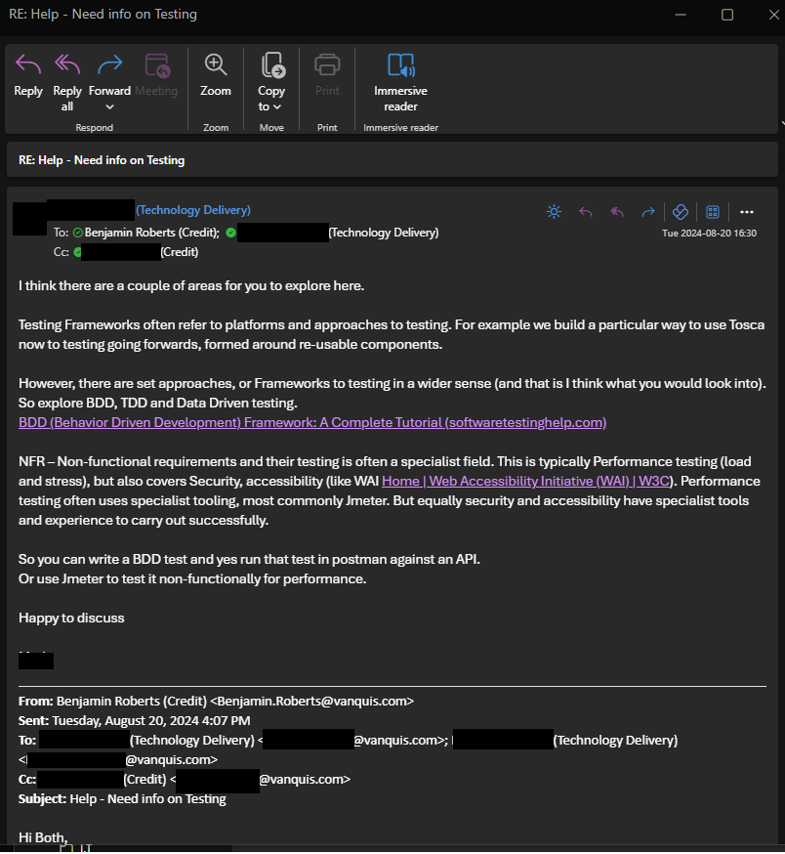

Figure 88- Email Response from IT with starting point suggestions

With this starting point, I’ve broken down the theory review into multiple sections below.

## Testing Frameworks

Software Testing Frameworks are a set of guidelines or rules used for creating and designing test cases and are comprised of tools and practices used to run these test cases. These could be providing functionality to users for writing tests, methods of managing test data, processes for storing results and more (Smartbear, 2024b). Applied, these refer to the tools we use to conduct testing activities.

Various software and language libraries have been developed to support teams conducting testing. Some examples of each are covered below:

### Software

|  |  |  |
| --- | --- | --- |
| **Tool** | **Description** | **Types of Testing used for** |
| Postman | A software designed to support teams with API development by providing tools to document and test API interfaces offered over the web (Postman, 2024).  Uses a version of the “Chai” Node.js library to provide functionality for Test cases from API responses. | * Integration * System * Performance * Negative/Destructive |
| JMeter | An open-source application built in pure Java designed for load testing functional behaviour and measuring performance (Apache, 2024) | * Integration * System * Performance |
| Selenium | Automated web browser input tool, allowing teams to create scripts that automate interaction with a Web App | * System * End to End * User Acceptance * Cross-Browser |
| Burp Suite | Provides a suite of tools for security testing web applications, used for identifying vulnerabilities within the application. Includes features for SQL Injection, Cross-site scripting and more (PortSwigger, 2024) | * Security |

Figure 89 - Testing Framework Software

### Language Libraries

|  |  |  |
| --- | --- | --- |
| **Language** | **Library** | **Functionality provided** |
| Java | JUnit | Unit Testing functionality, with integration with the IDE and Continuous Integration tools |
| Mockito | Mocking services, allowing certain method behaviour to be set to always return an expected result. |
| C# | NUnit | Unit Testing functionality, with integration with the IDE and Continuous Integration tools |
| moq | Mocking services, allowing certain method behaviour to be set to always return an expected result. |
| Javascript / Node.Js | Chai | Unit Testing functionality, with integration with the IDE and Continuous Integration tools |
| Python | Pytest | Unit Testing functionality, with integration with the IDE and Continuous Integration tools |

Figure 90- Testing Framework Language libraries

## Testing Methodologies

Software Testing Methodologies are various strategies/approaches used for testing an application for ensuring it looks and behaves as per requirements (SmartBear, 2024a). These form the strategic approach to how developers/teams will test a piece of software. The types of testing can be split into types:

1. **Functional**, including Unit, Integration, System and User Acceptable Testing
2. **Non**-**Functional**, including Performance, Security and Accessibility Testing

Aside from these different types of testing, an overall strategical plan for testing is required to be able to apply these different forms of testing effectively when developing software.

### Strategical Approach: Shift-Left Testing

To get started, I took up an offer from one of our technical IT Delivery Leads to discuss approaches to testing one-to-one in greater detail. I set up a Web Meeting for this:

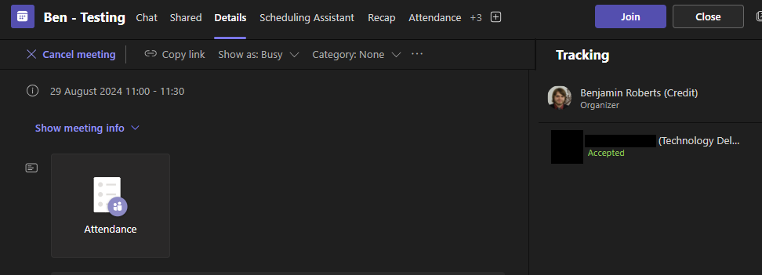

Figure 91- Microsoft Teams meeting for discussing approaches to Software Testing

Our Delivery Lead gave me good information to get started on and recommendations on what to investigate. One highlight was the “Shift-Left” approach to testing. This is an approach that aims to perform testing earlier in the development cycle, rather than having isolated phases of development and testing (IBM, 2023).

Shift Left Testing is accomplished by using various kinds of testing that can be executed throughout the software’s development, as demonstrated in the figure below:

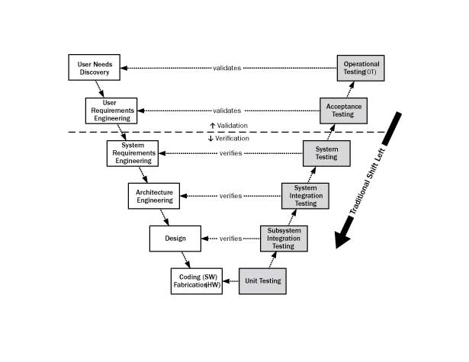

Figure 92- Traditional view o Shift-Left testing, with various forms of testing applied (Wikimedia.org, 2024)

Here, we see high level requirements broken down as the software development cycle continues, until we get down to the design and coding levels. From there, we immediately start different forms of testing, therefore moving testing from the end of the lifecycle to be directly integrated with the development. This is the “V-Model”, which allows development team to verify early on that their solutions match the requirements provided and validate they solve the business problems that the software is intended to address (IBM, 2023).

A key benefit of moving testing earlier into the cycle like this is that it allows bugs/faults to be identified earlier in the software development process. Bugs/Faults found later in the process lead to more costs as the software needs to be sent back to the development teams to fix, or in a worst-case scenario can create production level incidents that can cost the business significantly (ether financially or reputationally). The below figure visualises how cost to fix bug/faults increases as they are found later in the process:

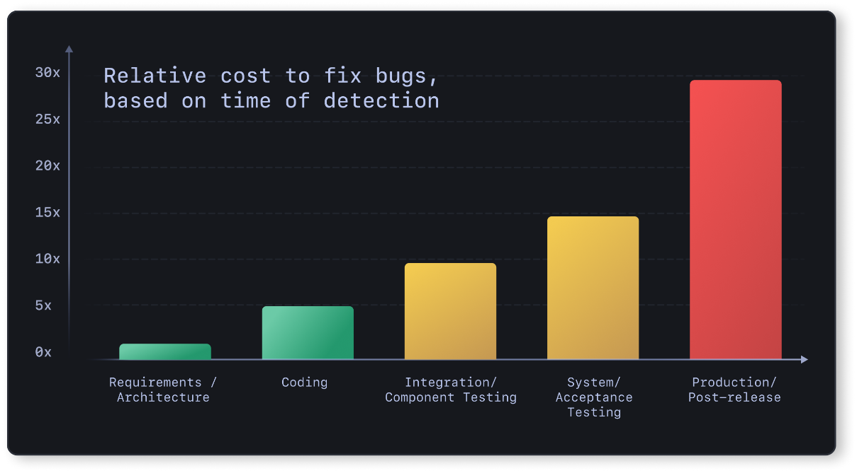

Figure 93 - Escalating costs of bugs/faults as they are found later in the Development process (Deepsource, 2019)

Dedicated end to end testing phases are still important under this strategy, but Shift-left allows potentially costly bugs to be found earlier in the process.

#### Behaviour Driven Development

Behaviour Driven Development is one way to apply this shift left strategy by bringing user requirements directly into the development and testing processes and using them as a basis for writing test cases. The idea is to write test cases in a plain English language that bridges the gap between technical and non-technical stakeholders, which simplifies communicating test results and is effective for getting business approvals to move to deployment (North, 2006). The test cases then form requirements the development team can use to develop from and communicate the status of those features back to the business easily. Test cases are therefore considered very early in the software development cycle i.e. testing “shifts-left”.

When meeting with internal technical stakeholders who lead our testing teams, they advised this is something we apply internally in our test cases via the “**Gherkin**” language. Gherkin is a plain text language design to be easy for non-programmers to use while also being concise enough to write effective test scenarios that emulate real-world business use cases (SmartBear, 2023a). The syntax makes use of various keywords to structure the test case, which every line must start with (Cucumber, 2024). Common ones I observed in our internal plans are:

|  |  |
| --- | --- |
| **Keyword** | **Meaning** |
| **Scenario/Example** | * “Scenario” is a synonym of “Example” i.e. Gherkin treats them as the same meaning * Used for describing a specific business rule the functionality under test is for |
| **Feature** | * Provides a high-level Description of a software feature (i.e. a piece of functionality to be delivered). * Useful for grouping related scenarios * Must always be the 1st Keyword |
| **Given** | * Provides the initial context of a test case * Idea is to put the system in a known state before any other interactions * Form the preconditions that must be met before executing a test case |
| **When** | * Describes an event/action taken by the user or system i.e. what the user/system would be doing when the test case is run |
| **Then** | * Describes the expected outcomes of the test case |
| **And** | * Used to join multiple “**Given**” statements * Also can be used to join multiple “**Then**” statements * Useful for making the test case more readable |
| **But** | * Similar to “**And**”, but can be used when the test case not intending for an action to happen e.g.   + *Then I should see something*   + *But I shouldn't see something else* |

Figure 94 - Table Breakdown of Gherkin Keywords (Cucumber, 2024)

Put together, a Gherkin test case example is:

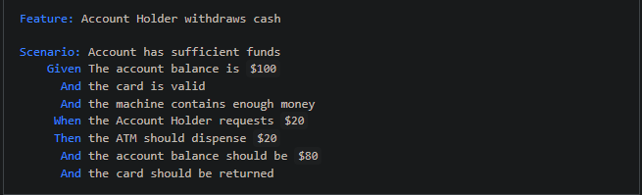

Figure 95- Generic example of a complete Gherkin Test case (SmartBear, 2023a)

I found in my organisation, our testing teams use Azure DevOps test plans, with the Gherkin language being used to structure the test cases. Below is an example of a Gherkin test case from one of our internal test plans:

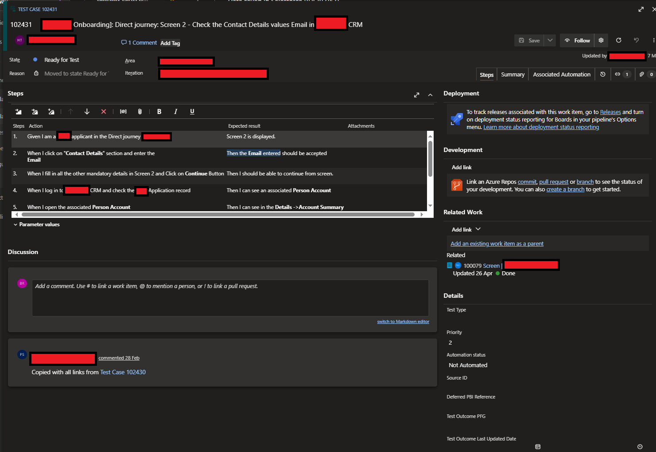

Figure 96 - Example of a workplace Test case written in Gherkin language (with sensitive information redacted)

#### Test Driven Development

Test Driven development is a precursor to Behaviour-Driven Development, with North (2005) using their experience with teaching Test Driven Development to develop the Behaviour-Driven Development methodology. It is similar in context due to that, although they are not mutually exclusive (Cucumber, 2024)

Visualised, the workflow looks like this:

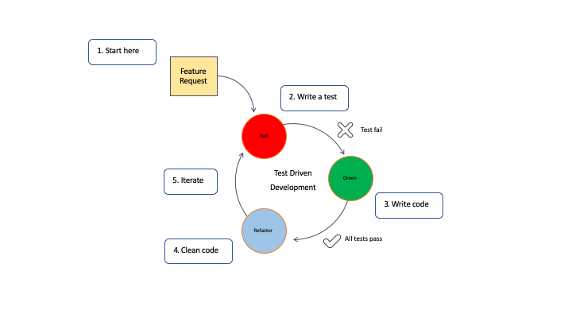

Figure 97- Visual of Test Driven Development (IBM, 2024)

The approach works by:

1. Writing test cases for a feature before writing any code for the feature itself, knowing that the test cases will fail initially.
2. The Development will then write just enough code to allow the test case to pass, therefore bringing part of the testing earlier into the Software Development cycle.
   1. By writing the test cases upfront like this, the development team can maximise the code coverage.
3. Once these test pass, then the development team is free to refactor the code, which could be for optimisation or for conforming to coding standards set by the client.
4. With the Tests already in place, they are free to make these changes and rapidly re-run the tests to confirm their changes have not introduced a defect into the code.
   1. This also allows for quick regression testing of existing functionality once a new feature request comes in.

### Functional Testing

Functional Testing is about the application against the business requirements set e.g. does a specific feature perform per expectations (SmartBear, 2024a). Different forms of Functional testing are:

* Unit Testing
* System Testing
* Integration Testing
* User Acceptance (UAT) Testing
* Negative/Destructive Testing

Typically, there is an order to how these forms of Functional testing are done, as seen below:

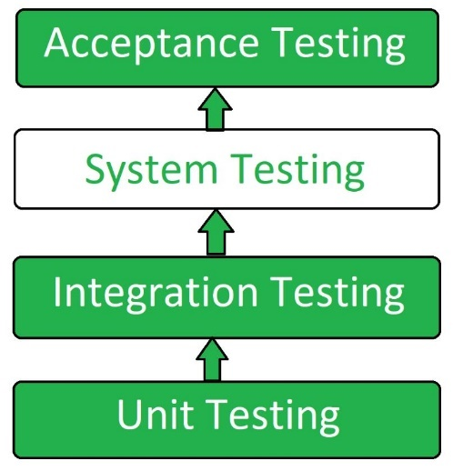

Figure 98 - Typical Hierarchy to order different types of Functional Testing is conducted (GeeksForGeeks, 2024b)

#### Unit Testing

Unit Testing involves testing small pieces of code in isolation, allowing the behaviour of the component under test to be proven without any dependency on other parts of the software (AWS, 2024). This is the typical 1st level of testing and is often performed by the development team (SmartBear, 2024a). The advantage of this is that it allows a developer to confirm that their written code performs the function it’s expected to without having to design specific test data to handle other components that could block access to the function under test.

My team do this kind of testing within our Credit Decisioning platform as a standard part of our development process. Each piece of functionality has multiple unit tests created for it to demonstrate every possible outcome the component under test could return.

**Test Cases**

Our internal Credit Decisioning engine uses a low code solution provided by a 3rd party supplier, which I’ve had prior training in. To expand my horizons, I’ve instead revisited my “Java Decisioning Program” project to conduct Unit Tests on Java components instead, allowing me to practice this form of testing in a more traditional coding space using the JUnit library.

|  |  |  |  |  |
| --- | --- | --- | --- | --- |
| **ID** | **Class** | **Type** | **Component Under Test (CUT)** | **Test Case (Gherkin)** |
| 1 | Functional | Unit | Scorecards - e1b09_score method | **Given** an applicant is applying for a loan  **When** they reach the Scorecard module  **And** the Champion Scorecard is run  **And** the value for the E1B09 variable is -1  **Then** the output of “e1b09_score” will be -20 |
| 2 | Functional | Unit | Scorecards - e1b09_score method | **Given** an applicant is applying for a loan  **When** they reach the Scorecard module  **And** the Champion Scorecard is run  **And** the value for the E1B09 variable is 0  **Then** the output of “e1b09_score” will be -20 |
| 3 | Functional | Unit | Scorecards - e1b09_score method | **Given** an applicant is applying for a loan  **When** they reach the Scorecard module  **And** the Champion Scorecard is run  **And** the value for the E1B09 variable is 1  **Then** the output of “e1b09_score” will be 10 |
| 4 | Functional | Unit | Scorecards - e1b09_score method | **Given** an applicant is applying for a loan  **When** they reach the Scorecard module  **And** the Champion Scorecard is run  **And** the value for the E1B09 variable is 2  **Then** the output of “e1b09_score” will be 10 |
| 5 | Functional | Unit | Scorecards - e1b09_score method | **Given** an applicant is applying for a loan  **When** they reach the Scorecard module  **And** the Champion Scorecard is run  **And** the value for the E1B09 variable is 3  **Then** the output of “e1b09_score” will be 20 |
| 6 | Functional | Unit | Scorecards - e1b09_score method | **Given** an applicant is applying for a loan  **When** they reach the Scorecard module  **And** the Champion Scorecard is run  **And** the value for the E1B09 variable is 4  **Then** the output of “e1b09_score” will be 20 |
| 7 | Functional | Unit | Scorecards - e1b09_score method | **Given** an applicant is applying for a loan  **When** they reach the Scorecard module  **And** the Champion Scorecard is run  **And** the value for the E1B09 variable is 5  **Then** the output of “e1b09_score” will be 30 |
| 8 | Functional | Unit | Scorecards - e1b09_score method | **Given** an applicant is applying for a loan  **When** they reach the Scorecard module  **And** the Champion Scorecard is run  **And** the value for the E1B09 variable is 5  **Then** the output of “e1b09_score” will be 30 |
| 9 | Functional | Unit | Scorecards - e1b09_score method | **Given** an applicant is applying for a loan  **When** they reach the Scorecard module  **And** the Champion Scorecard is run  **And** the value for the E1B09 variable is 7  **Then** the output of “e1b09_score” will be 18 |
| 10 | Functional | Unit | Scorecards - e1b09_score method | **Given** an applicant is applying for a loan  **When** they reach the Scorecard module  **And** the Champion Scorecard is run  **And** the value for the E1B09 variable is greater than 7 (e.g. 8)  **Then** the output of “e1b09_score” will be 18 |
| 11 | Functional | Unit | Scorecards - e1b09_score method | **Given** an applicant is applying for a loan  **When** they reach the Scorecard module  **And** the Champion Scorecard is run  **And** the value for the E1B09 variable is greater than 7 (e.g. 8)  **Then** the output of “e1b09_score” will be 18 |
| 12 | Functional | Unit | Scorecards - e1b09_score method | **Given** an applicant is applying for a loan  **When** they reach the Scorecard module  **And** the Champion Scorecard is run  **And** the value for the E1B09 variable has a value that falls outside the provided business logic (e.g. -999)  **Then** the output of “e1b09_score” will be -20 |
| 13 | Functional | Unit | Scorecards - e1b09_score method | **Given** an applicant is applying for a loan  **When** they reach the Scorecard module  **And** the Champion Scorecard is run  **And** the value for the E1B09 variable has a NULL value  **Then** the output of “e1b09_score” will be -20 |

Figure 99 - Unit Test cases

The below figure shows these test cases being applied in a JUnit class called **ChampionTest**, which calls the static “e1b09_score” method from the Champion class:

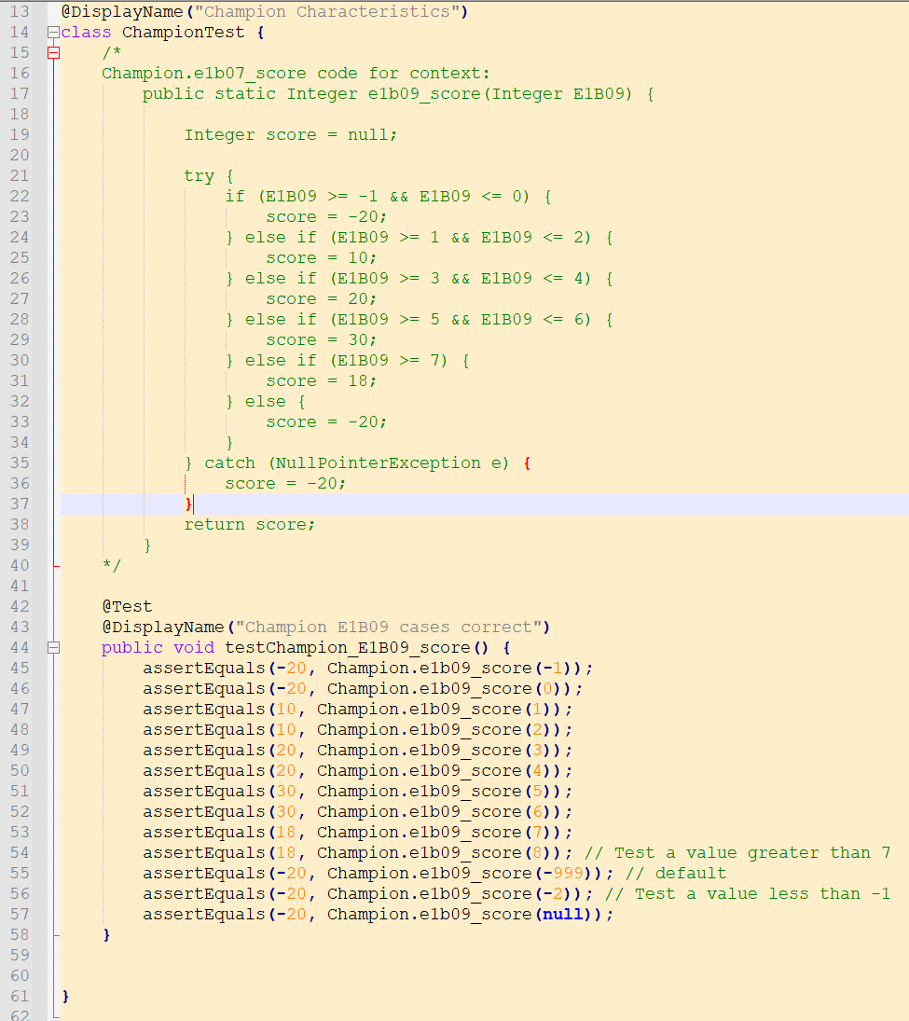

Figure 100- Java JUnit representation of a Unit Test my team would write within our Credit Decisioning platform

Unit Tests work on the concept of Assertions, which define a TRUE/FALSE condition that must evaluate to TRUE for the Unit Test to pass. Different Frameworks provide various ways to define these Assertions, but a common one is “**AssertEquals**”, which tests if the output of the component under test equals an expected value.

In this example, the 1st parameter passed into the “AssertEquals” method represents the expected value, while the 2nd parameter is the component under test. The method being passed in as the 2nd parameter returns a value back to “AssertEquals”, which can then determine if the test passes or fails by comparing the 2 parameters. Developer Tools then present the result back to the developer e.g. in our Credit Decisioning platform, this gets presented within a specific view available to the platform, seen below:

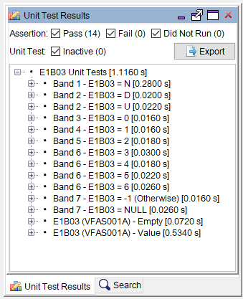

Figure 101- Unit Test Results as seen in our Credit Decisioning platform

Successful tests appear as regular text within this view, while failed tests will appear in red with a “FAIL” indicator next to them.

Once developed, Unit Tests can be run repeatedly. This makes them useful for confirming a component still works as intended if changes are made to it later e.g. in my team, we use them to confirm a component we’ve built works as expected before we arrange any code deployment to a pre-production environment for further rigorous testing.

#### System Testing

Systems testing is done on a completely integrated system to check the developed software meets the original business requirements and is typically done after Unit and Integration testing (GeeksForGeeks, 2024b). This process is core for ensuring the final product can deliver value to the business.

Typically, this testing is done by a dedicated test team, rather than the developers (SmartBear, 2024a). This separation gives the testers independence to test the software from an impartial perspective (GeeksForGeeks, 2024b), which can allow them to find issues that may not occur to the development team.

If any gaps/faults between the system and the requirements are found, these are communicated back to the development team to investigate.

Regression testing can also be done as part of this, which involves re-running test cases on existing features to ensure they have not created new defects in existing functionality.

Below shows a flowchart for the Process:

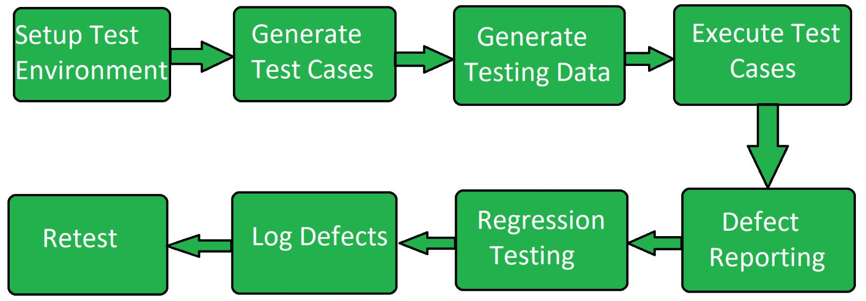

Figure 102 - Flowchart of the workflow for conducting System Testing (GeeksForGeeks, 2024b)

My team primarily uses the Postman software to conduct this kind of testing, specifically for its ability to send HTTP requests to API endpoints, which allows us to submit test cases to our Credit Decisioning engine. Our use case however is to rely on MI Files generated by the system that get loaded into a SQL Database. We use these files to validate the system works as expected via recreating the entire business logic in SQL.

Our current approach does not make full use of this software, as it has its own ability to run Test Scripts on the results of an API call, which can be used to conduct system testing e.g. the figure below is an auto-generated one to confirm the response received from a HTTP Service has the 200 status code, indicating a success:

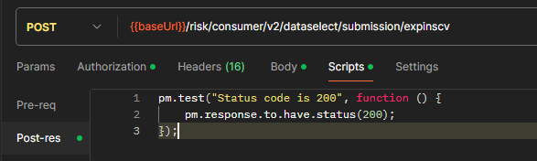

Figure 103- Generic Postman Test to check HTTP Status Code received

**Test Cases**

|  |  |  |  |  |
| --- | --- | --- | --- | --- |
| **ID** | **Class** | **Type** | **Component Under Test (CUT)** | **Test Case (Gherkin)** |
| 1 | Functional | System | Policy Rule – Existing Customer Decline | **Given** a single applicant is applying for a loan **When** the applicant is an is an existing customer **And** the applicants name, current postcode and date of birth match exactly to the existing customer database **Then** that applicant will be declined  **And** a HTTP Status Code 200 shall be received **And** *[Redacted]* policy code shall be returned to the front-end system |
| 2 | Functional | System | Policy Rule – Exclusions Decline | **Given** a single applicant is applying for a loan **When** the applicant is on the exclusion list **And** the applicants name, current postcode and date of birth match exactly to the exclusion list **Then** that applicant will be declined  **And** a HTTP Status Code 200 shall be received **And** *[Redacted]* policy code shall be returned to the front-end system |
| 3 | Functional | System | Data – Existing Customer agreement | **Given** a single applicant is applying for a loan **When** the applicant is an is an existing customer **And** the applicants name, current postcode and date of birth match exactly to the existing customer database  **Then** a HTTP Status Code 200 shall be received  **And** the current agreement number for the applicant will be returned in the response |

**Note**: Exact response structure these tests expect are redacted as this is sensitive information.

Figure 104 - System Test cases

Before I could do anything, I needed some test data to match against (as a precondition for these tests to be valid). I have built functionality in the past within our Credit Decisioning system for loading data into the back-end database the components in these test cases use. This works by using a HTTP POST Request with a request body containing the data to load. The figure below shows this in practice:

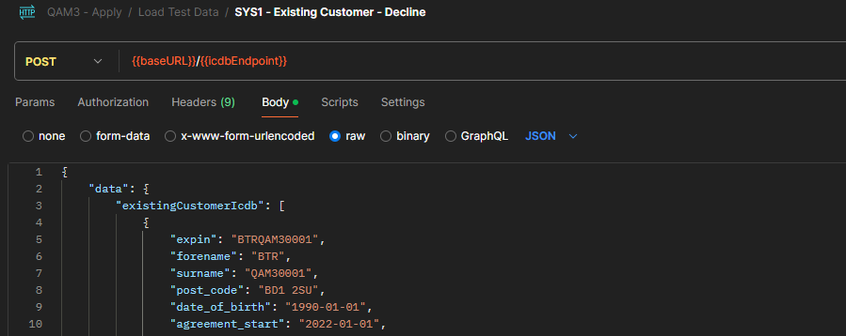

Figure 105 - Using Postman to load Test data for System Testing

To run these cases, I also wrote functions in Postman’s Scripts tab to check the JSON Response received for the expected data specified in the test case (the structure of which is similar for all 3 cases). Using the 1st test case as an example, these work by:

1. Wrapping within the “pm.test” method, which Postman uses to capture the result for it’s graphical representation of the results
2. Parsing the JSON message received and committing to a JavaScript array
3. Using a forEach loop on the above array to check for the expected data outputs
4. Using the “pm.expect” method to return a PASS/FAIL result back to the Postman UI, which is presented to the user

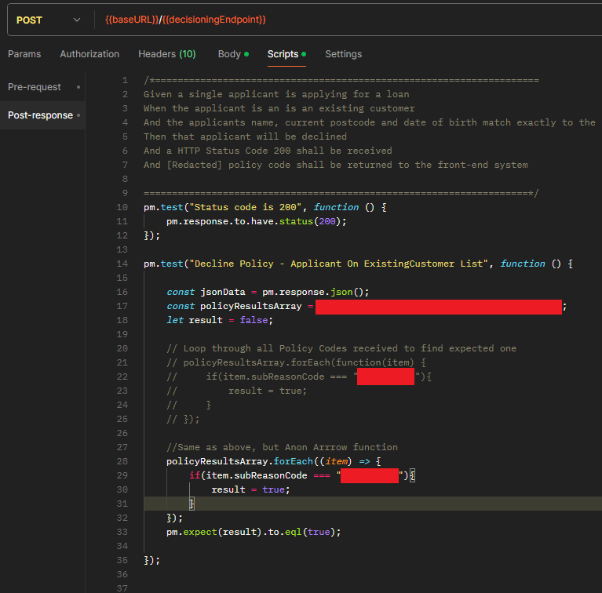

Figure 106 - Postman Test code in practice (with sensitive information redacted)

Once Postman is used to send an HTTP request, these test cases are run automatically and presented in a menu, as seen below for my 3 test cases:

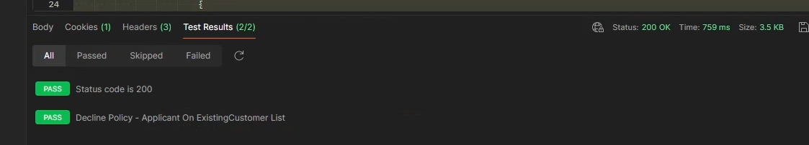

Figure 107 - Results for System Test Case 1

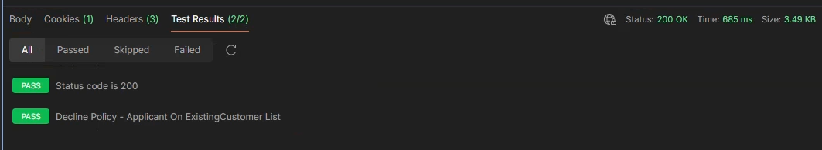

Figure 108 - Results for System Test Case 2

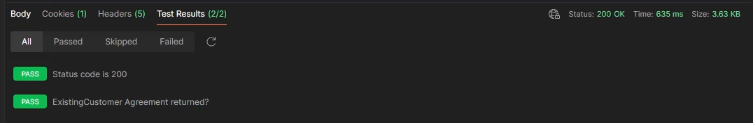

Figure 109 - Results for System Test Case 3

By using Postman’s functionality for Test Scripts like this, I see an opportunity to improve how my team conducts testing. System testing is core to use because it validates the business logic we implement performs as expected. Our current approach of relying on MI files loaded into a SQL database however creates an overhead due to the time it takes to receive and load the files into a database. This creates inefficiency and slows down testing. We may be able to use Postman like this to better automate our testing.

#### Integration Testing

Integration Testing tests the interface between 2 systems or modules, looking for potential issues that would impact the functionality of both systems/modules. This is typically done after Unit Testing and before System Testing (GeeksForGeeks, 2024a). Unit Tests would instead make use of mocking services to force specific responses from integrated systems where the components under test would require them, which keeps the scopes of the test scenarios separate.

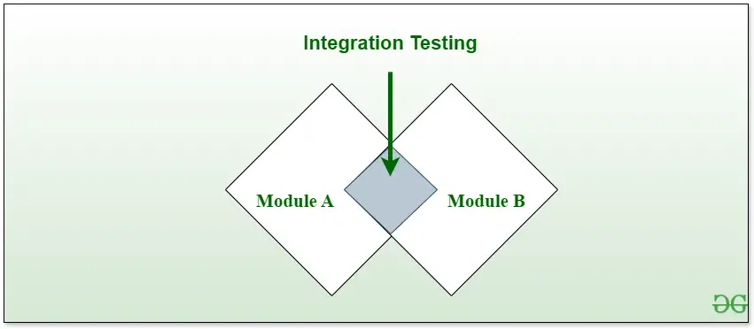

Figure 110- Visual Representation of Integration Testing (SmartBear, 2024a)

An applied example would be testing the communication one system has with integrated web services e.g. our internal Credit Decisioning engine integrates with API’s offered by the 3 main credit bureaus in the UK: Experian, TransUnion and Equifax. These providers return data on a person’s Credit file, which can be used for assessing a person’s credit worthiness in a more informed manner then solely relying on data provided by a person or from internal data the business holds.

For the benefits of the example to materialise however, the business needs a degree of confidence that the Credit Decisioning system can retrieve a proper response from the source API. Test cases therefore need to cover:

1. A successful connection can be made to the credit bureau API
2. The data returned is per expectations, based on the input provided e.g. if a person were to provide multiple addresses, the decisioning engine sends all of them to the credit bureau API and all are searched on the credit bureau’s service
3. The response from the credit bureau API can be successfully interpreted by the originating system

**Test Cases**

|  |  |  |  |  |
| --- | --- | --- | --- | --- |
| **ID** | **Class** | **Type** | **Component Under Test (CUT)** | **Test Case (Gherkin)** |
| 1 | Functional | Integration | DelphiSelect (Quotation) Integration | **Given** a single applicant is applying for a loan **When** a single address is given on their application **And** the applicant is not declined on any pre-bureau policy rules **Then** the system will make an HTTP API call to Experian DelphiSelect **And** a successful Response will be received  **And** this success will be logged in the Decisioning engine response |
| 2 | Functional | Integration | DelphiSelect (Quotation) Integration | **Given** a single applicant is applying for a loan **When** multiple addresses are given on their application **And** the applicant is not declined on any pre-bureau policy rules **Then** the system will make an HTTP API call to Experian DelphiSelect **And** a successful Response will be received  **And** this success will be logged in the Decisioning engine response |
| 3 | Functional | Integration | DelphiSelect (Quotation) Integration | **Given** joint applicants are applying for a loan **When** multiple addresses are given on their application **And** the applicant is not declined on any pre-bureau policy rules **Then** the system will make an HTTP API call to Experian DelphiSelect **And** a successful Response will be received  **And** this success will be logged in the Decisioning engine response |

Running these cases is the same process as the System tests, just with different data points and slightly different Javascript code e.g. for my 1st test case, the below code was used:

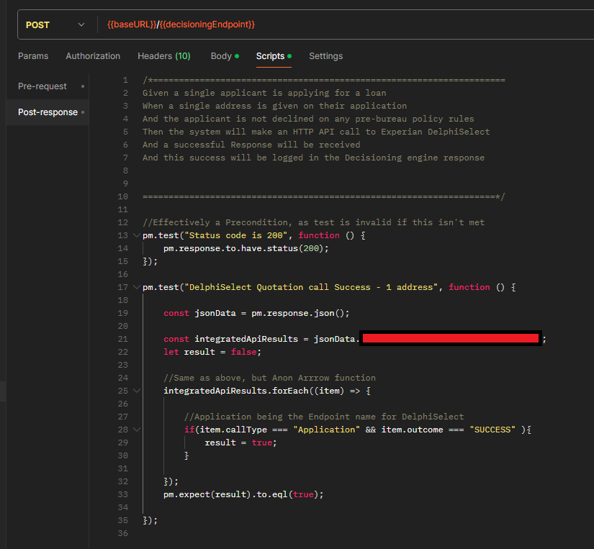

Figure 111 - Integration Test case 1 - JavaScript code

As I’m checking the same field in the response each time, I’m able to reuse this test code; only the data inputs need to change between tests.

One issue I ran into however was the initial all failed my test case (with the “Status Code is 200” just being used as a precondition:

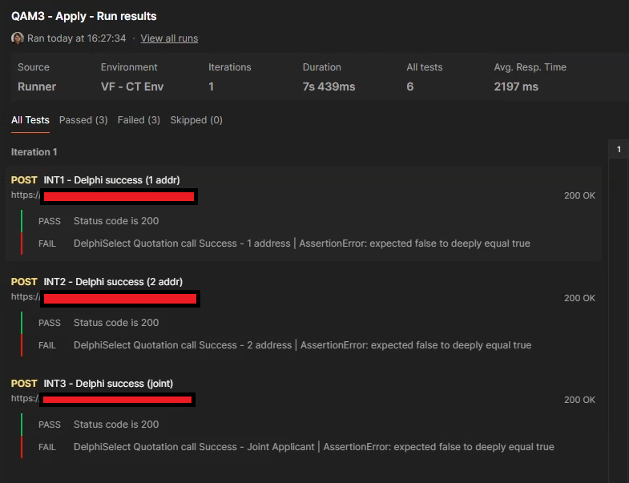

Figure 112- Initial run of Integration tests showing failures

The issue that caused this is that the system under test caches the responses it receives from the Integrated API’s (in this case, the DelphiSelect integration under test). This means when the same test data is re-used, the system will re-use this case rather than make a new HTTP call to the integrated API. Normally this is used as a cost-saving measure, but here it presents a barrier to repeatable test cases.

To handle this, I made use of functionality in the engine to delete cache records, which basically works by using a DELETE HTTP records to clear records based on provided data in the request (the specifics of how this works being redacted information). These are used to clean up the test data after running these cases:

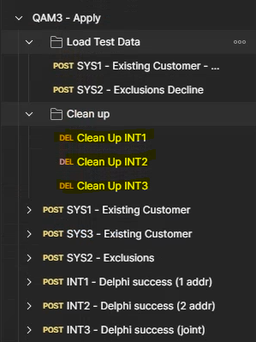

Figure 113- DELETE HTTP Requests added to clean up test data preventing repeatable testing

After I added these clean up steps to remove previously cached data that could skew the test results, my test cases passed:

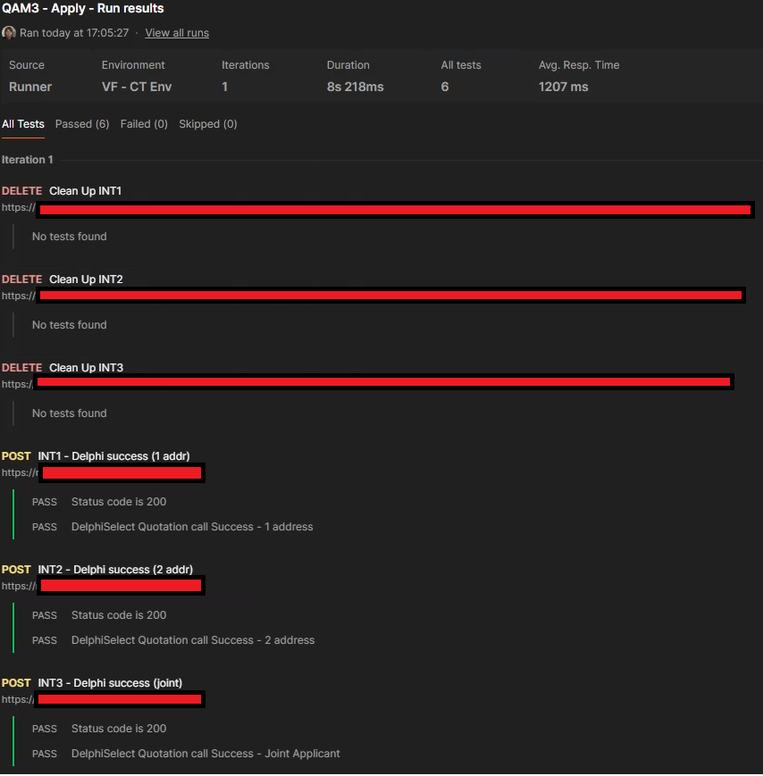

Figure 114- Integration Test cases passing after clean up steps added

### Non-Functional Testing

Non-Functional Testing focuses on the operational aspects of the software, rather than the features of the software e.g. testing how the software performs with multiple users in parallel (SmartBear, 2024a). Types of testing that fall under this are:

* Performance Testing
* Load Testing
* Security Testing (Penetration)
* Portability Testing
* Scalability Testing
* Recovery Testing

(GeeksForGeeks, 2024d)

For this project, I’ve conducted some of these test types on the Credit Decisioning system my team maintains:

#### Performance Testing

Performance Testing checks that the system/application performs per expectations under expected workloads (GeeksForGeeks, 2024c). One applied example is requiring the system/application to respond to user input within a reasonable amount of time (the threshold for this would be set as part of the requirements gathering stage of the software development process). This example was relevant to a recent project I worked on, which required our Credit Decisioning system to be able to respond to HTTP requests within 7 seconds for most requests, otherwise we risked losing potential customers.

The Postman Software I used for my Functional Tests have started to provide functionality for Performance Testing. Strangely though, this functionality is not available on the “Enterprise” Plan my organisation uses, despite being available on lower-level plans:

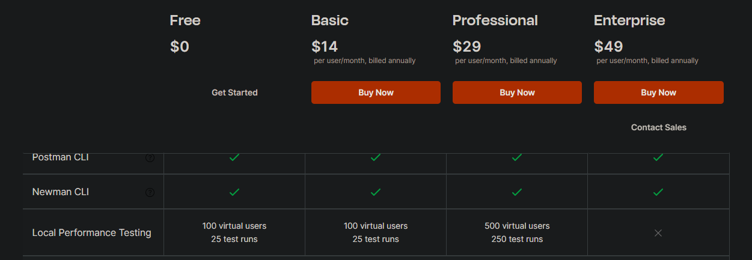

Figure 115 - Postman Software plans, showing Performance Testing features not being available on the Enterprise plan (Postman, 2024)

To work around this, I had to reach out to the helpdesk of the Postman software to see if there was any option to get this feature on the Enterprise plan. I got an email reply saying it was possible to raise an “Early Access” request:

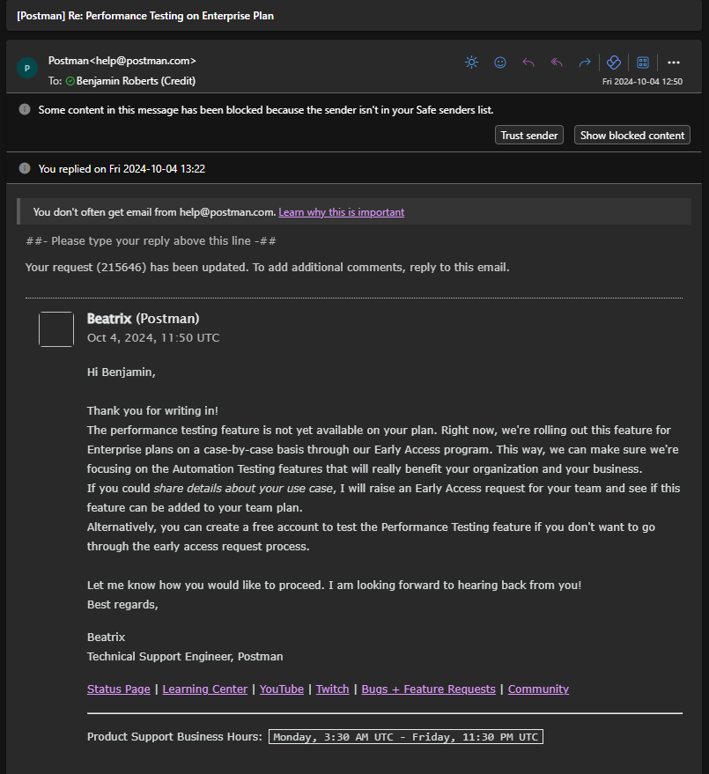

Figure 116 - Postman Support ticket about Early Access to Performance Testing feature

As there were no additional costs to requesting this feature, I chose to raise that request.

**Test Cases**

|  |  |  |  |  |
| --- | --- | --- | --- | --- |
| **ID** | **Class** | **Type** | **Scope** | **Test Case (Gherkin)** |
| 1 | Non-Functional | Performance | **Average Response Times** | **Given** the system is under load  **When** HTTP Requests are sent to the Decisioning Endpoint  **And** the request type is for a credit quotation offer  **And** the final decision returned in the responses is “Accept”  **Then** the average response time of the system will be <= 7 seconds |
| 2 | Non-Functional | Performance | **Response Times – 90th Percentile** | **Given** the system is under load  **When** HTTP Requests are sent to the Decisioning Endpoint  **And** the request type is for a credit quotation offer  **And** the final decision returned in the responses is “Accept”  **Then** response times of the system will be <= 7 seconds at the 90th Percentile (i.e. 90% of requests are <= 7 seconds) |

Once this Early Access request was completed, I was able to access this functionality via the “Run Collection” feature in Postman, which allows requests to be run in bulk:

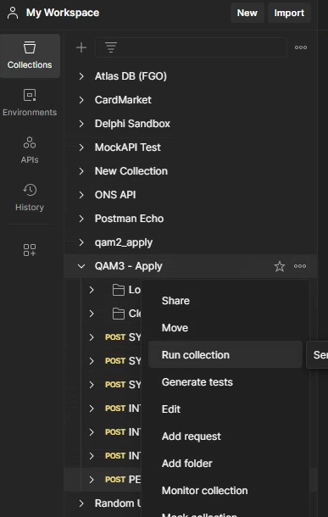

Figure 117- Demonstrating Postman’s "Run Collection" feature

Selecting this opens the collection runner. Shown below is the Performance tab, which enables Postman to conduct Performance testing. Multiple profiles are offered, which allows different types of testing to be conducted e.g. the “fixed” configuration I’ve used for these tests will configure the tool to run my HTTP requests with 5 users in parallel for 10 minutes (with the amount of users and length of the test configurable). There are also alternative run modes e.g. a “ramp up” mode exists that start with few users and adds more as the test run continues. For these test cases however, the fixed mode was sufficient.

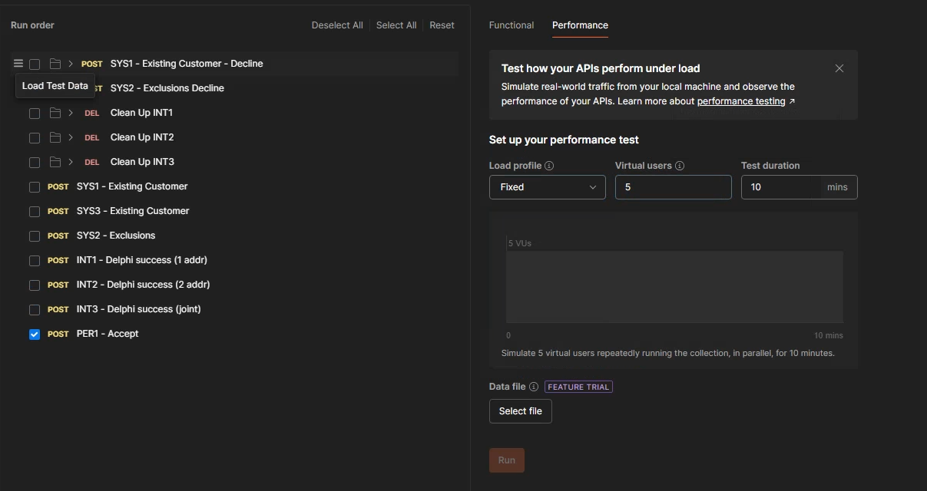

Figure 118- Configuring Postman's collection runner for my Performance Tests

Once started, Postman provides a line chart visualisation to show the results of the collection run e.g. the figure below is plotting the average API response time against the time the test was run. Summary details are also provided per HTTP requests used in the run (e.g. I only used 1, so only 1 is present). This presents final summary stats on performance time e.g. average, min, max and 90th percentile.

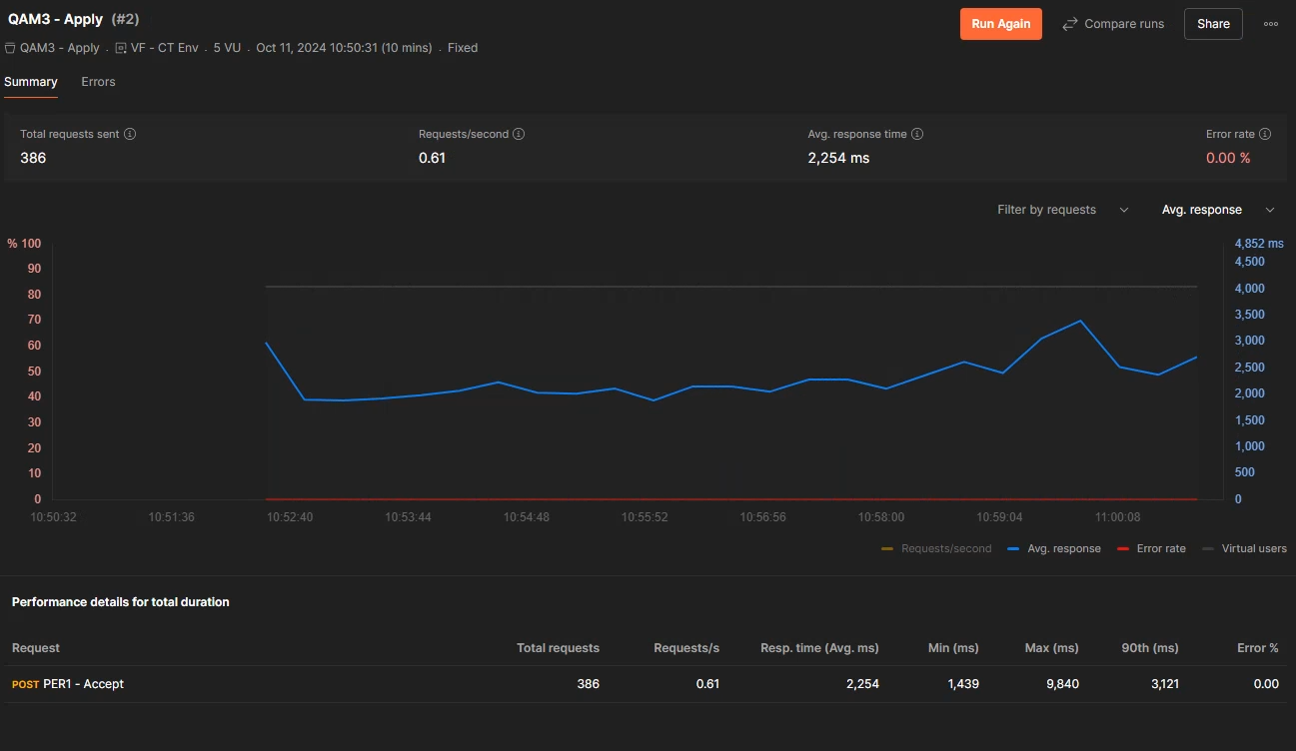

Figure 119 - Visualisation of Postman Performance testing results

These final totals give me the statistics I need for my test cases. In them I can see that both the average response time and the 90th percentile response time were below 7 seconds (i.e. 7000 milliseconds), so I can say my test cases passed.

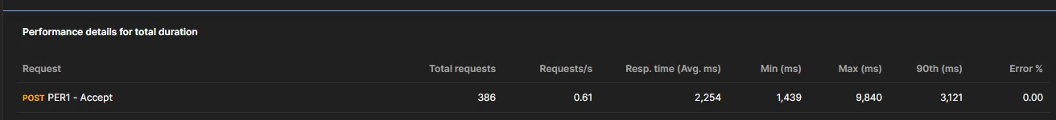

Figure 120 - Focus on final statistics of Performance Test run

Postman also allows these results to be exported, allowing copies to be retained for auditing purposes. I’ve exported a copy of the results and have included a copy of the output in Appendix A.

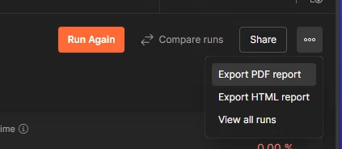

Figure 121 - Exporting Performance testing results to a PDF file

#### Load Testing

Load Testing is like Performance testing (often being grouped into it) but has a more specific scope. It focuses on the system being able to perform as expected when multiple requests are being made to the system e.g. 10+ users are attempting to use the same application in parallel. Failure of a system to pass this can be catastrophic e.g. (Smartbear SoapUI, 2024) details a case of the airline United failing to cope with load, forcing them to group flights globally for about an hour.

In my team’s case, this means that our Credit Decisioning service needs to be able to handle multiple applications for credit coming in from different people at the same time. Failing to do so means we’re unable to service those potential customers, who could look elsewhere for credit, resulting on lost revenue opportunities for us.

The same Postman functionality I used for my Performance testing also enables Load testing by simulating multiple HTTP requests being sent in parallel.

**Test Cases**

|  |  |  |  |  |
| --- | --- | --- | --- | --- |
| **ID** | **Class** | **Type** | **Scope** | **Test Case (Gherkin)** |
| 1 | Non-Functional | Load | **Parallel HTTP Requests** | **Given** the system is under load  **When** HTTP Requests are sent to the Decisioning Endpoint  **And** multiple requests are being sent in parallel  **Then** the system will accept requests from a maximum of 25 requests in parallel  **And** the HTTP Status Code 200 will be returned for all requests |

Using the same Postman functionality from my Performance tests, I’ve set up a test run appropriate to this test case:

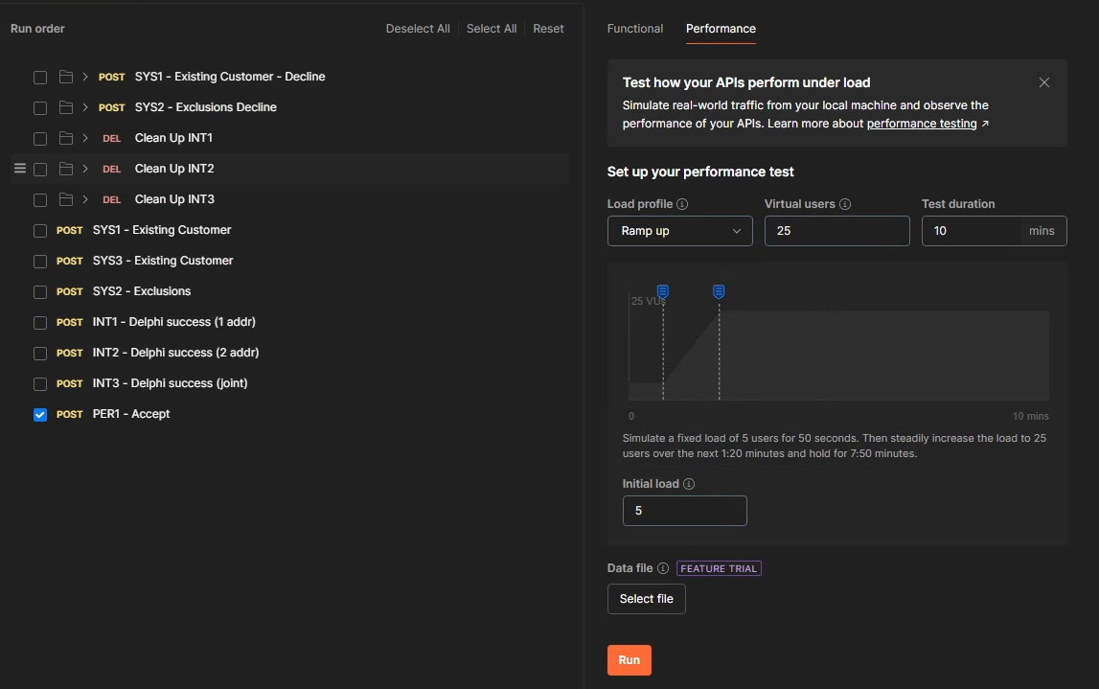

Figure 122 - Load Testing configuration used

To meet the requirements of the test case, this set up will:

* Use the “ramp up” profile, which will start the run from a low number of users and incrementally increase the number of parallel users as the test run continues
* Use a total of 25 users in parallel, with the ramp up starting from 5 users
* Run the test collection for a total of 10 minutes

The results from this run are summarised below:

* The Gray line on the visualisation created, which shows the load starting from a low number of users (i.e. the initial 5), then ramp up to the 25 users set out in the test case.
* Blue represents the average response time for successful requests
* Red indicates errors, which can be used here to judge the success/failure of the test case

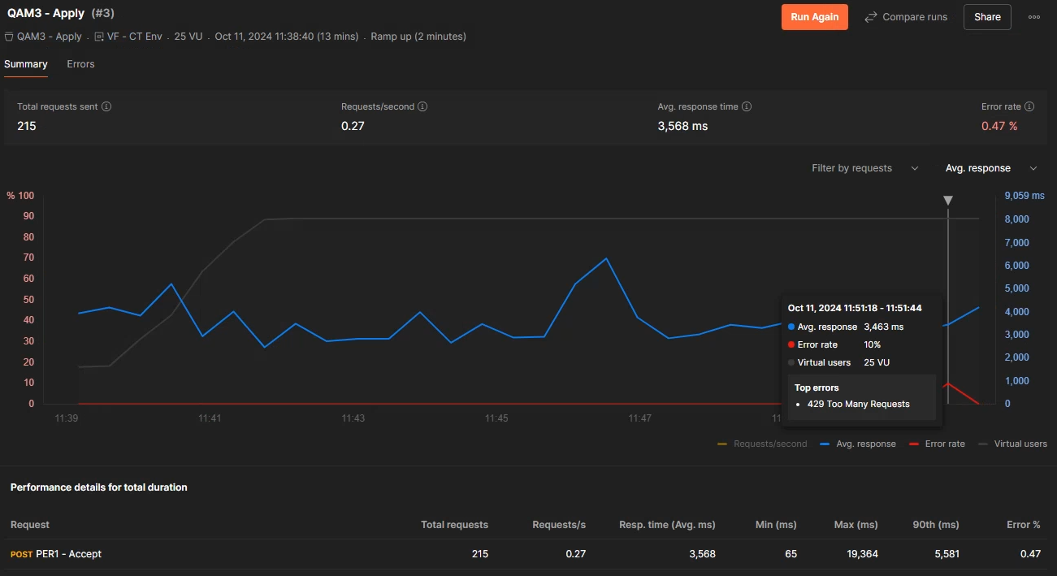

Figure 123 - Load Testing - results visualisation

We can see the red line increases, indicating an error occurred at some point during the test run. Hovering over the diagram within Postman provides more information e.g. the figure above shows that a HTTP 429 Too Many Requests error occurred, which indicates the test run sent more requests to the platform then the system under test was able to support (Mozilla, 2024).

Postman also has a separate “Errors” visualisation created as part of the test run, which provides further detail on the types of errors encounters. For my test case however, I only received the single HTTP 429 error.

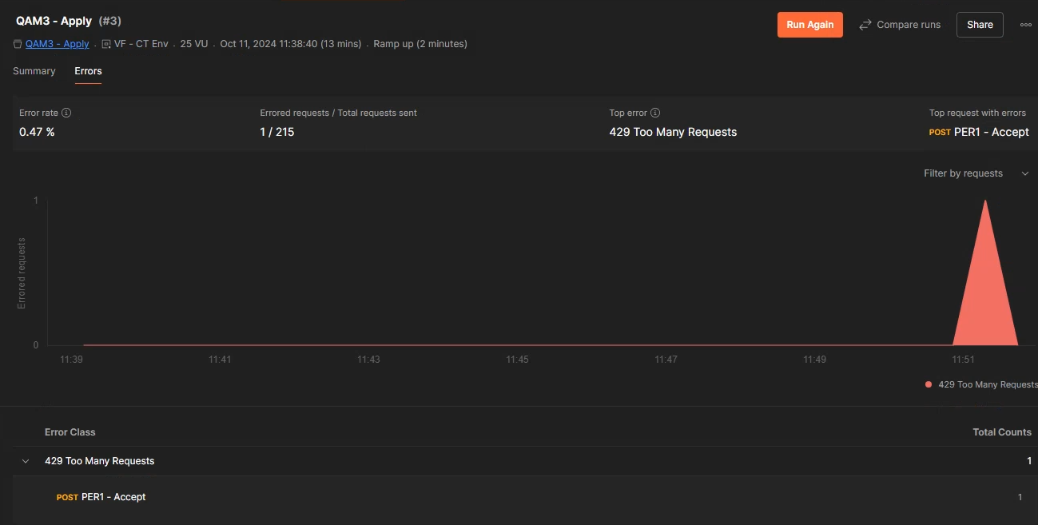

Figure 124 - Load Testing showing a single HTP 429 Error

This indicates that the systems (in its current environment) could break under the load of 25 users, so by the exact wording of my test case, that is a failure. The environment the system is deployed to would need to be re-scaled for it to work as expected under this test load. From a business point of view, that means committing additional computing resources (and therefore costs) to meet this requirement.

Like the performance tests, the full version of these result has been exported to a PDF file, which has been loaded into Appendix B.

#### Security Testing (Penetration)

Security Testing (also called Penetration Testing) is about discovering vulnerabilities within the application that a malicious user could take advantage of for various ends e.g. accessing user data, sabotage etc (UK Cyber Security Council, 2024). By this definition, Security Testing is critical for a commercial application as not testing for vulnerabilities can lead to exploitation e.g. my employer is within the banking industry, so security risks could lead to exposure of personal data or transactional data (Pahuja, 2024). The impact of such a leak can have reputation, regulatory and even legal consequences for our organization if a gap is left.

One key disadvantage of Security Testing in comparison to other methods however is the complexity involved. Conducting this testing requires specialised knowledge to conduct this type of testing (GeeksForGeeks, 2024e). For example:

* Strong knowledge of the code languages used and known vulnerabilities
* Knowledge of common attack vectors e.g. SQL
* Compliance standards an application/system must be held to (either as good practice or for regulatory reasons)

Specialised tools do exist to support this testing e.g. Burp Suite is a powerful one I found while researching frameworks for security testing (PortSwigger, 2024), however this is a licensed product.

Due to these points, the responsibility of Security testing is not something directly handled by my team. We have specialised teams to conduct this kind of testing internally. Our 3rd party supplier for our Credit Decisioning system also have their own teams and assurances on security (details of which are trade secrets). I’ve descoped conducting this testing from this report because of this.

## Conclusion

Testing forms a critical part of the Software Development Lifecycle, as it ensures that the software/system developed is of a quality that brings value to the business/clients and achieves the requirements it set out to do. Many frameworks have been developed over time to provide tools to development teams to enable this.

Bringing testing as early on into the development life cycle has been the approach of agile teams, per the “Shift-Left“ strategy. While this can incur upfront costs (e.g. additional dev/test resources needed to start a development), doing this helps ensure software quality earlier on in the development cycle and mitigates the risk of testing becoming a secondary concern as project deadlines approach. Upfront cost can also be offset by the increased cost that a bug/defect can have if it is found later in the development process e.g. a bug found in a Test environment is much cheaper than Production, as shown in (Deepsource, 2019).

The number of different types of testing devised is huge, beyond what is covered in this report. No test plan can rely solely on one/a few forms of testing, as different viewpoints are considered by different test types e.g. Unit Testing attempts to remove integration with other components from its scope, so potential defects in integration could be missed by relying on this alone; integration testing would also be needed. A well-rounded test plan therefore must consider multiple methodologies to create confidence in the quality of the software.

# DevOps Framework End 2 End

The goal of this project was to create documentation for my team’s Change Framework and how we use DevOps to orchestrate it. The writing style therefore is written as such that it does not use a 1st person perspective throughout most of it.

## Background / Context

To understand our Decisioning Engine Development process end to end, there are a few sections of background knowledge needed to understand why we do things & the content behind them:

### Agile vs Waterfall Project Management

Agile and Waterfall are both established approaches to Project Management, which structure how the project is worked on, how individual deliverables relate to each other & the sequencing of the project stages. Each methodology approaches these points differently:

#### Waterfall

Waterfall is the older of the two approaches, with the term originating in 1970. It is characterized by:

* Project stages are clearly and rigidly defined from the start of the program e.g. Requirements Gathering, Design, Implementation, Testing
* Stages are done in a strict flow e.g. all Requirements must be gathered before starting design.
* A usable product is only available at the end of project, when all requirements are met.
* Scope is clearly defined at the start, with change requests being judged difficult and costly (and therefore discouraged)
* Detailed documentation is created at each stage e.g. requirements, specifications for the technical designs.

(Royce, 1970) & (Radigan, 2024)

#### Agile

Agile is a newer approach characterised by the Agile Manifesto (2024). It is characterized by:

* The project is broken down into smaller iterations, with the scope of work set for each iteration
* Work is broken down into individual Product Backlog Items (PBI’s) that can be delivered independently, with a definition of “done” being defined by the team to judge when one is ready for release.
* Workable versions of the product are ready at the end of each iteration, but only with the functionality in scope for the current and previous iterations.
* Change is welcomed and supported by these working iterations e.g. a change can be moved into a later iteration with less difficulty or cost then the Waterfall approach.
* Documentation is secondary to the actual development, which can lead to issues where implementations become difficult to understand and require source code access.
* Teams are empowered to self-organise.

(Agile Manifesto, 2024) & (Radigan, 2024)

Agile is a framework rather than a specific interpretation on how to manage a project. Any process that adheres to the principles can be considered agile e.g. SCRUM.

#### Deliverables in Agile

Agile uses Product Backlog Items (PBI’s)/deliverables to break down the work to be delivered. These can then be added to agile iterations to deliver solutions. Project Management tools using the agile framework can use their own definitions and categories of deliverables to orchestrate the process. For example, my organization uses Azure DevOps, which calls these “Work Items”. Multiple work item types exist by default for the process, as well as allowing the team to create their own to suit individual management requirements.

In the Azure DevOps agile implementation, a hierarchy exists to these work items to help orchestrate the process and define the definition of done for the requirements. Shown below is how these relate to each other:

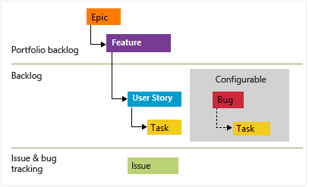

Figure 125 - Typical hierarchy of agile Work Items (Microsoft Learn, 2024)

|  |  |
| --- | --- |
| **Work Item Type** | **Description** |
| **Epic** | A large body of work that spans multiple iterations to be considered fully delivered. This is used to provide strategic context to the more granular work item types.  Epics are not always strictly necessary e.g. for a Change Request that could be completed in 1 sprint, then a parent epic is redundant. |
| **Feature** | A functional component that meets part of an Epic e.g. a function to get an Identity Verification on a person. Typically, they only span 1 sprint but may span more if needed.  For smaller scale changes, our preference is to use a Feature to group related Product Backlog Items rather than Epics. |
| **Product Backlog Item (PBI’s)** | Specific Pieces of work that deliver value to end users (i.e. User Stories). These are the most granular that can be added to iterations for planning work. |
| **Bug / Defect** | Tracks an issue found with previously delivered work, which covers both requirements not being met and issues found in production.  Azure DevOps allows an organisation to configure how to manage these. Our team manages them alongside PBI’s. |
| **Task** | A more granular item for PBI’s and Bugs/Defects that a team can use to track specific work done to complete the task e.g. unit testing, method coding etc. |
| **Impediment** | A unique type of work item used to track blockers that prevent the completion of other work items. This can be used to track progress against resolving the blocker and any discussion/agreements had to resolve it. |

As a rule, a work item is considered “done” by default in Azure DevOps if all the child items have been completed e.g. a Feature is done when all the child Product Backlog Items attached to it are marked done.

### DevOps

DevOps is the framework we use to manage in our developments throughout the organisation, but it goes beyond project management. It is a set of practices, tools and philosophy to integrate processed between various IT and Business teams (Atlassian a, 2024).

At its core it aims to:

* Break down “silos” by building the team to contain multiple different skillsets, which allows the team to develop and manage the solution end to end across the entire life cycle of the solution.
* Empower the team by bringing in these different skillsets to the team, meaning decision making can be done within the team itself with less need to seek approvals outside the team.
* Automate processes to provide various benefits that ultimately reduce time to market for new solutions/changes e.g. automated testing, continuous integration/continuous deployment (CICD)

The term “DevOps” itself is a portmanteau of “Development” and “Operations”, to signify how these 2 functions come together to form a team that manages the solution over its entire life cycle. A team will contain skillsets needed to develop and test the solution (the “Development”), as well as staff will skill sets in managing infrastructure to host the solution and adapt needs accordingly (the “Operations”).

There is a lifecycle to DevOps that orchestrates how the process works. This is shown in the figure below:

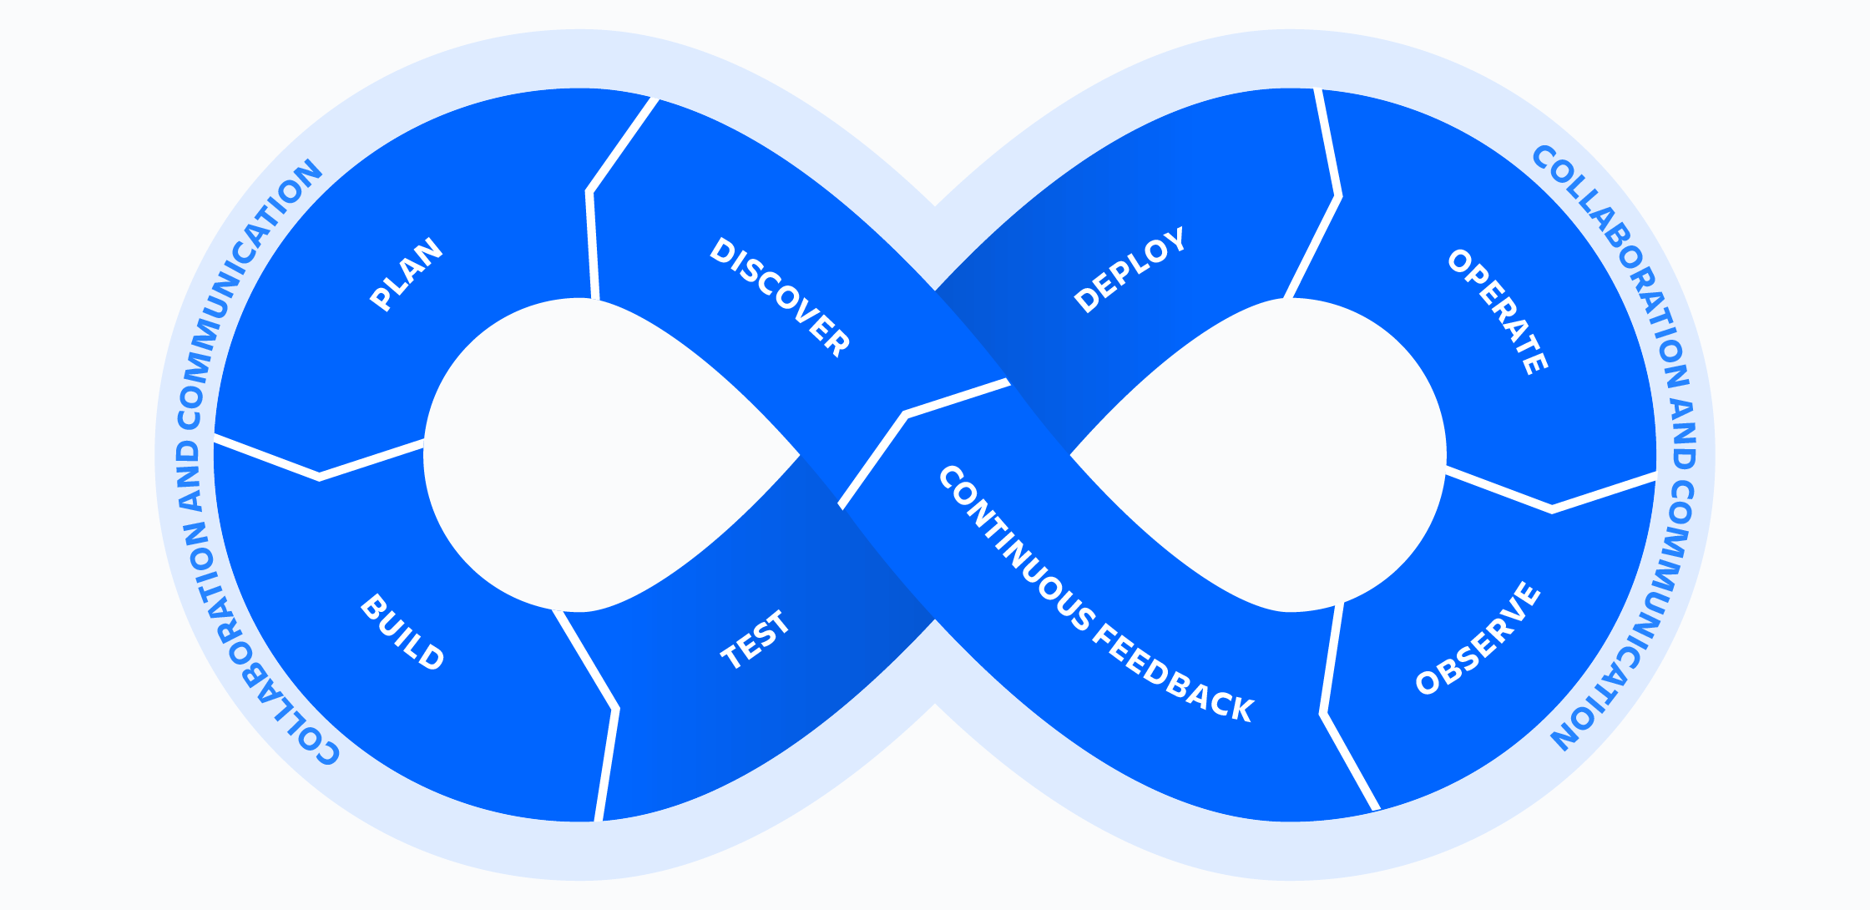

Figure 126 - DevOps Lifecycle (Atlassian a, 2024)

* **Discover** – Identify needs, problems or opportunities to define an iteration’s objective.
* **Plan** – Select work items/user stories and create timelines for the iteration.
* **Build** – develop code for solution and write test cases.
* **Test** – Executing test cases for the solution (ether via automation or manual as required)
* **Deploy** – Deploying developed code to an environment for testing (or full release if production ready)
* **Operate** – Day to day management of the software.
* **Observe** – Monitoring the deployed solution for issues/errors.
* **Continuous Feedback** – Taking feedback from end-users to plan improvements

### Stakeholders and Roles

The DevOps Framework promotes several different roles and responsibilities that orchestrate the process. There are a series of traditional roles in the framework that can be identified e.g. Developers, Testers, Product Owners, DevOps Manager (Coursera, 2023), however these roles should not be treated as dogmatic (i.e. they may not all be applicable to the project and should be adapted accordingly). In line with this, our team and its workflow only make use of specific roles required.

The below table identifies these roles, explains their responsibilities and maps internal job titles/roles to them (as they are not named one to one):

|  |  |  |
| --- | --- | --- |
| **DevOps Role** | **Responsibilities** | **Internal Stakeholders fulfilling this role** |
| **End User / Customers** | * Provide the initial requirements i.e. a problem to be solved that a development will work towards * Also act as the validation that the requirements/acceptance criteria have been met i.e. if they are not happy, then the development cannot be considered a success. * In an internal context for our teams’ processes, this refers to any team with a need to implement business logic within the Decisioning Engine e.g.   + Credit Strategy for specific Policy Rules to mitigate Credit Risk   + Decision Science for Scorecards and similar Models that assess the risk of a customer going “bad” i.e. they don’t repay their credit.   + Fraud teams with Policy Rules to mitigate Fraud Risk | * Credit Strategy * Fraud * Decision Science * Compliance |
| **Business Sponsor** | * A stakeholder with the authority to advocate for the development at the senior levels of management within the organisation. * Considers the development from the strategic viewpoint of the organisation, so that it stays aligned with overall goals. * Controls or input into the project’s budget | * Executive Member (ExCo) / C-Level Staff + their assigned Delegates * Directors * Heads of Function |
| **Product Owner** | * Supports End-Users/Customers in translating their requirements (which may start off as abstract) into actionable user stories/work items. * Manages the Product Backlog; a list of user stories/work items waiting to be completed. * Drives the feedback loop process i.e. once user stories are done, work with end-users for further feedback. | * Head of Function * Credit System Managers * Lead Analysts * dedicated Product Owners (on large scale projects and on the end-to-end solution as a whole) |
| **Developers** | * Team members actually building the software/solution i.e. they create the code that will meet the defined requirements. * Take ownership of the code and its quality, therefore define the quality standards the team will use for the code & how those will be assessed. * For example, our team conduct manual code reviews to after work items are marked as ready to check standards have been met. * Pair Programming methodology is applied where needed in developments, ether because the requirements require a new form of functionality that no existing template covers, for upskilling other members of the team or for general support/collaboration | * Credit System Managers * Credit Risk Analysts (Lead, Senior and Junior) * External Zoot support (where needed and budgeted for) |
| **QA Specialist (Testers)** | * Create Test Scenarios from the requirements/user stories, for both functional and non-functional requirements e.g. Policy Rules execute as expected for function, while non-function could be overall response times are in tolerable levels in aggregate (Average, Max, Percentiles etc) * Supports in planning how we can bring testing into the process as early as possible to minimise the risk of costly bugs making it into the production environment (i.e. Shift-Left Testing) * Source and create the test data needed to execute these scenarios and communicate blockers when found. * Writes the validation logic for assessing these scenarios e.g. independent validation via SQL using the data generated by the system, automated test cases in Postman | * Credit System Managers * Credit Risk Analysts (Lead, Senior and Junior) * External Zoot QA team (due to the shared SaaS environment requiring their own testing to meet their SOC2 audit requirements) |
| **Release Manager** | * Can also think of as a “sprint” manager. * Plans the releases into UAT and Production environments. * Sets the expectations on when a release should be targeted i.e. the sprint dates. * Assigns the business friendly “version number” to the build, based on an agreed standard e.g. Calander versioning, Semantic versioning. * Creates and consolidates all the necessary documentation that goes into a release e.g. release note, build specification. * Creates the deployable versions of the release within Zoot. | * Credit System Managers * Lead Credit Risk Analysts |
| **Other traditional DevOps Roles we typically don’t use** | | |
| **DevOps Engineer / Automation Architect** | * Focus on the Optimisation of the DevOps pipeline, to minimise the time between releases as much as possible. * Will work on set up and maintenance of automation services e.g. Continuous Integration/Continuous Delivery (CICD) * Coach the team in best practices to make best use of these automation pipelines | N/a – Design of the Zoot WebRules tool (low code) means this isn’t applicable to its full potential due the manual deployment steps required by the tool.  Some potential exists to automate testing but can be picked up by the QA Specialists/Testers. |
| **Security Engineer** | * A specialist Development & Testing function focused on the security of the solution i.e. potential vulnerabilities that a malicious user could use to gain unauthorised access to the system. * This requires a specific skill and knowledge set that justify having a separate role. * Operating on a shared Software as a Service (Saas), our 3rd party provider must regular conduct this testing as part of their SOC2 audit requirements | * n/a – Dedicated resource exists for this within the IT Department, who possess the skillset needed. * Our 3rd party provider also conducts this testing |

(Mindk, 2024), (Coursera, 2023), (DevOps Institute, 2021), (Schwaber, 2020)

### Software Development Life Cycle (SDLC)

The Software Development Life Cycle (SDLC) is a process framework used to break down the effort that is required to deliver software into individual stages, creating the benefits of adding visibility of the process to all stakeholders (be they business or technical) & to promote forward planning (Amazon AWS, 2024).

The Figure below illustrates how this cycle applies to our team’s development process. **Important to note is that despite the waterfall-like diagram, previous stages can and should be revisited as needed** e.g.

* If the Design stage shows more clarity is needed on the requirements to effectively implement them, the development team is empowered to go back to the Requirements/Planning stages to seek this; an “Impediment” work item can be used to track discussion on this.
* If defects are found within a deployed build and all stakeholders involved agree the defects are critical (i.e. they would cause unacceptable harm to the users of the software & there is no workaround), then the team must go back into the Design/Development stages to address the defect before proceeding further into the cycle

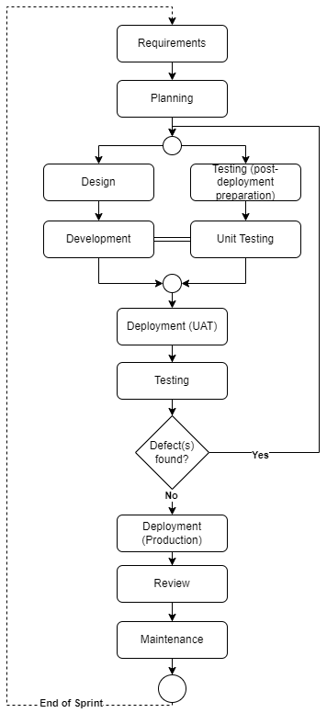

Figure 127 - Software Development Life Cycle (SDLC) as applied in Decisioning Engine Development

Any software development will ultimately find itself following this cycle (even if only subconsciously). Interpretations of this cycle may use different names, but the stages stay the same. At the high-level, these stages are:

|  |  |  |  |
| --- | --- | --- | --- |
| **Stage** | **Detail** | **Inputs** | **Outputs** |
| **Requirements** | The goals of the development are captured here i.e. what the team are building. This stage asks “**what the current problem is**” that we’re trying to solve (Stackify Team, 2024).  In a format project, this will take input from various stakeholders across the business (e.g. Product, IT, Project Managers etc) to define what the development should achieve and the acceptance criteria those stakeholders will use to consider them met. Which stakeholders are involved will vary on the scope of the change.  **For all requirements & acceptance criteria**, our expectation is that these will have been “**signed-off**” by the requesting team, which confirms they have reviewed them and are happy the wording represents their intentions. Any changes after this would require a formal Change Request. | * Context and SME views on a problem our development should solve | * Actionable Requirements & Acceptance Criteria that can be used to plan and design a solution to the defined problem. * User Stories/Work Items loaded into the strategic DevOps tool (e.g. Azure DevOps) |
| **Planning** | Often, this is combined with the Requirements stage e.g. (Amazon AWS, 2024).  This stage is where the development team will review the requirement and consider how to get them into a project plan for implementation, with timelines for when they can be delivered. To do this, multiple factors are considered. | * Approved requirements * Team availability * Business priority * Effort estimates required to implement. * Costs involved | * Implementation plan with timelines * Budget |
| **Design** | Here, the development team figure out how best to meet the given requirements. A set of Development Principles should guide the team on how to approach this (e.g. reusing existing functionality where possible).  This could include the power to make technology choices, but as we work within an existing low-code tool (Zoot), this typically is not applicable to us & would be consider in the Requirements stage if it was e.g. Fraud team providing a requirement to integrate with a new detection provider. | * Approved requirements * existing functionality available | * Actionable software design |
| **Development /**  **Implementation** | Self–explanatory; this is where the Development team will code up the design to meet the business requirements.  In the interest of testing early and often, developers will also conduct Unit Testing at this stage to create confidence they their developed code works as intended in isolation, aiding us to avoid potentially costly defects early in the process. **Effectively, this means the Testing stage starts in parallel with this stage** (Amazon AWS, 2024). | * Approved requirements * Agreed design | * Software code |
| **Deployment** | Deployment involves the development team creating a “version” of the software i.e. all code changes are finalised and packaged into a version that can be put into a dedicated test environment for more though testing.  This will be requirement multiple times, as code must first pass through a lower test environment for testing before a production deployment is done. This ensures only quality software is deployed and mitigates the risk to end users of faulty software, which can be costly to the business. | * Finalised code * Evidence of successful Unit Tests (to create confidence in the build) | * Software version ready for multiple forms of testing * Completed change management documentation (for production) |
| **Testing** | Once a build is deployed, various forms of testing are conducted to confirm:   * If the developed code performs per the original requirements/acceptance criteria * Existing functionality continues to work i.e. Regression testing. * Integration between code modules and 3rd party API’s work as expected.   While the Development/Implantation stage is ongoing, the testing staff will create their test scenarios and source any test data needed to execute them. | * User stories / Work Items with requirements that can be used to create test scenarios | * Test Scenarios (functional, non-functional, integration) * Test data * Defect reports (if any found) * Evidence of test success |
| **Review** | Work completed in earlier phases is brought to review by relevant stakeholders:   * Written code is presented for Code Review (ether manually by senior developers or automated via tooling) to ensure software quality and security. * Functionality is presented to end users to confirm the work completed meets the Acceptance Criteria and can be considered done | * Work Items/User Stories ready for end user/stakeholder acceptance. * Code Reviews within the Development team | * Sprint Review, to demo developed features/functionality to end users. * Updates Estimates of user stories/work items, which can be used to support estimating similar work in later sprints |
| **Maintenance** | After Production deployment, the software moves into a monitoring phase, where the team focuses on keeping the solution running, involving:   * Monitoring performance e.g. system load * Logging errors generated by the system and escalating to the correct SME’s for review and planning resolutions. * Assessing impact of software, package and/or security updates (where applicable)   Effectively, this is when the change(s) fall into our BAU workload. | * Monitoring requirements * Error reports (if found by users or logged by the system) | * New user stories/work items (if identified) * Defect reports (depending on cause of errors) |

### The “Definition of Done”

The *Definition of Done* (DoD) represents the teams shared understanding and agreement of what criteria is used to judge a work item, user story or iteration “complete” i.e. it is the defined goal post for the team to work towards. Defining and documenting this ensures consistency, quality, and alignment with business objectives in all work completed by the team. It also provides direction for the team in providing milestones that can be used to judge the progress of work completed, creating confidence that work completed is ready for release (ether to Production or to test environments).

For our team’s purposes, the criteria we use is:

**Design**

1. Logic has been added to our independent specifications / system documentation (more on this in “Development Standards”)
2. Existing templates have been identified (if available)
3. If a new template can be created from the work completed to help support future work, then plans are in place to create this (e.g. a new Work Item to do so)

**Development**

1. All code created within the Decisioning Engine is complete.
2. Unit Tests accompany all code AND/OR existing Unit Tests have been updated when altering existing code.
3. All Unit Tests attached to the work item return a PASS.
4. Unit Tests cover all the branching paths in logic within code e.g. IF Conditions, AND/OR logics.
5. Peer Code Reviews have been completed & confirm Development Standards have been adhered to

**Test**

1. Work Item has been tested and proved working within an End-to-End scenario (i.e. post Deployment to a UAT Test Environment)
2. Branching logic within the designed code has been independently tested from the Developers (i.e. 2nd pair of eyes confirm the code works as expected)

**Overall**

1. Actual Effort has been captured for comparison against the original Estimate.
2. New types of Work Items are added into the Master Reference List to support future estimations.

All the criteria above must be met for a work item, user story or iteration to be considered “done” i.e. the above stages are not to be looked at in isolation, although they can mark handover milestones.

## SDLC Applied

### Requirements

|  |  |
| --- | --- |
| **Stakeholders Required** | * Customers (i.e. Strategy Teams) * Business Sponsor * Credit Risk Analysts |
| **Inputs** | Technical Requirements Document template |
| **Outputs** | Completed Technical Requirements Document including:   * **“In English” Business Requirements** from the customer team(s) about what changes they want made to the Decisioning System e.g. new functionality, altering existing functionality or removing functionality. * **Any pseudo-code for complex calculations** the customer team(s) want building within the system to support new functionality/altering existing functionality. * **DevOps “feature” work items** that can be used in the Planning stage |

Before we can start any work, we need formal requirements from the business about what functionality they want implementing in the decision systems (be this new functionality, changes, or removing functionality).

To capture these, we use what we call a “**Technical Requirements Document (TRD)**”, a standard template we’ve developed to:

1. **Capture who the responsible stakeholder** for this work will be on the business side (a Business Sponsor)
2. The **business context behind the work requested**, which supports us in prioritising the work e.g. this work will increase lending volumes by x%, will close open audit risks etc.
3. **User stories capturing the specific requirements** of the customers that we can load directly into Azure DevOps
4. **Specific logic** in the form **of Pseudo-code for any complex calculations** that need to be created e.g. calculations from raw data from the Credit Bureaus (Experian, TransUnion and/or Equifax). This needs to be captured here due to the higher complexity creating more risk that implementation of User Stories may not match expectations.
5. State **what is in scope** for the change **and what is out of scope**, allowing us to set expectations accordingly.
6. **Any known risks** upfront that could impact our ability to deliver these changes, or could damage the business if the work is not prioritised appropriately

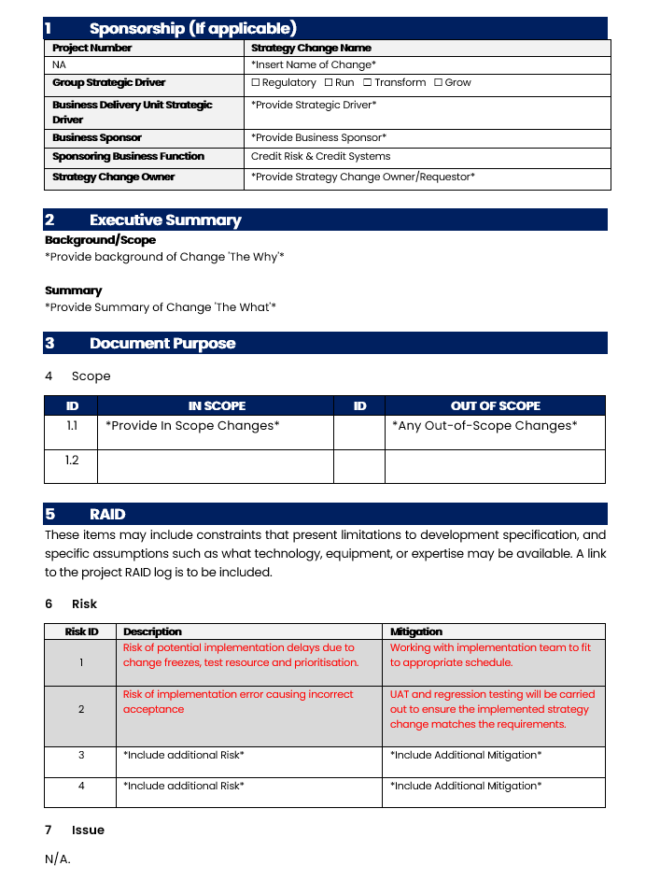

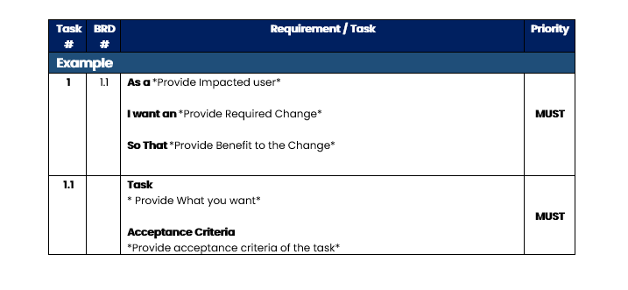

Figure 128 - Technical Requirements Document Template Cover page

#### Workflow

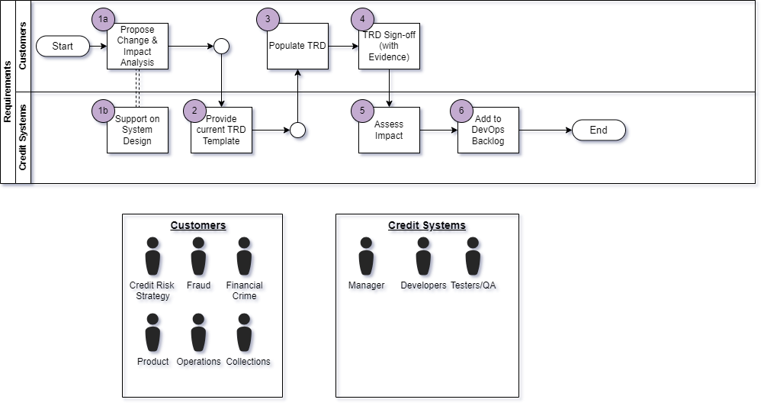

Figure 129 - Workflow of the Requirements stage + roles involved.

|  |  |  |
| --- | --- | --- |
| **Step** | **Name** | **Explain** |
| 1a | Propose Change & Impact Analysis | The “customers” i.e. the team with the requirements will propose changes as part of their business as usual (BAU) responsibilities, and will conduct an impact analysis of their proposals, covering topics such as:   * Impact on lending volumes (and revenue/profitability by extension) * What risks/problems the change addresses * If any new risks arise because of the change |
| 1b | Support on System Design | The Credit Systems team will provide support to these “customer” teams in this process by:   * Advising on implementations currently within the system to help inform the specific business logic of the change. * Providing technical information on 3rd party data usage e.g. raw data from credit bureaus   Note that this **does inherently overlap with the “Design” stage of the SDLC**. That is **not an issue**; the intention of our approach is not to rigidly stick to this (like Waterfall). The focus is on delivering requirements with value to the business as quickly and effectively as possible. |
| 2 | Provide current TRD Template | Once the “customer” team communicates they can formalise their proposal, the Credit System team will provide the latest **Technical Requirements Document (TRD)** template. |
| 3 | Populate TRD | The “customer” then populates the template with their requirements, providing User Stories and exact business logic they want implementing.  The Credit System will support this as required/able to e.g. clarify the template where needed and advising on exact business logic where needed (e.g. handling unexpected values in the proposed data points used in the business logic). |
| 4 | TRD Sign-Off (with evidence) | Once populated, the “customer” team will send the TRD back to the Credit Systems team.  **Sign-off Approval** from a business sponsor must also be provided (in writing) for the change to be actioned. This is vital for governance reasons as this demonstrates that the implications of the change have.  Depending on the impact of the change, Credit System may also ask for confirmation of approval from the Credit Committee (a panel made up of C-Suite stakeholders who must approve changes where the financial implications reach a certain threshold). |
| 5 | Assess Impact | Once the TRD is received, the Credit System team will do their own impact assessment, covering:   * Components impacted by the proposed change. * Any support required outside the team e.g. IT, 3rd parties. * Identifying any potential Blockers * High level idea of the complexity of the change |
| 6 | Add to DevOps Backlog | Once the ramification of the change is understood, the requirements are loaded into our DevOps management tool: Azure DevOps.  These are loaded as “feature”- level or “epic”-level items, depending on the complexity and size of the change.  That allows the team to proceed with the **Planning** stage. |

By the end of the stage, we should have an Azure DevOps work item like the below figure:

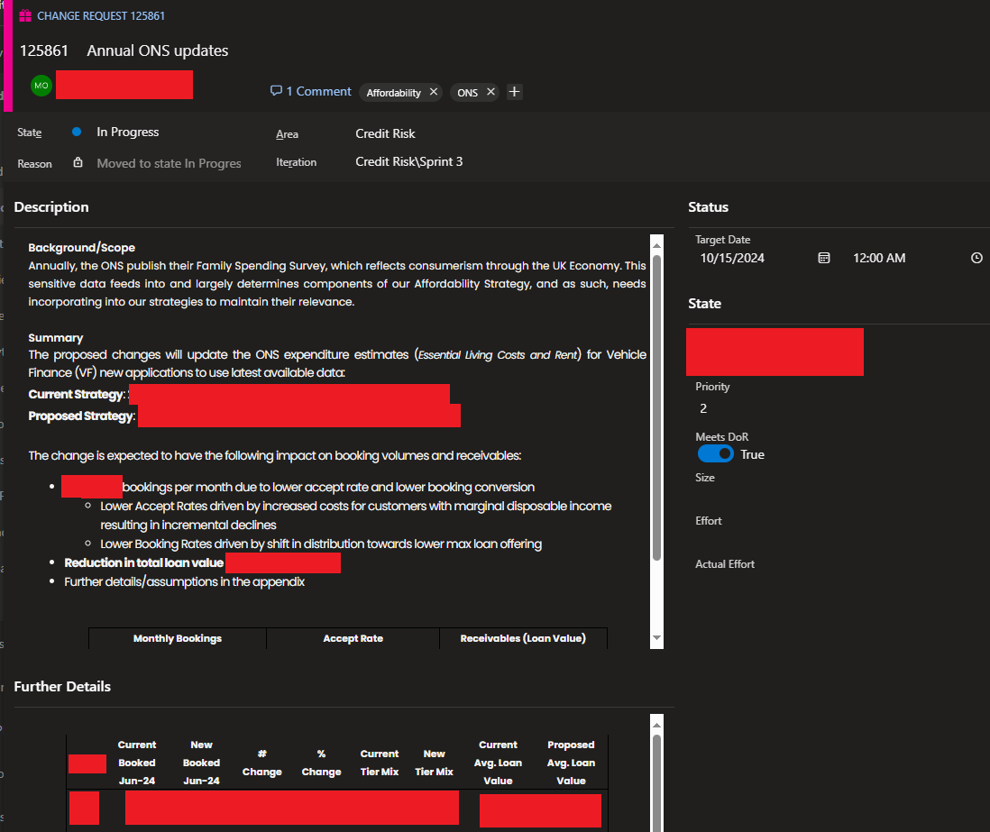

Figure 130 - Example of a Change Request loaded in Azure DevOps, ready for Planning.

### Planning

|  |  |
| --- | --- |
| **Stakeholders Required** | * Customers (i.e. Strategy Teams) * Business Sponsor * Credit Risk Analysts |
| **Inputs** | * Epic / Feature level Work items (i.e. high-level change requests from the customer “teams”) * Work Item Backlog (including PBI’s and Bug Reports) * Master Reference List for PBI Estimates |
| **Outputs** | * Distinct Product Backlog Items (PBI’s) added into the Backlog to break down the higher-level Work Items into more granular * Estimates/Sizing’s for PBI’s * PBI’s moved into a Sprint, allowing work to commence. * Version Number to use for the new build of the Decisioning Engine |

“Planning” is where the team starts detailing the specifics of “what” and “when” requirements provided by the “customer” teams will be delivered, involving:

* Distil high level features/change requests into **individual Product Backlog Items**, which represent individual pieces of work that can be assigned to team members.
* Estimates and sizing’s for the PBI(s), which give stakeholders an indication of how much effort it is expected to take to complete.
* A steer on how to prioritise backlog PBI’s and new requests, based on the strategic business objectives of the organisation and the benefits of each PBI/request.
* A Sprint Planning session where PBI’s are moved into an “Iteration” for work to start, after considering priorities and efforts required.

Note that “**effort”** here **should not** be taken to mean “**time to complete”.** Estimates by this measurement tend to be unreliable as team availability, blockers and misjudged complexity can skew this (Atlassian Community, 2024). This is covered in more detail under “Estimates: Sizing changes”.

#### Workflow

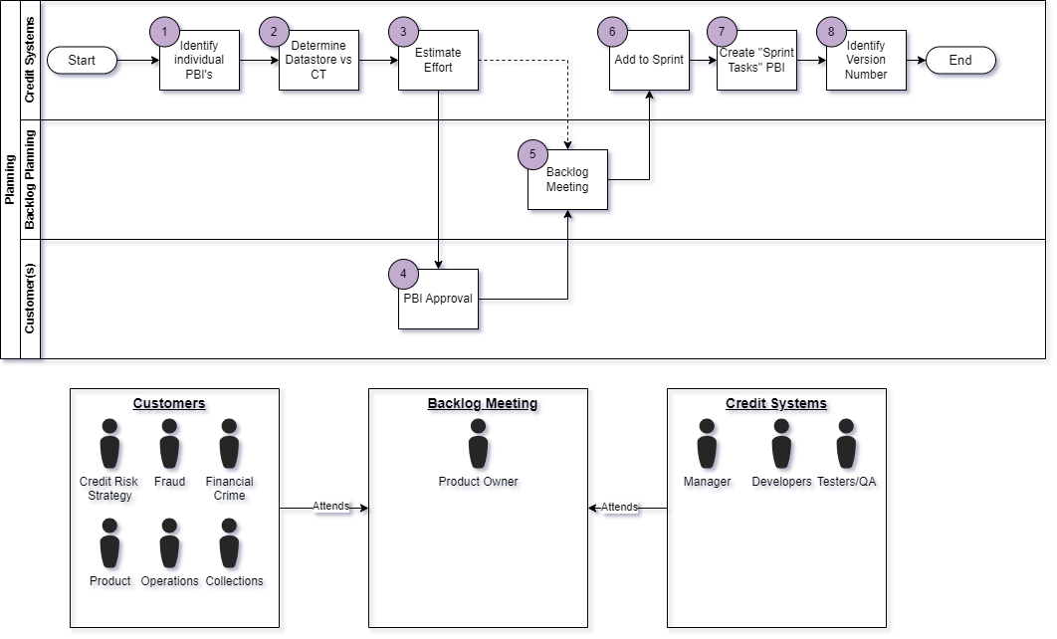

Figure 131 - Workflow diagram of the Planning stage + roles involved.

|  |  |  |
| --- | --- | --- |
| **Step** | **Name** | **Explain** |
| 1 | Identify Individual PBI’s | From the Technical Requirements document, the Credit Systems Team needs to break down the requirements into individual Product Backlog Items (PBI’s).  This will help set up the Estimation/Sizing phase & support allocating resources. |
| 2 | Determine Datastore vs CT | In line with one of our coding standards (see “Use Datastore Functionality where possible”, we first need to identify if the change can be implemented via updating an existing Datastore table (basically a change in environment configuration when compared to full code stack solutions), or if a full deployment of the platform is needed  The” Datastore Deployments” as we call them are significantly easier to implement, as it allows a much simpler deployment process to be used due to how it minimises the risk of unintended changes being made, making them the preferred way to implement changes where possible.  Identifying this early is important for managing the “customer(s)” team expectations on how long a change will take to implement. |
| 3 | Estimate Effort | PBI’s are then assigned a “sizing”, a metric we use to judge how much effort is needed to complete the PBI, per the team’s definition of “done”.  See section “*Estimates: Sizing changes*” for more information. |
| 4 | PBI Approval | The “Customer(s)” team then needs to be prompted to review the PBI’s  **This should be done by assigning them to them in Azure DevOps** **& leaving a comment** along the lines of “please comment approval and update the state to Approved”. DevOps will automate a notification to the assigned user with the comment update (see below: “Figure 132 - Azure DevOps notification created when a PBI is assigned to a user, with a comment left for them clarifying what action is ”).  Once the “customer” user moved the PBI into the “Approved” state**, DevOps will automatically log that approval to the PBI History**, giving us a record of approval for Auditing/Governance (see “Figure 133 - History of the PBI, showing it being moved into Approved and the user who ” for reference. |
| 5 | Backlog Meeting | The Credit Systems team holds a weekly “Backlog Meeting” with representatives of the “customer” teams to walkthrough the backlog & progress made.  This gives the teams a forum to discuss work completed & plan out what PBI’s will go into the next upcoming sprint. “Customer” teams also can advocate for PBI’s related to their remits.  Collaboration tools allowing group calls are all that is needed to conduct this e.g. Microsoft Teams as seen in Figure 135- Example of Backlog Meetings set up in Microsoft Teams |
| 6 | Add to Sprint | From the discussion from the Backlog Meeting, the Credit Systems team will move PBI’s into an upcoming Sprint. |
| 7 | Create “Sprint Tasks” PBI | This is a specific PBI created by the Credit Systems team to manage governance tasks related to a sprint (it does not originate from customer teams). All sprints must include this, with Task items covering:   * Deployments to UAT and Production environments (as separate tasks) * Creating evidence of test completion for the customer teams to review * Updating the logic in Exceptions Monitoring reports we produce * Obtain documented approval from the Release Manager to proceed with Production Deployment |
| 8 | Identify Version Number | If a new build of the Decisioning Engine is required by the requirements, then Credit Systems must identify the next version number to user. This will be used in the documentation of the work completed.  This is expanded on in “Versioning Strategy”. |

Examples of the automated notifications, how history is tracked in Azure DevOps, and what a complete PBI should look like are below:

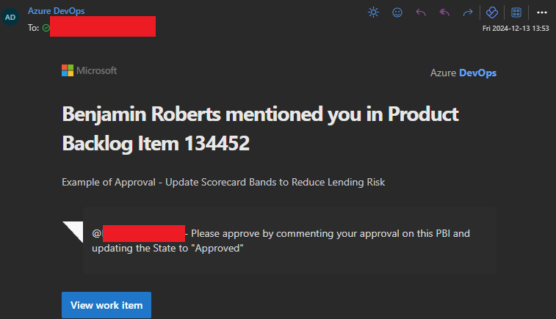

Figure 132 - Azure DevOps notification created when a PBI is assigned to a user, with a comment left for them clarifying what action is needed.

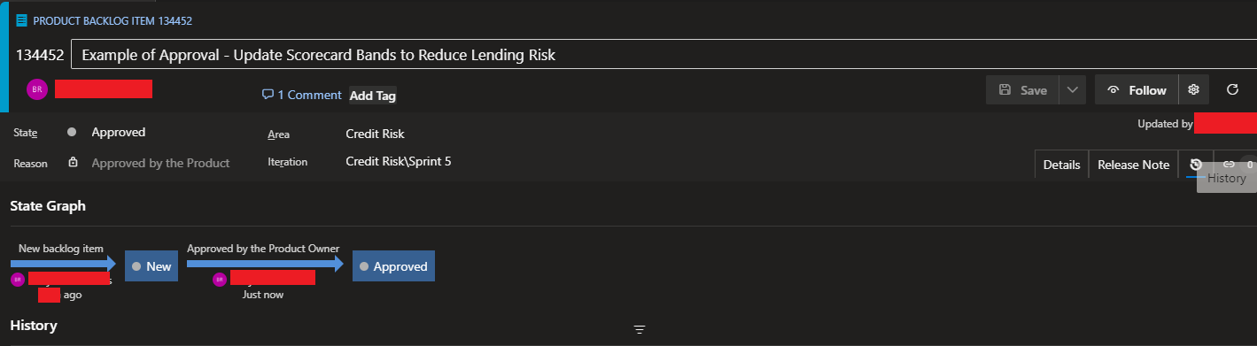

Figure 133 - History of the PBI, showing it being moved into Approved and the user who did.

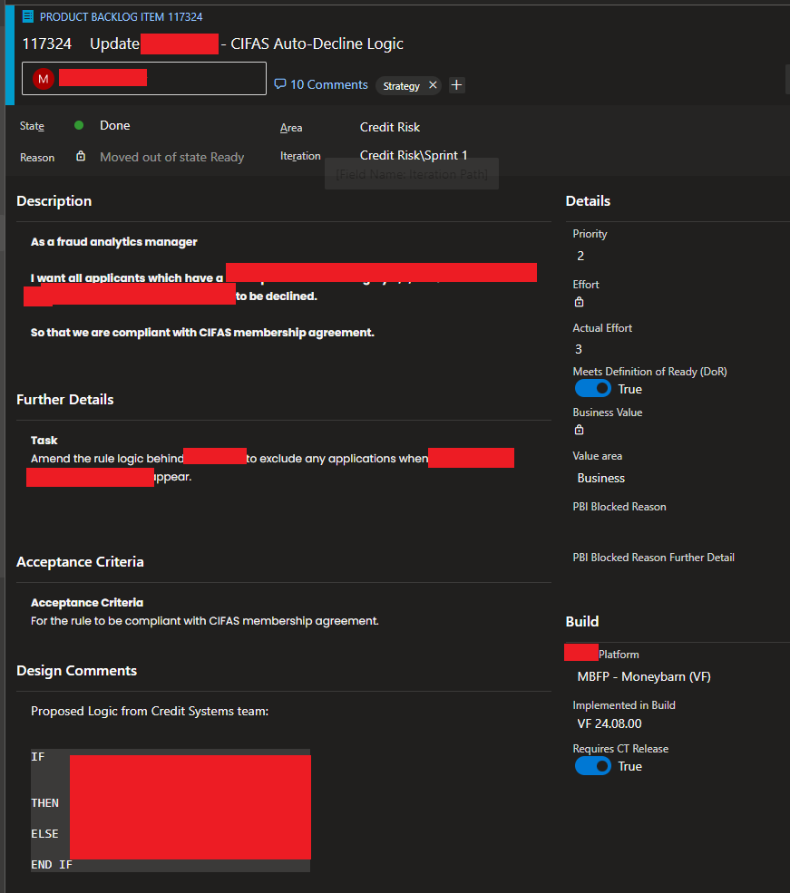

Figure 134 - Example of a Product Backlog Item (redacted where needed) with all the detail required for Development to commence.

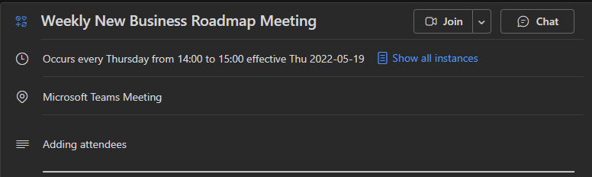

Figure 135- Example of Backlog Meetings set up in Microsoft Teams

#### Estimates: Sizing changes

Estimates are how we predict the amount of effort a given Work Item will need to complete. This must align to our “definition of done”, meaning that they must consider the time needed to complete the design, development and testing.

Estimates are valuable for:

1. Setting Stakeholder expectations on when requested changes/functionality can be completed.
2. Help with prioritisation e.g. “quick win” changes requiring lower effort can be identified.
3. Supports allocating resources e.g. work items with higher estimates will likely require more senior resources.

(Cohn, 2005)

Estimates **must account for the all the effort required** to complete a work item **i.e. all Development, Design and Testing** activities.

Historically, to do estimates we’ve used “T-Shirt Sizing” to judge the size of a Work Item, due to its ease of use. One key downside however is that this makes it hard to quantify the work items relative to other work items. Another is that Azure DevOps’s default definition of effort is based on numeric values, which are used to plot the team’s availability against the total effort of all work items in scope.

To better align to this, the below figure maps these T-Shirt sizing’s to numbers of the Fibonacci Sequence, a mathematical sequence where the next number in the sequence is equal to the sum of the previous 2 numbers. The exponential growth this sequence creates is effective or representing how the effort required to complete a more complex task increase. It also adds an allowance for unknowns which can increase effort required. The gaps between these numbers can be used as a rough guide on how long a work item will take to complete (although this is not a commitment that it will take that long).

|  |  |  |  |
| --- | --- | --- | --- |
| **T-Shirt Size** | **Relative Effort Description** | **Mapped Fibonacci Points** | **Estimated Hours** |
| XS (Extra Small) | Trivial task, minimal complexity | 1 | 1 hour |
| S (Small) | Low complexity, well established task with many past related PBI's supporting the estimate | 2 | 2–3 hours |
| M (Median) | Moderate complexity, with many related PBI's supporting the estimate | 3 | 3–5 hours |
| 5 | 5–8 hours |
| L (Large) | High complexity with potential unknowns, may not have past related PBI's to support estimation | 8 | 8–13 hours |
| XL (Extra Large) | Complex with significant unknowns & no past related PBI's to support estimation | 13 | 13–21 hours |
| XXL (Extra Extra Large) | No longer a single PBI at this point, consider breaking down further | 21+ | 21+ hours |

Figure 136- Matrix of T-Shirt sizing to Fibonacci Sequence Story Points

There isn’t an exact science to estimating work items. Inherently we rely on past experience with similar requirements to do this & we judge the current work item relative to those (Easy Agile, 2024). We maintain a “Master Reference List” that should be used as a guide to help estimate work items. This list consolidates how long different types of Work Items have taken in the past, with the efforts being re-assessed post completion to ensure the listed effort is accurate.

Below is a sample of this Master Reference List, with examples of the T-Shirt sizing and mapping to Fibonacci in practice:

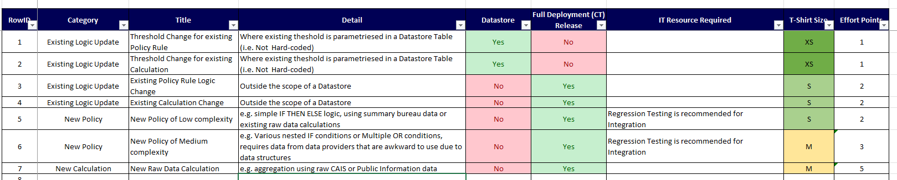

Figure 137 - Example of Master Reference List, describing previous Work Items and sizes.

#### Versioning Strategy

The Zoot tool does have its own functionality for assigning Version IDs to completed builds, however this is not effective as the ID’s take the form of GUID Ids e.g. abe67022-7f10-4b2d-99d5-b1b6fe04a1d4. This makes it difficult to compare different builds.

Our solution to that is to create a separate Version Number that provides business context. It is important to do this as part of the Planning stage as we’ll reference it multiple times throughout the rest of the cycle. Identifying the next version number to use is the responsibility of the Credit Systems team (specifically the Managers or the Lead Analysts).

Our approach to this currently follows the convention of **Calander Versioning**. This is a simple versioning structure that makes use of Calander date rather than arbitrary numeric values that require deeper knowledge of the system to understand (CalVer, 2024). This distinguishes it from the alternative **Semantic Versioning** considered**,** which does use such a sequence,

The format can be adapted to suit individual needs. Our format is broken down below:

***<<Product Acronym>>_YY.MM.xx***

|  |  |  |
| --- | --- | --- |
| **Part** | **Description** | **Examples** |
| <<Product Acronym>>_ | A short name or acronym for the platform we’re currently working on in this iteration. Useful for distinguishing between separate product builds, which have their own business logic. | Cards VF (for Vehicle Finance)  PL (for Personal Loans) |
| _ (underscore) | Underscore character to split the Product Acronym from the numeric sequence.  Historically, spaces have also been used, but going forward underscores should be (as space characters are typical special characters, and this version number is used as a string in places, which can cause complications with parsing). | _ |
| YY | Current Year, to 2 digits only | 24  25  26 |
| MM | Current Month | 1  2  10  12 |
| xx | Iteration Number  This should start from 0 for the 1st build created. For each subsequent build we have to make within the Calander month (ether due to bugs found or to new iterations), increment this by 1. | 0  1  4 |

This versioning is effective to our needs as:

1. It provides a simple and easy to use formats for all stakeholders to understand.
2. Different versions can easily be compared by using the Year and Month sequences.
3. We treat every change as potentially breaking to downstream systems (as changes could involve removing data used by downstream systems, which would necessitate a wider collaborative effort)

### Design & Development

Typically, in the SDLC, these are individual stages. For our purposes however, there is not enough distinction between these stages e.g. the low code tool using a graphical interface means it can be more beneficial to mock of a design within the tool.

The **Design/Development** and **Testing** stages can be done in parallel to a point:

* **QA/Testers** can prepare test scenarios and data using the **requirements** to prepare for the **Testing** stage in full.
* The **Developers** can continue design/development activities at the same time.

This should be encouraged so that Testing can start immediately after Deployment, with minimal delay.

#### Process

|  |  |
| --- | --- |
| **Stakeholders Required** | * Lead Developer(s) * Developers * Testers / QA * “Customer” teams – when reviewing implementation together is possible |
| **Inputs** | * Work Items within an Iteration * Availability of all team resources |
| **Outputs** | * Code/functionality that meets the Acceptance Criteria stated in the Work Items * Unit Tests confirming the code/functionality behaves as expected. * Confirmation that code adheres to our development standards (via Peer Review) * Any potential new templates that can be created from new functionality have been identified |

#### Workflow

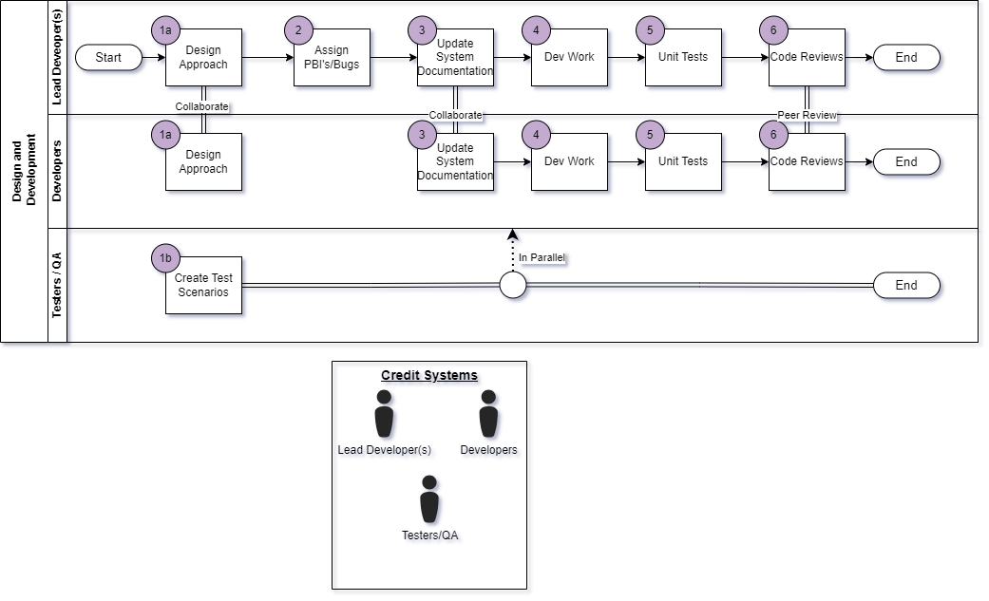

Figure 138 - Workflow of the Design & Planning phases + roles involved.

|  |  |  |
| --- | --- | --- |
| **Step** | **Name** | **Explain** |
| 1a | Design Approach | Before jumping straight into Zoot, review the PBI/Bug requirements to consider how to approach the design.  For implementation, Developers should always check the repository of templates to see if we’ve created one relevant to the current requirements e.g. a Policy Rule template before. If so, then this should be used so that we can maintain consistency and adhere to development standards (see “**Error! Reference source not found.**” for more). |
| 1b | Create Test Scenarios | Throughout the entire Design and Development phase, the **Testers/QA** resources should identify what test scenarios are needed e.g. what steps need to be taken to ensure new functionality works as expected.  This will become important in the “Testing” stage, where we’ll conduct more through System and UAT Testing then we will in the Development stage.  The Test Scenarios must also cover Regression scenarios, to ensure changes made have not broken existing functionality. |
| 2 | Assign PBI’s/Bug | PBI’s and Bugs within the Sprint need to be assigned to individual developers to work on, allowing the team to focus and not duplicate work. |
| 3 | Update System Documentation | **Before** starting any development work within the tool itself, we must update the separate **Build Specification** we maintain as part of the build documentation.  Currently we use an Excel file for this, which a version of is created per build e.g.  A close-up of a sign  Description automatically generated  *Figure 139 - Example Specification Document for a build of the system (exact content is Redacted.*  This serves multiple purposes:   1. Maintains a separate design outside of the system, so that it can be built within other tools as needed e.g. test scripts. See “Avoid Lock-in – Why we maintain a separate Build Specification” for more. 2. Creates/Maintains documentation as we build, often a challenge in agile project management. 3. Provides documentation we can share with other stakeholders (e.g. audit) without giving access to Zoot itself (which incurs licensing costs) |
| 4 | Dev Work | Developers work on their assigned PBI’s / Work items, collaborating where it’s beneficial to.  If an existing template has been identified in the Design Approach stage, then that should be used to simplify the development and maintain consistency.  If not, then the developer should consider if their Work Item could be used as a template going forward. If it can, them mark it as so on the Work Item in Azure DevOps. |
| 5 | Unit Tests | Once the code has been created within the system, Unit Tests must be created to test the code works as expected under scenarios that can reasonably be expected to occur e.g.   * All paths within the graphical interface of the low code tool * Any OR conditions   Stickly speaking, this is the inverse of **Test-Driven Development**, as we’re writing the code for the solution rather than the Unit Tests. This is somewhat necessary by the graphical interface of Zoot, which needs existing objects to use.  Developers should however approach development with their Unit Test Scenarios in mind i.e. inadequate Unit Tests is an automatic failure when conducting Code Reviews. |
| 6 | Code Reviews | Once a Developer has completed their code and their Unit Tests, the PBI should be:   1. Moved into the state “**Code Review**”. 2. Assigned to another Developer to review (or to the Lead Developer to assign to another member of the team)   Code Reviews check that:   * Requirements of the PBI / Work Item have been met. * **Error! Reference source not found.** have been adhered to * Unit Tests provide adequate coverage of the code.   If the team wishes, we can also arrange a demo of the implementation with the “customer” teams to get their feedback. This can help confirm stakeholder intentions have been met. This is dependent on the team & stakeholders’ availability, however.  Note that due to the nature of Zoot as a SaaS, we don’t have automated functionality to assess code, hence the need for manual review. |

#### Collaboration

The team is expected to stay in regular contact with each other during a sprint/iteration. The below methods are expected and encouraged:

* **Regular “Stand Ups”** – These are short meetings (about 15 minutes) where each member of the team gives a short update on the Work Items assigned to them, including progress made and blockers. This helps keep the entire team up to date on progress and can be used as a forum to help support each other
* **Team Chat / Channel** – This can be set up in tools like Microsoft Teams or Slack and will include all members of the team. This allows the team to communicate ad-hoc during the sprint.
* **Ad-hoc Calls** – Where the team wishes or is necessary, separate calls (via Microsoft Teams or other tools) can be set up to review a Work Item in more detail e.g. applying Pair Programming

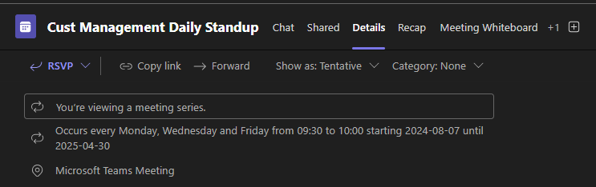

Figure 140 - Example of a Stand-Up series, set up in Microsoft Teams

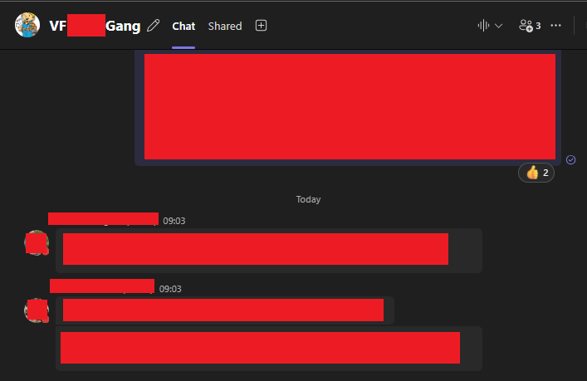

Figure 141 - Example of a Team Chat, set up in Microsoft Teams

### Deployment (UAT)

|  |  |
| --- | --- |
| **Stakeholders Required** | * Release Manager (typically the Lead Developer, but can also be the Credit System Managers) * Lead Developer(s) * Developers * Testers / QA |
| **Inputs** | * Work Items (PBI’s, Bugs/Defects) ready for deployment |
| **Outputs** | * A complete version of the Decisioning Engine deployed to a test environment, able to receive HTTP calls |

Once all Work Items in scope of the current iteration have completed Design and Development, the Deployment can begin. We split this into 2 phases:

* UAT Deployment, where we only deploy to a test region for further testing (Unit Testing in the Development stage not being enough to promote to production)
* Production Deployment i.e. end-users start to make use of the new build.

This is split like this to enable more through testing before we deploy to Production, where bugs/defects will have a material impact on the business (e.g. financial) if not identified prior.

By the end of this stage, we’ll have a version(s) of the Decisioning Engine with our latest changes deployed to a test environment. This will be capable to receiving HTTP calls (ether from other systems or via software like Postman) and acts as an enabler for the testing phase.

#### Workflow

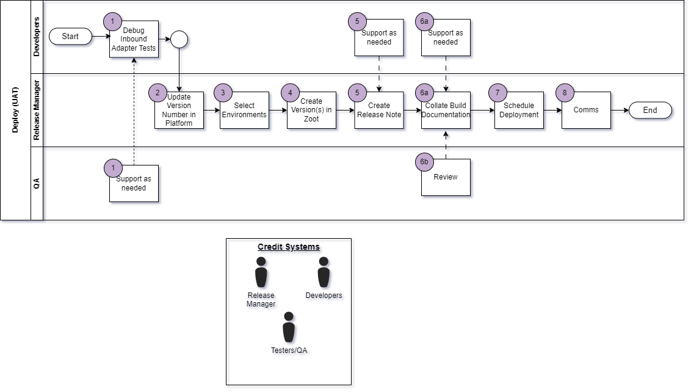

Figure 142 - Workflow of the Deployment phase + roles involved.

|  |  |  |
| --- | --- | --- |
| **Step** | **Name** | **Explain** |
| 1 | Debug Inbound Adapter Tests | Before we proceed with any deployment, we must make use of Zoot’s inbuilt Debug Inbound Adapter functionality.  This allows us to make a HTTP call to the solution as if it were deployed to a true test environment. Doing this gives us an early Integration Test between components, which can allow us to catch early bugs before deployment (saving us time later). Figure 143- Example of Debug Inbound Adapter demonstrates this.  This functionality is limited e.g. cannot send requests in batches and must be done manually. As such, we only need to see:   1. 1 Request for each Endpoint/Application Type go through all the modules (i.e. a Happy Path) 2. HTTP 200 returned, which can be identified easily with the Error hander step as seen in Figure 143. If the Green Line of the UI does not go down the “IF Error” step, then we have a HTTP 200.   Alongside the Unit Tests done in the Development stage, this is an application of **Test Early and Often**. By doing as much testing as we can in the earlier stages of the lifecycle, we minimise the chance of bugs/defects being found in Production (where they are most costly). This catches cases where our changes may break the integration between modules, which can result in a wasted deployment (and the costs associated with it). |
| 2 | Update Version Number on Platform | Next, the Version Number stored within the platform must be updated. The tool does have its own automatic versioning, however GUID IDs are used for this e.g. abe67022-7f10-4b2d-99d5-b1b6fe04a1d4. These aren’t useful from a business standpoint as we can’t easily compare versions.  Instead, we apply our own Version Number/ID manually, which is logged in the API Response, MI Files and logs of the platform. See “Versioning Strategy” for the exact methodology behind this.  We do this using Zoot’s Datastore functionality, with a field in the Build Configuration table storing the value (see Figure 144). |
| 3 | Select Environments | Before proceeding any further, confirm which environments we’re deploying to (as we maintain multiple test environments). This information will be needed in the later steps.  Our typical pattern is:  **A =** Production-mirror i.e. version deployed here always aligns with production. Useful for Datastore/Config changes planned that do not need a full development cycle.  **B & C =** Environments used for System & Integration Testing on the latest builds  **Copy of Live (COL) =** A unique environment that sits in Zoot’s Production region, rather than a lower UAT one. This is used for conducting Copy of Live Testing (which uses real customer data). It is with the Production Region as that region is designed for handling customer data and is compliant with GDPR (while the lower test regions are not tested for this compliance). See “When to use Copy of Live?” for more. |
| 4 | Create Versions in Zoot | Now, we can version the platform (the specific process to doing so is out of scope for this document).  A version must be created for every environment we want to deploy to, with the environment name appended to the version number e.g. VF_24.11.00b (for the B environment) and VF_24.11.00c (for the C environment). The appended character is vital later as this Version ID is what the GUI tool uses to distinguish separate versions. |
| 5 | Create Release Note | A release note must be created, showing all the work items in scope for this deployment. This is for later Change Management and Auditing review.  Examples of this are seen in Figure 145 and Figure 146. |
| 6 | Collate Build Information | **All** documentation related to a build must be collated on SharePoint, so that we have a single source to refer to for anything related to the build.  The below is expected:   * The Build Specification (the one updated as part of the Development stage) * The Data Contract & Swagger, which defines the Request/Response and Endpoints in the build. * An “MI Specification”, which documents the MI File we create for each call to the Decisioning System * The Release Note created above. * Any manual approvals received for the work completed so far e.g. Work Item approval where not logged in Azure DevOps, relevant Committee approval to proceed with proposed changes (e.g. Credit Committee) |
| 7 | Schedule Deployment | Now we can schedule the deployment. Currently this must be done by the Zoot team rather than in-house, as architecture is shared with other Zoot clients due to its nature as a software as a service (SaaS). Isolating these deployment permissions is part of Zoot’s SOC2 Audit Requirements.  To arrange the deployment, contact the Zoot Project Manager and the Zoot Tech Lead with the below information:   * What version we want to deploy * To what environments (A, B, C, COL) * Date and Time to deploy (treat this as a target, as the Zoot team need some advance notice to secure the resource)   Given the need to book Zoot resource, it is best to communicate the intention to deploy earlier if working on tight timelines e.g. inform them during the development stage if needed. |
| 8 | Comms | Once we deployment is scheduled, the Zoot team will confirm it’s deployment.  Internally, this should be shared with all stakeholders needed for this deployment (Release Manager, Developers and Testers/QA). |

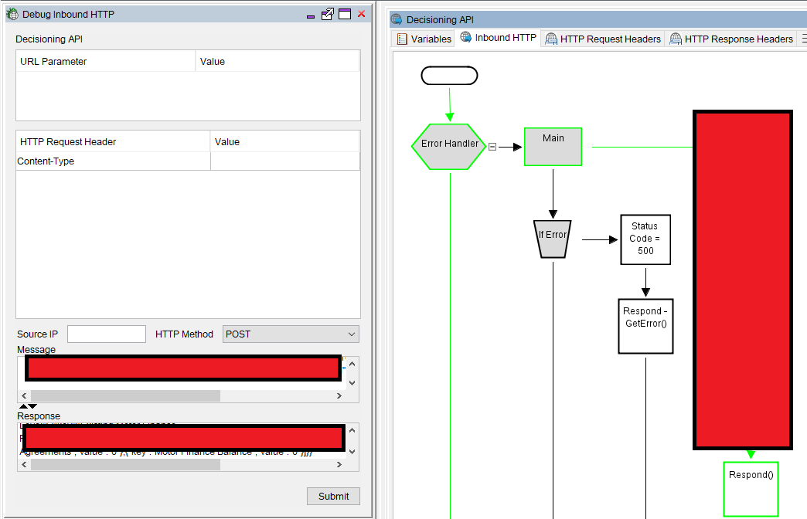

Figure 143- Example of Debug Inbound Adapter test.

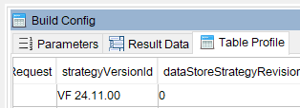

Figure 144 - Example of business-friendly version number set within the platform.

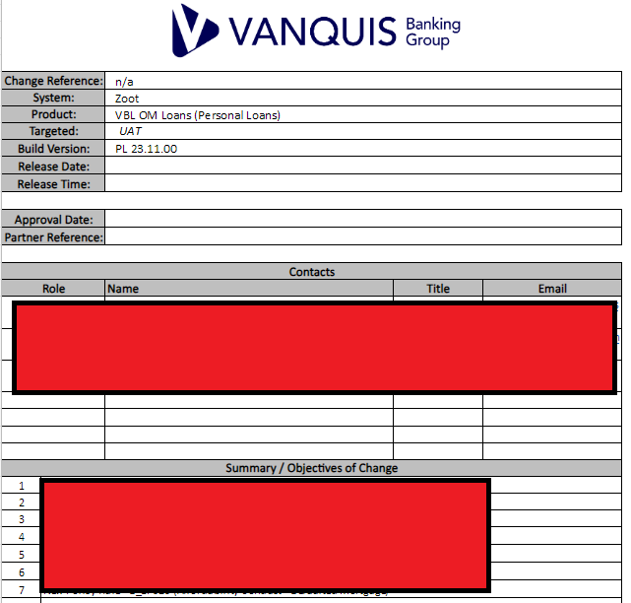

Figure 145 - Release Note (part 1), showing the high-level summary of the changes in the build and contacts.

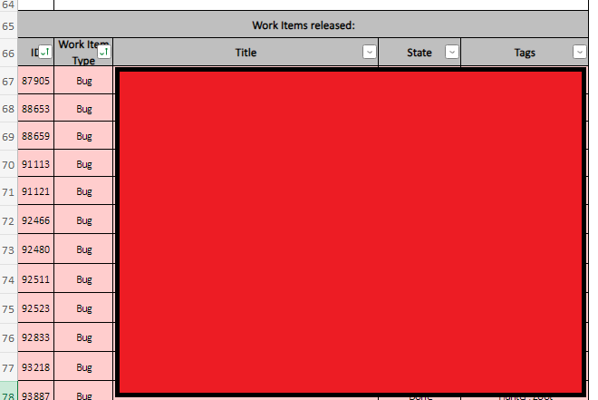

Figure 146 - Release Note (Part 2), showing the individual Work Items deployed in the release

#### What about CICD (Continuous Integration/Continuous Deployment)?

For context first: Continuous Integration/Continuous Deployment (CI/CD) are automation approaches to simplify delivering code changes to a solution. In theory, they could greatly simplify our Development Lifecycle.

Each is its own approach:

* **Continuous Integration** uses automation to integrate code changes into a build of the system immediately, using required plugin tooling where needed e.g. to compile code. When a developer saves their changes (e.g. git commit), then this process triggers a build of the platform and automatically executes any automated tests defined for it (e.g. Unit Tests) & provides a report on the results. This means with every build; we always have a workable version to deploy (assuming all the tests pass). Tooling for this process also supports multiple developers.
* **Continuous Deployment** is an extension of this. When a build from Continuous Integration passes all automated testing for it & no other build issues are identified (per the configuration given), then those code changes are automatically deployed to production.

From the above, there are indeed benefits to applying these practices in our own workflow, however we have numerous technical and governance barriers preventing it:

1. Requiring Zoot Input to deploy means that we can’t set up a continuous integration. We would need Zoot to provide the permissions for us to make our own deployments, requiring a solution that allows them to maintain their SOC2 compliance.
2. There is no integration with the Zoot GUI Interface to a tool supporting Continuous Integration like Jenkins (at least not one they’ve communicated to us). All deployments must be manually done through their GUI Tool
3. **Continuous Deployment** specifically does not comply with our organisation’s change management process, which requires all changes to be assessed and reviewed by our Change Management team (and more, depending on impacted stakeholders) before going into production. This governance layer is not compatible with Continuous Deployment.

These barriers unfortunately mean that we cannot make use of these concepts. We could in theory apply something similar using automated testing functionality e.g. Azure DevOps Pipelines, but these need to be investigated in further detail. Even if this was done, it would not be a true CI/CD setup until the technical barriers are resolved.

### Testing

|  |  |
| --- | --- |
| **Stakeholders Required** | * Testers / QA * “Customer” teams involved in the change(s) (i.e. Credit Strategy, Fraud) |
| **Inputs** | * Software capable of sending HTTP POST Requests (Postman being our tool of choice) * Test Scenarios Identified * Sample of existing customer data (if Copy of Live Testing is required) |
| **Outputs** | * Test Plan * Testing Results * New Work Items in Azure DevOps for any Defect/Bug(s) found. * Test Completion Report * Exceptions Script, which can be used to monitor the system in future |

In the Testing Phase, the Tester/QA resource conduct their own independent **System & Integration Testing**. While Unit Testing is expected within the Design and Development stage, that alone is not enough for a build to be promoted to production. To do that, we need evidence of functionality working within an end-to-end context (which a deployed build provides). Having separate System & Integration testing provides this, and having separate resources from the developers brings a fresh perspective.

The Testing Phase can be broken down into 3 parts:

1. **Preparation** – Planning what test scenarios need to be run & what test data is needed. This needs to cover both new functionality and existing functionality (i.e. **Regression** **Testing**)
2. **Execution** – Running all test scenarios & looking for cases where Expected result <> Actual (suggesting a bug). Our decisioning engine operates as a HTTP API, so this is done by sending HTTP Requests to the API with specific test data relevant to a scenario and checking the Response matches expectations.
3. **Documentation** - Consolidating all results into a report that can be shared with stakeholders e.g. “customer” teams for sign-off to deploy into production, evidence of testing for auditing and Change Management review.

**Changes of significant complexity may also justify “Copy of Live” testing**, where we’ll use the data of our actual customers (i.e. someone who has applied for a credit agreement with us) and run it through the new build. Given the **Data Protection/GDPR implications** of this however, this should only be used when **absolutely necessary** (see “When to use Copy of Live?” for more).

#### Workflow

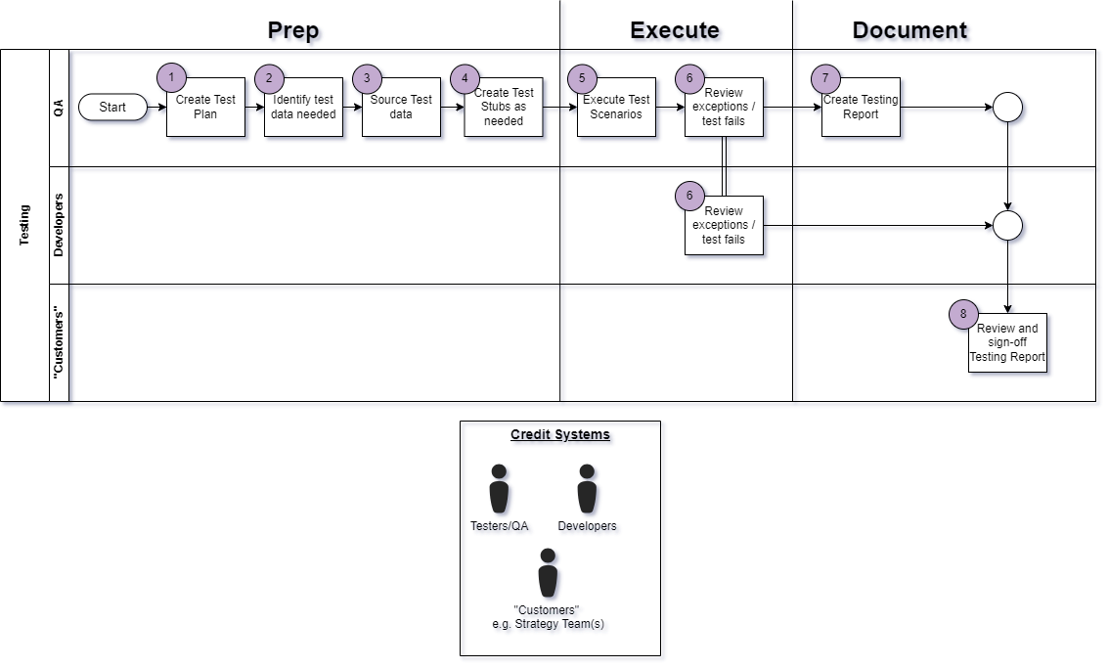

Figure 147 - Workflow for the Testing phase

|  |  |  |
| --- | --- | --- |
| **Step** | **Name** | **Explain** |
| 1 | Create Test Plan | Test Scenarios should have been identified as part of the Design & Development stage.  These need to be documented within the Test Completion Report (see “Figure 148”). Rather than having a dedicated Test Plan document, we use the Test Completion Report as a “1-stop” document that reviewing teams can use to see what testing was done (both for new functionality and regression).  An example of this is seen in Figure 148 below. |
| 2 | Identify test data needed | Once the scenarios and plan are ready, we need to find test data we can use to execute the scenarios.  Sources we have are:   * **Bureau** Test data (e.g. eCTDB) – Test Data provided by Credit Bureaus based on randomised records they hold on their customers, allowing live calls to be made to their API’s with variety in the data returned. * **Test Stubs –** Mocked API Responses from the Data Providers used by the Decisioning Engine (e.g. Credit Bureaus like Experian, TransUnion & Equifax). Useful for reliable and repeatable test scenarios, as we’re not dependent on external systems always providing the same data for a given test record. * **Copy of Live –** Similar to Bureau Test data but without the randomisation (i.e. data represents an actual person). Much richer than the Bureau Test data, however it requires Data Protection measures to be taken. |
| 3 | Source Test Data | Once the data needed has been identified, Tester/QA will need to source it:   * **Bureau** Test data packs available are saved on SharePoint. * **Test Stub packs** should be saved to SharePoint as they are created. Ideally, we’d re-use existing ones rather than creating new records, so we can keep the full pack for regression) * **Copy of Live data** must be sourced from production databases (the process of how to do this is not in scope for this document) |
| 4 | Create Test Stubs as needed | Our preference for **System Testing** is to use **Test Stubs**, as they are:   1. Not dependent on 3rd parties to use, since we create them ourselves. 2. Static i.e. we can use the same stubs multiple times and get the same result. 3. Re-usable e.g. we can provide them to other teams testing downstream systems integrated with our Decisioning Engine 4. Provide a Test Pack we can use for Regression Testing as the Decisioning Engine changes over time.   Therefore, it’s expected that every development will need to create Test Stubs of some kind (or re-use) existing ones. Testers/QA resources are free to do so as needed.  The exact process for doing so is not in the scope of this document. |
| 5 | Execute Test Scenarios | Once all **Preparation** is done, **Execution** can begin.  Running the test scenarios requires sending HTTP Requests to the Decisioning System, which will begin the decisioning process. This will output:   1. A HTTP Response in a JSON Format 2. An “Mi File”, which the decisioning engine will create and send to us via an integrated HTTP service.   Both are used to determine if a test case has passed. Different approaches can be used, but at minimum we need to see the HTTP Response return a 200 code at this stage (indicating the HTTP call was successful, therefore the decisioning engine returned a valid result).  Postman is our software of choice for this. An example of it in use is shown below in Figure 149. This software allows us to send HTTP Requests in bulk, allowing us to run all our test scenarios at once (hence why test data is prepared in advance). |
| 6 | Review exceptions / test fails | Once the test scenarios are run, we need to check that the actual results match the expected ones. Any mismatches are referred to as an “Exception” and the test scenario must be marked as Failed. Ether the HTTP Response(s) or the Mi File(s) can be used to do this. |
| 7 | Create Testing Report | Once all test scenarios have been run, we need to document the results for review from the “customer” teams i.e. the team requesting the change(s).  This is the **Test Completion Report**. Earlier, we added the Scenarios into this; now we need to add the results.  Our **preferred way to do this currently is to use the MI Files to independently re-create the decisioning strategy** outside the system under test e.g. loading the files in a database and using SQL code to verify the results. These files contain all the data needed to do so. If the system under test is performing as expected, then the results from the system will match exactly to this independent recreation.  The MI File approach is preferred due to SQL being a common skill across our team and across most of our “customer” teams, aiding collaboration. Critically, this also outputs an “**Exceptions” script** which can be re-used in Production to monitor the system and confirm it continues to work as expected. This becomes an essential part of our Maintenance work. This approach also allows us to feed the results into our Test Completion Report, to simplify the documentation process. |
| 8 | Review and Sign-off Testing Report | Once the Test Completion Report is ready, it is provided to the “customer” teams to review and sign-off.  Only once we have their sign-off will we arrange a deployment to Production, as not having this can have financial or compliance repercussions e.g. a flawed change could create a gap in our credit risk strategy, resulting in misrepresenting the risk a given person applying for credit represents.  This report will also be needed in the “Deployment (Production)” phase. |

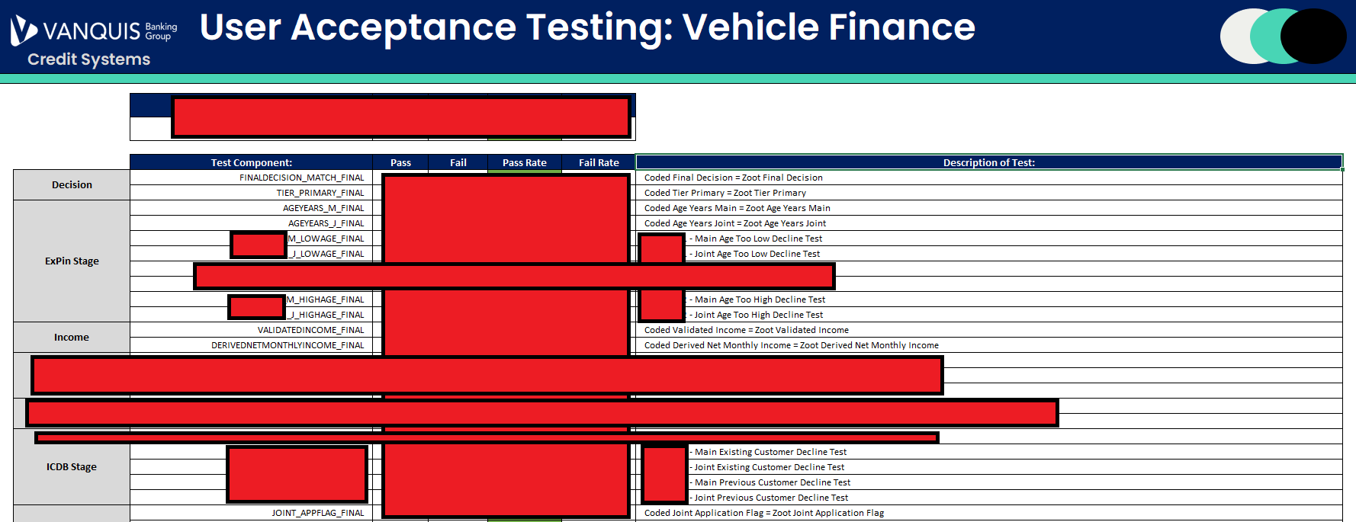

Figure 148 - Example of the Test Completion Report showing the Test Scenarios, with sensitive information redacted.

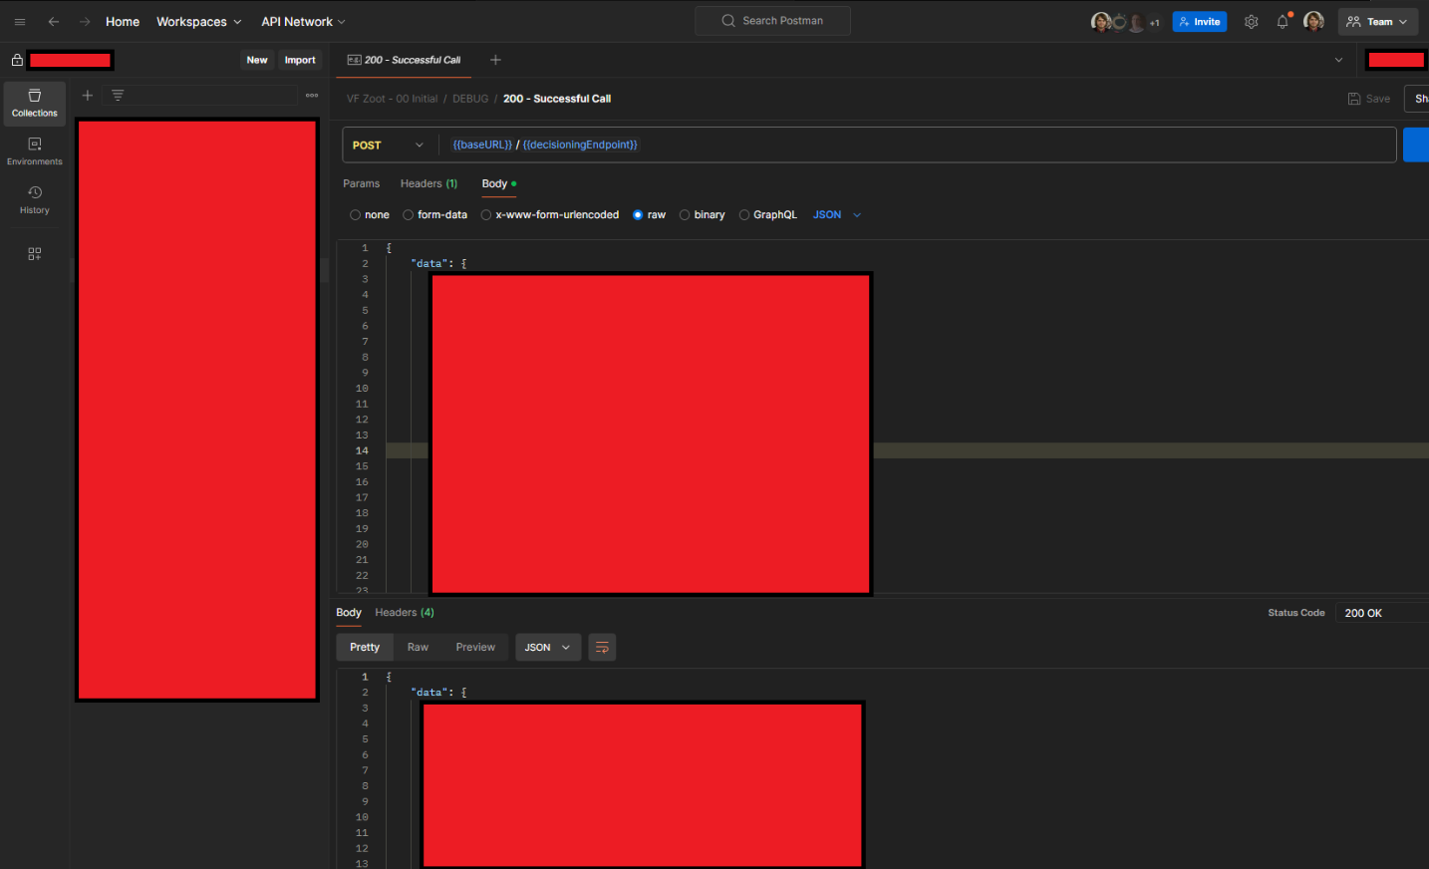

Figure 149 - Example of Postman in use, with a JSON Request and a HTTP 200 Response received (exact message bodies redacted)

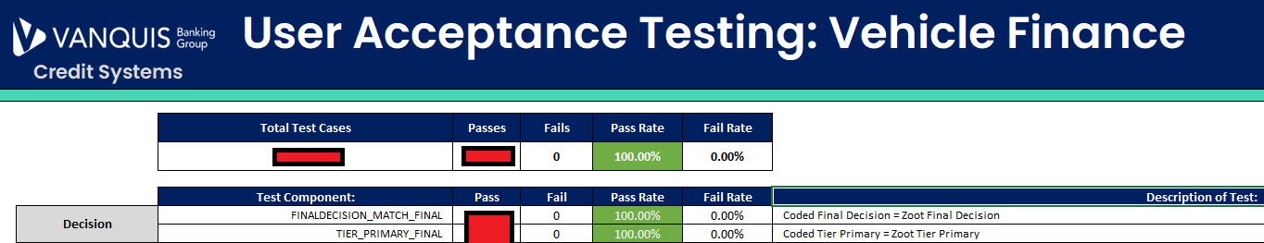

Figure 150 – Snippet of the Test Completion Report showing the pass rate of all test scenarios

#### When to use Copy of Live?

Some changes we make become large enough in scope that it becomes very difficult to test with Test Stubs and Test Data provided alone. Examples of such changes include:

* Scorecard changes, based on data provided by External Data Providers e.g. the Credit Bureaus
* External Data Provider changes (e.g. configuration impacts the data we will receive from them)
* New calculations using granular raw data from Data Providers e.g. Experian CAIS data.
* Significant re-design of back-end processes

To ensure adequate test coverage with as many granular test data records as possible, “Copy of Live” Testing can be done. This process uses data from actual people we’ve gathered from Production and re-submits it to the latest build of the Decisioning Engine deployed within a test environment. This allows us to effectively use production data as if they were new test records, which brings potentially thousands more test data records we can use to rigorously test our changes prior to Production. The mass influx of test records this gives us can significantly reduce the risks of any change.

The real benefit of this testing is the interaction it has with 3rd party Data Providers. For example: Experian’s Credit File data is made up of thousands of summary variables that can be used to judge the credit worthiness of a person, as well as many blocks of raw data that are used to create these. Creating randomised data for testing that can test every eventuality possible within these variables is extremely difficult, due to the sheer volume of possibilities. Copy of Live is the solution to this problem, as those possibilities already exist in real production data.

Applying the “Estimates: Sizing changes” logic, **Extra Large changes (and above)** are when this form of testing becomes recommended, as the unknowns those changes involve present greater risk.

Critical to make this work however is that the external Data Providers we’re using must be able to support this testing. This is typically a configuration option within the account settings or the HTTP Request message we send to the Data Provider. Not all Data Providers support this testing, so this must be identified early when creating a test plan.

As we need actual person data, “Copy of Live” Testing is controversial. Being based on actual people makes the data subject to Data Protection legislation (e.g. GDPR), which has led to compliance queries in its usage in the past. Previous systems have sought exceptions with the Compliance team to allow this testing to be done, however the core of the issues was not addressed. To do so, I’ve developed a strategic process to address these concerns. A summary of how is covered in the table below (note that the exact workflow of the process is not in scope of this document).

|  |  |  |
| --- | --- | --- |
| **#** | **Challenge** | **Solution** |
| 1 | Test Environments are not designed to use PII Data i.e. are not GDPR Compliant | Copy of Live testing makes uses of an actual Production environment (separate from our main one), which is GDPR compliant |
| 2 | PII Data is exposed to Testers & QA, with open ended access requirements | Rather than extract and submit the PII data to the Decisioning System (as if it were a test record), the system itself will make a HTTPS Request to our database to get the data instead, removing the need to manually extract data.  The Database can then use its **Masking** functionality to obfuscate the PII Data to the Testers/QA. They only need to know what results to expect from the record i.e. the actual PII Data is only needed by the Decisioning Engine.  Using a HTTPS request also encrypts the data in transit, protecting the PII Data. |
| 3 | Extracted PII Data is put into flat files, which cannot be traced | The above solution also resolves this. Users attempting to extract the masked data within the database will just see obfuscated values e.g. *********** |
| 4 | Data Retention Policy cannot be applied to extracted data | Retrieving the data over HTTP(S) means no data is manually extracted.  Therefore, all data is held within existing databases with Data Retention policies applied. |

### Deployment (Production)

|  |  |
| --- | --- |
| **Stakeholders Required** | * Release Manager * Change Management * “Customer” teams (for awareness) |
| **Inputs** | * Test Completion Report * Tested build of the Decisioning System in a test environment |
| **Outputs** | * Fully tested build of the Decisioning System in Production * Change Record logged with the Change Management team. * Evidence of new functionality working as expected. * Evidence of no exceptions in existing functionality |

Deploying to Production varies from UAT, as there are established Change Governance processes set by other teams we must adhere to. The workflow covered in this section walks through all the detail needed to comply to this.

Deployment to Production works on the basis of promoting a build already developed in a test environment to a Production one i.e. we take a fully tested build in a lower environment once we’re confident it has no critical bugs/defects.

Currently, Production Deployments can only be done by our 3rd party partner we license our decisioning system from. This is a requirement our partner enforces due to operating their software as a service on a shared cloud with all their clients, so enforcing this forms part of the SOC2 Audit compliance.

#### Workflow

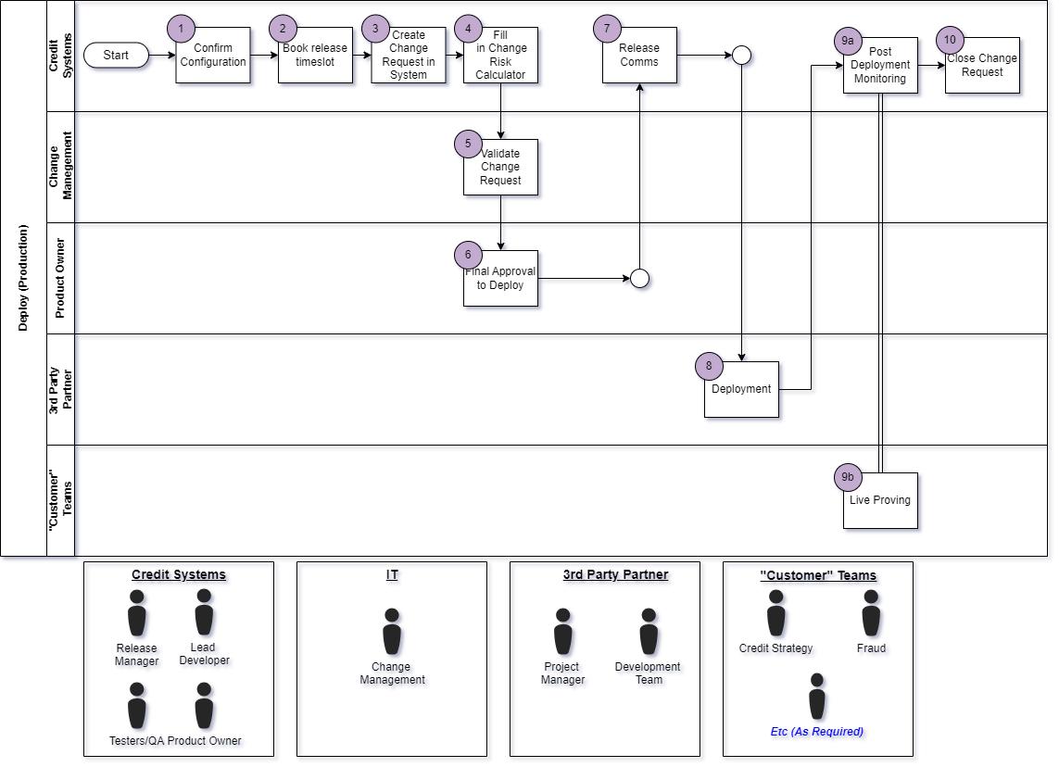

Figure 151 - Workflow of Production Deployment

|  |  |  |
| --- | --- | --- |
| **Step** | **Name** | **Explain** |
| 1 | Confirm Configuration | Before the deployment is arranged, the **Lead Developer** must confirm the configuration within the Test Environment that will be promoted to Production.  This is to ensure no configuration intended solely for UAT makes it into Production, which would invalidate our testing. For example, if we’ve disabled a Policy Rule in the test environments for some test cases, then these should be re-enabled if they are expected in Production. |
| 2 | Create Change Request in System | Our organisation-wide Change Management Framework requires that **a Change Request** be raised **before** any deployment to Production. Our Change Management team uses these to:   1. Inform the IT Operations teams of when to expect the change, so that if any issues are identified (ether in the system itself or in dependent systems), the team(s) is aware that it be related to a change. 2. Keep a record of the change for auditing. 3. Confirm which users (if any) will be impacted by the deployment, ether internal or external to the business.   An example request is shown in “Figure 152”. The request must include:   * Details of that the change is. * Exact Start and End times of the change (covering initial deployment and planned monitoring) * A Rollout plan i.e. how exactly we’ll conduct the deployment. * A Back-Out plan, in case the deployment needs to be reversed. * Any impact(s) of not implementing the change/deployment. * Evidence of testing e.g. the **Test Completion Report** we created in our **Testing** phase. |
| 3 | Fill in Change Risk Calculator | The Change request calculator is a critical part of the form that determines the risk level of a change, guiding the amount of advance notice that must be given (called “lead time”) and the levels of approval a change must get the be authorised for deployment.  Changes will fall into these categories:   * **Normal** – Lower risk change that will not visibly impact users. Requires at least 2 days advance notice. * **CAB** – Higher risk changes that must be discussed and approved in our “Change Approval Board” committee before continuing. Requires at least 5 days’ notice. * **Emergency / Urgent** – Exceptional changes that are only to be raised to resolve (Emergencies) or prevent (Urgent) incidents which cause harm to our end users, be that ether financial, reputational etc. Rather than advance notice, the Change Management team should be contacted to arrange these |
| 4 | Book Release Slot | Our 3rd Party Partner and our internal Change Management team require advance notice of any Production deployment, which ensures they can book the necessary resource to support the deployment and to conduct assessments.  Once we know the lead time we must give the Change Management team, then the release slot can be booked with our 3rd party team with confidence.  This can be done earlier if needed. Our internal Change Management Framework does have an exception for missed lead times, but this requires additional approval. |
| 5 | Validate Change Request | Once the form is complete, Change Management will validate the Change Request paperwork to ensure it is filled in correctly, with an adequate amount of detail.  This is their internal workflow before authorising a change. |
| 6 | Final Approval to Deploy | Once Change Management have completed their validation, the Change Request must then be assigned to a team leader for final approval.  This is done within the Change Management system. An example is shown in “Figure 153”.  For a **Normal** Change, this approval alone is enough. For any other change, the change must also be approved by the Change Approval Board (CAB). If this is required, then the Change Management team will invite the **Lead Developer** who created the change request to the approval board. These are hosted via Web Conferencing, see “Figure 154” for an example. |
| 7 | Release Comms | Once the release is approved for deployment, a communication needs to be sent informing relevant stakeholders of the change. An example of this is seen in “Figure 155”.  We’ve set up distribution lists to contain the email addresses of all stakeholders who need to be aware of changes to specific platforms.  Distribution Lists:  <<redacted>> |
| 8 | Deployment | Once the Release Slot is secured, our 3rd Party partner will commence deployment at the agreed date and time.  Once this is complete, another communication should be sent once deployment has completed, as seen in “Figure 156”. |
| 9a | Post Deployment Monitoring | After deployment, the Credit Systems team should monitor the system for any errors and/or exceptions to the defined decisioning strategy. The SQL Code used during the Testing phase can be re-used for this.  These could be indicators of the release not performing as expected. |
| 9b | Live Proving | At the same time, the “customer” teams who requested the change are expected to do their own monitoring to confirm the change is performing as expected. |
| 10 | Close Change Request | Regardless of success or failure of the deployment, the Change Request needs to be closed within the Change Management system.  “Figure 157” shows this being done for a successful change. |

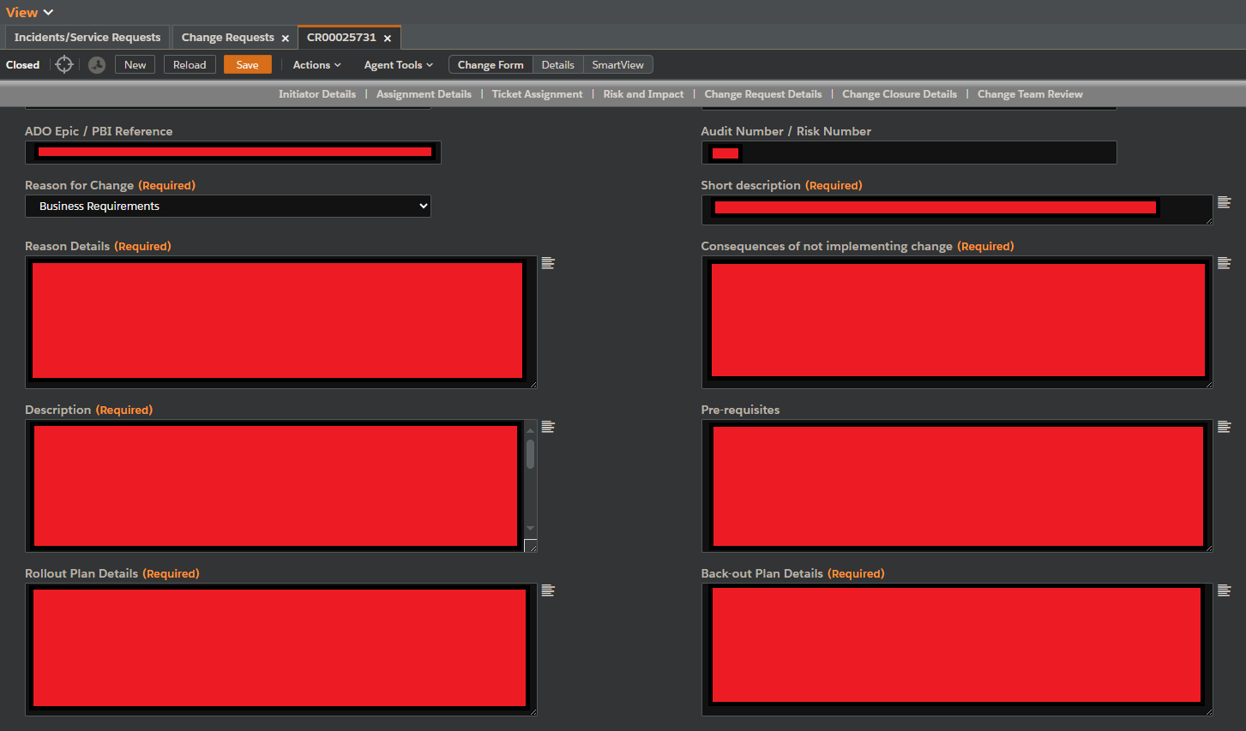

Figure 152 - Example Change Request form (which specifics redacted)

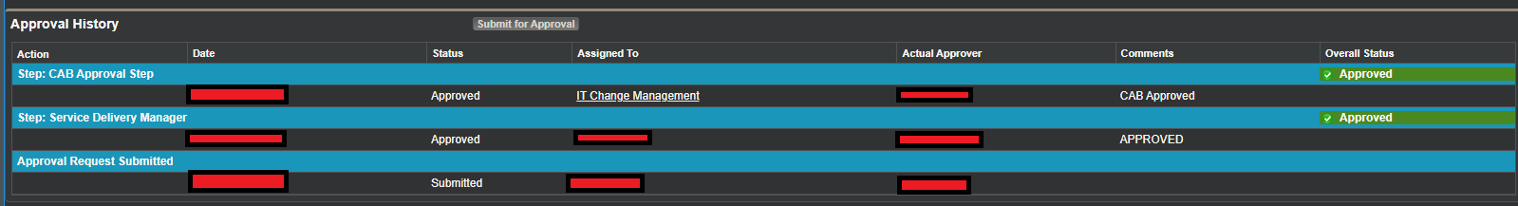

Figure 153 -Approval workflow as seen in the change management system.

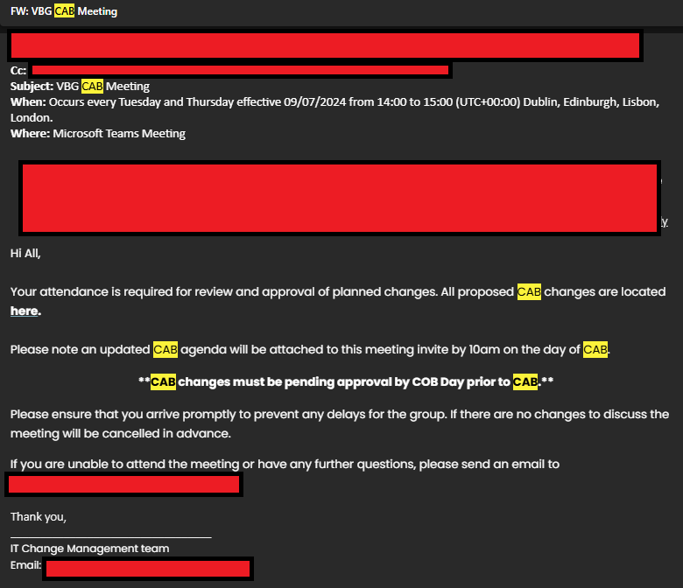

Figure 154- Outlook meeting invite to Change Approval Board (CAB)

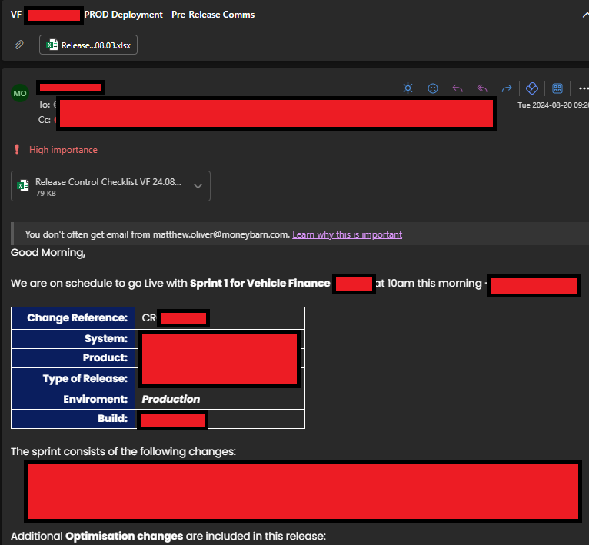

Figure 155 - Pre-deployment communication informing stakeholders across the business of the change.

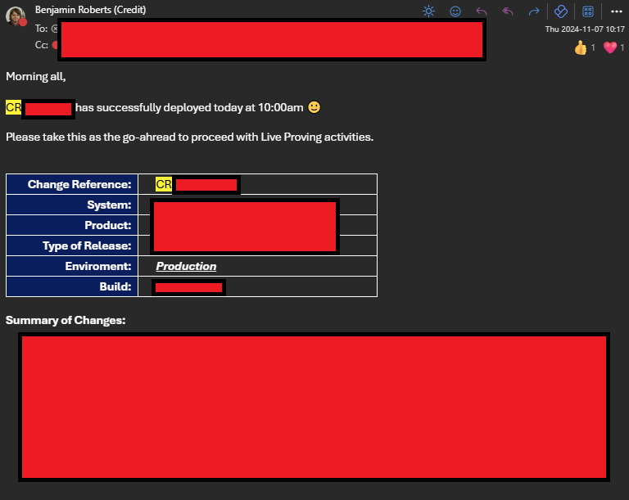

Figure 156 - Post Deployment communication informing stakeholders across the business that the change is in production.

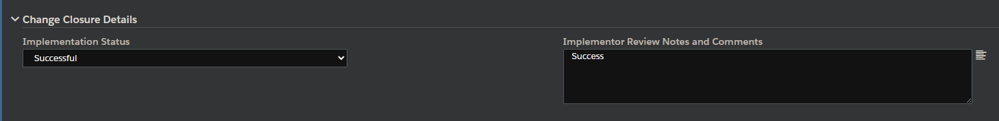

Figure 157 - Post change review section of the Change Request Form

### Review

|  |  |
| --- | --- |
| **Stakeholders Required** | * Developers * Testers/QA * Release Manager * Product Owner |
| **Inputs** | * Feedback from completed Work Items in the last iteration. * Actual Efforts required to complete Work Items |
| **Outputs** | * Action plans to improve processes (if identified). * Updates to the Master Reference List for PBI Estimates, based on lessons learned from the Sprint & new types of requirements delivered |

Once Production Deployment is done, the iteration is considered “complete”. Before starting another, we should take time to reflect on the recently completed one. The forum for this is the “**Sprint Review**”. This is done to:

* Compare actual effort required to estimates. We can use these to update our Master Reference List to support more accurately estimating similar Work Items in future iterations.
* Discuss things that went well and things that did not go well in the last iteration. This can be about anything e.g. development standards, process workflows etc. This can be used to create action plans to improve processes going forward.

After review, the changes fall back into regular BAU Maintenance tasks.

#### Sprint Review

The “**Sprint Review**” is the place to **review the outcome of an iteration**, to review what went well (or didn’t) and to help guide how we plan the next iteration (Scrum.org, 2025). This **should include all stakeholders within the iteration team** (e.g. developers, testers, release manager). Setting up and inviting the correct stakeholders is the responsibility of the **Product Owner**.

Typical discussion points are:

* Each member of the team discussing Work Items they completed (i.e. are “Done”) and ones they haven’t been able to complete.
* Confirm with “customer” teams that the work completed meets their requirements, and if not, what the gaps are.
* Commenting on what blockers the team have faced, and how we can prevent similar ones in future.
* Determine what Work Items to prioritize next.

Our team does not regularly do these currently (a gap in our DevOps implementation compared to a standard framework). For inspiration on how we can improve, we can look to our IT Teams. For example, our IT Delivery teams create a demo of delivered functionality to their end-users and document this within a PowerPoint presentation. An example is shown in the figure below:

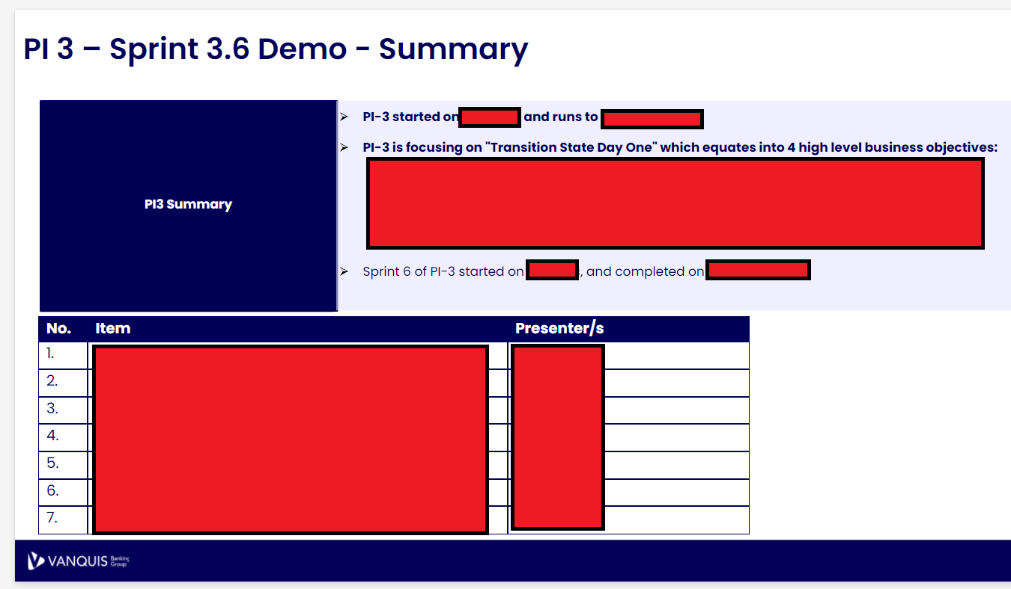

Figure 158 - Summary slide of a Demo presentation created by our IT Teams for an end of Sprint Review.

Our team could use something similar to this to orchestrate Sprint Reviews, which would allow use to be better at continuously improving our processes and standards.

## Development Standards

All code we develop needs to follow these standards, set to ensure:

* High Quality code is created and can be maintained over time.
* Developed codes are consistent with previous similar work items e.g. all Policy Rules follow the same design.
* Adequate Unit Testing is in place to create confidence in code prior to deployment.

### Clean Code - Use Datastore Functionality where possible

When creating new logic within Zoot, Developers should always parameterise their logic as much as possible by making use of Datastore Functionality (i.e. Zoot’s version of environment variables/tables). This is to conform with the **Clean Code Principle of avoiding “magic numbers”**; an idea proposed that having hard-coded thresholds obscures the meaning of the specific values used (Martin, 2009).

For example, if we have a Policy Rule that does a numeric comparison against a threshold. We could hard-code this and it would technically work (shown in Figure 159 - Example of a condition using a Hard-Coded ). By doing so however, we leave one of these “magic numbers" in the code.

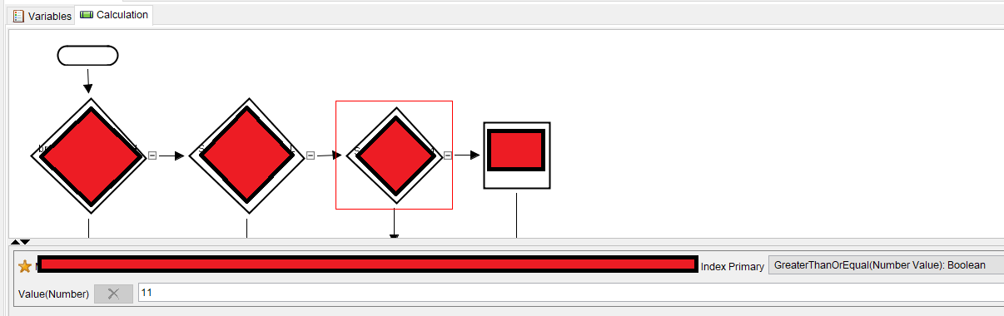

Figure 159 - Example of a condition using a Hard-Coded threshold.

Instead, we should make use of the Zoot’s Datastore Functionality to parameterise this, as seen in Figure 160 below:

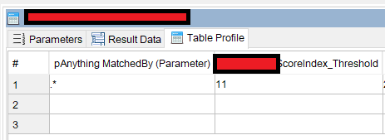

Figure 160 - Parameterised threshold within Zoot’s Datastore Functionality

Then, we can insert this parameter into the code, which shows the name of the parameter rather than an abstract number:

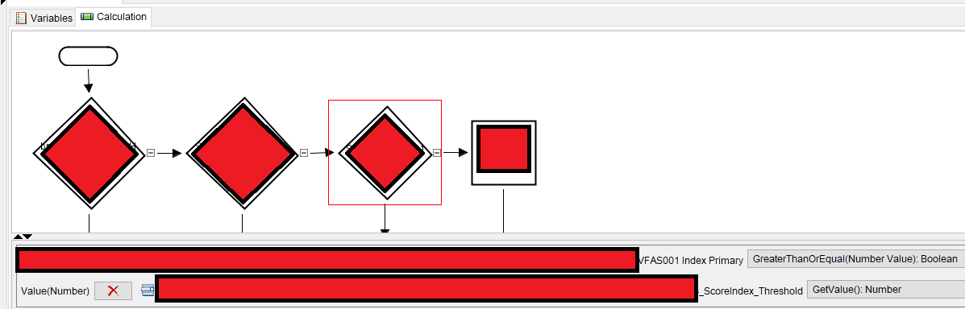

Figure 161- The same code as the previous figure, but instead using a Parameter with a Meaningful Name

By doing this we have:

1. Avoided a “magic number/logic”, where having a Hard-Coded threshold in the logic obscures why that specific number/value was choses & what it represents. By using a Datastore Parameter instead, **we assign a meaningful name** to that threshold, which makes it clear to later developers what the purpose of it is.
2. Provided a form of future proofing to the solution. **Zoot allows us to modify these Datastore Parameters outside of a of a normal Code Deployment** (as they are closer to environment variables then full code). This means **if we later receive a change request to update the threshold, we can do so more quickly and easily**, leading to better outcomes for our “customer” teams.

### SOLID: Single Responsibility

**Components we develop should only do 1 single thing, meaning that if/when we must change it, the component only has 1 reason to change**. This is an application of the SOLID Single Responsibility principle and while the principles (Baeldung, 2024)**.** The SOLID Principles are more clearly related to full code scenarios e.g. Java, C# etc, however we can still find applications for them in low code tools like ours.

**By giving components only 1 reason to change, we reduce the risk of introducing bugs** when making changes to the code e.g. if a component holds multiple responsibilities and our change only involves 1 of them, then we risk introducing a bug into the other responsibilities. Good practice would be to avoid this scenario all together by adhering to this principle.

**For a good example of following this**, the below figure shows a module that makes a HTTP Request to one of the UK’s Credit Bureau’s, giving us a rich set of data on an end-user applying for a loan, allowing us to make an informed credit decision. Making this HTTP call is the only thing this module does, therefore we can call this module outside of any business logic that makes use of this data, giving us flexibility on its use e.g. we can call this module whenever we have need of that Credit Bureau’s data before any business logic to ensure we have it.

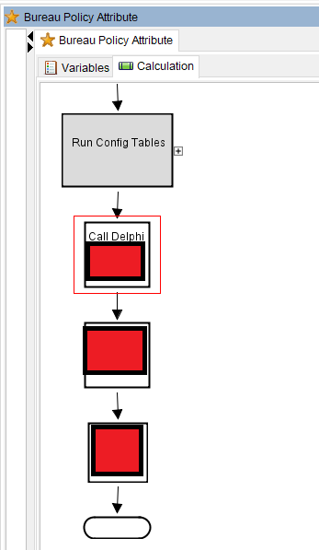

Figure 162 - Example of a module conforming to Single Responsibility

**For a bad example of code not following this**, the below figure shows an Income Verification Module within Zoot. The purpose of this module is the check that the income provided to use by end-users applying for a loan is accurate, using a data provided from Credit Bureau’s to judge this. In this flow however, we’ve implemented both the logic to make the HTTP API call to these Credit bureaus and the logic that determines this Income Verification. There is no individual logic to call the Credit Bureau API’s, therefore if we want to do this, then we also must run the entire Income Verification logic, which may not be needed and therefore brings a higher risk of a bug being introduced.

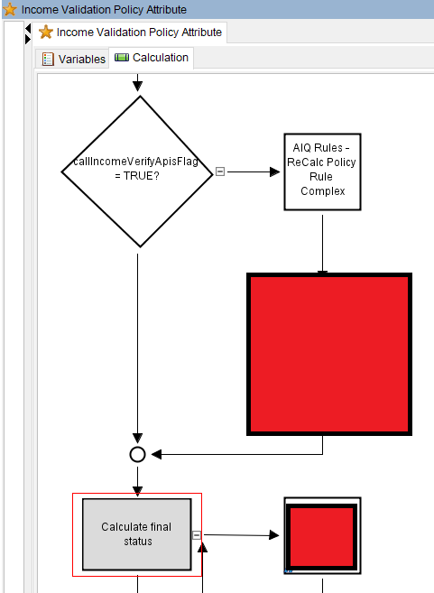

Figure 163 - Example of Single Responsibility failure.

### Avoid Lock-in – Why we maintain a separate Build Specification

Per step 3 in the “Design & Development” stage, we must always make sure our system documentation is updated whenever a change is made, ensuring that this documentation is always accurate per build.

For Example, the below figure shows a new Policy Rule that’s been added into the latest build (exact business logic has been redacted). We highlight this in Green to help users identify the changes (as our current format for this documentation is an Excel File, which has limited Track Changes functionality).

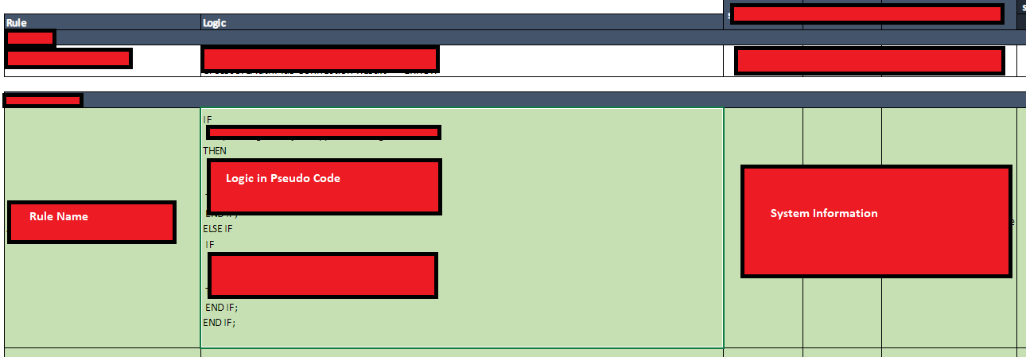

Figure 164 - The Build Specification being updated.

By doing this:

1. **We have a set of requirements always available if we need to implement the same business logic elsewhere** e.g. creating exceptions reporting. This also helps us **avoid a lock in scenario** where if we need to migrate the entire system into a new platform (e.g. 2024 Vehicle Finance Migration Project), then we have a pre-written set of requirements ready, not bloated by Technical Debt within the system itself. This can save months of work.
2. **We maintain a document that can be shared with other stakeholders**, allowing them to understand what logic is built within the system without having to give them a licence to access the systems (and the costs that incurs)
3. **We maintain a high-level overview of the system per build**. One drawback of Zoot is that it is not immediately apparent how all the components of the system come together to form a complete end-to-end flow, which was one advantage previous systems our team have used had over our current one (e.g. Powercurve).
4. **Per build documentation is available**. By creating a new version of the Build Specification for each version of the decisioning engine we develop, we maintain a history of changes that can be referred to back to as needed e.g. auditing.

### Code Reuse (Templates)

Before starting the design of a Work Item, we should check if any existing Templates can be used. From past Work Items, we have created a template that can be used as a basis for new work items as requires. Existing ones are shown below:

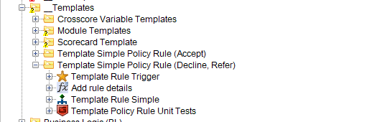

Figure 165 - Example of existing templates within the Web Rules platform, for common components we develop.

To dig into 1 example: The **template Policy Rules** provide frameworks to creating new Policy Rules, with the lower-level components that connect to the inner backend workings of the platform already implemented. **This allows our team to focus solely on implementing the business logic**.

The Unit Tests within the template also contain pre-existing assertions for how the Policy Rule logs it’s results into the platform’s Data Model, saving the developers time when testing this.

By making use of these existing templates, we:

* Ensure we have a consistent design between related work items, allowing individual team members to switch between related components, aiding collaboration.
* Sets a testing standard for what checks are expected within the Unit Tests
* Saves development time by giving developers a partially constructed solution, without having to start from scratch.

### DRY (Don’t repeat yourself)

**Shared Procedures / Functions:**

Occasionally, we’ll find some logic that we end up having to use multiple times, across multiple components. Rather than rebuild this logic each time, we ideally would want a callable function/procedure that can be used instead. This is an application of the “Don’t Repeat Yourself” principle, which guides programmers to have a single, definitive representation of a piece of logic when it would be used in multiple places (Hunt & Thomas, 2019).

We’ve created a series of Procedures that can be reused across the platform to adhere to this. These are stored within the “Shared Platform Objects” folder:

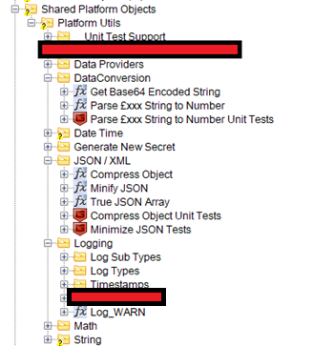

Figure 166 - Shared Platform Objects folder, showing multiple re-usable procedures.

Examples of existing procedures developed are:

* **Parse £xxx String to Number** – This will take an input String argument storing a currency value (e.g. £100) and parse it into a numeric field, handling all the string cleaning steps necessary to be left with only the number.
* **Minify JSON** – Takes an input JSON String as it’s input and removes any redundant fields e.g. Key-Value pairs where the value is NULL & any white space characters. This reduces the overall size of the JSON, allowing for a more efficient data transfer.
* **Compress JSON –** Similar to Minify JSON, but only removes the white-space characters. Useful alternative when the requirement is to retain Key-Value pairs where the value is NULL.
* **Log_WARN** – This will take several arguments related to an unusual behaviour within the system and store a record of it available for later review. The procedure itself handles creating all the necessary entries in the data models storing the record

All of these are used in multiple places across the platform. By using a single procedure for these, we can update this single procedure if we find unexpected values/errors later in Production, which will avoid having to change multiple pieces of logic (also applying Single Responsibility).

**In-Platform Enums/Global Values:**

Another application of this principle is how Enums and Global Values are used. Throughout the platform, there are a few use cases where we use the same value across multiple places e.g. when generating our API Response where Income and Expenditure is returned, we use a JSON field called “dataSource” to identify where the calculation came from. The values of this field are controlled by Enums (i.e. we pre-define what values are acceptable). We could use raw text as shown in the figure below, however this effectively Hard-Codes the value, its usage cannot be traced, and we have to repeat this every time it’s needed.

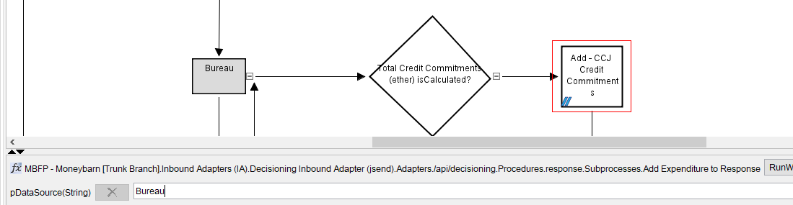

Figure 167 - Bad Practice example of approaching Enum values in code.

Instead, to conform to the DRY principle, we want a single representation of this. That is where this “**Types**” folder comes in, seen in the figure below. Instead, we create an Attribute here with the default value of “Bureau”, meaning that we now have a usable object hold the value instead. Since this is an actual object now, Zoot’s search functionality can find all instances of its usage.

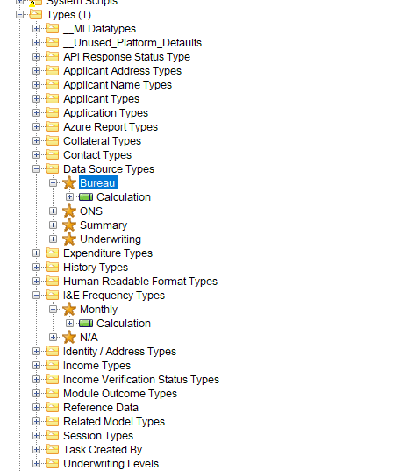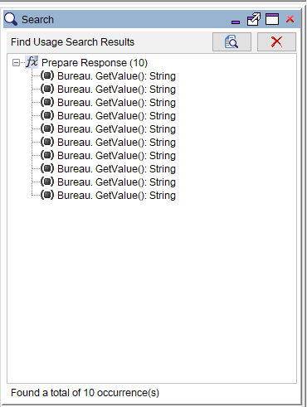

Figure 168 - Attribute Objects in the platform used instead of raw text, with all occurrences shown via the Search functionality.

With this new object, we can use it in place of the raw string we had before, for the same result. This approach however:

* Makes it easy to change the value of the Enum later if needed (needing to only change 1 value instead of multiple)
* Allows all usage of that value to be traced across the platform using the in-built search functionality.

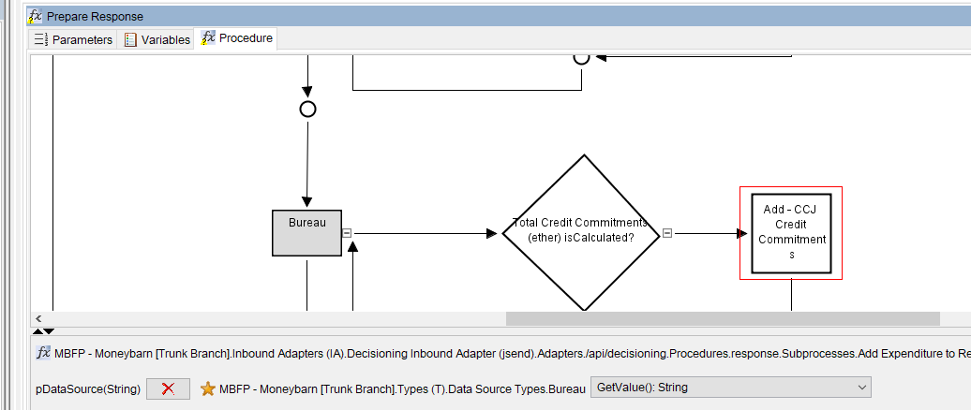

Figure 169- Good Practice example of approaching Enum values in code.

### KISS

KISS is an acronym standing for “Keep It Simple, Stupid”, a tongue in cheek way of advocating for keeping systems/code bases as simple as possible to make them easier to:

* Understand (for all stakeholders)
* Maintain
* Debug

(Hunt & Thomas, 2019)

The principle can be used to guide how we implement requirements into the system. One way we can apply this is to break down complex logic into more manageable pieces. For example, we have a requirement to authenticate an applicant’s identity before providing them with a line of credit, even if they meet all our other lending requirements. This is a Know Your Customer (KYC) compliance requirement enforced by our regulators. To do this, our Fraud Team have created a validation logic based on data provided from one of our 3rd party Data Providers:

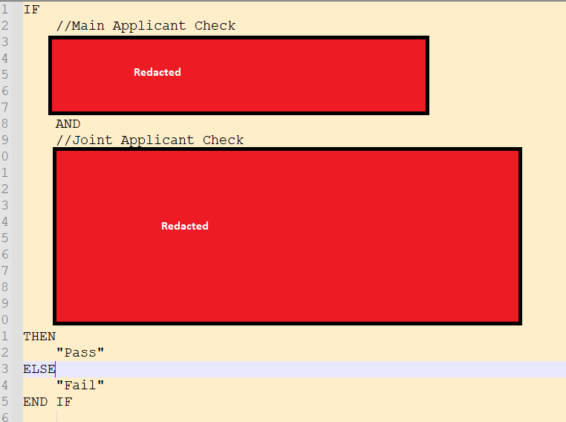

Figure 170 - Example of Business Logic Requirements, showing complexity in the design (exact logic has been redacted)

The various nested IF conditions, along with the OR conditions and the need to check both a Main applicant and a Joint Applicant make this logic much more complex than it initially appears and causes some design questions to be raised. Strictly speaking, we could implement this within a single Policy Rule, but that brings challenges:

1. The data points within the 3rd party Data Provider are not as simple to get to as this requirement makes out to be, hiding some of the complexity and therefore would bloat a single policy rule design.
2. The OR conditions create multiple scenarios where the entire statement could evaluate to TRUE, creating many distinct test scenarios. As this is just a single logic as is, we’d have no way of knowing which individual logic was used to verify the applicant(s), creating problems in the Review & Maintenance stage later e.g. if we want analyse if 1 condition applies more than others.

By applying the KISS mindset, we can simplify this logic by:

1. Separating out the checks on each Applicant into their own calculations and Policy Rules, making it easier to implement and test the logic for each.
2. Capturing the specific Data Points from the 3rd Party Data Provider separately, which can be logged separately for easier debugging.
3. Breaking down the OR conditions into distinct Policy Rules, which would give us individual identifiers for when each condition is it, allowing for later analysis.

## Concluding Summary

This document has broken down our DevOps framework in detail, step by step. It should be considered as the basis for how we orchestrate our Development and Operations (i.e. DevOps) processes.

Several Development standards have been identified to aid developers in creating quality logic within our decisioning system tool. These should be adhered to and actively monitored in Code Reviews, as they allow us to create maintainable code.

There are several pain points identified, specifically around deployment:

* Having our deployments (both UAT and Production) done by our 3rd party partner adds an additional barrier that reduces time to market.
* Releases become chargeable, adding pressure to both the budget to account for this and to the developers, as this limits our ability to deliver bug fixes if any are found in testing e.g. if budgets only account for 1 release, then additional funding must be requested.
* Having to book Production timeslots risks having to select a time that is not optimal e.g. core business hours where API traffic is highest.
* Manual deployments negate any possibility of implementing Continuous Integration, limiting our ability to make rapid changes.

These issues have been acknowledged, and proposals to allow us to do our own deployments are ongoing. The solution being considered would deliver this functionality to us while allowing our 3rd party partner to remain compliant with their SOC2 Audit Requirements.

Our Work Item Estimation processes could be more evolved to make better use of Azure DevOps functionality. This document has proposed how to move from our current T-Shirt sizing methods to a numeric approach based on the Fibonacci Sequence, which Azure DevOps can use to visualise work completed over time.

# Microservices, Databases and API’s

## Introduction

Currently our Credit Decisioning system is set up as standalone “**monolithic**” platforms, a traditional architecture approach where all components of the software are compiled into a single network and code base, tightly coupling it all together (Atlassian, 2024). The figure below shows this visualised:

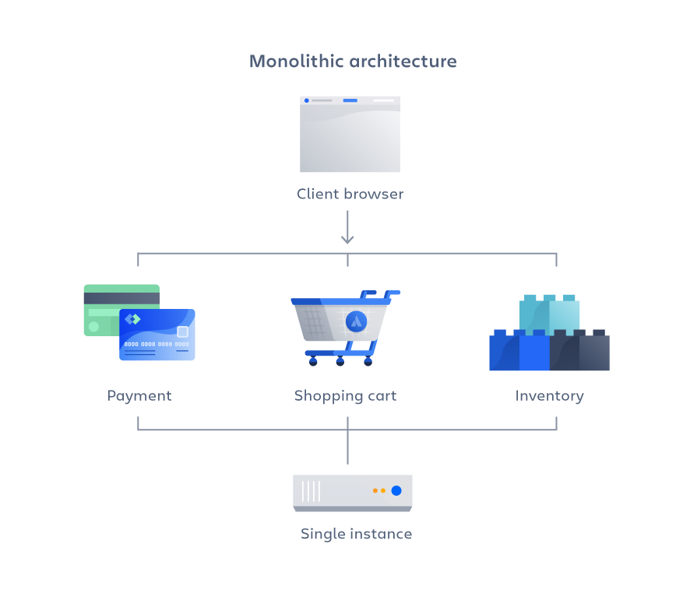

Figure 171 - Example of a Monolith platform (Atlassian, 2024)

This has been useful to date for getting our platforms ready for production on tight project timelines but has led to issues. Specifically, we see occurrences where we integrate with multiple HTTP API’s provided by 3rd parties across multiple platforms, but each platform uses its own code base to do this, leading to small differences in implementation.

This paper will examine the current architecture and tooling, look for potential issues and what alternatives are possible.

## Discovery

Before exploring existing architecture, topics relevant to examining the current decisioning system architecture are explored in the sections below.

### Relational Databases

A Relational Database (full name “Relational Database Management System", or RMDBS when abbreviated) is a storage solution that stores data in rows and columns, across various tables within the database. Examples of these types of databases are:

* Microsoft SQL Server
* MySQL
* OracleDB
* SQLite

The rows and columns make up “records” within the tables. Columns are used to capture specific data points, while rows hold the value for those columns. The table structure allows the data to be structured logically e.g. columns that all relate to an order on an e-commerce site (e.g. identifier, datetime) would all be in 1 table.

#### Keys

Tables relate to each other through “keys”. Different types of keys are used to structure data:

* **Primary Keys** – Column(s) in the table that uniquely identify a record. Ideally this would be a single column within the table, but it can be made up of multiple fields (these types being called “Composite Keys”
* **Foreign Keys** – A column within a table that references a record within another table. These are used to join tables to each other as needed e.g. analytics. When a column is declared as a foreign key, it references another column in a different table to establish a relationship with it. Once in place, values for the foreign key much match the references column in the other table.

The figure below visualises how these are used to relate tables. In it, “EmployerID” is the Primary Key of the “Employees” table. This is also referenced in the “Sales” table.

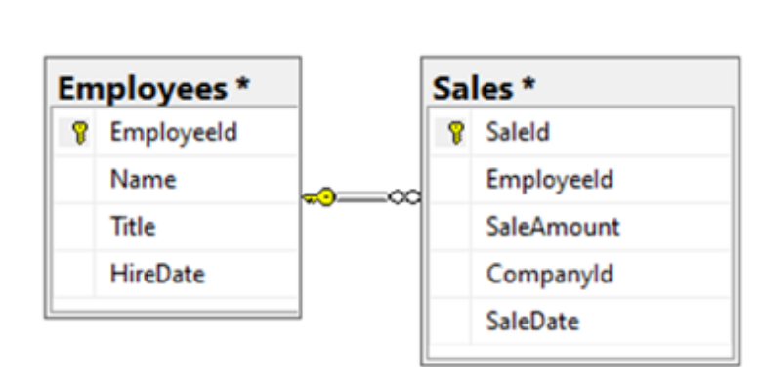

Figure 172 - Example of tables in a relational database, where a Foreign Key "EmployeeId" is used to relate the tables (Pluralsight, 2020)

#### Data Relationships

Tables within a relational database can have many types of relationships, which dictate the result you’d expect when joining tables together. At the high level, these relationships are:

|  |  |
| --- | --- |
| **Type** | **Description** |
| One-to-One | Records within Table A will join onto exactly one record from Table B, and no more than that.  Where it is possible there is no matching record in Table B, we call that a One-to-Zero or One relationship. |
| One-to-Many | One record within Table A will join onto ether one or multiple records from Table B (dependent per record).  The “to-Many” part of this relationship is strictly 1 way e.g. the multiple Records in B will only join onto 1 Record in Table A. |
| Many-to-Many | Multiple records within Table A will join onto multiple records from Table B.  This type of relationship should be discouraged, as they lead to complex joins that require significant computational power to calculate, resulting in slow queries.  One way to avoid this relationship is to create a table between the 2 tables, each with a One-to-Many relationship to this new table. For example: Table A and Table B have a Many-to-Many relationship. To avoid this, we create a Table C and create a One-to-Many relationship to it for both Table A and B. Doing so creates an intermediary that pre-stores the matching records between Tables A & B, minimising the computational resources needed to calculate the otherwise complex join when querying the database. |

#### Normalisation

Splitting the data like this allows “**normalisation**” to be achieved, meaning the data is organised to eliminate data anomalies (DataCamp, 2024). Examples of these anomalies are:

* Duplicate data points across several tables e.g. employee details. Without normalisation, any update would have to be done in multiple tables
* Redundancy – The same duplication means redundant data is in the system, which requires more storage space (and cost) to store

Normalisation is important to a relational database as it helps achieve referential integrity i.e. data is consistent across tables. Organising the data into structured tables prevents these data anomalies from occurring by ensures that updates, deletions, or additions in one table are reflected consistently across related tables. Attempting such an operation will return an error, preventing orphaned records or inconsistencies in the data. This help support reliable data management and data quality.

### Non-Relational (NoSQL) Databases

A non-relational database (also called NoSQL) also stores data, but does not use a table, row, identifying and relational keys structure like a traditional relational database does (Pluralsight, 2020). There are instead various forms of non-relational databases that are tailored to specific requirements but the data not being stored in a relational manner is the commonality between them. These database types have gained the term “NoSQL” due to this, as the lack of a relational model removes the traditional use case for the SQL language (Microsoft Learn, 2024).

Examples of these are:

|  |  |  |  |
| --- | --- | --- | --- |
| **Types** | **Details** | **Use Cases** | **Example solutions** |
| **Document** | Contains data in a set of named string fields and object data values, referred to as a document (Microsoft Learn, 2024). Typically, this will take the form of a semi-structured format of data e.g. JSON, XML, YAML.  Multiple data entities can be combined into this document (e.g. customer details, order details etc), unlike a relational database which would separate these entities into tables. These documents also do not need to have the same structure.  Specific documents can be retrieved by a key, which uniquely identifies the document.  See Figure 173 for a visualisation of this. | * E-commerce data where items attributes differ product to product * Customer Data Management * Real-time analytics | * MongoDB * Azure Cosmos DB * Google Cloud Firestore |
| **Key-Value** | A simple table structure that stores data in 2 columns: the “key” and the “value”. The “key” column is used as the identifier for the data and the “value” columns stores the data point. Unlike a document store however, this is just a simple value.  The data is stored using a hashing function on the “key” value (hashing functions are one-way transformations, hence why this is not done on the “value” as well). Using the hash function allows for an efficient lookup.  These are optimised for simple lookup operations, where data need not be compared across multiple tables e.g. configuration options.  See Figure 174 for a visualisation of this. | * Caching session data on an application * Storing user preferences * Shopping cart data | * Couchbase * Amazon DynamoDB * Azure Table Storage |
| **Column-oriented** | These are like traditional Relational databases in that data is stored within rows & columns. Unlike relational databases however, data is stored within the columns of the table. Each record is still stored with a unique identifier, but the columns are grouped into “families” and these store logically related data points, which can be retrieved together. (Amazon AWS, 2024). This allows large amounts of data to be stored together and retrieved quickly.  These columns are not fixed. They can scale as needed and do not need to have pre-defined data types, removing the normalisation constraints of a typical relational database.  See Figure 175 for a visualisation of this. | * Logs * Read-heavy workloads e.g. analytics * Time-stamped data | * Amazon DynamoDB * Azure Cosmos DB * Google Cloud Datastore |
| **Graph** | Data is stored in the form of “nodes” and “edges”:   * “Nodes” represent entities e.g. a person, department * “Edges” represent the relationship between these nodes e.g. 1 person reports to another   (Microsoft Learn, 2024)  This storage allows the data to be represented graphically, hence the name.  See Figure 176 for a visualisation of this. | * Social Networks, for relationships between users * Supply chain management, via mapping out dependencies | * Azure Cosmos DB * ArangoDB |

*Example solutions sourced from* (Strauch, n/a)

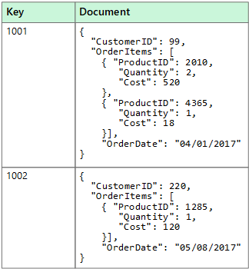

Figure 173 - Example of data storage in a Document store, a type of non-relational database (Microsoft Learn, 2024)

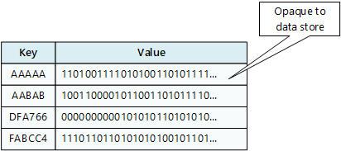

Figure 174 - Visual representation of a Key-Value store (Microsoft Learn, 2024)

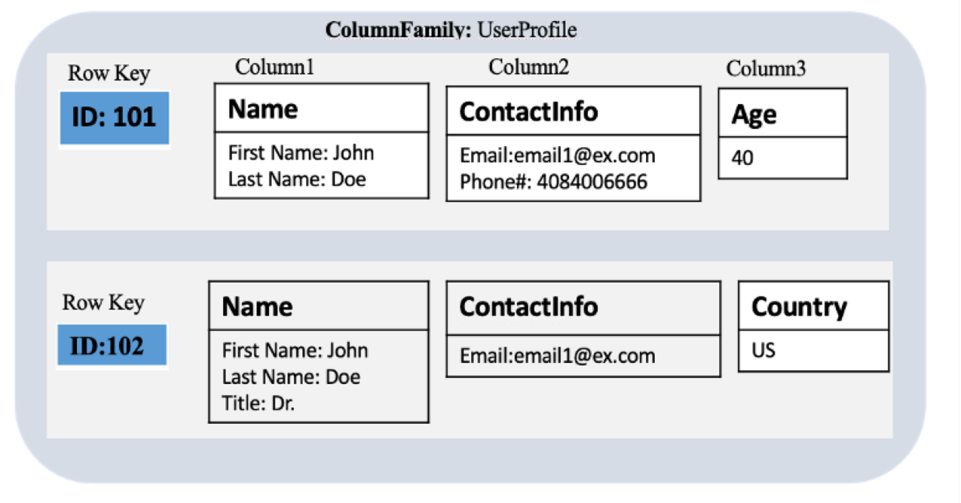

Figure 175 - Visual representation of a column database (Amazon AWS, 2024)

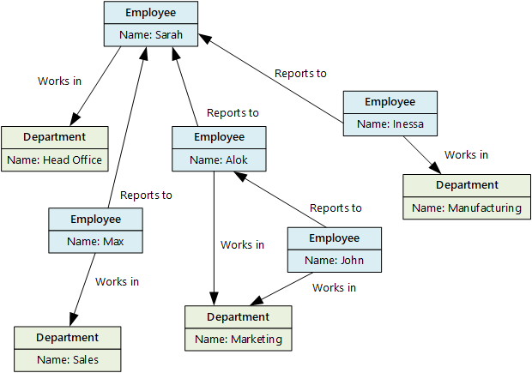

Figure 176 - Representation of a graphical database (Microsoft Learn, 2024)

#### Vs Relational Databases

There are some common differences between the various types of non-relational databases compared to relational ones. These are explored below:

|  |  |
| --- | --- |
| **Non Relational** | **Relational** |
| Non-Relational databases do not specifically have to confirm to a set schema the same way a relational model does.  This makes non-relational databases more reliable for data without fixed structures, or data that frequently changes | Data must be structured e.g. a table in a relational database must define columns with set datatypes. |
| Data is de-normalised, leading to potentially redundant/duplicate data that is unsuitable for analytics or reporting | Data is normalised, creating referential integrity in the data. |
| Data retrieval is simple and normally does not require joining other tables | Complex joins may be required |
| Excel at high availability and performance, where latency times are measured in milliseconds while performing millions of transactions per seconds |  |

(Microsoft Learn, 2022)

A summary takeaway I see form this is that non-relational databases are preferred for applications that require fast read times and do not require complex operations. For use cases that do require this however (e.g. analytics and reporting on key business performance indicators), a traditional relational database would be more suitable.

### Current Architecture

The below sections contain details of the existing architecture of our decisioning systems and how the data they generate is stored and used by front-end systems.

#### Overview

Below, I have summarised the architecture into a diagram:

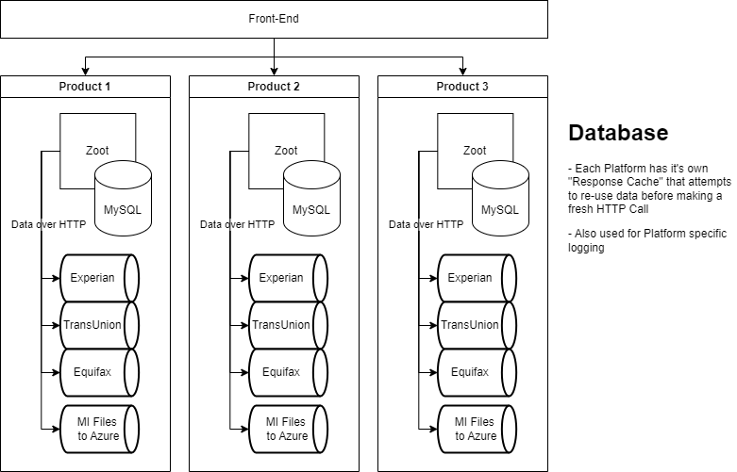

Figure 177 - Current Architecture for calling External Data Providers

Our Decisioning Systems is currently split on a by-product basis i.e. for every product we offer, we use an individual instance of the decisioning system e.g. one for Loans, one for Cards etc. This is done so that individual decisioning logic that only applies to 1 product can be developed and maintained without the risk of introducing breaking changes into other products.

The decisioning system itself takes the form of a HTTP API. Front-end systems will send POST HTTP Requests to the system containing necessary data collected from the customer to make an informed credit decision. This data includes:

* Name
* Address
* Income
* Expenditure

The system uses this data to call Data Provider services offered by Credit Bureaus (e.g. Experian, TransUnion & Equifax) to obtain additional data. All this data is then used to execute a Credit Decisioning strategy to judge the credit risk of lending to an applicant. The system will then send a Response back to the front end with this decision, allowing the front-end to handle ether the onboarding steps (if the applicant is approved) or the decline process (if they are not).

#### Databases

Each instance also contains its own database; a MySQL relational database which is used for various purposes:

* Each HTTP Request/Response is logged for auditing
* Previous requests from the same applicant can be looked up e.g. if someone changes their details between applications, to get a preferable decision to them
* **Responses from external data providers are cached**, in case the same applicant re-enters the system. This allows the data to be reused, saving costs on calling these services (which are chargeable per call).

MySQL was not a specific tool choice by us. It was chosen by our 3rd Party partner & is deeply integrated into the Zoot system. As such, we are unlikely to be able to change it. MySQL however is a flexible solution, which provides some mitigation against this risk e.g. it can store and parse JSON documents, allowing it to effectively function as a Document-type non-relational database.

#### Connecting Data to User Interfaces

The HTTP Response created by the decisioning systems is critical. By itself, this is just a data set. The front-end system interprets this data to direct where the applicant journey should go next.

Figure 178 below for example shows part of the response that contains the decision made by the decisioning system on an application. The “finalDecisionReason” and “decisionReasonCodes” are the critical fields here, as differing values can be used to control what the next steps for an application should be.

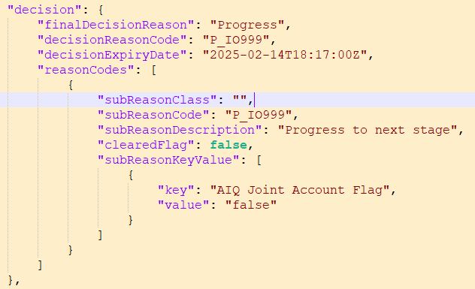

Figure 178 - Snippet of the Decisioning Engines HTTP Response, which the front-end references to control the next screen shown to applicants

The “Progress” values seen here are an instruction for the front-end to show a “Congratulations” screen to the applicant, to indicate we can provisionally offer then a credit product (subject to other checks in the journey). An example of this screen is shown in the figure below (note that this is for an older build of the front-end system).

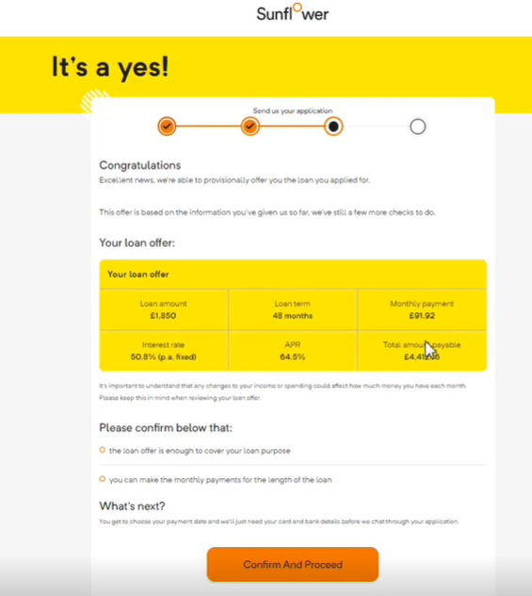

Figure 179 - Front-end screen shown to applicants for a "Progress" result.

That only covers the parts the customer sees. In the background, the front-end system also creates several records within its own system to record relevant information on the application. This is to cover audit scenarios where a full view of how the applicant went through the application journey is needed & what decisions are made. Another use case is that this data can be referenced by the Operations teams when an application needs to be manually approved before a credit product can be offered.

Decision records like the one shown in Figure 178 above are saved in what the front-end calls “Check” records. The figure below shows an example:

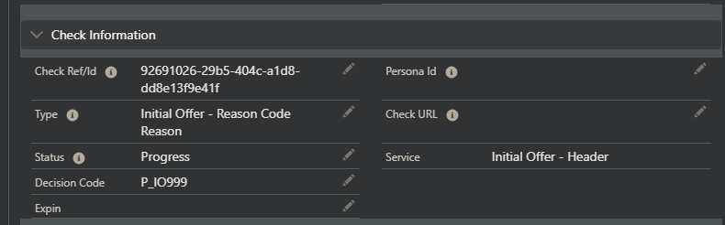

Figure 180 - Check Record in the Front-End system, saving a record of the decision(s) received from the decisioning system

That is not the only record created however. Multiple check records are created based on data received in the HTTP Response from the decisioning system, covering other data points seen besides the main decision, as shown in the figure below:

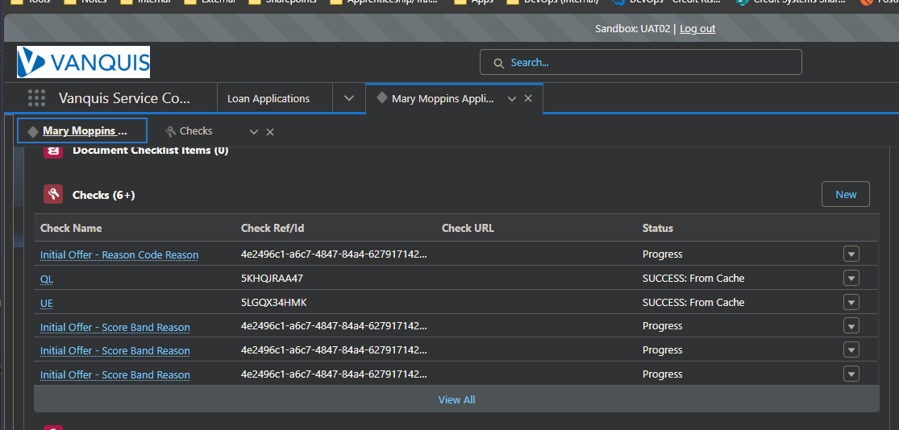

Figure 181 - Multiple Check records created in the Front-End system (UAT Environment as to not show any actual customer data)

Figure 181 shows additional check records. These are based on other data blocks received in the response e.g. the “scorecards” data maps to the data seen in the Check record show in Figure 183, while one of the entries in the “externalInfo” data maps to the record shown in Figure 184. Data mapping logic within the front-end system parses the JSON response received to create as many records as required, allowing the front-end to maintain a complete record of the application, in a cleaner User Interface then a raw JSON can provide.

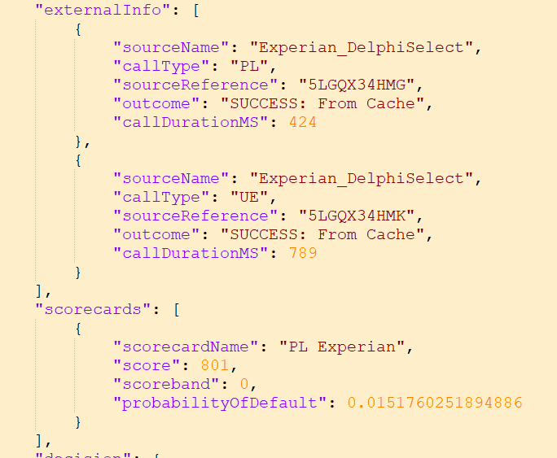

Figure 182 - Additional blocks of data within the decisioning engine HTTP Response

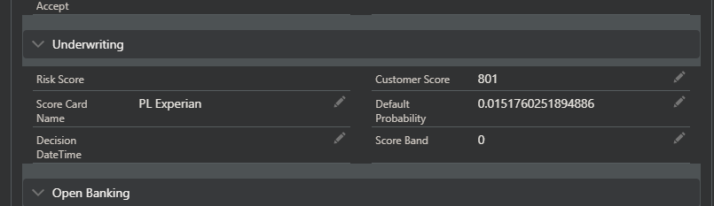

Figure 183 - Check record created from the Scorecard data from the decisioning engine's HTTP response

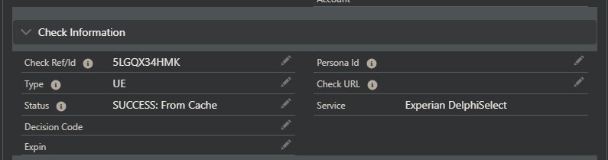

Figure 184 - Check record created from the External Info data from the decisioning engine's HTTP Response

## Strengths and Weaknesses

From reviewing the architecture and including reflections on recent work experience, I have identified the following strengths and weaknesses of the architecture:

|  |  |
| --- | --- |
| **Strengths** | |
|  | Using isolated instances of the decisioning system per product helps make the business logic implementation more maintainable.  For example, if changes are only needed in the business logic for evaluating Cards credit risk, this split means we would not risk creating breaking changes in the business logic for evaluating credit risk for a Vehicle Finance product. The split platforms mean the logic is isolated from one another. |
|  | The MySQL database solution can support both relational and non-relational database design paradigms, making it flexible for different use cases.  It also specifically has options for horizontal scaling, allowing the database to gain more processing power as demand increases. |
| **Weaknesses** | |
|  | HTTP Integrations with 3rd Parties are currently being built per monolithic product platform. These effectively means we are duplicating code per platform and as these are independent, they can differ.  This has been a risk that has materialised in recent history e.g. in 2024 we found a critical issue where the integration between an Experian API differed between 2 of our platforms. The way address data was being mapped into the request to the Experian API differed and resulted in the Experian API not consuming these properly. This negatively impacted the data we received back from that API and presented regulatory and compliance implications, requiring us to roll back the impacted build i.e. revert to an earlier production build. |
|  | Data stored in the Database cannot be re-used per platform, as they are all isolated from each other.  For example, the Response Cache use case stores responses from external data providers and attempts to re-use them before making new API calls. As each call is chargeable, this reduces costs. The isolation however means it is theoretically possible for an applicant to apply for each individual product we offer & we’d call the Data Provider service each time. Assuming the request data is the same (i.e. name, address, date of birth), then we’d get the same response from the data provider for each call.  This would be a barrier if we wanted to build a customer management process that checks a customer’s eligibility for each product (i.e. cross sell). |
|  | If there is Business Logic that is shared across platforms, we’d currently need to implement this on each individual platform.  This could be mitigated however by importing the necessary business logic between platforms (e.g. with version control). A design doing this however must be modular i.e. not have any dependencies on processes specific to a single platform. |

## Alternative – Microservice Architecture

The weaknesses identified in the above section highlight pain points in our current architecture. These weaknesses are symptoms of the monolithic approach we’ve taken so far. To resolve these, we can look at using a “microservice” approach.

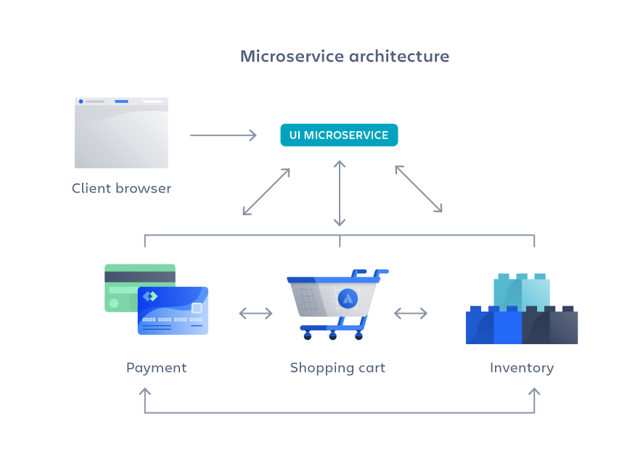

Figure 185 - Visual representation of a Microservice Architecture (Atlassian, 2024)

The Microservice architecture differs from monoliths in that instead of packaging all components into a single code base, multiple independent services are created and split into their own code bases, each performing a specific business logic. The resulting services then communicate with each other as needed e.g. via HTTP calls (Atlassian, 2024).

This approach allows for business logic to be decoupled from each other, bringing benefits over traditional monoliths:

* The independent services can be re-used across other solutions as needed e.g. if a later business project required a payment service, we would not need to build a new one
* The services are independent of each other, allowing changes to be made without the risk of breaking another service
* Splitting the services creates smaller code bases, making the solution easier to maintain and test, and therefore minimising time to market for changes
* The small code base also creates less opportunity to be “locked in” to specific technology choices, bringing more freedom in upgrading

(Atlassian, 2024)

### Proposed Architecture

Based on this idea of Microservices, I propose the to split off our 3rd party data provider integrations into Microservices, where our product platforms would instead call these services instead of using integrations built within the platform itself. Figure 186 shows this visualised:

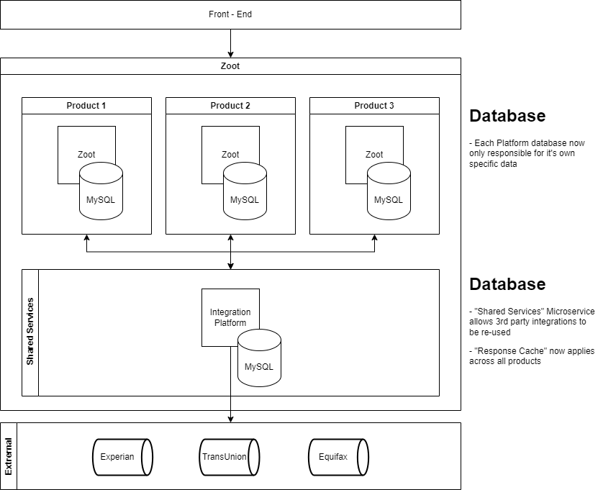

Figure 186 - Proposed changes to Architecture, focusing on reusing API Integrations

Instead of integrating 3rd party APIs per product platform, we instead set up a new platform solely for calling these services. This will allow for **a consistent integration between these services to be used**, resolving the 1st weakness identified previously.

Using a single platform with a single Response Cache database also resolves the 2nd weakness, as this singular entry point to the integrations means we can share a database for these services**, allowing cached data to be re-used across platform**s.

Strictly speaking, a **true microservice architecture would use separate platforms for each 3rd party service we’d use**, however **doing so increases the costs** (as our 3rd party partner bills us per platform). Having a singular platform allows the above benefits while minimising this platform cost overhead, trading off not fully isolating each 3rd party service.

### How to Implement

Currently, our decisioning engine instances parse the JSON/XML responses from these 3rd party services into a Schema, allowing the data within to be used by the platform. This schema must pre-declare every object and variable within the structure. Anything not captured is dropped. An example of one such schema is shown below:

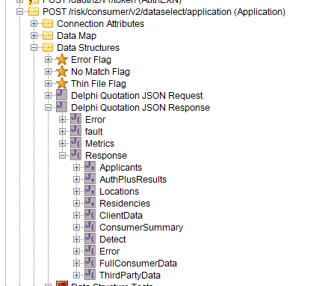

Figure 187 - JSON Schema for an Experian API Product as seen within our low-code decisioning engine

Making this architecture change could have implications on how this is referenced. For example, variables/objects using this schema reference the exact path, with the below figure showing a variable called “MatchTo” being used in an IF-condition RegEx logic:

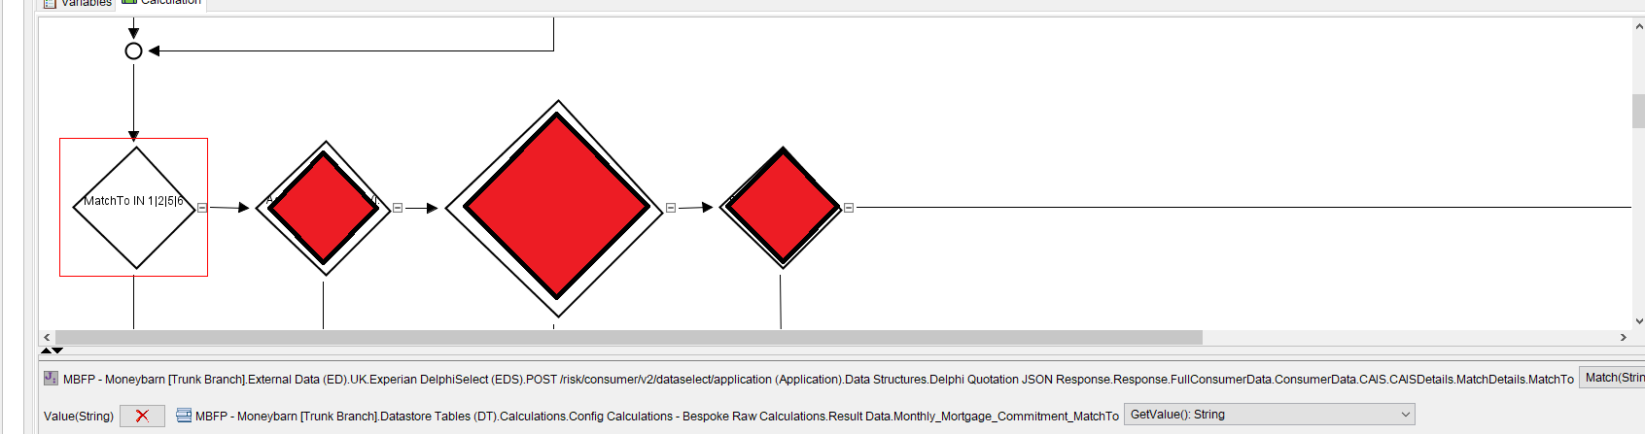

Figure 188 - Example of a RegEx match function being used on a variable within this parsed JSON schema

To avoid having to refactor any code, we’d have to pass the response from the 3rd party data provider exactly as is when designing our microservice payloads, so that it would still conform to this schema. This could become a limitation, as it limits our ability to create useful logging information from the HTTP call to the 3rd party service.

We could instead wrap the raw response from the data providers inside a “providerPayload” object, which opens the schema for additional metadata to be passed. A proposal for how this could look is below:

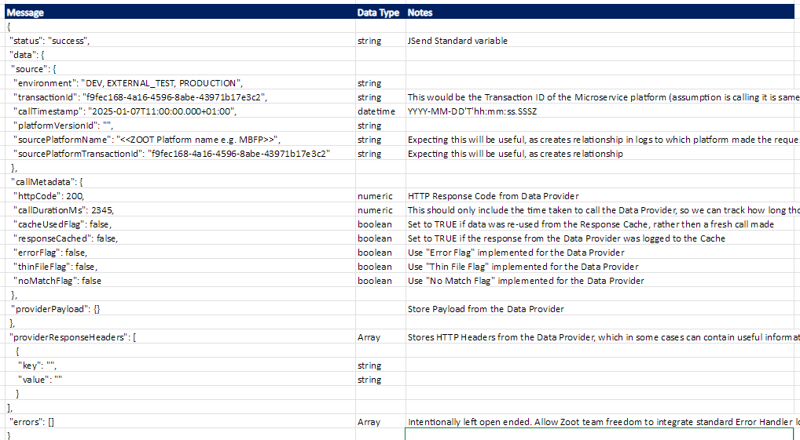

Figure 189 - Proposed JSON Schema for the Microservice Payloads

This structure will:

* Allow the payload from the data providers to be captured exactly as is, meaning if new data is added, we don’t need to update the schema for it to be captured. The exact format that can accomplish this however needs investigating. I have a concern that system limitations within our 3rd party decisioning engine tool mean that this may not be true if the raw payload from the data provider is saved as an object. It may be required to save the raw payload as a string instead to avoid this (preferably as a Base64 encoded value to avoid issues with special characters).
* Additional data from the microservice platform can be recorded e.g. call duration to the data provider in milliseconds, allowing us to record this for MI Purposes e.g. measuring the overhead using the microservice architecture adds compared to the current direct integration done per platform

## Conclusion

There are some painful weaknesses within our existing monolithic platforms around how they integrate with 3rd party services. The single code base nature of monolithic platforms means we duplicate the code required for these integrations to each platform. Each platform then makes changes to this code, resulting in differing implementations. We’ve already seen a critical bug in production because of this.

Moving the 3rd party data integrations to a separate platform in a microservice fashion would mitigate this and provide us with re-usable services. Ideally, we’d split off each data provider into its own microservice, however this would incur additional cost, as the core architecture of the decisioning engine software provided by our 3rd party partner means that a separate platform would have to be created for each service. They bill us per platform, so this approach would significantly increase costs. As a compromise, the proposed solution outlined in this document uses a shared platform to host these integrations, allowing the benefits to be realised with minimal cost.

There is one potential problem with the proposed solution, where the need for a predefined schema means we could lose data if the 3rd party provided add new variables or objects. How to mitigate this is an action to work with our 3rd party partner with. There is however a workaround identified here, where we could encode the raw payload from the providers in Base 64 and provide in the microservice response as a string, avoiding the risk at the cost of requiring decoding within the platforms.

# Additional Evidence

# Final Reflections

## Future Development

# Appendices

## React Web App

Below is some additional work I did for the React Web App project but have not included as part of the final project. Reasons for this include:

* Work was made redundant with later commits made to the repositories
* Work was incompatible with the end goal of the project or it’s aspirations

### Initial Backend attempt, with React & Node.JS running via the “concurrently” library

The “**mssql**” module I need to connect my React application to an Azure SQL Database is a Node.js module, so I needed to create a Node Backend to be able to make use of this. I followed this guide from (Barger, 2021) to do this.

For this to work, I required the “express” module, so I used npm to ensure that was available:

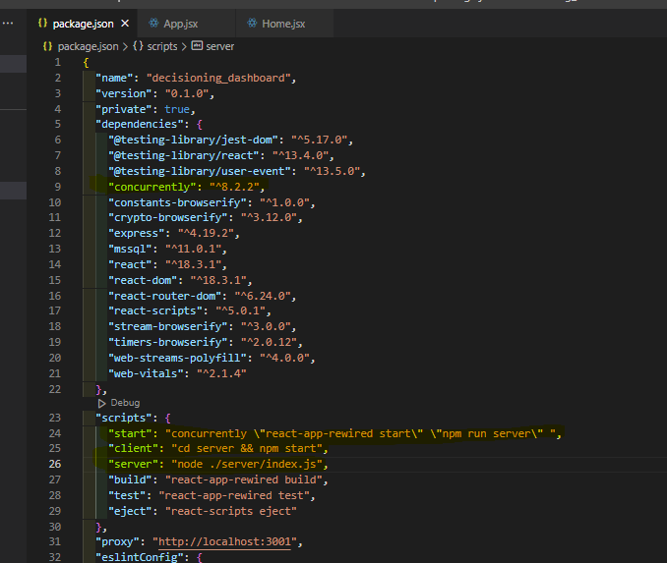

Figure 190- Initial Backend npm start logic

This worked on my local machine. However, it did not when I deployed to my Azure host. Rather than debug this, I thought it would be easier to implement a separate Node.js server as a backend and access as an HTTP call in the React Application. Therefore, this was scrapped.

### Hosting in Azure Static Web App

One thing I wanted to do to allow testing of the application is to make it available to other users, which would enable UAT testing directly with multiple colleagues. To do this though, I needed a way to deploy the application.

I already had a Visual Studio Professional subscription (which has monthly Azure credits) from my employer, so this was my 1st idea for a hosting solution. I came across the Static Web App resources, which would allow me to link to the GitHub repository directly. Shown below is how I configured this:

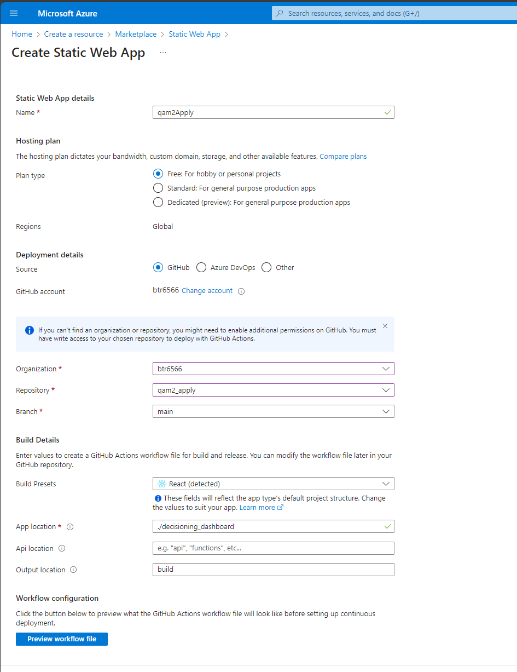

Figure 191 - Setting up an Azure Static Web App to host the React application

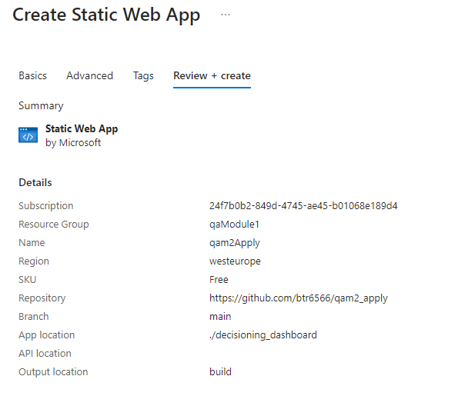

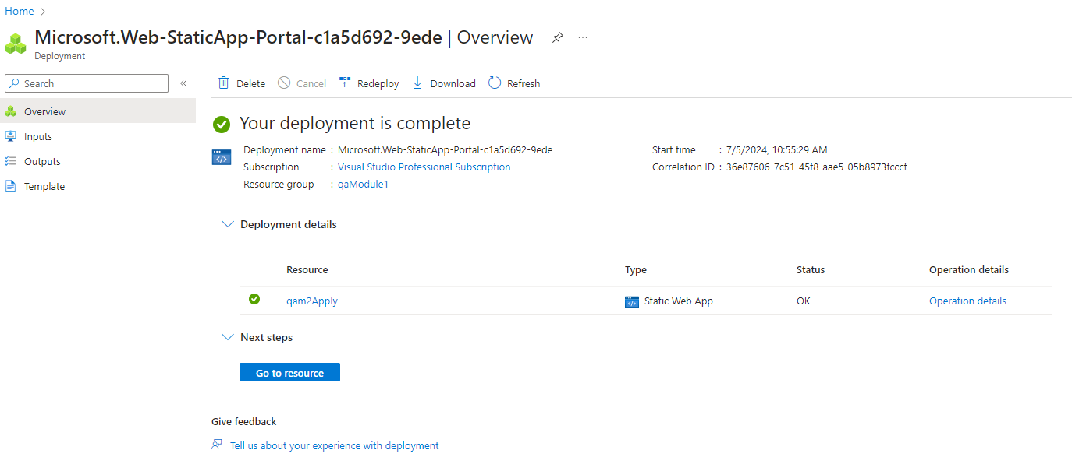

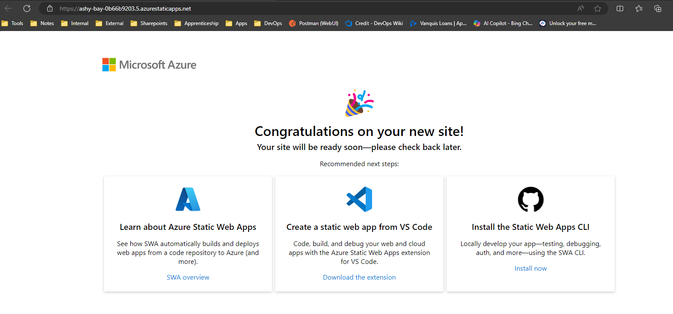

After the deployment, I tried using the default URL Azure provided to see if I could access the application. This was successful:

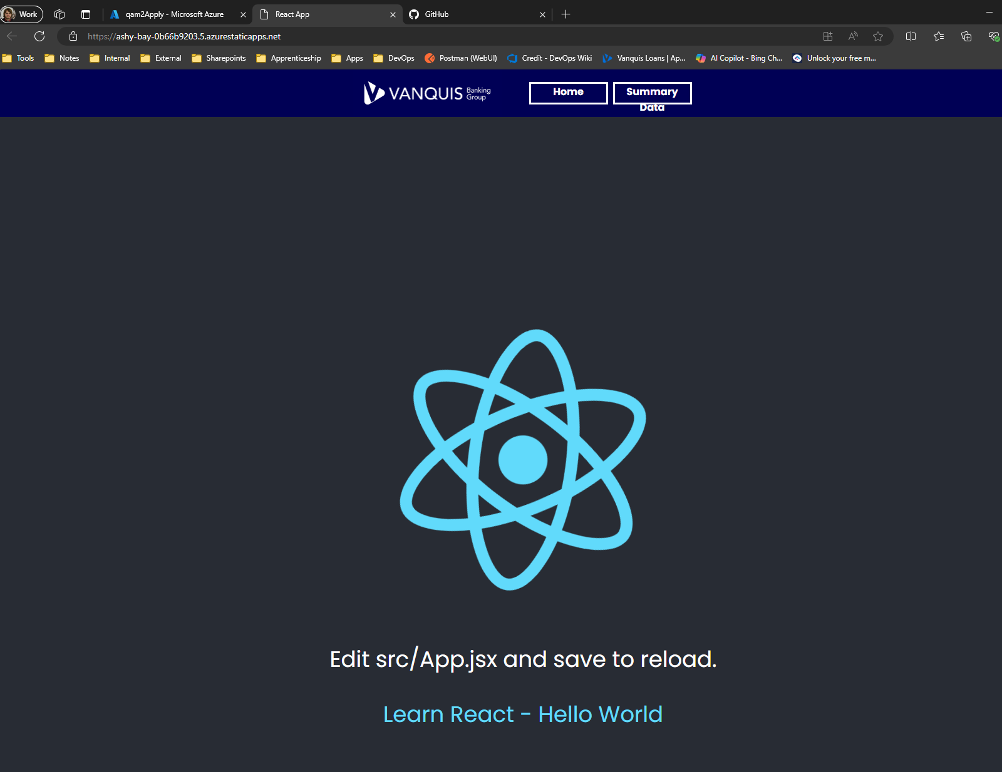

Figure 192 - The React App home page as deployed to the Azure Static Web App

#### Confirming access

I needed to know if this deployed application was accessible by other users. To confirm this, I asked one of my colleagues (referred to as MO in the screenshot below) to try accessing the link and confirm what they see. This would be an example of communicating with a non-technical stakeholder, as doing this kind of deployment (i.e. with a React application) is outside the scope of what this stakeholder does. This was successful:

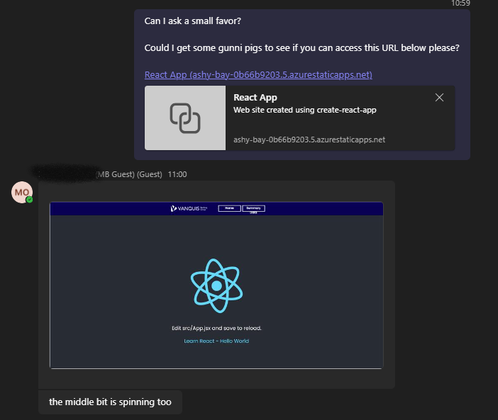

Figure 193 - Confirmation a user can access the deployed React App

This gave me a proof of concept that this method of deploying a React Application to an Azure based host would work with the resources available to me. When the need for a full Backend became apparent however, I needed to consider how the deployed application would communicate with the Backend, which I did not consider with this Static Web App. I therefore scrapped this.

## Application Testing

### Appendix A – Exported PDF Report of Performance Testing results

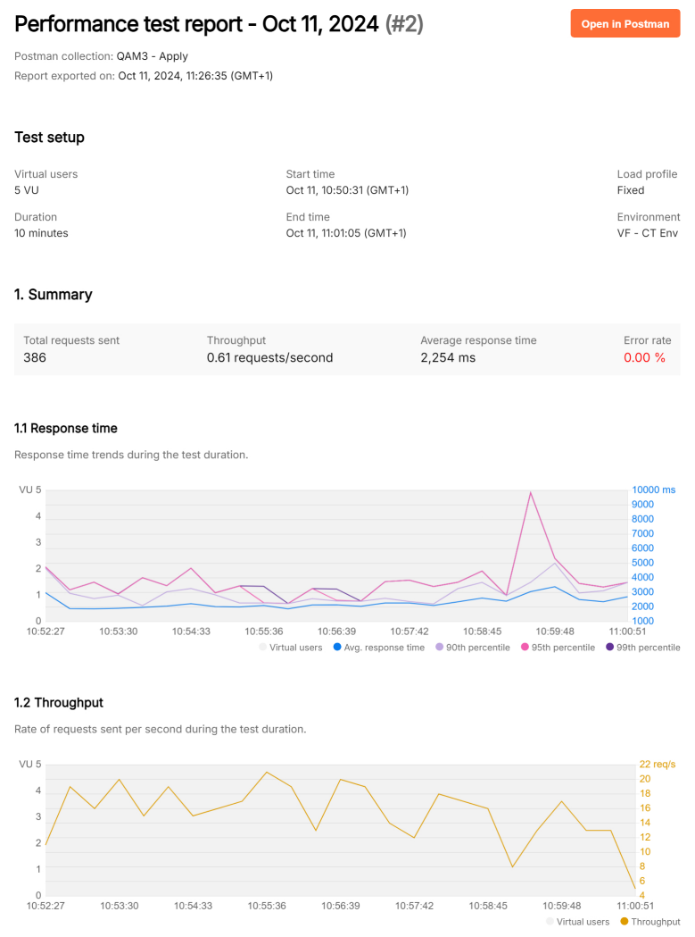

Figure 194 - Postman Performance Test Report - Page 1

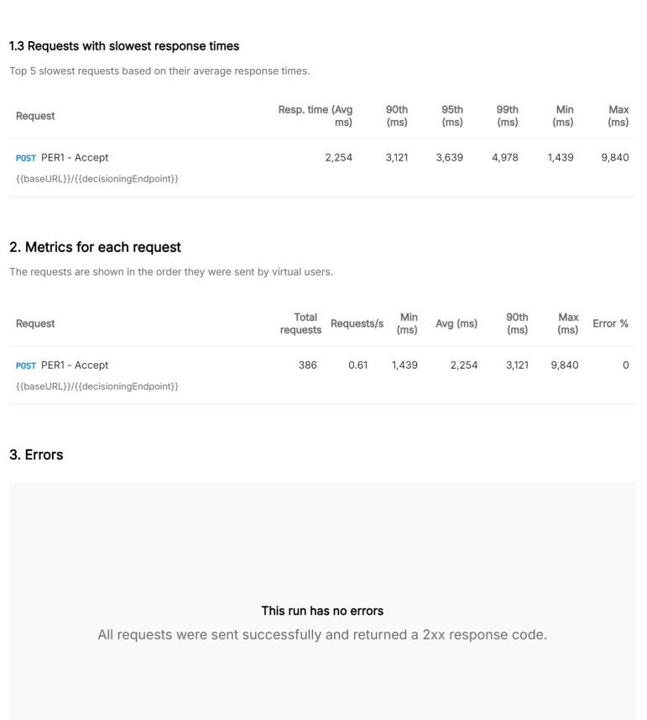

Figure 195- Postman Performance Test Report - Page 2

### Appendix B – Exported PDF of Load Testing Results

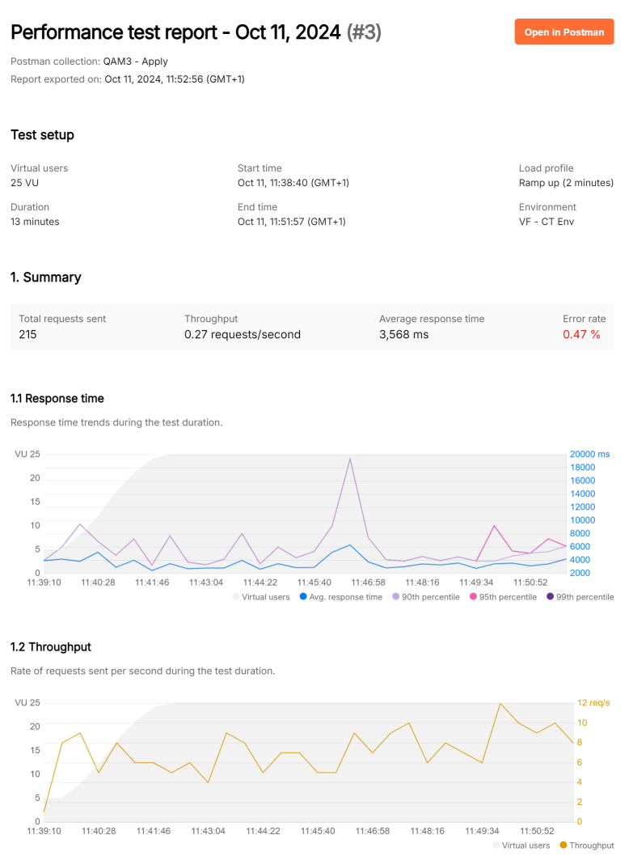

Figure 196 - Postman Load Testing Report - Page 1

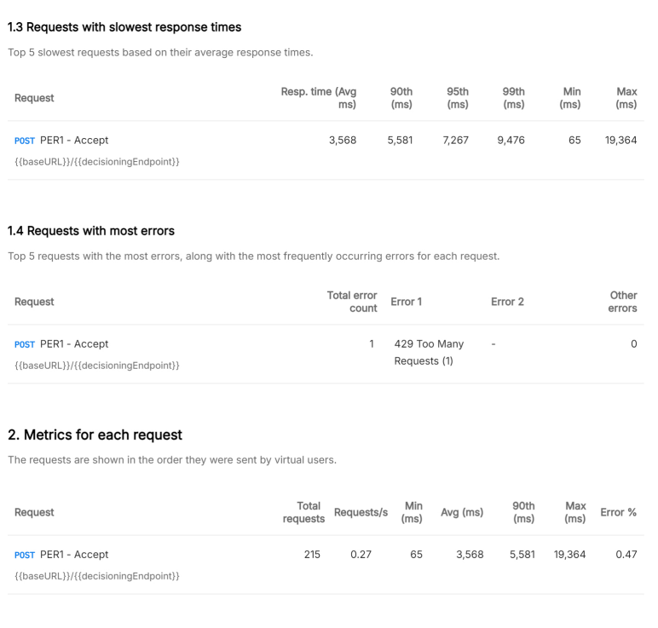

Figure 197 - Postman Load Testing Report - Page 2

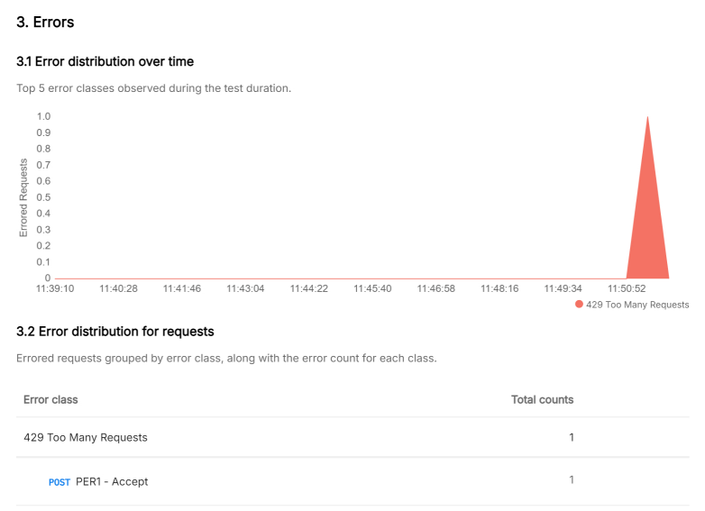

Figure 198- Postman Load Testing Report - Page 3

## Acronyms and Terms

|  |  |  |
| --- | --- | --- |
| Term | Synonym(s) | Description |
| Acceptance Criteria |  | Criteria that accompany a User Story that captures the conditions that must be met before a story can be considered “done”. These are agreed with the end user/stakeholder and sets the expectations that must be met. For a Developer, they also set the scope of the task. |
| Calander Versioning |  | Simple versioning structure that makes use of Calander date rather than arbitrary numeric values |
| Client Test | CT, External Test (ET) | Older name for “External Test,” which still see’s popular usage amongst development teams.  Zoot environment(s) used by our teams for functional & non-functional testing of the platform. |
| Copy of Live | COL | A form of testing using real customer data in a test environment. Should only be used when strictly necessary due to the PII Data usage required.  Useful for:   * Proving impact of changes against known customers * Testing the system more thoroughly compared to relying on test data available from integrated services |
| C-Level | Executive | Executive members of the organisation, reporting directly to the Board of Directors e.g. Chief Executive Officer (CEO), Chief Risk Officer (CRO), Chief Financial Officer (CFO) etc. |
| Data Provider | External Info, External Data | Term used by Zoot to refer to an outbound service that it retrieves data from as part of the implemented business logic.  Most common examples will be the 3 Credit Bureaus (Experian, TransUnion and Equifax), but the term applies to any service Zoot calls. |
| General Data Protection Regulation | GDPR | European Union (EU) initiative that defines the rights of Data Subjects (i.e. people) on how their data can be collected & used. Also governs how this data can be transferred outside the EU.  The UK has adapted this into its own Data Protection Act. |
| Experian Credit Test Database | eCTDB | Test data that can be used for testing systems using Experian Products. The data is based on randomised credit files, allowing a variety of actual API responses to be used in testing without any Data Protection concerns. There is however only a limited amount of record (about 2000) and there is no guarantee they will contain data relevant to the test case. |
| External Test | ET, Client Test (CT) | Zoot environment(s) used by our teams for functional & non-functional testing of the platform |
| Internal Test | IT | Zoot environment(s) used exclusively by the Zoot team for QA Purposes, before they deploy to External Test and allow clients to conduct their own UAT testing.  This is done as an Audit Control/Requirement, as Zoot operates on a shared Cloud and this QA testing helps confirm the new version won’t adversely impact the shared cloud, which would impact other clients. |
| Impediment |  | A specific type of work item in DevOps that captures a blocker to other user stories e.g. a User Story cannot be completed because there is ambiguity in the requirements that were not initially identifies. An Impediment can be used to orchestrate and log stakeholder input into resolving the blocker and allow the development to continue. |
| Pair Programming |  | 2 Developers actively collaboration on a single piece of code or work item. The idea is that they both take a specific role to solve the problem presented together, with the expectation that by doing so, they’ll create higher quality code and help each other develop their skills. For example, 1 developer takes the “driver” role of actively writing the code, while the other takes the “navigator” role of providing feedback in real time that the “driver” can implement immediately. |
| Personal Identifiable Information | PII | Data subject to the Data Protection Act and GDPR, as it can be used to personally identify a customer. High quality controls must be in place for managing this data per these acts. |
| Software as a Service | SaaS |  |
| SOC2 | System and Organization Controls (SOC) 2 | Independent third-party examination reports that demonstrate how an organisation achieves key compliance controls and objectives (Atlassian b, 2025).  Specifically examines the security, availability, processing integrity, confidentiality, and privacy of customer data through a comprehensive assessment of a service provider’s controls (SOC, 2025). |
| Technical Requirements Document | TRD | A template used by the Credit Systems team to capture requirements from Strategy Teams about changes they want to the Decisioning systems. Using a template helps ensure the necessary level of detail and approvals are captured. |
| User Acceptance Testing | UAT | User Acceptance Testing (UAT) is the final phase in the strategy development process.  During UAT, business users/testers, test the strategy changes in real-world conditions to ensure it meets the business requirements and functions as expected.  This stage is crucial for identifying any issues or improvements needed before the strategy change is released to the Production Environment. |
| User Stories |  | Description of a feature/functionality from the perspective of an end-user. They are written to capture the value, need, and outcome of a proposed development to provide a solution to an identified problem/ask.  Typically, user storied follow the format:  “  *As a [role],*  *I want [a capability or action],*  *so that [a specific benefit or value].*  “  Should be accompanied with Acceptance Criteria, which are the conditions that are agreed with the end user/stakeholder to confirm the story is complete. |
| Unit Test |  | Automated tests created to verify expected behaviour of individual components or units of code e.g. functions.  These are done in isolation from the rest of the system e.g. we only test things directly related to the component under test. They ensure that each unit performs as expected under various conditions, catching bugs early in development. |

## Guidance (Delete this later)

Portfolio Formatting

- Cover page - name, date, professional design, company branding

- Table of contents

- Overall introduction - Introduce yourself, your role, your company, the apprenticeship etc.

- Apply activities inserted one after another

- Any further evidence they wish to include (communication, problem solving, creative thinking etc if it is relevant to the workplace)

- Overall reflection - talk about what went well, the challenges, future plans etc...

Consider the following;

- Page numbers

- Header, footer, subheadings

- Consistent text font, size, style

# Bibliography

Agile Manifesto, 2024. *Principles behind the Agile Manifesto.* [Online]   
Available at: https://agilemanifesto.org/principles.html  
[Accessed 09 12 2024].

Amazon AWS, 2024b. *What is SDLC (Software Development Lifecycle)?.* [Online]   
Available at: https://aws.amazon.com/what-is/sdlc/#:~:text=The%20software%20development%20lifecycle%20(SDLC,expectations%20during%20production%20and%20beyond.  
[Accessed 28 06 2024].

Amazon AWS, 2024. *Types of NoSQL databases.* [Online]   
Available at: https://docs.aws.amazon.com/whitepapers/latest/choosing-an-aws-nosql-database/types-of-nosql-databases.html  
[Accessed 17 01 2024].

Amazon AWS, 2024. *What is SDLC (Software Development Lifecycle)?.* [Online]   
Available at: https://aws.amazon.com/what-is/sdlc/

Apache, 2024. *Apache JMeter.* [Online]   
Available at: https://jmeter.apache.org/  
[Accessed 27 09 2024].

Atlassian a, 2024. *What Is DevOps?.* [Online]   
Available at: https://www.atlassian.com/devops  
[Accessed 09 12 2024].

Atlassian b, 2025. *SOC 2.* [Online]   
Available at: https://www.atlassian.com/trust/compliance/resources/soc2  
[Accessed 08 01 2025].

Atlassian, 2024. *Microservices vs. monolithic architecture.* [Online]   
Available at: https://www.atlassian.com/microservices/microservices-architecture/microservices-vs-monolith#:~:text=A%20monolithic%20architecture%20is%20a%20singular%2C%20large%20computing%20network%20with,of%20the%20service%2Dside%20interface.  
[Accessed 16 01 2024].

AWS, 2024. *What is Unit Testing?.* [Online]   
Available at: https://aws.amazon.com/what-is/unit-testing/#:~:text=Unit%20testing%20is%20the%20process,test%20for%20each%20code%20unit.  
[Accessed 20 09 2024].

AWS, n.d.. *What is Unit Testing? - Unit Testing Explained - AWS.* [Online]   
Available at: https://aws.amazon.com/what-is/unit-testing/  
[Accessed 22 01 2024].

Baeldung, 2024. *Single Responsibility Principle in Java.* [Online]   
Available at: https://www.baeldung.com/java-single-responsibility-principle  
[Accessed 17 12 2024].

Barger, R., 2021. *How to Create a React App with a Node Backend: The Complete Guide.* [Online]   
Available at: https://www.freecodecamp.org/news/how-to-create-a-react-app-with-a-node-backend-the-complete-guide/  
[Accessed 05 07 2024].

Bechtold et al, 2024. *JUnit Jupiter API.* [Online]   
Available at: https://junit.org/junit5/docs/current/user-guide/  
[Accessed 05 06 2024].

Bionic Turtle, 2011. *FRM: Logistic distribution maps credit score to probability of default (PD).* [Online]   
Available at: https://www.youtube.com/watch?v=HnQ6QjeGMm0  
[Accessed 09 05 2024].

CalVer, 2024. *Calendar Versioning.* [Online]   
Available at: https://calver.org/  
[Accessed 20 12 2024].

Cohn, M., 2005. *Agile Estimating and Planning.* s.l.:Pearson.

Coursera, 2023. *7 DevOps Roles that Make a Team Successful.* [Online]   
Available at: https://www.coursera.org/articles/devops-roles  
[Accessed 06 12 2024].

Cucumber, 2024. *Gherkin Reference.* [Online]   
Available at: https://cucumber.io/docs/gherkin/reference/  
[Accessed 20 09 2024].

Cucumber, 2024. *Understanding the Differences Between BDD & TDD.* [Online]   
Available at: https://cucumber.io/blog/bdd/bdd-vs-tdd/  
[Accessed 20 09 2024].

DataCamp, 2024. *Normalization in SQL (1NF - 5NF): A Beginner’s Guide.* [Online]   
Available at: https://www.datacamp.com/tutorial/normalization-in-sql  
[Accessed 20 01 2024].

Deepsource, 2019. *The exponential cost of fixing bugs.* [Online]   
Available at: https://deepsource.com/blog/exponential-cost-of-fixing-bugs  
[Accessed 20 09 2024].

DevOps Institute, 2021. *The Agile Service.* [Online]   
Available at: https://www.devopsinstitute.com/wp-content/uploads/2023/03/the-agile-service-management-guide.pdf  
[Accessed 06 12 2024].

Easy Agile, 2024. *The Problem with Agile Estimation | Easy Agile.* [Online]   
Available at: https://www.easyagile.com/blog/problem-with-agile-estimation/  
[Accessed 13 12 2024].

Experian, 2024. *DelphiSelect API Documentation - for Credit Decisioning data.* [Online]   
Available at: https://developer.experian.com/products/uk/delphi-select/delphi-select-api-docs   
[Accessed 17 05 2024].

Express, n.d.. *Express application generator.* [Online]   
Available at: https://expressjs.com/en/starter/generator.html  
[Accessed 05 06 2024].

Facebook, 2024. *Adding custom environment variables. Create React App Documentation.* [Online]   
Available at: https://create-react-app.dev/docs/adding-custom-environment-variables/  
[Accessed 05 08 2024].

FICO, 2020. *A Guide to Champion/Challenger Testing Approaches: Overview and Benefits..* [Online]   
Available at: https://community.fico.com/s/blog-post/a5Q2E000000YNqoUAG/fico2227  
[Accessed 17 05 2024].

Geeks for Geeks, 2024a. *Switch Statements in Java.* [Online]   
Available at: https://www.geeksforgeeks.org/switch-statement-in-java/   
[Accessed 06 17 2024].

GeeksForGeeks, 2024a. *Integration Testing – Software Engineering.* [Online]   
Available at: https://www.geeksforgeeks.org/software-engineering-integration-testing/   
[Accessed 20 09 2024].

GeeksForGeeks, 2024b. *System Testing – Software Engineering.* [Online]   
Available at: https://www.geeksforgeeks.org/system-testing/  
[Accessed 20 09 2024].

GeeksForGeeks, 2024c. *Performance Testing – Software Testing.* [Online]   
Available at: https://www.geeksforgeeks.org/performance-testing-software-testing/  
[Accessed 4 10 2024].

GeeksForGeeks, 2024d. *Non-Functional Testing.* [Online]   
Available at: https://www.geeksforgeeks.org/software-testing-non-functional-testing/  
[Accessed 04 10 2024].

GeeksForGeeks, 2024e. *Security Testing.* [Online]   
Available at: https://www.geeksforgeeks.org/security-testing/  
[Accessed 04 10 2024].

Google, 2024. *GSON Libary.* [Online]   
Available at: https://mvnrepository.com/artifact/com.google.code.gson/gson  
[Accessed 05 06 2024].

Hunt, A. & Thomas, D., 2019. *The Pragmatic Programmer: Your Journey to Mastery. 20th Anniversary Edition.* 20th Anniversary Edition ed. Boston: Addison-Wesley.

IBM, 2023. *What is shift-left testing?.* [Online]   
Available at: https://www.ibm.com/topics/shift-left-testing  
[Accessed 13 09 2024].

IBM, 2024. *5 steps of test-driven development.* [Online]   
Available at: https://developer.ibm.com/articles/5-steps-of-test-driven-development/  
[Accessed 30 09 2024].

Iconic Digital Marketing Agency, 2024. *The importance of brand guidelines.* [Online]   
Available at: https://iconicdigitalagency.com/blog/branding/the-importance-of-brand-guidelines/  
[Accessed 05 08 2024].

Martin, R., 2009. *Clean Code: A Handbook of Agile Software Craftsmanship.* s.l.:Prentice Hall.

Microsoft Azure, 2010. *Adding Users to Your SQL Azure Database.* [Online]   
Available at: https://azure.microsoft.com/en-us/blog/adding-users-to-your-sql-azure-database/  
[Accessed 03 05 2024].

Microsoft Learn, 2022. *SQL vs. NoSQL data.* [Online]   
Available at: https://learn.microsoft.com/en-us/dotnet/architecture/cloud-native/relational-vs-nosql-data  
[Accessed 21 01 2024].

Microsoft Learn, 2024. *Define features and epics to organize your backlog.* [Online]   
Available at: https://learn.microsoft.com/en-us/azure/devops/boards/backlogs/define-features-epics?view=azure-devops&tabs=agile-process  
[Accessed 11 12 2024].

Microsoft Learn, 2024. *Non-relational data and NoSQL.* [Online]   
Available at: https://learn.microsoft.com/en-us/azure/architecture/data-guide/big-data/non-relational-data  
[Accessed 16 01 2024].

Microsoft, 2023a. *Northwind Database - TSQL.* [Online]   
Available at: https://github.com/microsoft/sql-server-samples/blob/master/samples/databases/northwind-pubs/instnwn  
[Accessed 01 05 2024].

Microsoft, 2024a. *Database-level roles.* [Online]   
Available at: https://learn.microsoft.com/en-us/sql/relational-databases/security/authentication-access/database-l  
[Accessed 05 06 2024].

Microsoft, 2024b. *MS SQL JDBC.* [Online]   
Available at: https://mvnrepository.com/artifact/com.microsoft.sqlserver/mssql-jdbc  
[Accessed 05 06 2024].

Microsoft, 2024c. *Proof of concept connecting to SQL using Node.js.* [Online]   
Available at: https://learn.microsoft.com/en-us/sql/connect/node-js/step-3-proof-of-concept-connecting-to-sql-using-node-js?view=sql-server-ver16  
[Accessed 09 08 2024].

Mindk, 2024. *7 Key DevOps Roles and Responsibilities of an Effective Team.* [Online]   
Available at: https://www.mindk.com/blog/devops-roles/  
[Accessed 06 12 2024].

Mozilla Support, n.d.. *Pop-up blocker settings, exceptions and troubleshooting.* [Online]   
Available at: https://support.mozilla.org/en-US/kb/pop-blocker-settings-exceptions-troubleshooting  
[Accessed 06 08 2024].

Mozilla, 2024a. *Polyfill.* [Online]   
Available at: https://developer.mozilla.org/en-US/docs/Glossary/Polyfill  
[Accessed 05 07 2024].

Mozilla, 2024b. *CSS - Top Property.* [Online]   
Available at: https://developer.mozilla.org/en-US/docs/Web/CSS/top  
[Accessed 09 08 2024].

Mozilla, 2024. *HTTP Status Codes.* [Online]   
Available at: https://developer.mozilla.org/en-US/docs/Web/HTTP/Status  
[Accessed 11 10 2024].

North, 2006. *Introducing BDD.* [Online]   
Available at: https://dannorth.net/introducing-bdd/  
[Accessed 20 09 2024].

Pahuja, A., 2024. *https://www.getastra.com/blog/security-audit/banking-application-testing/.* [Online]   
Available at: https://www.getastra.com/blog/security-audit/banking-application-testing/  
[Accessed 04 10 2024].

Pluralsight, 2020. *Relational vs Non-Relational Databases.* [Online]   
Available at: https://www.pluralsight.com/resources/blog/software-development/relational-vs-non-relational-databases#:~:text=There%20are%20five%20popular%20non,used%20for%20a%20single%20application.  
[Accessed 16 01 2024].

PortSwigger, 2024. *Burp Suite Professional Features.* [Online]   
Available at: https://portswigger.net/burp/pro/features  
[Accessed 30 09 2024].

Postman, 2024. *Postman Pricing.* [Online]   
Available at: https://www.postman.com/pricing/  
[Accessed 04 10 2024].

Postman, 2024. *Tools.* [Online]   
Available at: https://www.postman.com/product/tools/  
[Accessed 20 09 2024].

QA Apprenticeships, 2024. *Module 1 - Java JDBC Slides.* [Online]   
Available at: https://github.com/broberts-gtw/LVL_4_Software_Dev_Repo/blob/main/Module%201%20-%20Intro%20to%20Software%20Development/Live%20Course%201%20Materials/__Course%20Stretch%20files/Java/presentation/JDBC.pptx  
[Accessed 01 05 2024].

Radigan, D., 2024. *Agile vs. waterfall project management.* [Online]   
Available at: https://www.atlassian.com/agile/project-management/project-management-intro  
[Accessed 09 12 2024].

React Router, n.d.. *React Router - Link Object.* [Online]   
Available at: https://reactrouter.com/en/main/components/link  
[Accessed 09 08 2024].

Royce, W., 1970. *Managing the Development of Large Software Systems.* [Online]   
Available at: https://www.praxisframework.org/files/royce1970.pdf  
[Accessed 09 12 2024].

Schwaber, K. a. S. J., 2020. *The 2020 Scrum Guide.* [Online]   
Available at: https://scrumguides.org/scrum-guide.html#scrum-team  
[Accessed 06 12 2024].

Scrum.org, 2025. *What is a Sprint Review?.* [Online]   
Available at: https://www.scrum.org/resources/what-is-a-sprint-review  
[Accessed 08 01 2025].

Silva et al, 2020. *A logistic regression model for consumer default risk - National Library of Medicine.* [Online]   
Available at: https://www.ncbi.nlm.nih.gov/pmc/articles/PMC9041570/  
[Accessed 09 05 2024].

Smartbear SoapUI, 2024. *Why Load Testing Is Important.* [Online]   
Available at: https://www.soapui.org/learn/load-testing/why-load-testing-is-important/  
[Accessed 04 10 2024].

SmartBear, 2023a. *Writing scenarios with Gherkin syntax.* [Online]   
Available at: https://support.smartbear.com/cucumberstudio/docs/bdd/write-gherkin-scenarios.html  
[Accessed 20 09 2024].

SmartBear, 2024a. *Software Testing Methodologies.* [Online]   
Available at: https://smartbear.com/learn/automated-testing/software-testing-methodologies/  
[Accessed 20 09 2024].

Smartbear, 2024b. *Test Automation Frameworks.* [Online]   
Available at: https://smartbear.com/learn/automated-testing/test-automation-frameworks/  
[Accessed 27 09 2024].

Snowflake, 2024. *Access Control.* [Online]   
Available at: https://docs.snowflake.com/en/user-guide/security-access-control-overview  
[Accessed 05 06 2024].

SOC, 2025. *Sytem and Organisation Contols.* [Online]   
Available at: https://soc2.co.uk/  
[Accessed 08 01 2025].

SQLite, 2024. *SQLite Features.* [Online]   
Available at: https://www.sqlite.org/features.html  
[Accessed 06 08 2024].

Stack Overflow , 2021. *Adding objects to an array list.* [Online]   
Available at: https://stackoverflow.com/questions/70406298/adding-objects-to-an-array-list-cannot-invoke-xxx-add-b  
[Accessed 14 05 2024].

Stack Overflow, 2008. *Can an abstract class have a constructor?.* [Online]   
Available at: https://stackoverflow.com/questions/260666/can-an-abstract-class-have-a-constructor  
[Accessed 03 05 2024].

Stack Overflow, 2014. *No 'Access-Control-Allow-Origin' - Node / Apache Port Issue..* [Online]   
Available at: 09  
[Accessed 08 2024 2024].

Stack Overflow, 2024. *babel-preset-react-app, is importing the "@babel/plugin-proposal-private-property-in-object" package without declaring.* [Online]   
Available at: https://stackoverflow.com/questions/76435306/babel-preset-react-app-is-importing-the-babel-plugin-proposal-private-propert  
[Accessed 28 06 2004].

Stackify Team, 2024. *What Is SDLC? Understand the Software Development Life Cycle.* [Online]   
Available at: https://stackify.com/what-is-sdlc/

Strauch, C., n/a. *NoSQL Databases.* [Online]   
Available at: https://www.christof-strauch.de/nosqldbs.pdf  
[Accessed 17 01 2024].

TutorialsPoint.com, n.d.. *JUnit - Test Framework - Tutorialspoint.* [Online]   
Available at: https://www.tutorialspoint.com/junit/junit_test_framework.htm  
[Accessed 22 01 2025].

UK Cyber Security Council, 2024. *Security Testing.* [Online]   
Available at: https://www.ukcybersecuritycouncil.org.uk/careers-and-learning/cyber-career-framework/security-testing/  
[Accessed 04 10 2024].

UK Government, 2018. *Data Protection Act 2018.* [Online]   
Available at: https://www.legislation.gov.uk/ukpga/2018/12/contents/enacted   
[Accessed 17 06 2024].

W3Schools, 2024a. *Java Abstraction.* [Online]   
Available at: https://www.w3schools.com/java/java_abstract.asp  
[Accessed 03 05 2024].

W3Schools, 2024b. *CSS Layout - The position Property.* [Online]   
Available at: https://www.w3schools.com/css/css_positioning.asp  
[Accessed 09 08 2024].

W3Schools, 2024c. *Fetch API.* [Online]   
Available at: https://www.w3schools.com/jsref/api_fetch.asp  
[Accessed 05 08 2024].

W3Techs, 2024. *Usage statistics and market share of CSS frameworks for websites.* [Online]   
Available at: https://w3techs.com/technologies/overview/css_framework  
[Accessed 06 08 2024].

WeAreDevelopers, 2024. *Best CSS Frameworks.* [Online]   
Available at: https://www.wearedevelopers.com/magazine/best-css-frameworks  
[Accessed 06 08 2024].

Wikimedia.org, 2024. *Traditional-Shift-Left.* [Online]   
Available at: https://upload.wikimedia.org/wikipedia/commons/2/2c/Traditional-Shift-Left.jpg  
[Accessed 20 09 2024].

Yasar, K., 2024. *What is an API endpoint.* [Online]   
Available at: https://www.techtarget.com/searchapparchitecture/definition/API-endpoint  
[Accessed 05 08 2024].